**LINUX**

**What is an OS?**

* An OS is a software that acts as an interface between computer hardware components and the user.
* Every computer system must have at least one operating system to run other programs.

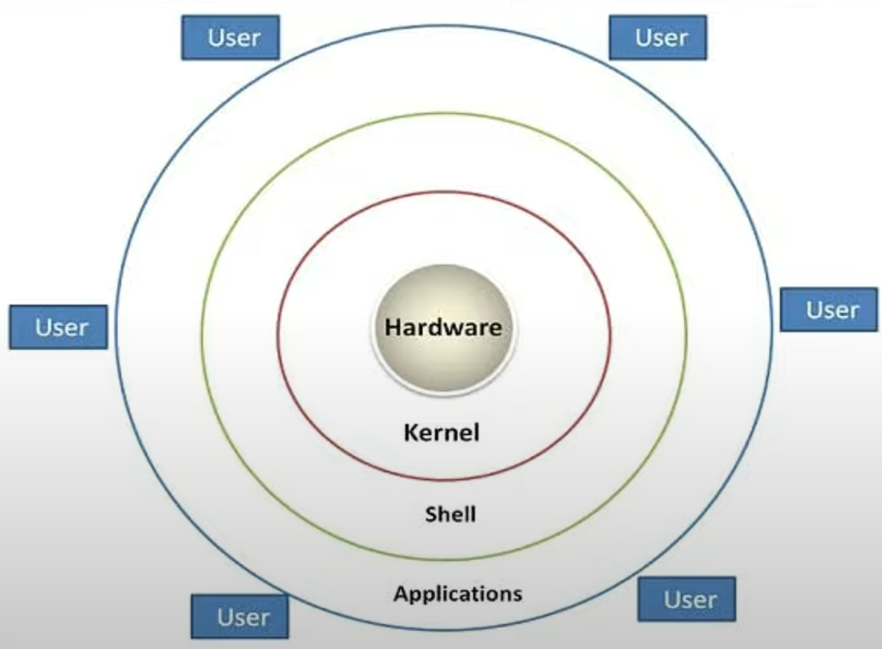

**What is Kernel?**

* Kernel is the core component of a Linux operating system that manages system resources (like RAM, CPU, Hard disk, etc.) and facilities communication between hardware and software.
* It acts as an intermediary between applications and the physical hardware of the computer, ensuring efficient and secure operation of the system.
* Linux uses the monolithic kernel which consumes more running space whereas Windows uses the micro-kernel which takes less space but lowers the system running efficiency than Linux.

**Types / Flavors of Linux:**

We have different flavors of Windows like xp, Windows 7, Windows Home, Windows 8, Windows 10, Windows 11.

Similar to Windows, we have different flavors of Linux as well like ubuntu, Redhat, Centos, Debian, Mandira, Slackware, Fedora, etc.

**Advantages of Linux:**

* Free of Cost
* Open Source
* Customizable
* Secure
* Easy to install
* Strong community support
* Easy to use
* Lightweight

**Windows File System / Folder Structure:**

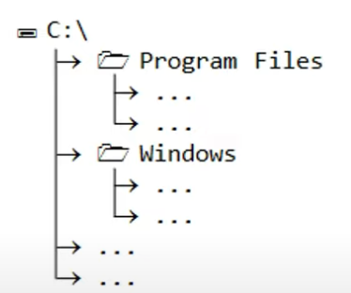

* Desktop, Downloads, Music, Documents, Videos, D drive, E drive => All are part of C drive.
* Windows uses backward slash (\) for Windows folder structure.

**Linux File System:**

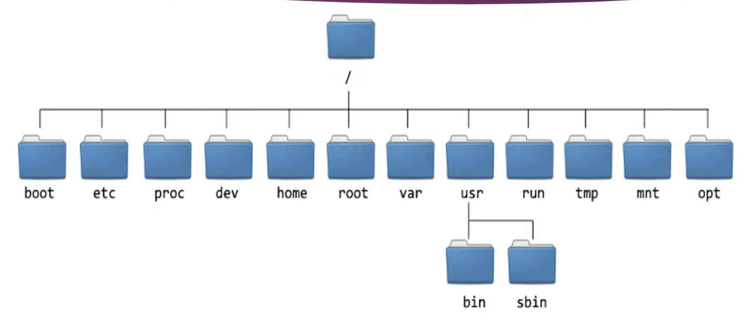

* Linux uses forward slash (/) for Linux directory (folder structure in Windows).
* We have some default directories (root, boot, bin, var, etc, media, etc.) in Linux

**User accounts in Linux:**

* Non-root user
  + They are regular or normal users with limited permissions
* Root user
  + They have full permissions
    - Software installation
    - User creation
    - Configuration file changes

**User accounts in Windows:**

* Adminstartor (Full permissions)
* Default user account (Limited permissions)

**Shell:**

* In Linux, Shell is a command-line interpreter that provides a user interface for interacting with the operating system.
* It allows users to execute commands and run scripts.
* Users can run the commands from Applications, then, shell will come into picture and start the execution.
* Flow will start from Applications > Shell > Kernel > Hardware. Response will be back to the same way:

**Types of Command Line Shells:**

* bash (default)
* dash
* sh
* csh
* tcsh
* fish
* zsh
* ksh

echo $SHELL (To check the default Shell in Linux)

echo $0 (To display current using Shell)

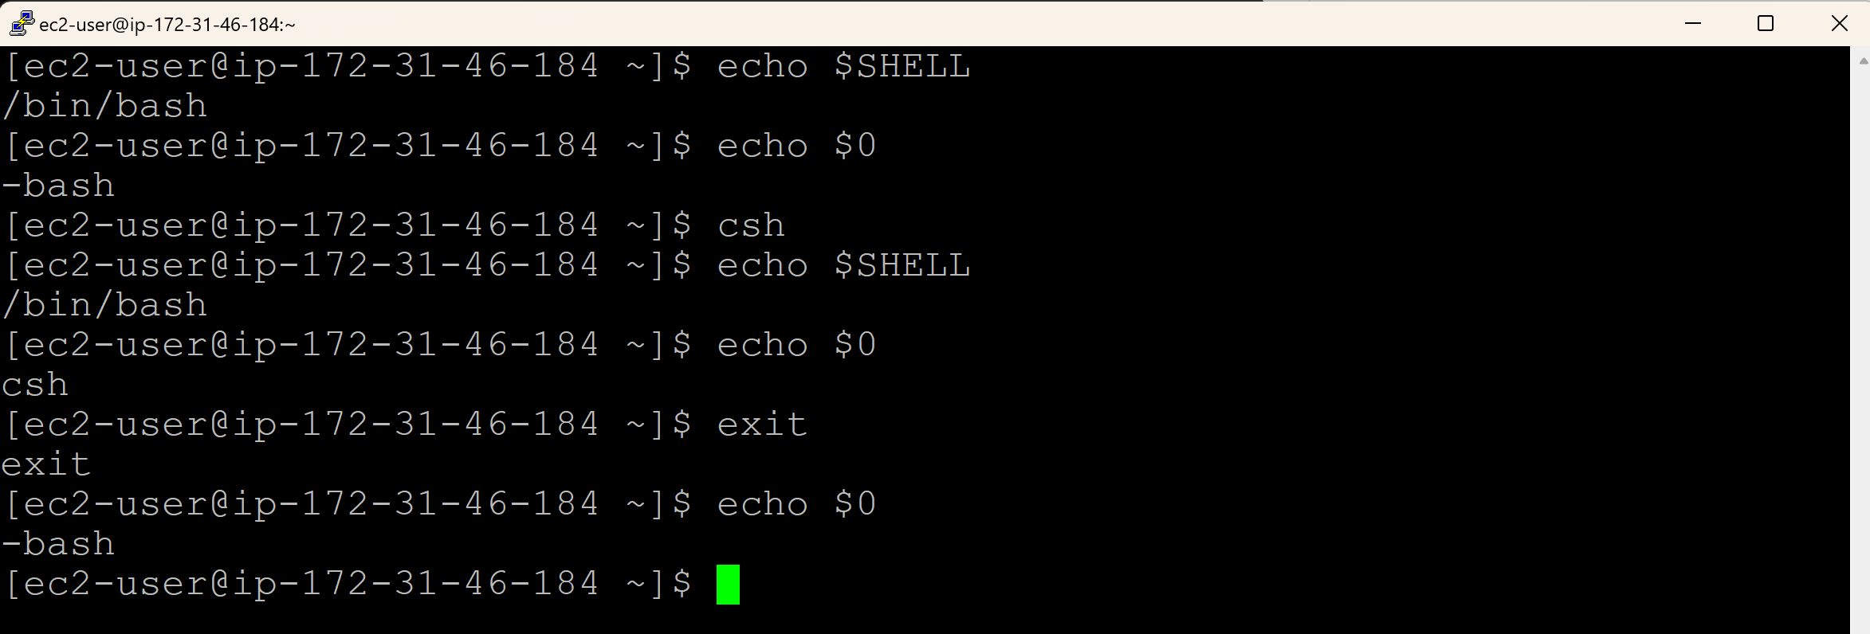

**Linux File System:**



* Linux uses forward slash (/) for Linux directory (folder structure in Windows).
* We have some default directories (root, boot, bin, var, etc, media, etc.) in Linux

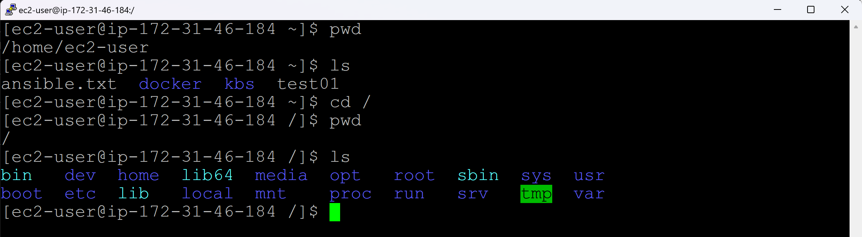

/bin (commands will be used by normal users)

* Contains essential binary executables (e.g., ls, cp, cat)

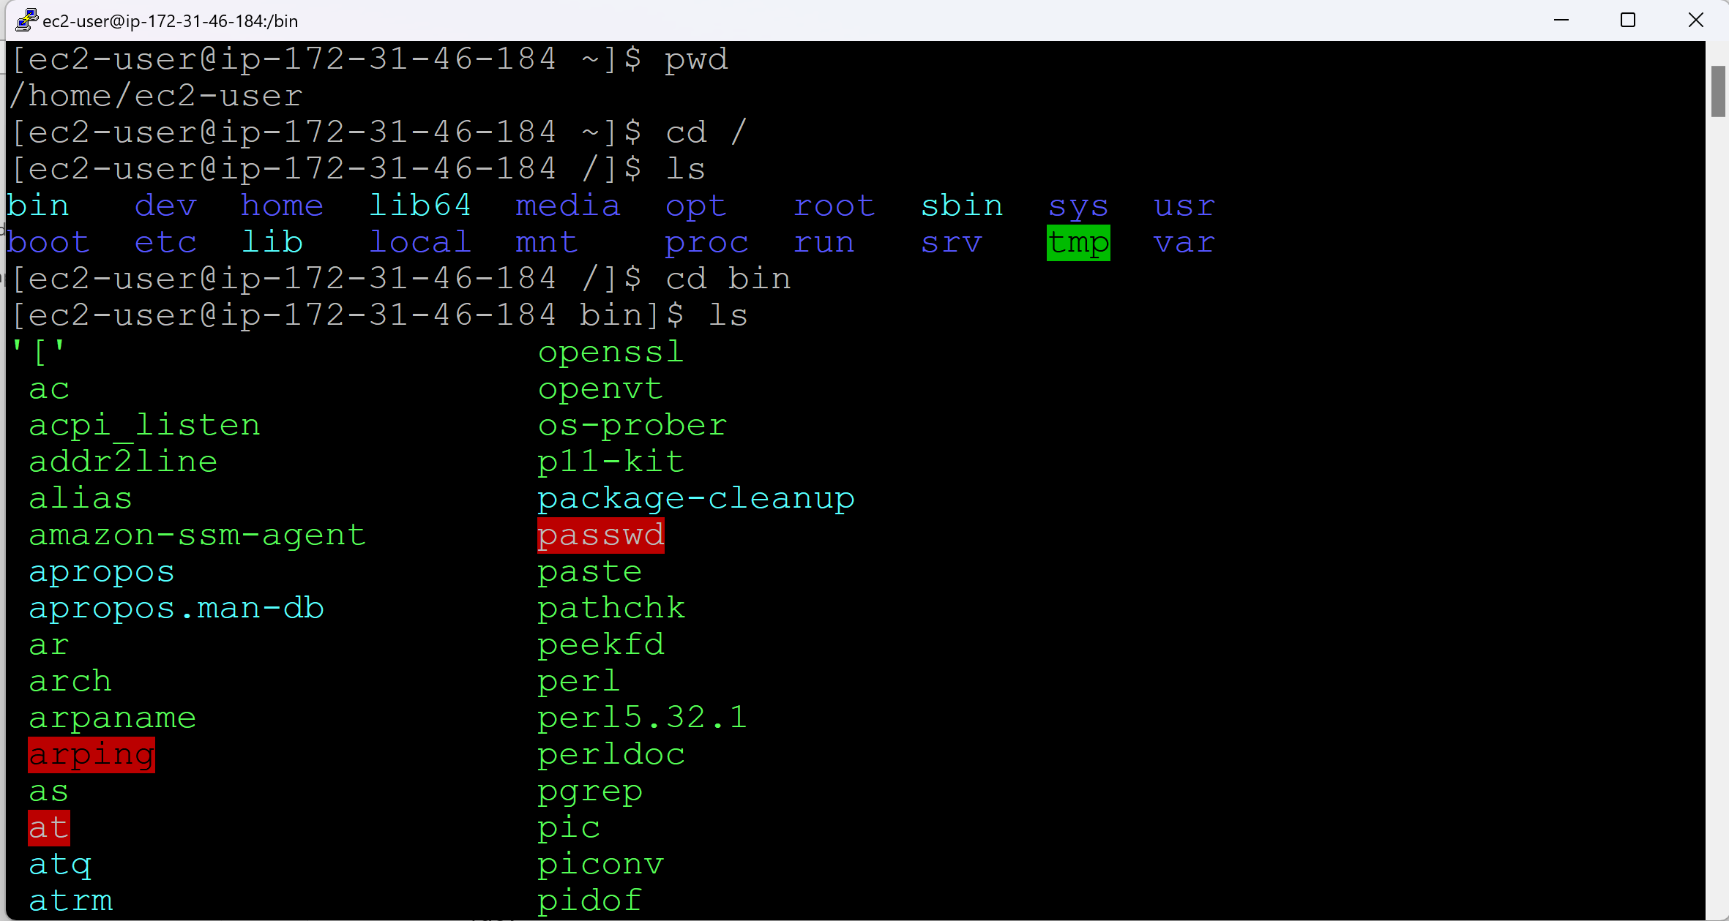

/sbin (commands will be used by root users)

sbin – Super bin

* Contains system binaries (e.g., system administration commands)

/boot

* Contains the boot loader files (e.g., GRUB) and the kernel.

/dev

* Contains device files that represent hardware devices.

/etc

* Contains system configuration files. (Similar to C:\Program Files in Windows)

/home

* Contains the home directories for users.

/lib

* Contains shared libraries needed by system programs and the kernel.

/opt

* Contains optional software packages.

/var

* Contains variable data, such as logs and spool files.v

/mnt

* Temporarily mounted filesystems.

/tmp

* Contains temporary files.

/root

* The home directory for the root user.

**Shell Scripting Setup:**

AWS Account > Launch EC2

Install PuTTY, SuperPuTTY, PuTTYgen, WinSCP, Notepad++

Connect through PuTTY, SuperPuTTY, PuTTYgen, WinSCP

* Install PuTTY
* *Open PuTTYgen (is only requierd to convert .pem to .ppk file)*
  + *File > Load Private key*
  + *Select ‘All Files’ and select ‘.pem’ file > Open*
  + *Click on OK button of the pop-up*
  + *Click on ‘Save private key’*
  + *Click on ‘Yes’ button of the pop-up*
  + *Give a name to the file and click on ‘Save’ >.ppk file will get created*
  + *Close PuTTYgen*
* Open PuTTY
  + Copy the ‘Public ip address’ of the EC2 instnace from AWS and paste it under ‘Host name’.
  + Left side, expand SSH > expand Auth > select ‘Credentials’ > Browse for the .ppk file against ‘Private key file for authentication’
  + Left side, go back to ‘Session’ > Enter the name for ‘Saved Sessions’ and click on ‘Save’
  + Click on ‘Open’
  + Login as: ubuntu
* Here are some common default usernames based on the AMI:
  + Amazon Linux, Amazon Linux 2: ec2-user
  + Ubuntu: ubuntu
  + Debian: admin or debian
  + CentOS: centos
  + Fedora: fedora
  + RHEL (Red Hat Enterprise Linux): ec2-user or root
  + SUSE: ec2-user or root
* The disadvantage of PuTTY is, we cannot open multiple tabs in PuTTY like in Chrome.
* This can be achieved with the help of SuperPuTTY. It is an extension of PuTTY.
* Install SuperPuTTY
* Open SuperPuTTY

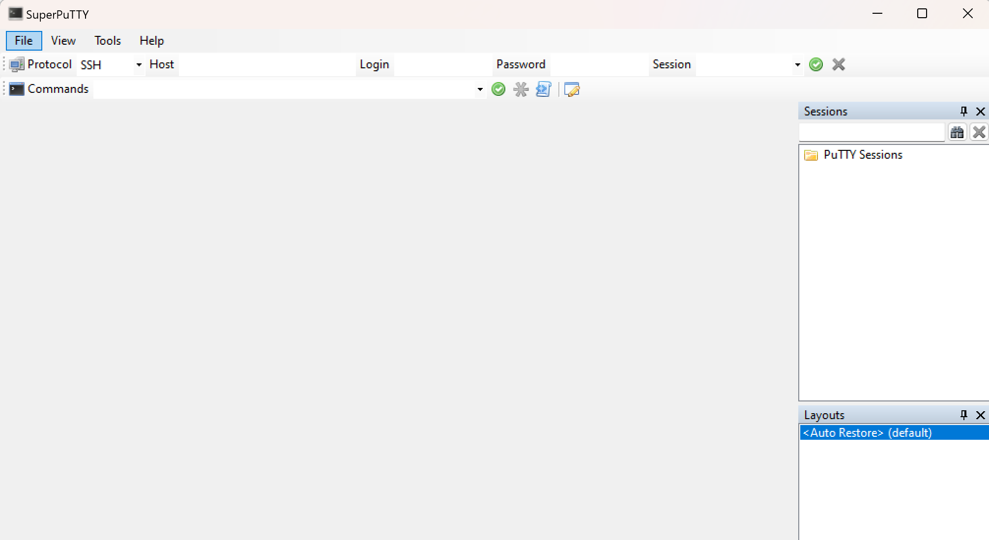

* Select the Session

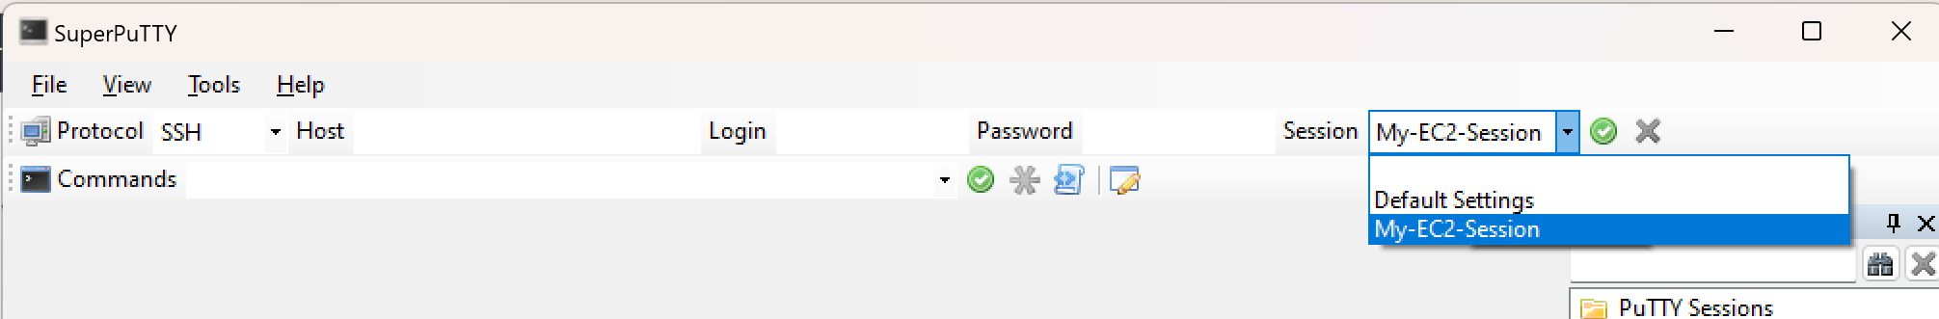

* Copy the Public ip address from AWS EC2 instance and paste it under Host and hit Enter.

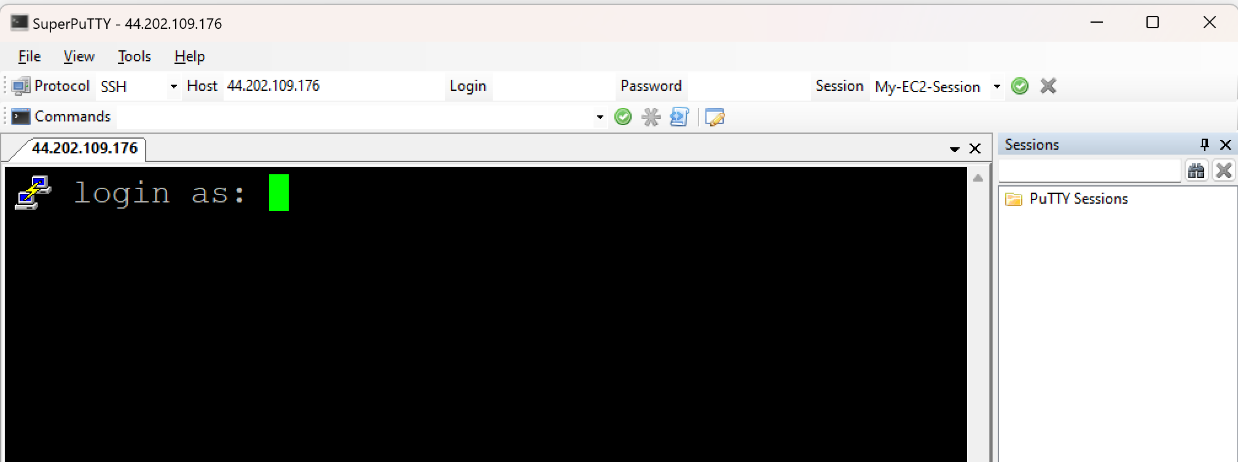

* Login as ubuntu and hit enter

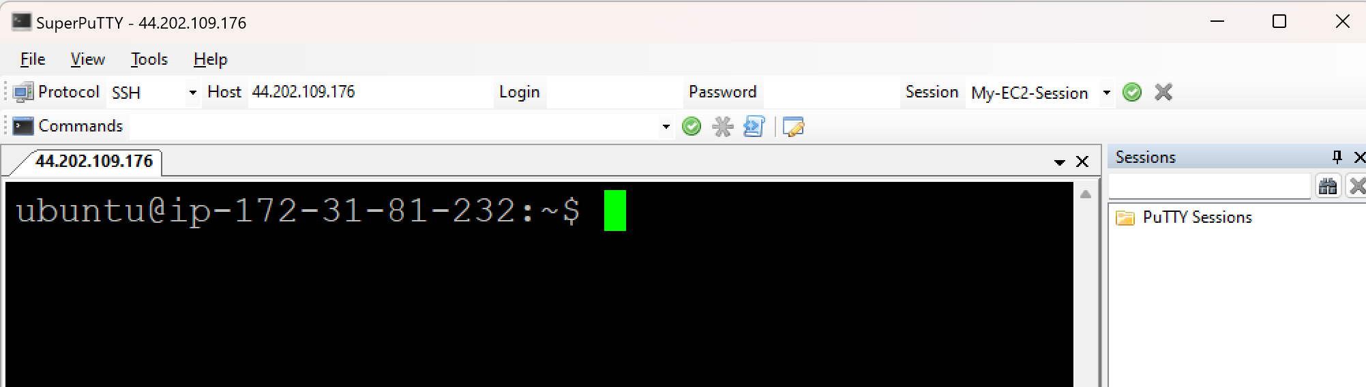

* Similarly go to Host and hit enter key > Another tab will be opened

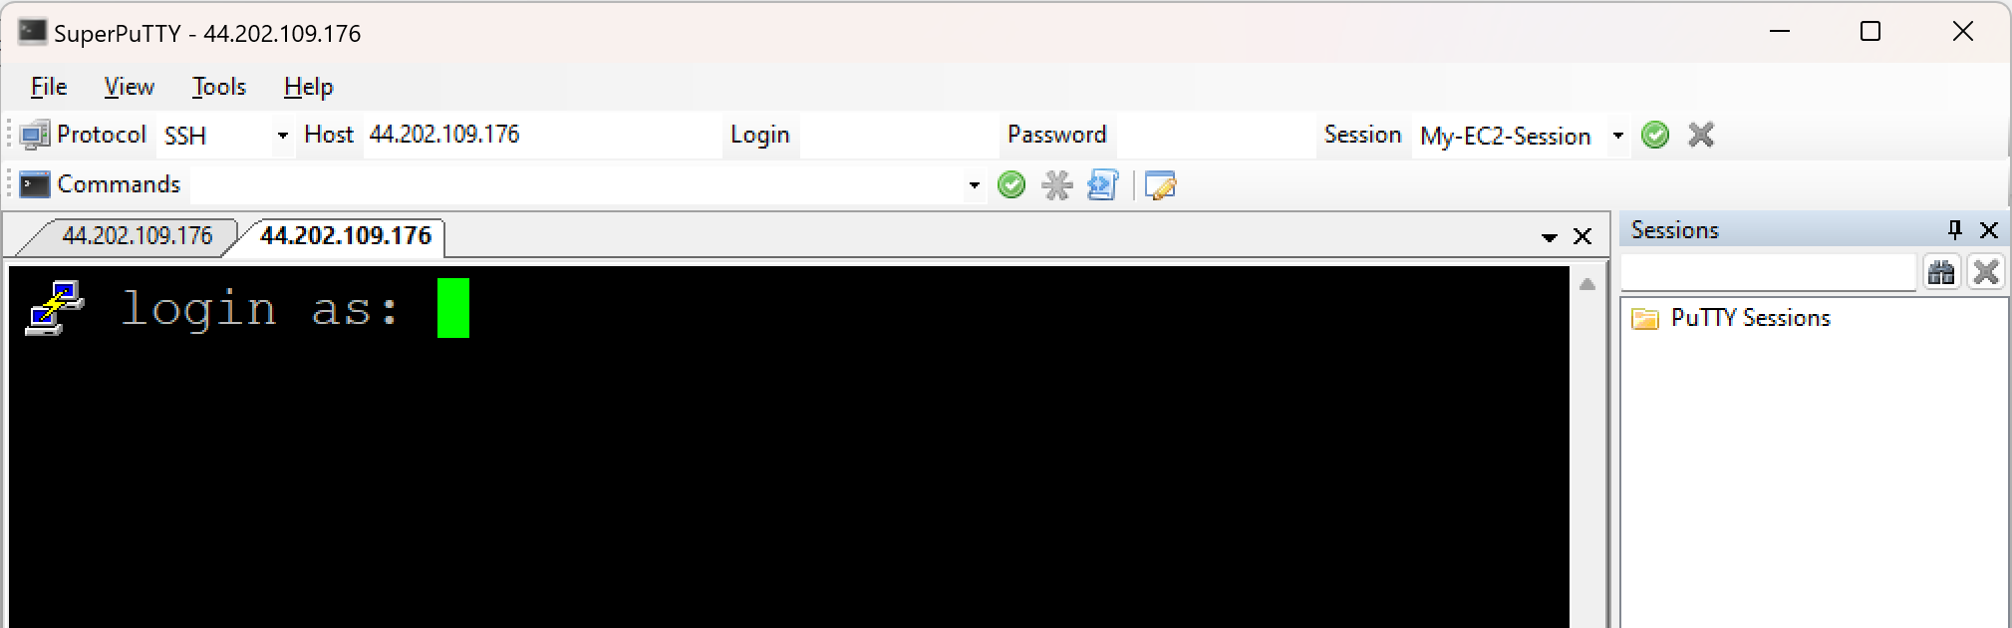

* Login as ubuntu

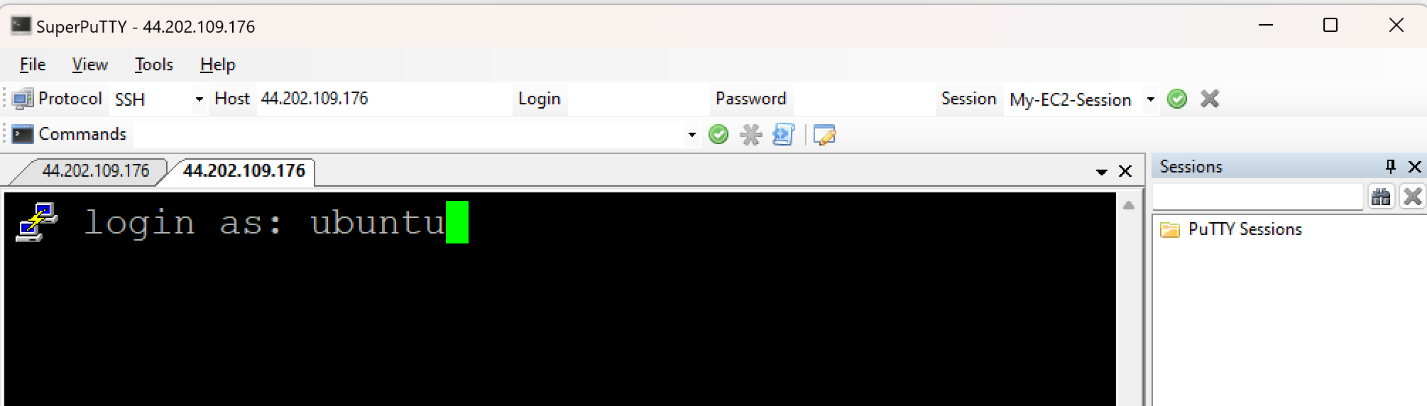

* Hit enter key

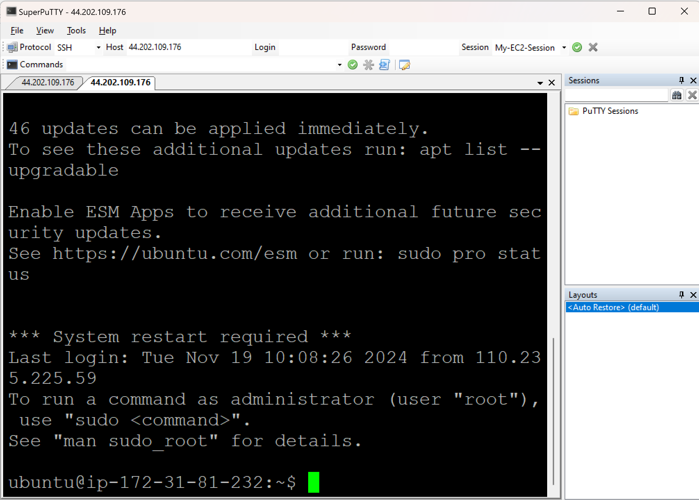

**Connecting Linux with WinSCP:**

* Open WinSCP (It is an UI kind of tool for LINUX server)

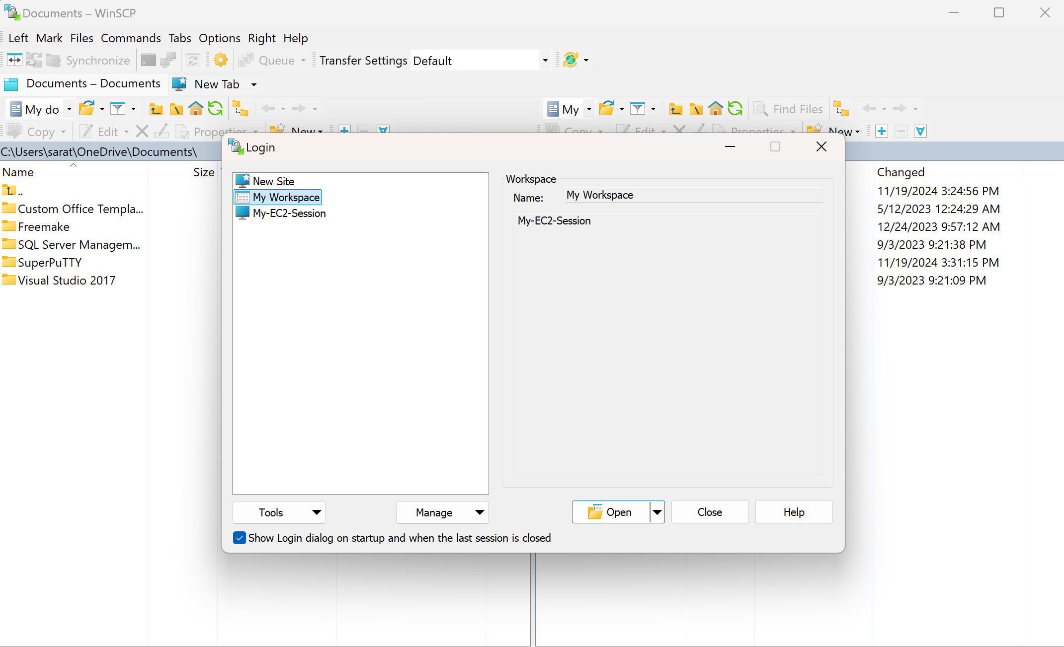

* Select the Login session

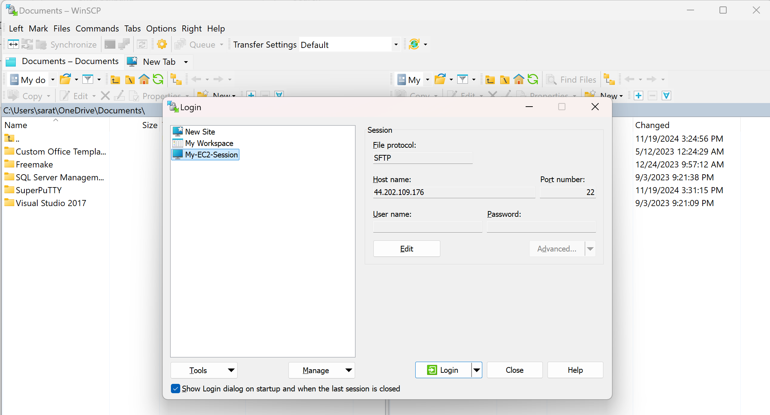

* Click on Login

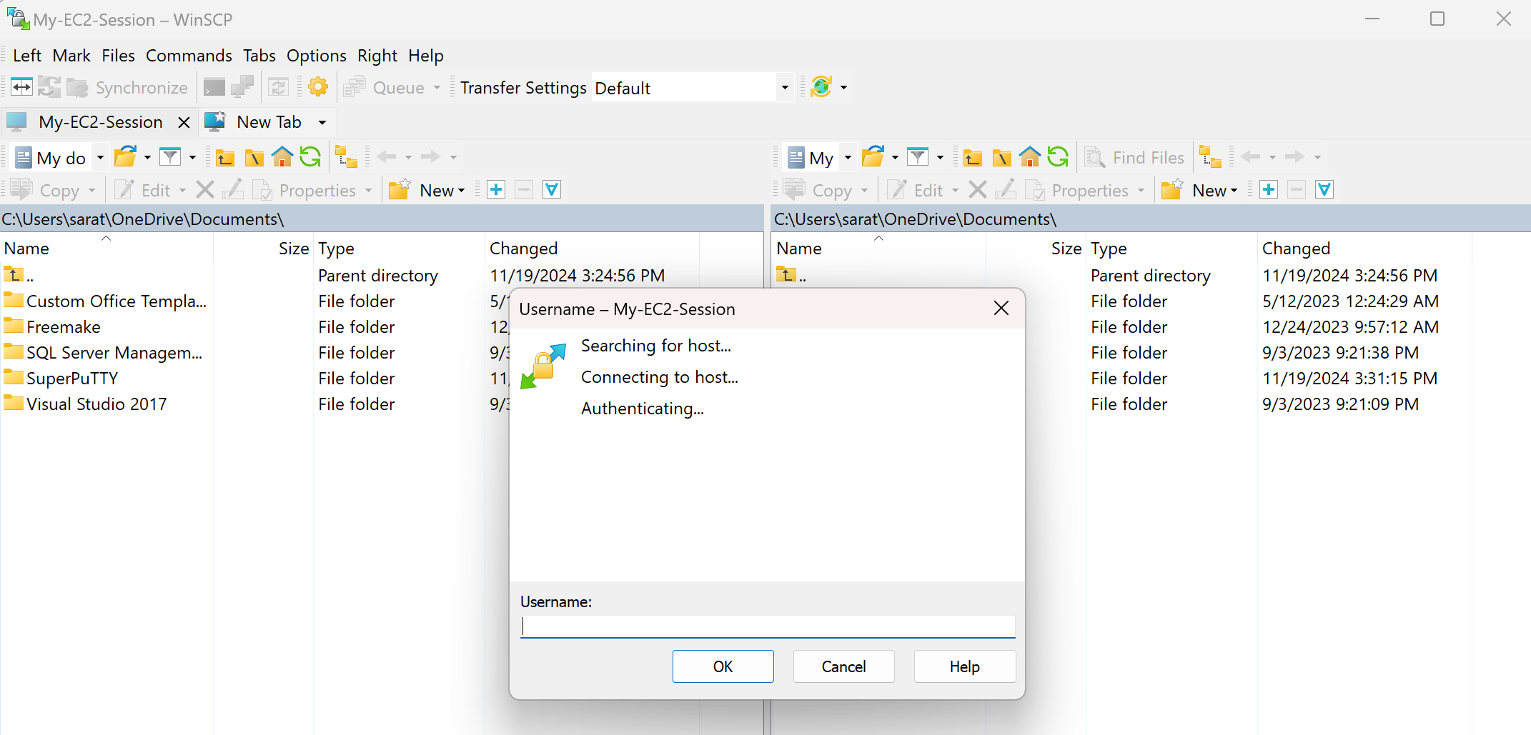

* Enter ‘Username’ as ubuntu and click on OK button

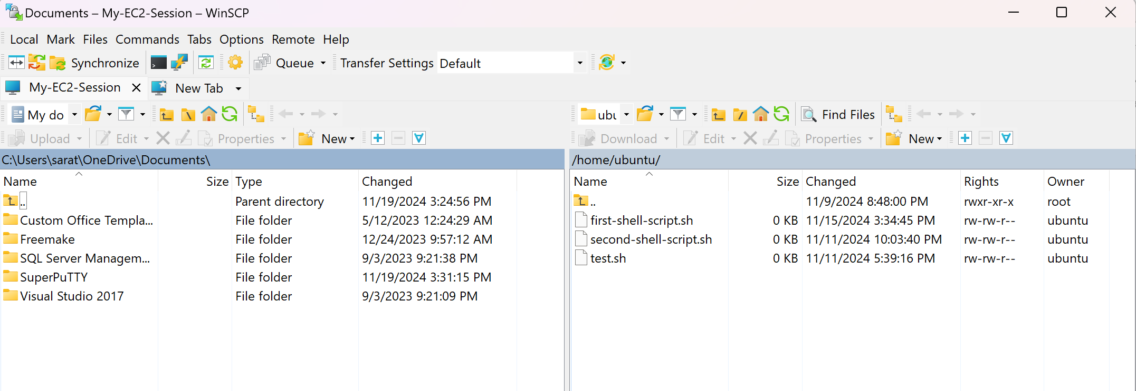

* Left side view is the folders/files from the local whereas right side view is the files from the Linux server.
* You can transfer files from local to Linux server just by clicking drag and drop.
* Options > Preferences > Editors > Add

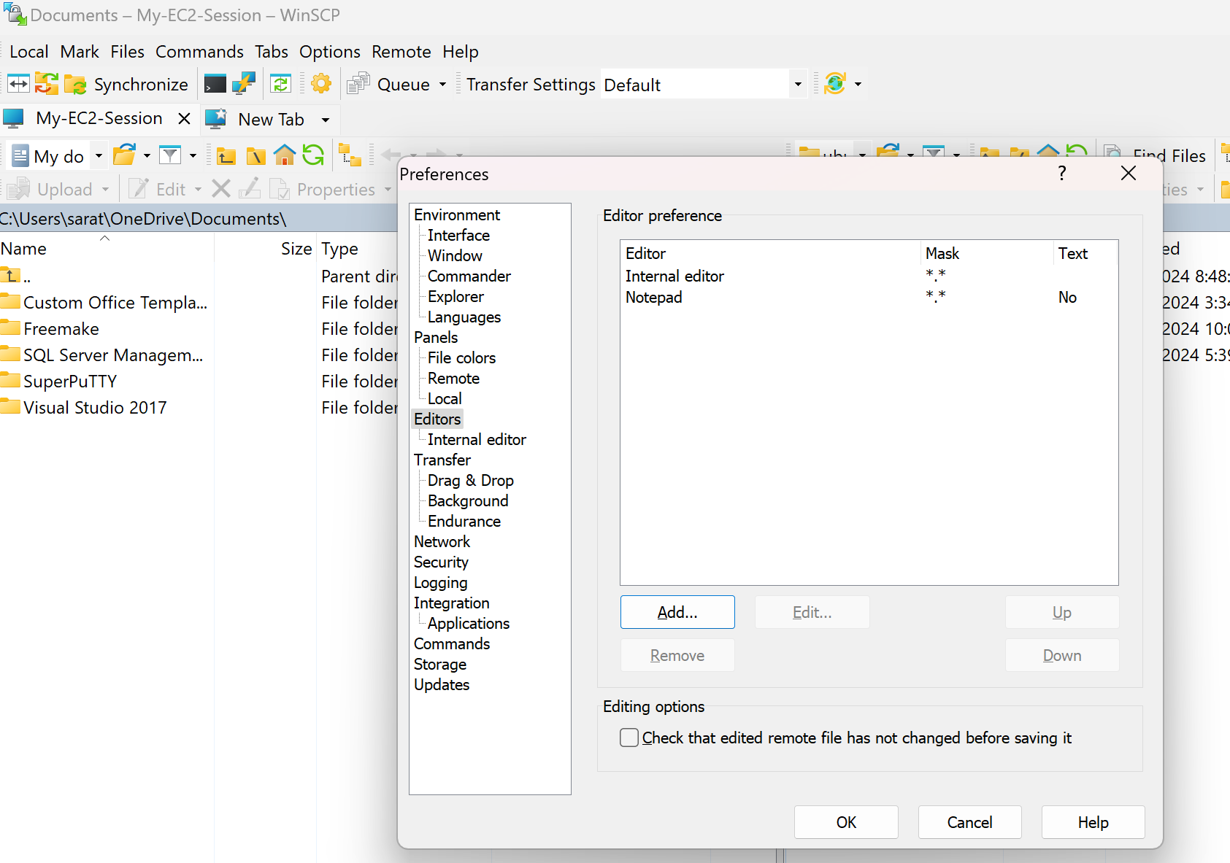

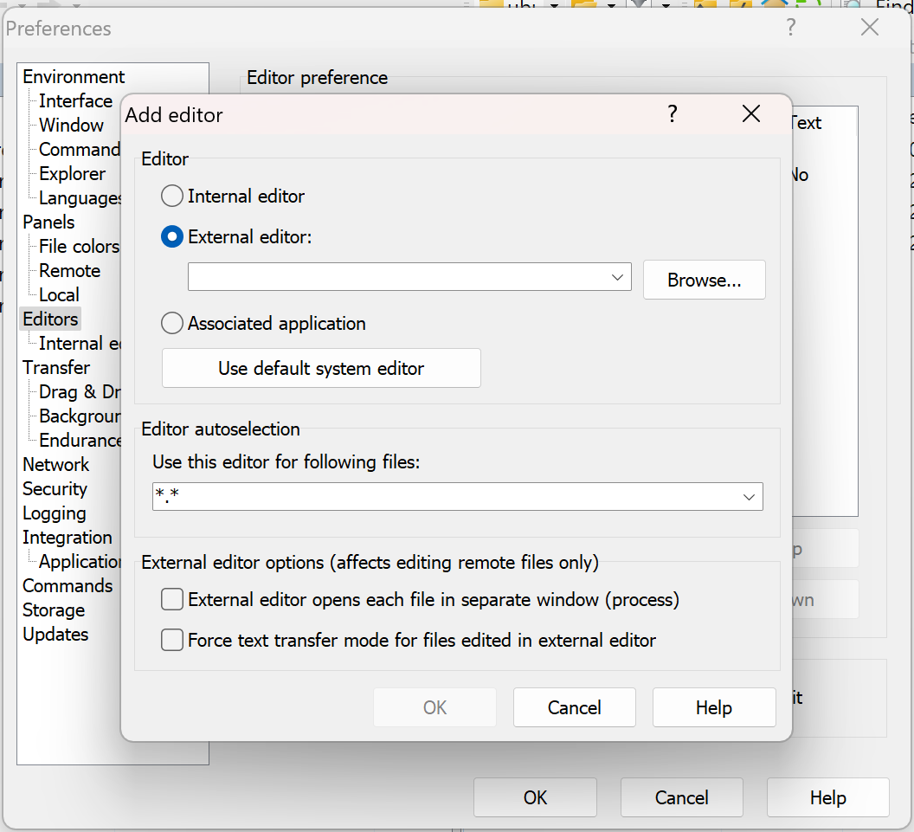

* Browse for the Notepad++ exe file (C:\Program Files\Notepad++\notepad++.exe) and click on OK button

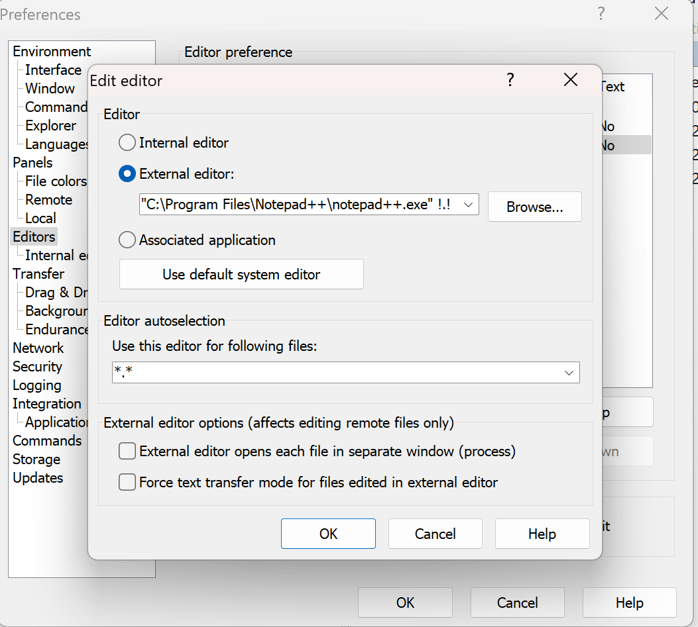

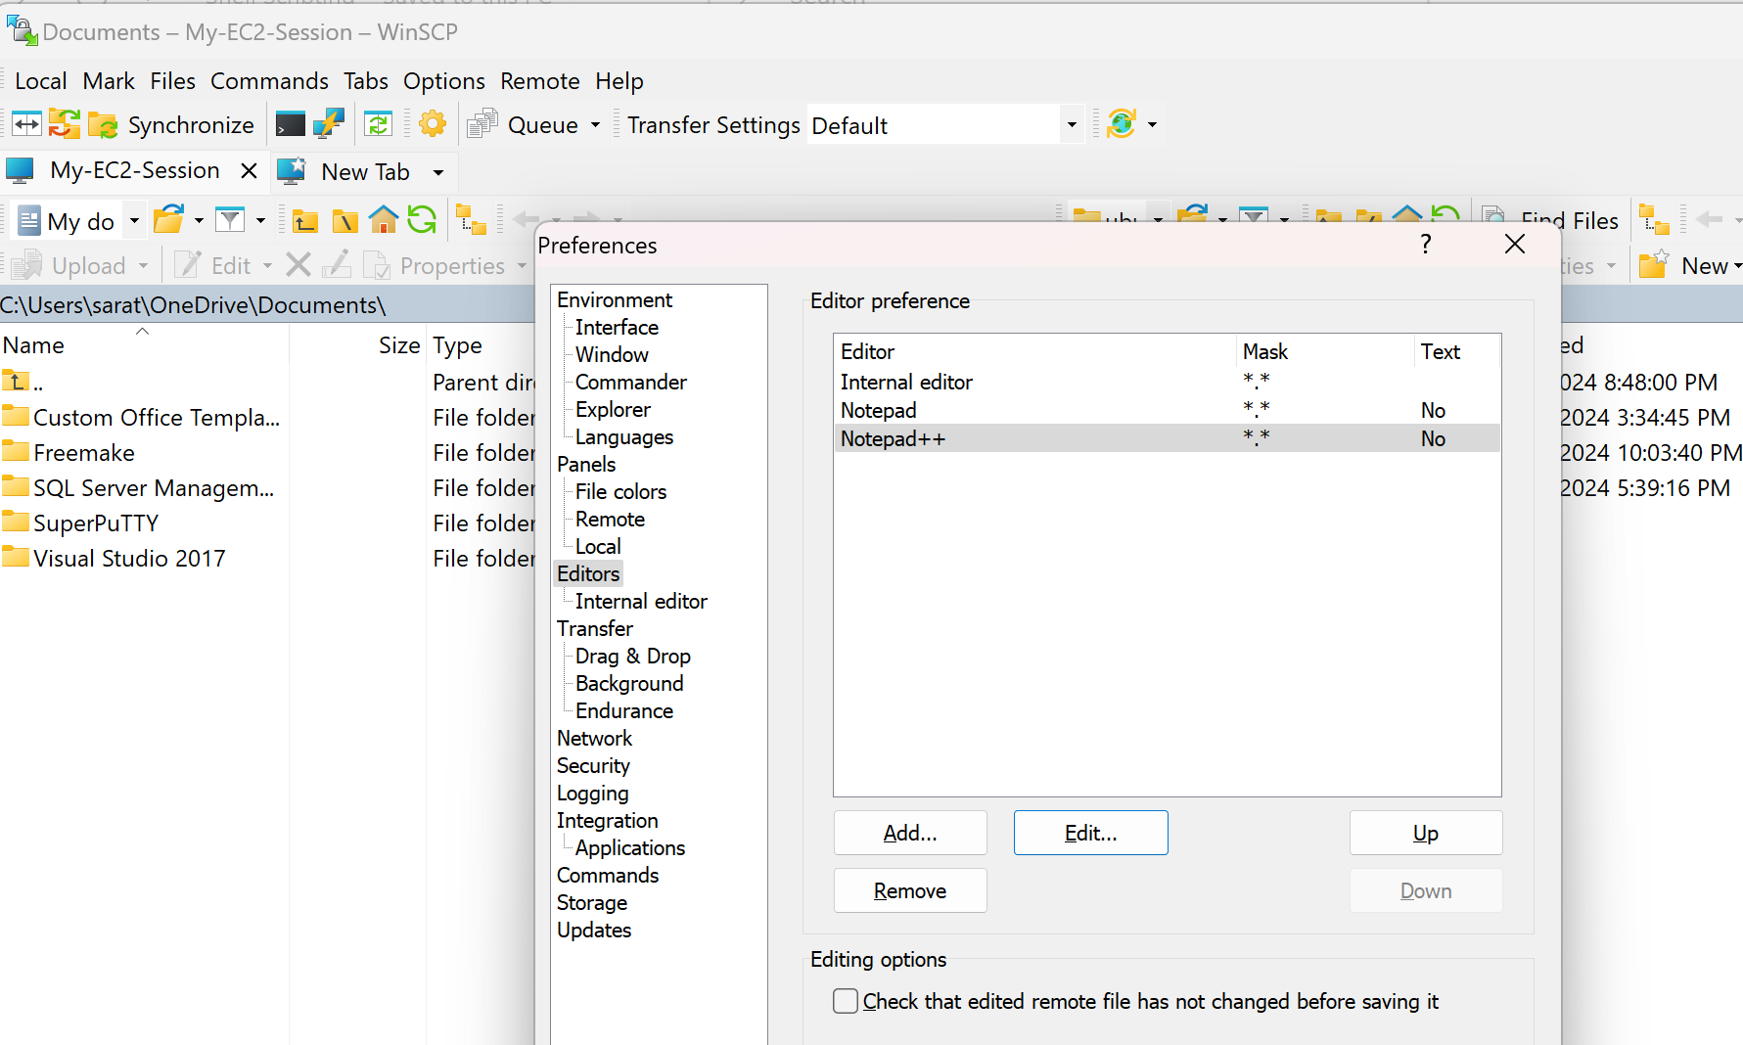

* Select the Notepad++ and click on Up button and bring it to the top.

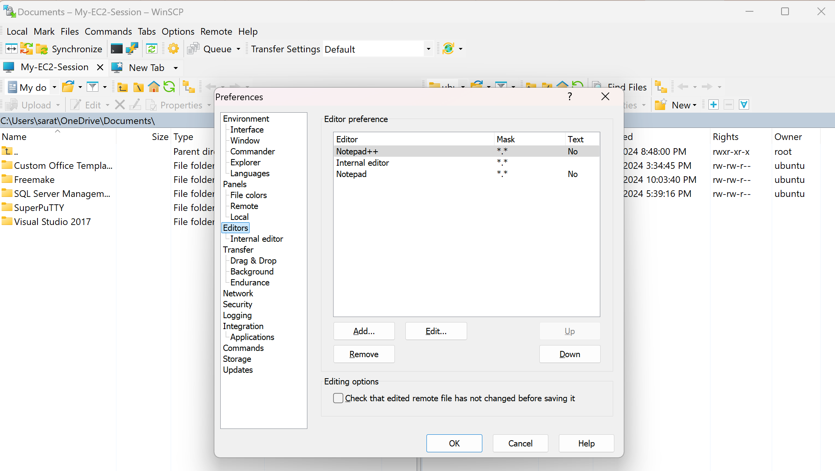

**What is shebang?**

* Shebang (#!/bin/bash) should be the first line in shell scripting that will tell us the path of the interpreter.
* Interpreter (Executor) is a software which is required to execute the lines of script.

**What is the difference between #!/bin/sh and #!/bin/bash?**

Previously both of them were same because /bin/sh was redirecting to /bin/bash using the linking concept. And now it is not the same because some of the operating systems have decided to use /bin/dash as default, so your script might not execute, if you are writing in bash scripting on a machine wher /bin/dash is default.

**What is Shell scripting in Linux?**

Shell scripting in Linux is a process of autmating your day to day activities on your Linux compute.

**Fundementals of Shell scripting:**

* In Linux, the way that you talk to your operating system using SHELL commands.
* Shell commands are **case-sensitive**.
* Inside the server, we can keep **public key**.
* And **Private key** can be given to the person who wants to access the server.
* We can connect to the Linux server with **ssh** key.
* **ssh** is nothing but **Secure Shell Protocol**.
* Port number for ssh key is 22.

**Commands to create a file:**

touch

cat

vim

nano

**touch command:**

touch <filename>

touch <filename01> <filename02> <filename03>

touch <filename>{1..n}

* We can create one or multiple empty files at a time using touch command.

**Creating a file:**

touch test01.txt

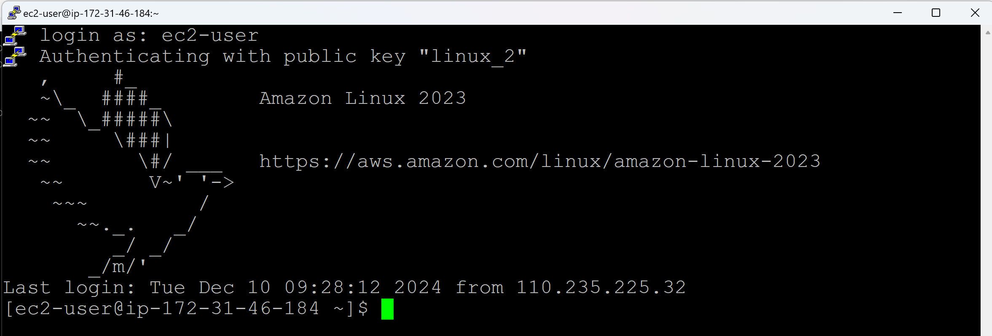

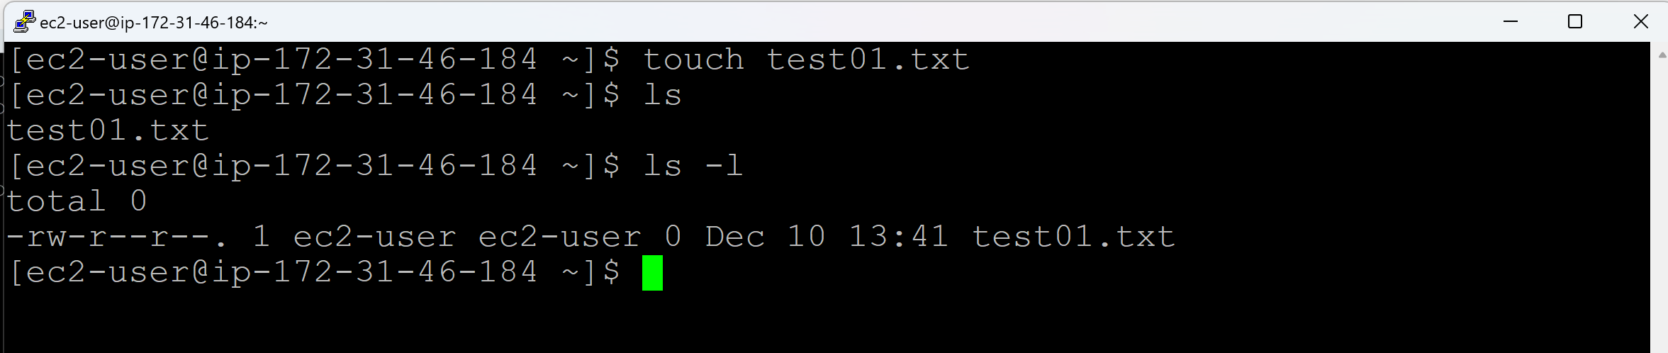

**Creating multple files at a time:**

touch test02.txt test03.txt Test

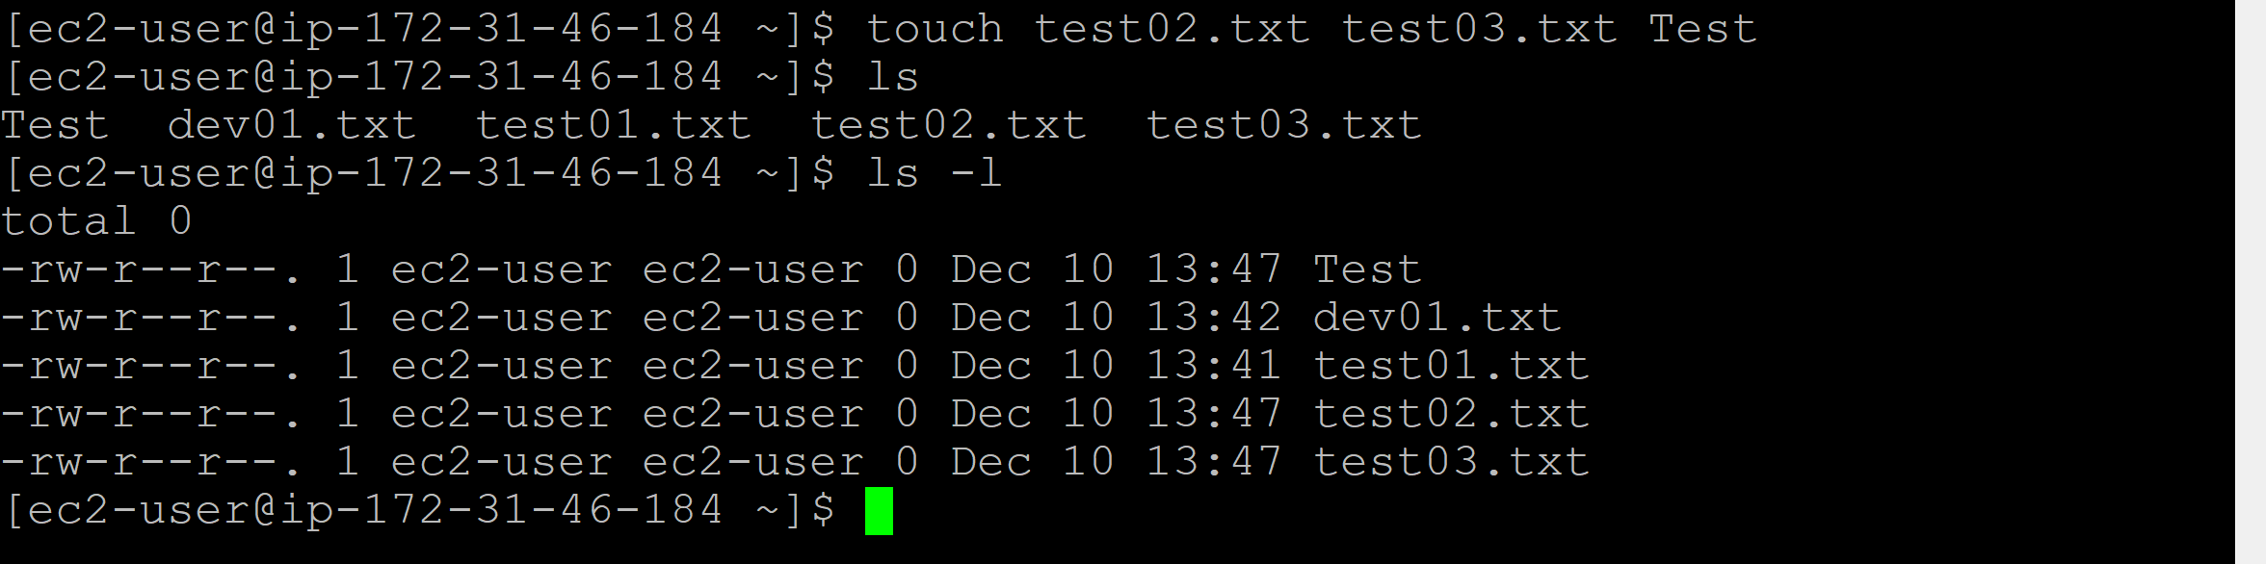

**Creating 100 files at a time:**

touch ansible{1..100}



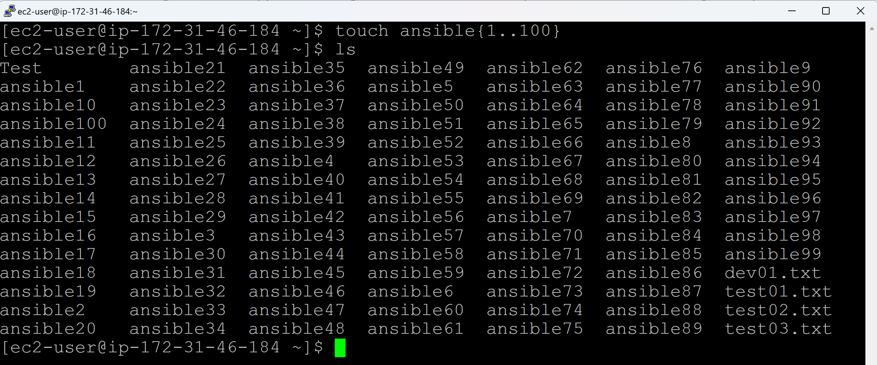

**Command to remove/delete files/directories:**

rm <filename>

rm Test

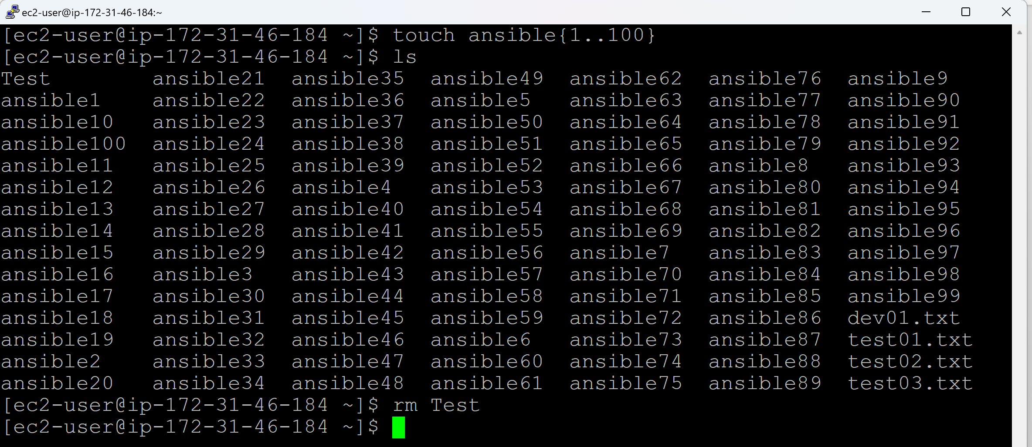

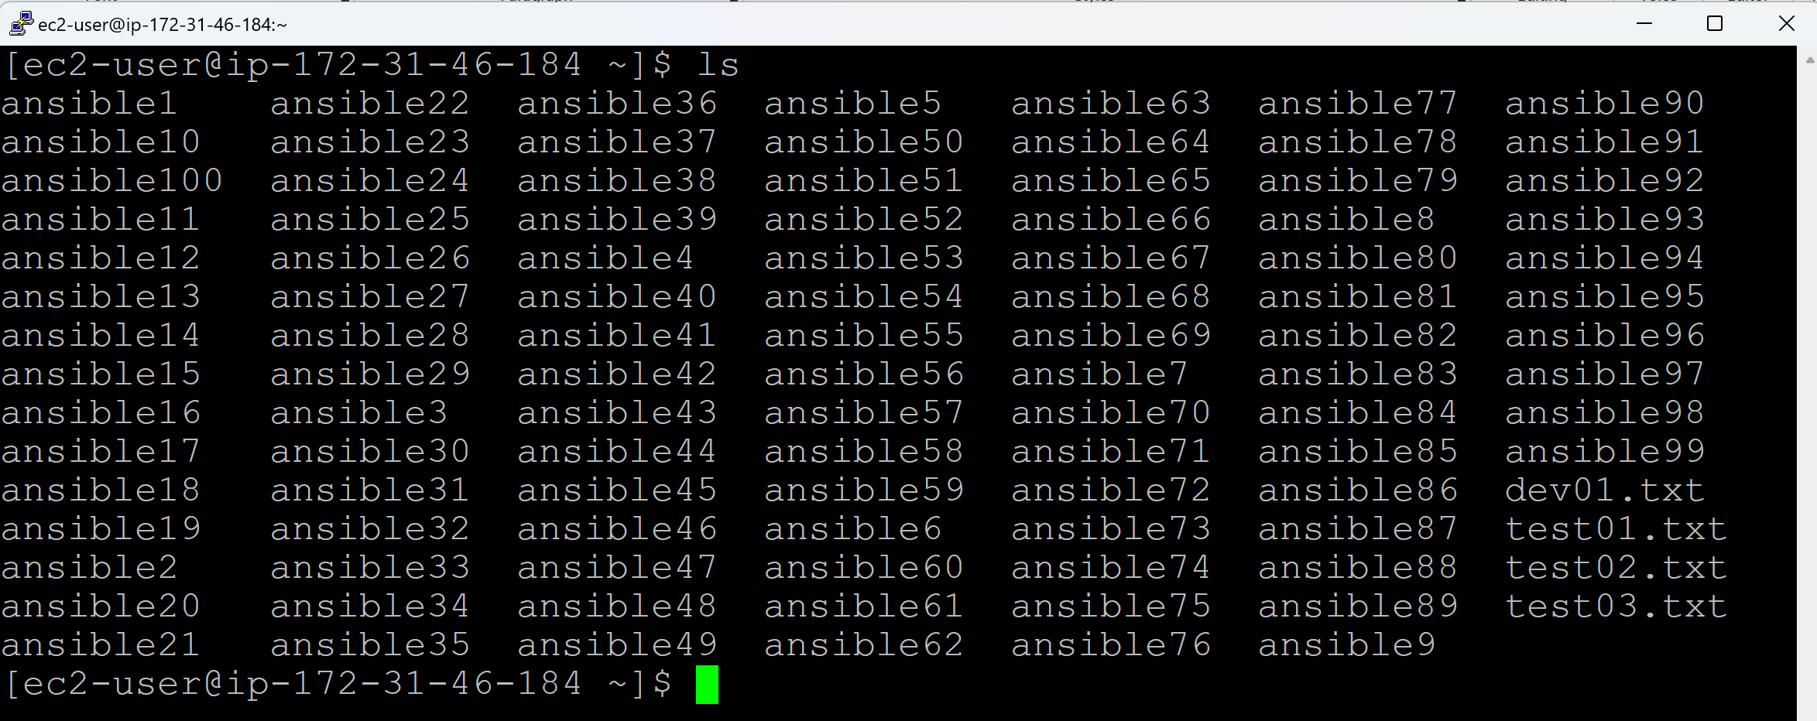

**Removing multiple files at a time:**

rm ansible{1..100}

rm ansible* (Removes all the files with name starting with ansible)

rm <filename1> <filename2>

rm * (Removes all the files)

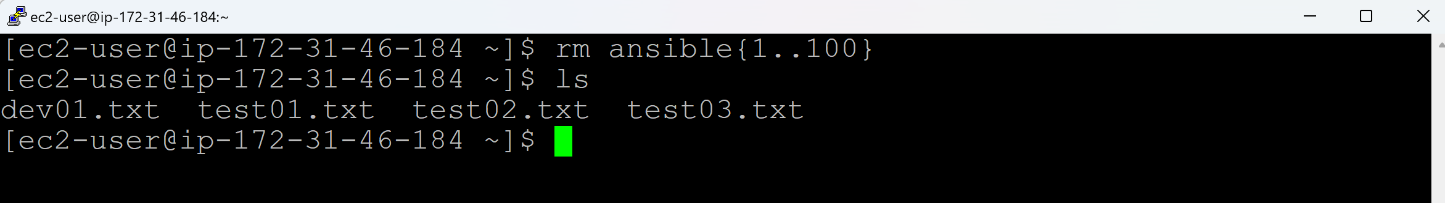

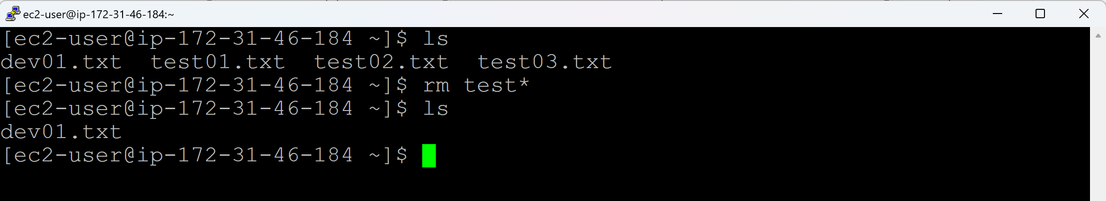

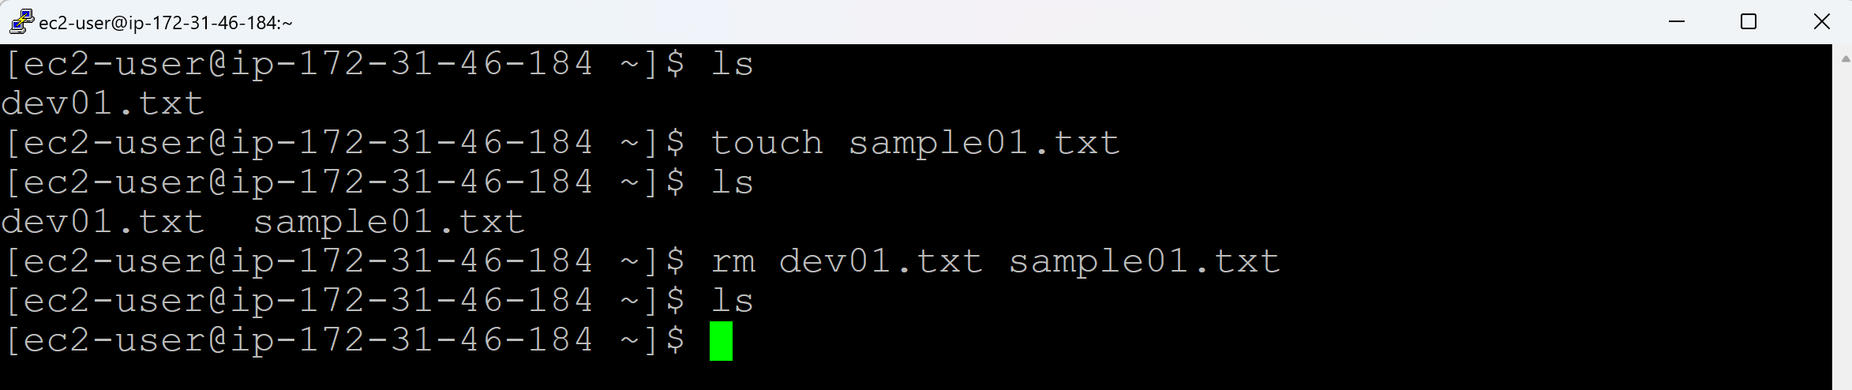

**cat command:**

cat > <filename>

* We can create new empty files. (cat > <filename>)
* We can create new files along with data. (cat > <filename>)
* We can append the new data to an existing file. (cat >> <filename>)
* We can check the data of the file. (cat <filename>)

**Creating the empty file:**

cat > test01.txt

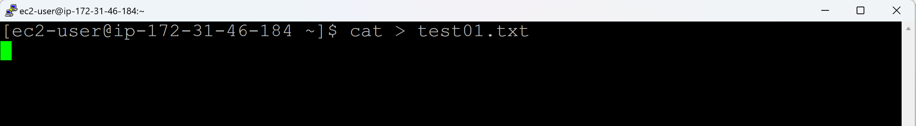

Press Ctrl+D to save an empty file

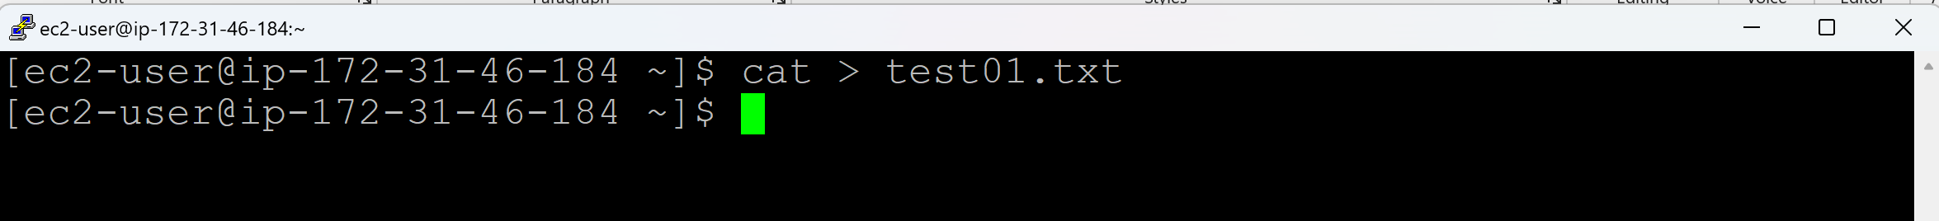

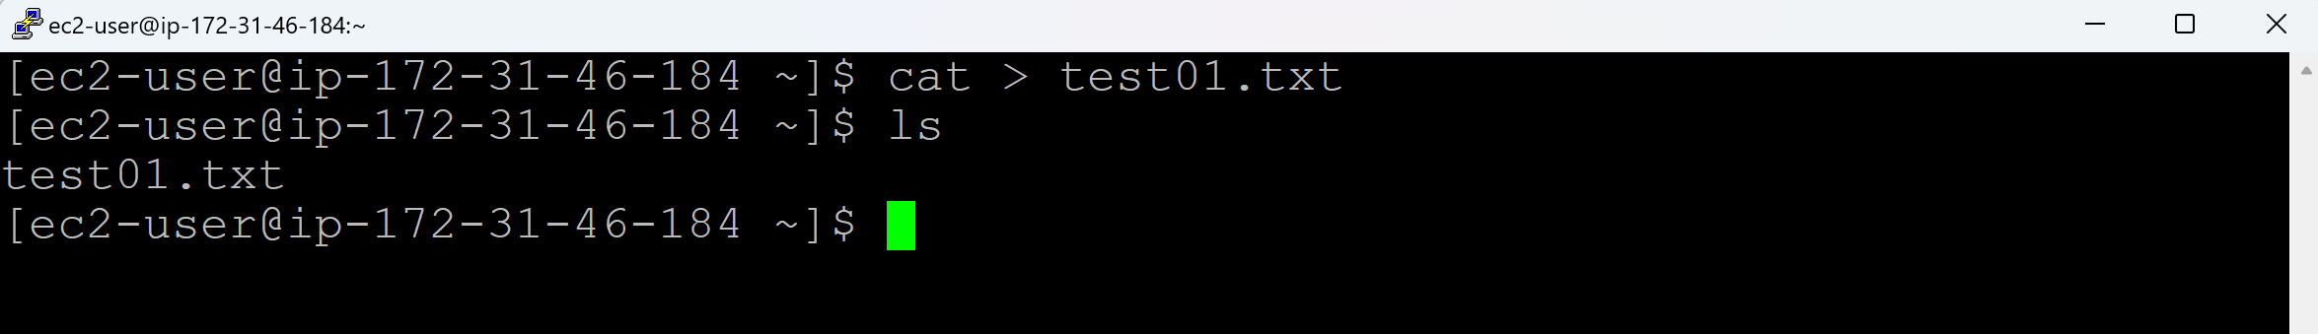

**To check the data in the file:**

cat <filename>

cat test01.txt

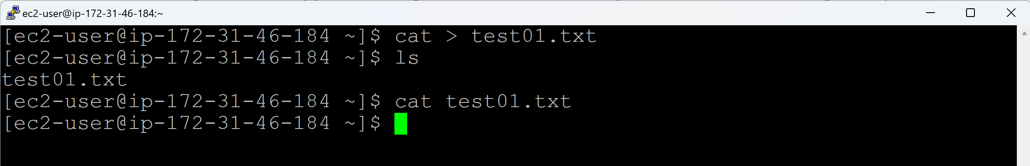

File name will be displayed automatically, when you press Tab after entering first letter of a file name.

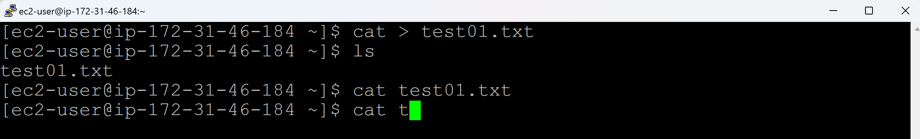

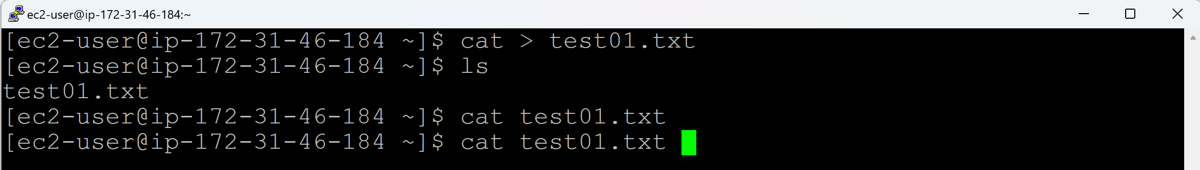

**Creating a file with some data:**

cat > test02.txt

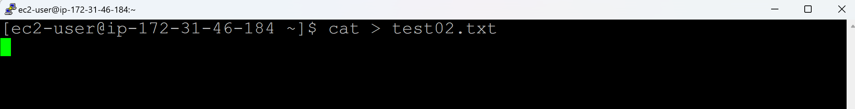

Enter the data in the file

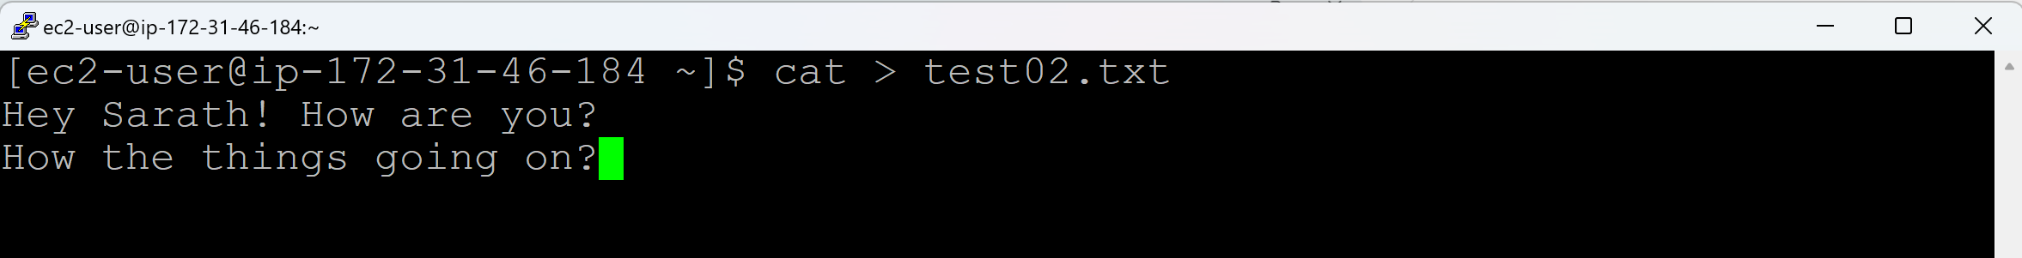

Press Ctrl+D to save the file

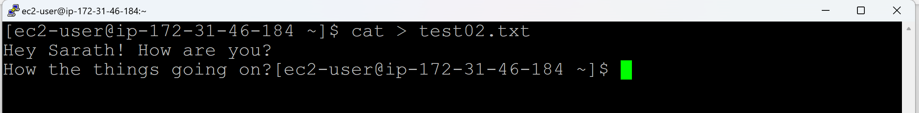

**To check the data in the file:**

cat <filename>

cat test02.txt

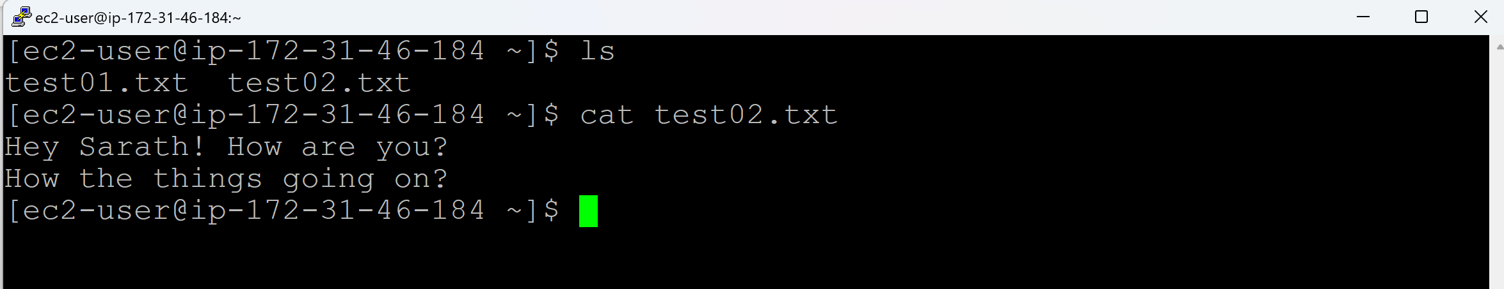

**To append the data in the file:**

cat >> <filename>

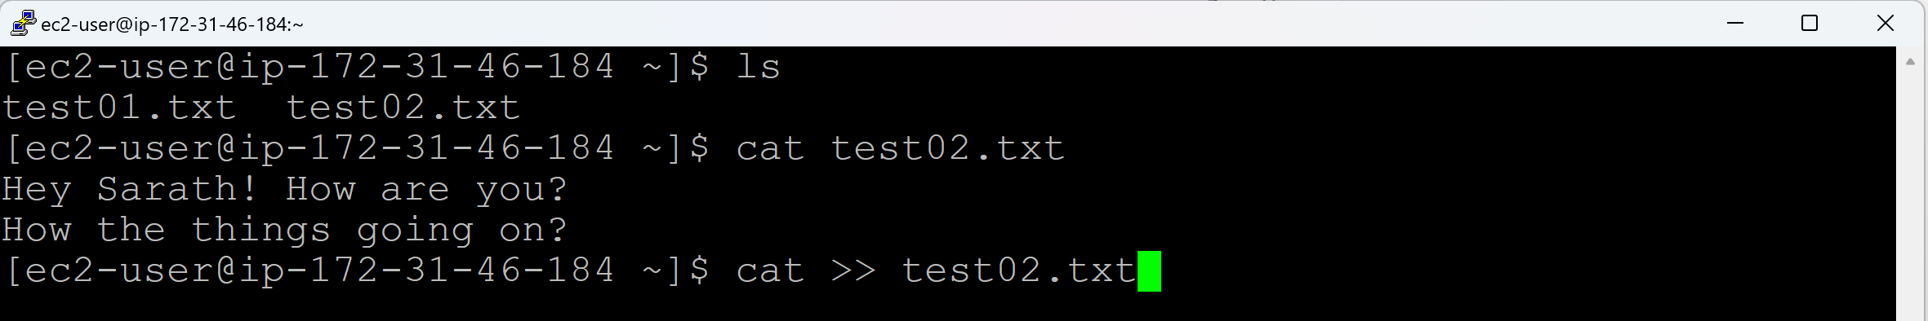

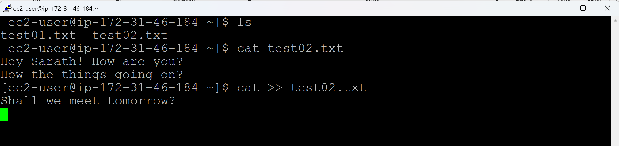

Press Ctrl+D to save the file

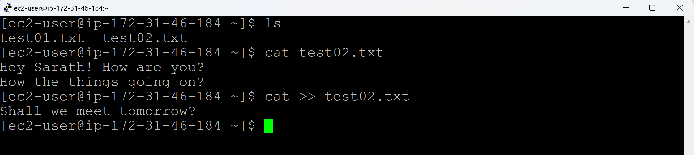

**To check the data in the file:**

cat <filename>

cat test02.txt

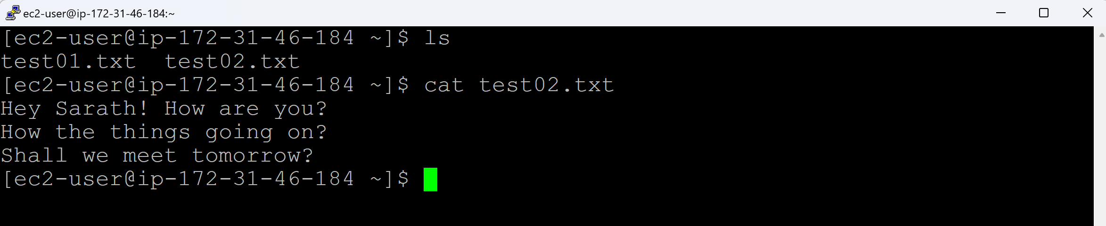

If there are 1000 lines in the file, and you cannot identify 555th line. In that case, it is good to give numbering to the lines.

cat -n <filename>

cat -n test02.txt

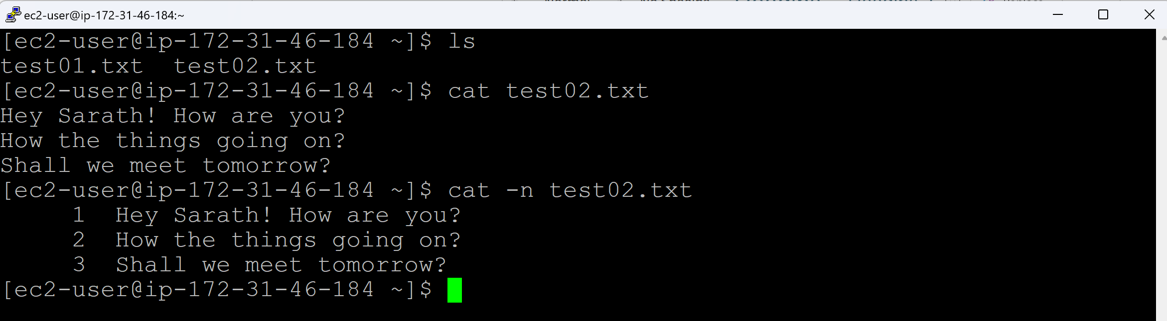

**To check the data in multiple files:**

cat <filename1> <filename2>

cat test01.txt test02.txt

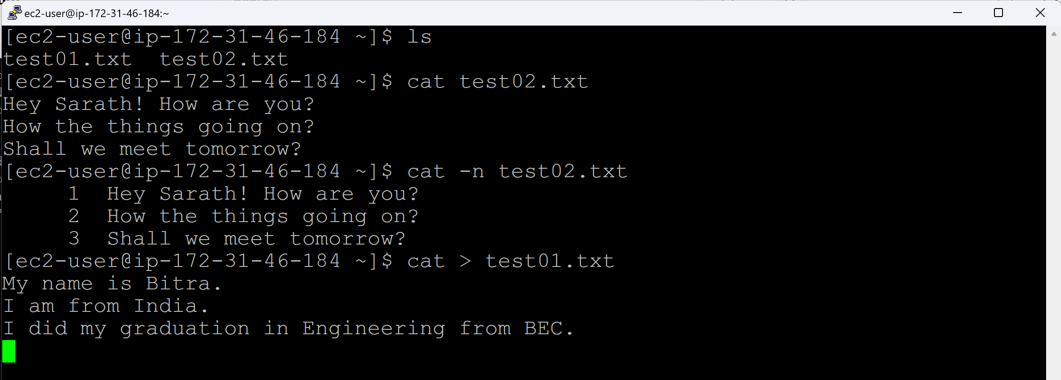

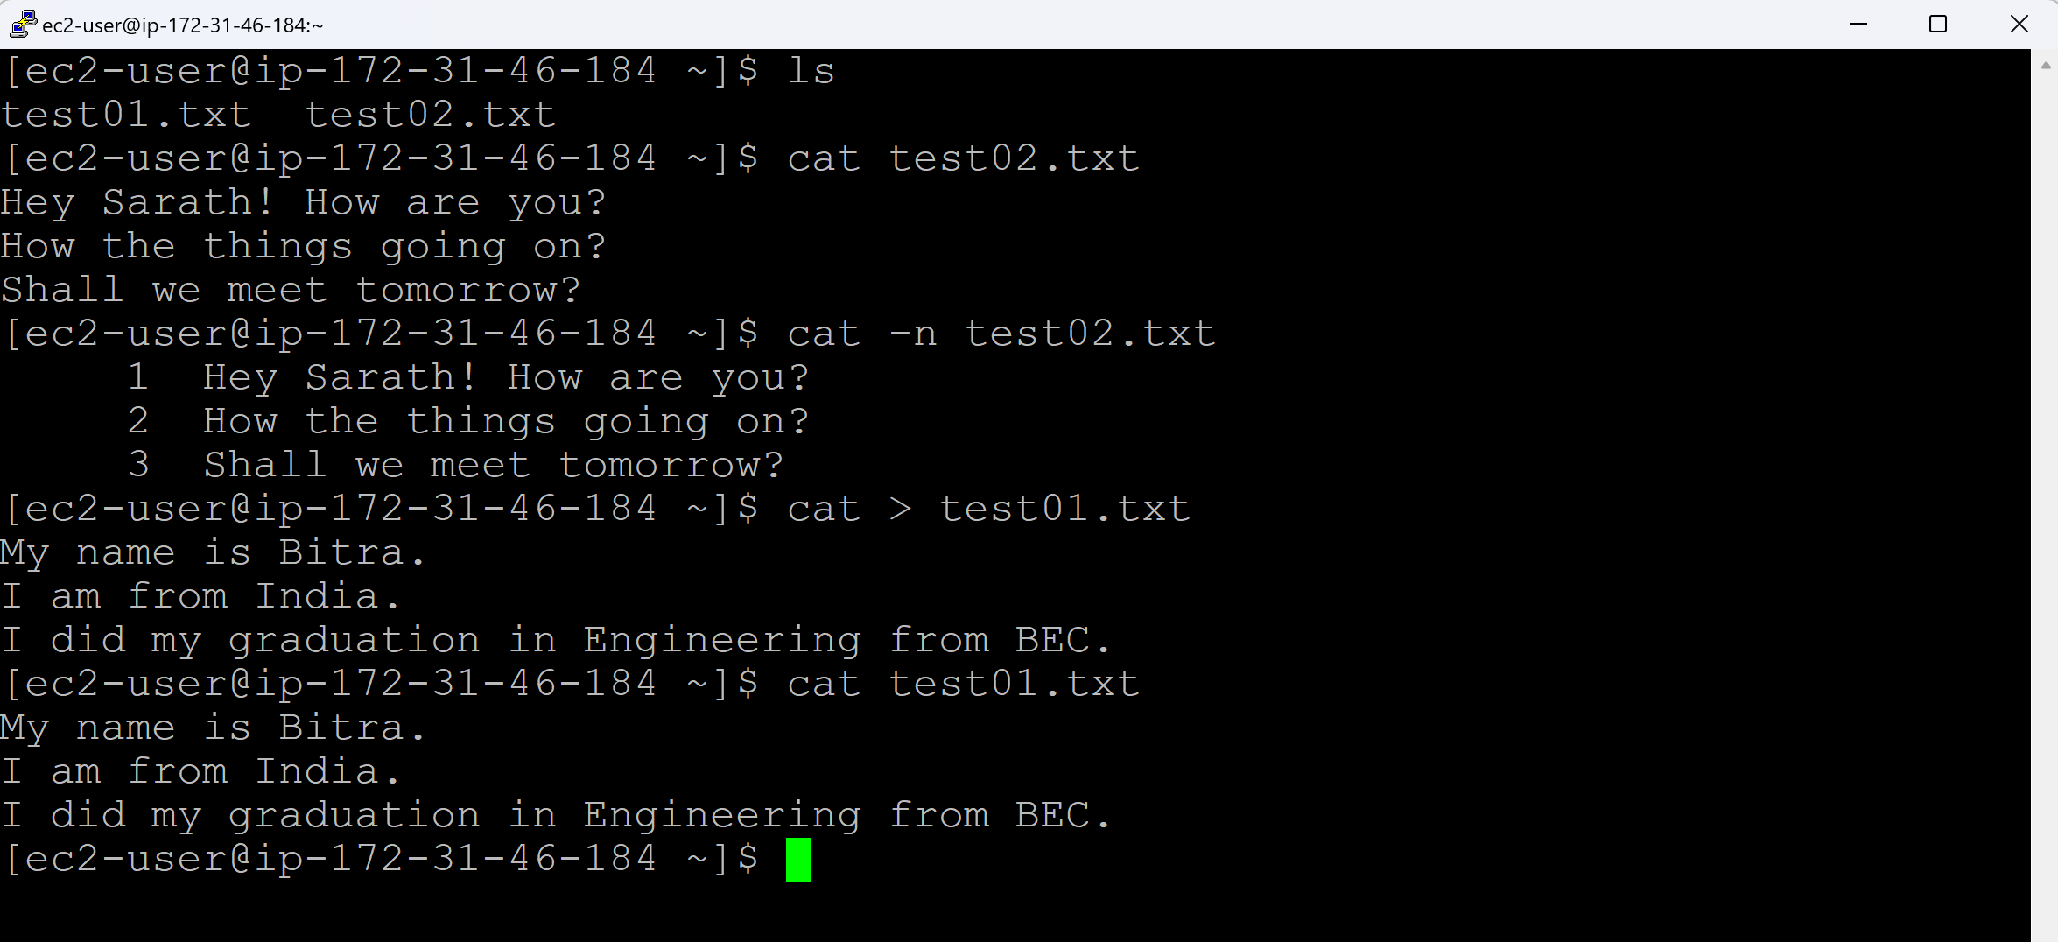

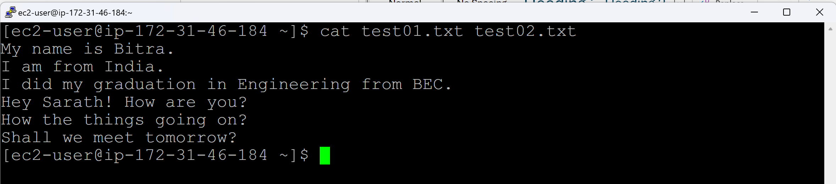

**To display the data in reverse:**

tac <filename>

tac test01.txt

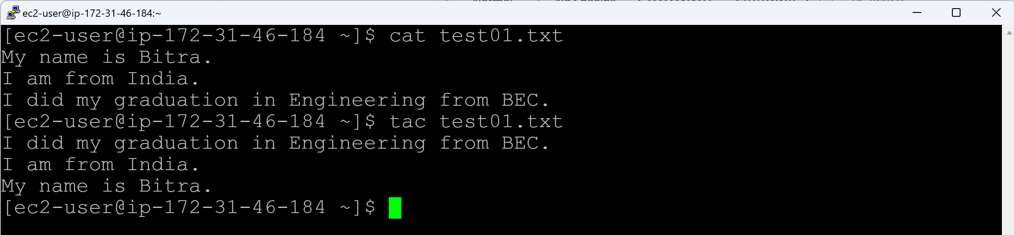

**Command to clear the screen:**

clear

Ctrl+L

**Day 14 (vim)**

* We cannot edit or delete text in a file through cat command.
* To overcom this, we have vim (visual) editor.

There are 3 modes in vim to create a file or edit a file:

* Normal mode (or) Command mode (or) Default mode
* Insert mode
* Command line mode (or) colon mode

**vim <filename>** = Open a file and write content inside the file.

If the file is not there, it will create a file, open it and write content inside the file.

* + click on ‘I’ key, so that you can start writing the content inside the file.
  + click on ‘Esc’ key
  + **:wq** - Save changes and Quit. Fails if you don't have write permissions.
  + **:wq!** – Force save and quit, even if the file is read-only (requires privileges).
  + **:q!** – Quit. It will NOT write what you have enered and quit.

**All the below shortcust can be done in Command mode, not in other modes.**

**yy** = copies the line (Place the cursor at the starting of the line that you want to copy)

**p** = pastes the copied line (Place the cursor where you want to paste the copied line)

**dd** = cut the line (Place the cursor at the starting of the line that you want to copy)

**10p** = pastes the copied line 10 times (Place the cursor where you want to paste the copied line)

**gg** = If your cursor is in middle of the file, and you want to go to top of the file, press g 2 times.

**G** = If your cursor is in middle of the file, and you want to go to bottom of the file, press G.

**All the below replace actions can be done in Colon mode.**

**:s/<word-to-find>/<word-to-replace>/g** = Replace all the occurances of old word with the new word in the current line.

**:%s/<word-to-find>/<word-to-replace>/g** = Replace all the occurances of old word with the new word in the current file.

**:1,7s/<word-to-find>/<word-to-replace>/g =** Replace all the occurances of old word with the new word from 1 to 7 lines in the current file.

**:set nu** = Set numbering. To display the numbering for each line in the file.

**:set nonu** = Set No numbering.

**:/<word-to-search>** = It will search for the word from top.

**:?<word-to-search>** = It will search for the word from bottom.

**:noh** = No highlight. It will unhighlight the previous searched word.

**Command to create a directory:**

mkdir <directoryname>

mkdir <directory01> <directory02> <directory03>

mkdir <directoryname>{1..n}

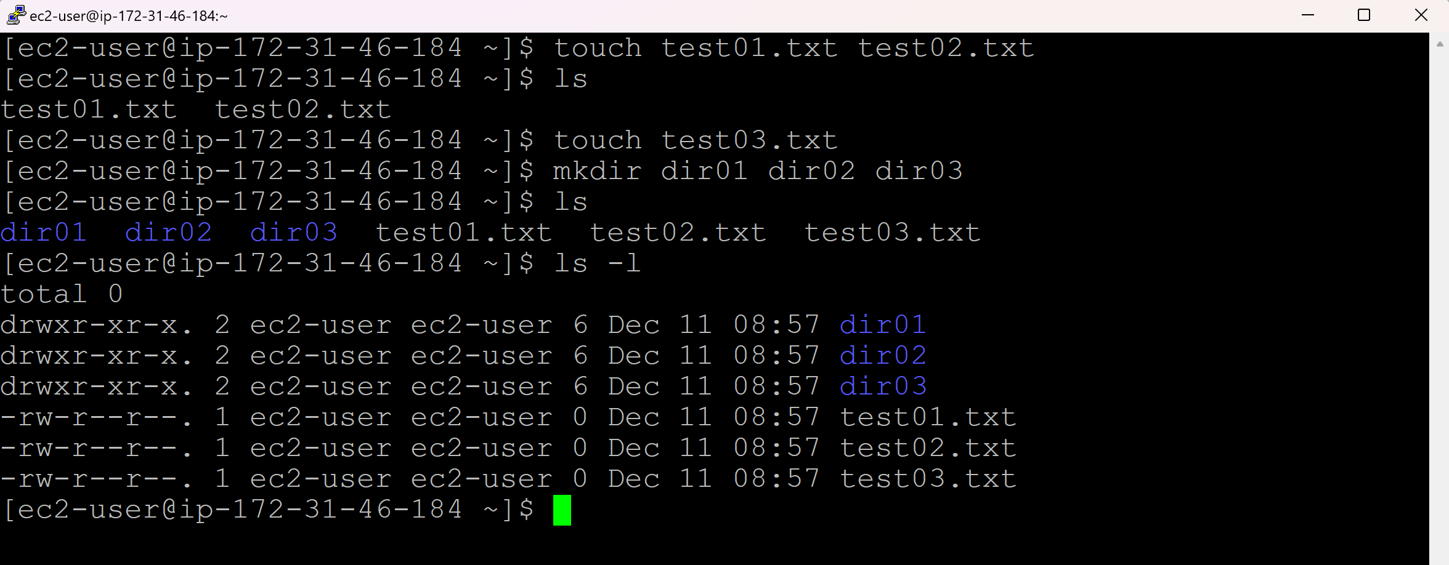

* The line starts with **–** is a **file**.
* The line starts with **d** is a **directory**.
* The line starts with **l** is a **link**.
* The line start with **.** is a hidden file/directory

**Command to remove a directory:**

rm <filename1> (Removes a single file)

rm <filename1> <filename2> (Removes multiple files)

rm * (Removes all files)

rm -r <directoryname>

rm -r <directoryname>{1..100}

rm -r ansible* (Removes all directories starting with the name ansible)

rm -r * (Removes all files and directories)

rmdir <emptydirectoryname> (Removes empty directory only)

‘r’ refers to recursive here. It removes all the files or directories or both in any directory.

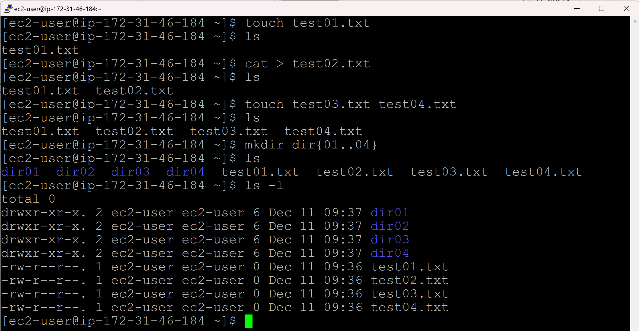

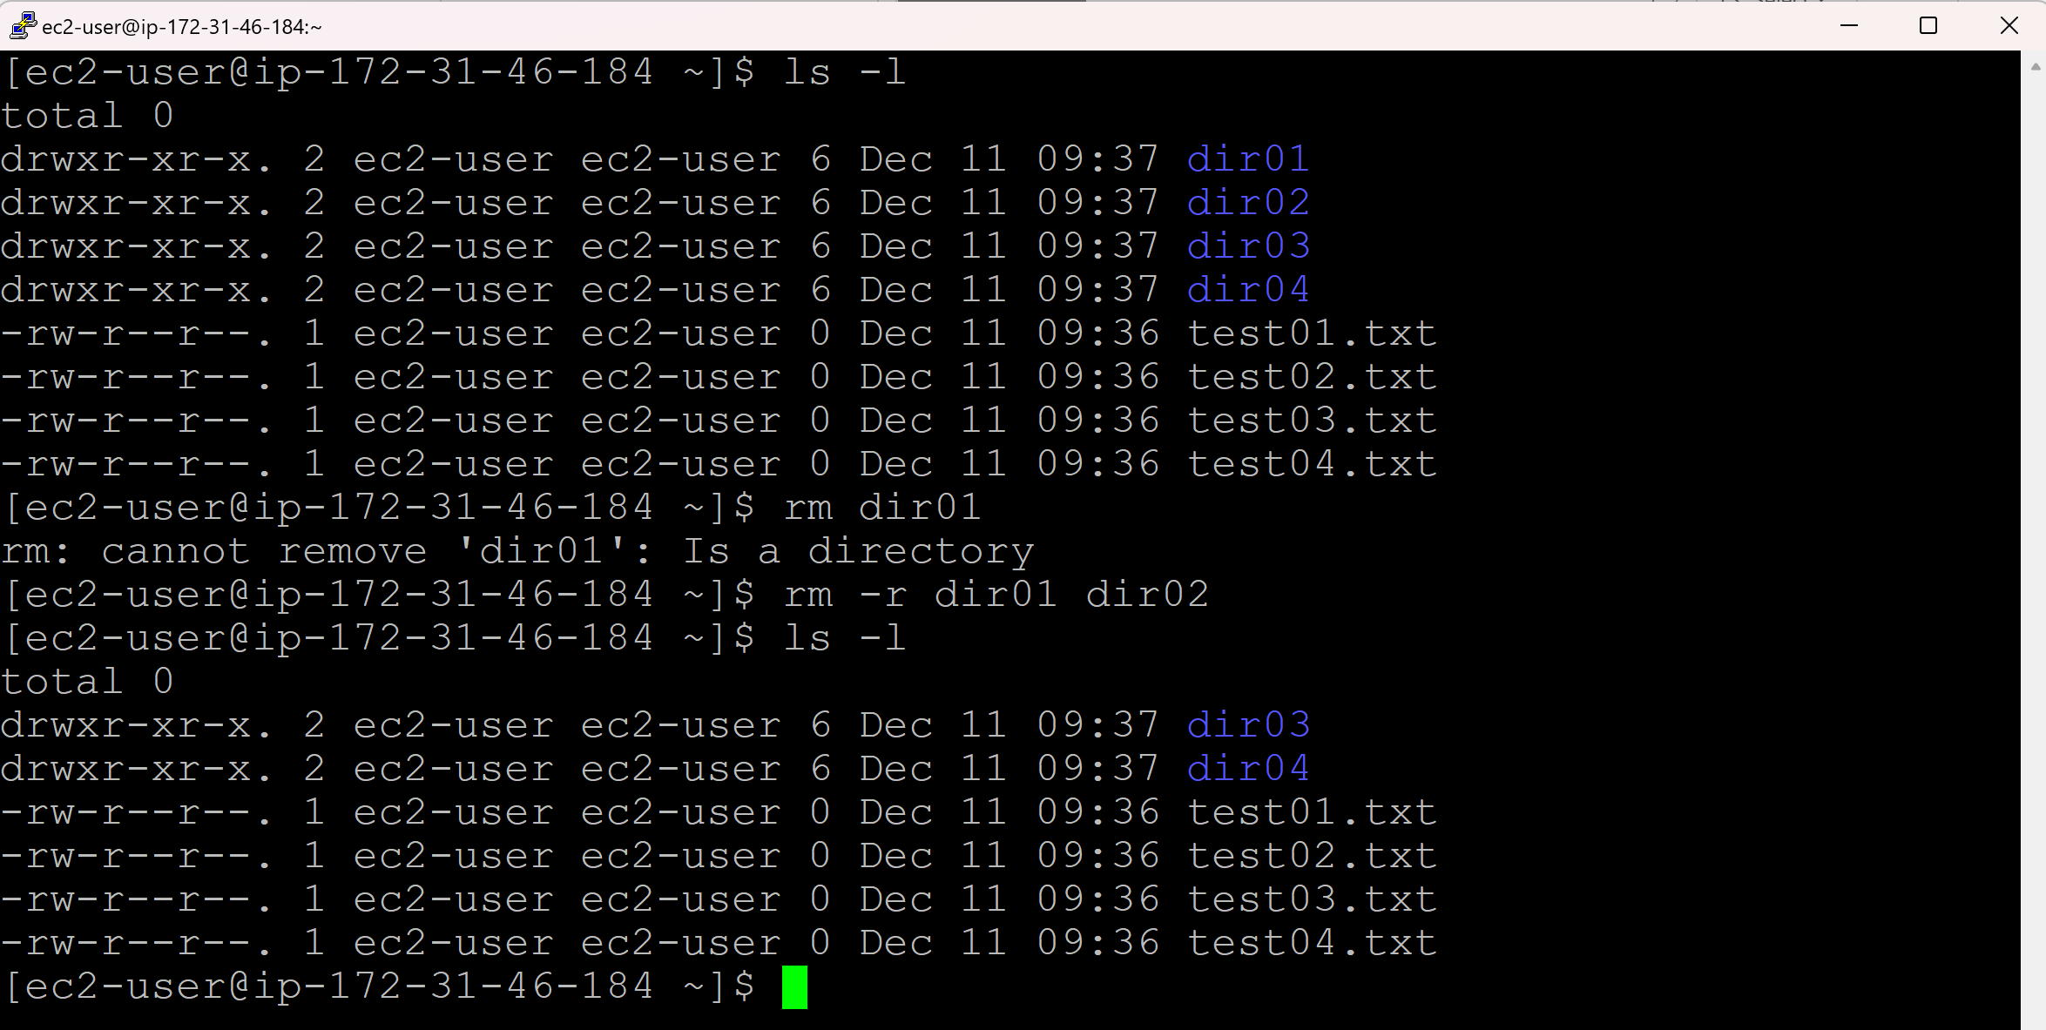

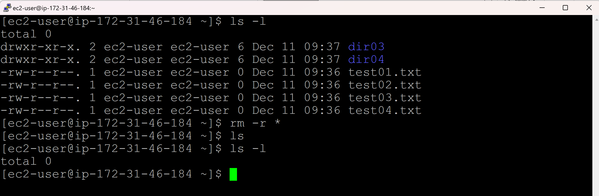

**Changing Directory:**

cd <directoryname> (change directory)

cd .. (change directory one level up)

cd ../.. (change directory two levels up)

cd ../../.. (change directory three levels up)

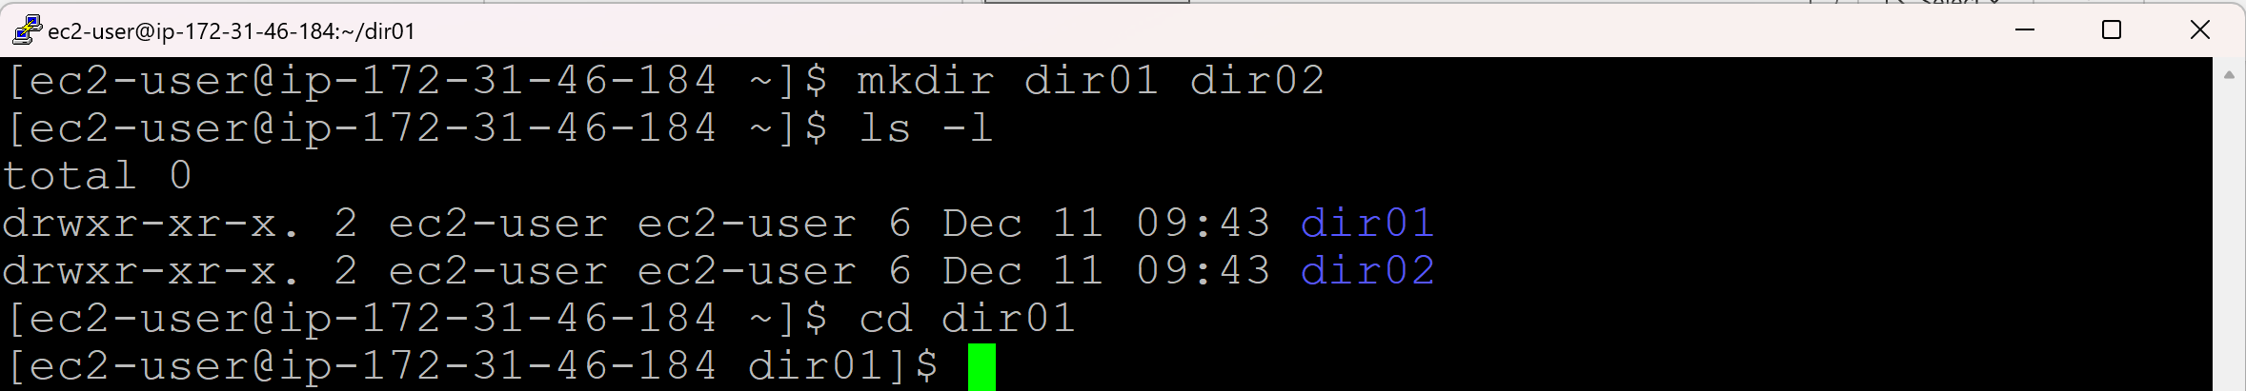

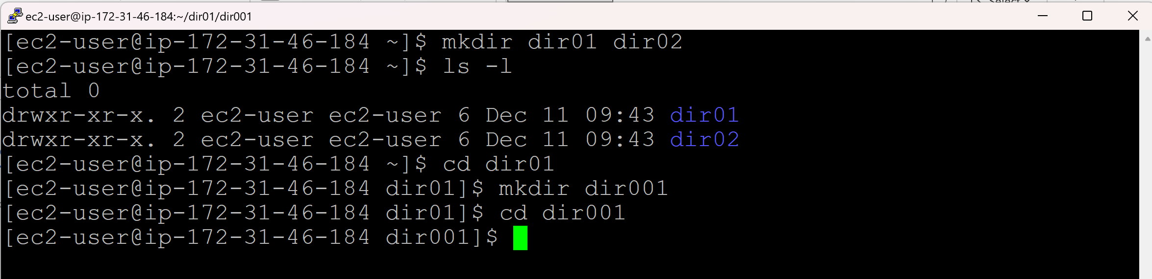

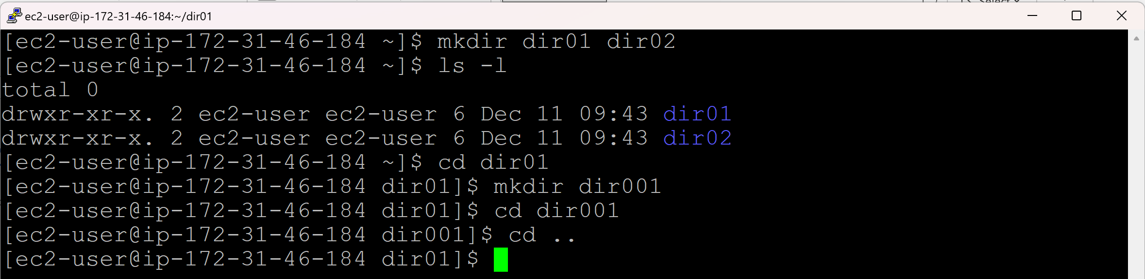

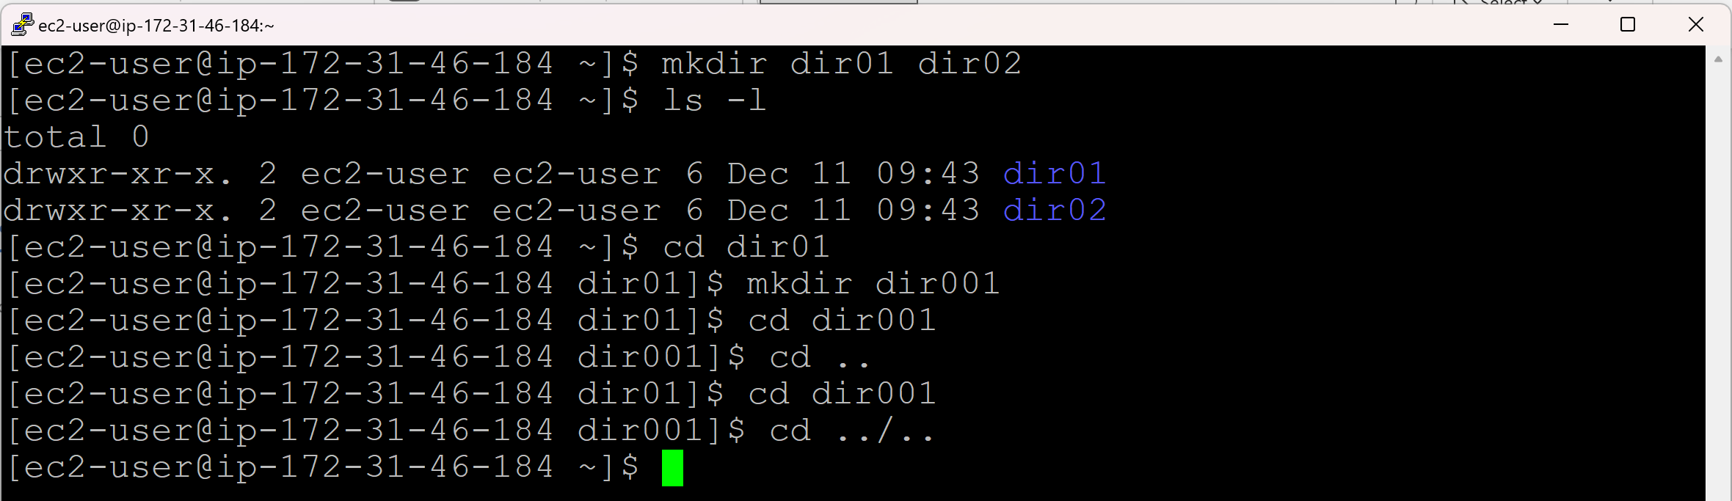

**Copy data from one file to another:**

cp <filename1> <filename2>

If <filename2> doesn’t exist, a new file with a <filename2> will be created and copy the data from <filename1> to <filename2>

cp <filename> <directoryname>

cp <filename1> <filename2> <directoryname>

cp -r <directoryname1> <directoryname2>

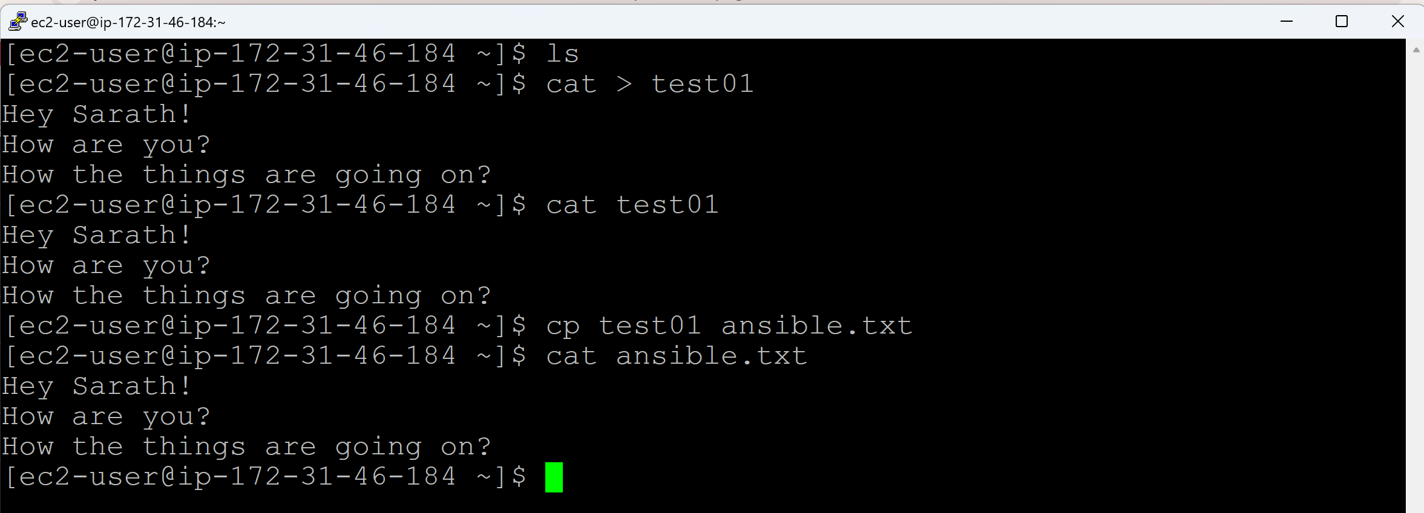

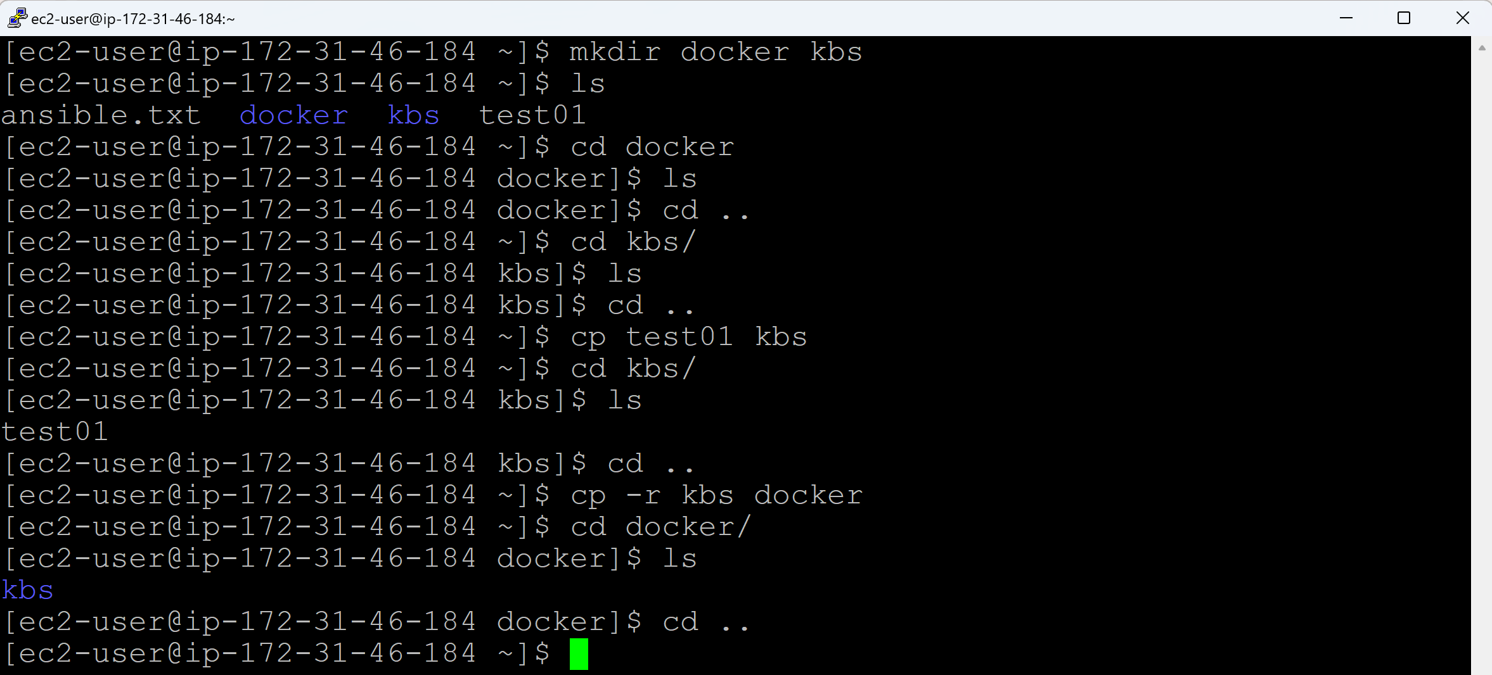

**Move a file to directory:**

**Move multiple files to a directory:**

**Move a directory to another directory:**

**Rename a file:**

**Rename a directory:**

mv <filename> <directoryname>

mv <filename1> <filename2> <directoryname>

mv <directoryname1> <directoryname2>

mv <filename> <new_filename>

mv <directoryname> <new_directoryname>

**Day 09 (ls, logname, whoami, sudo, pwd, uname)**

**ls command:**

ls (List files and directories in the current directory)

ls <directoryname> (List the contents of a specific directory)

ls -a (List hidden files)

‘a’ referes to all

ls -l (Lists the detailed information)

‘l’ referes to long listing format

ls -la (Lists the detailed information and hidden files)

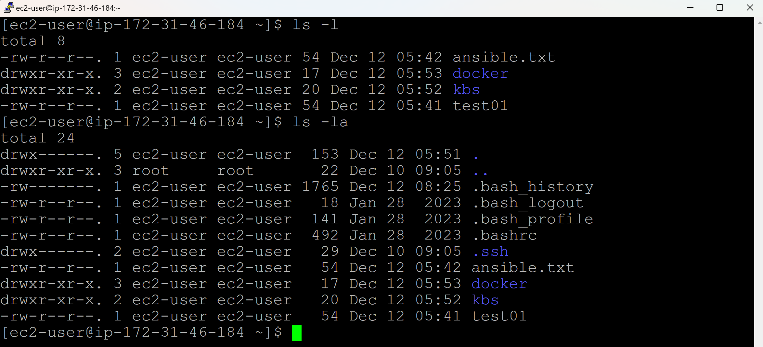

**logname command:**

logname (who initially login to the server)

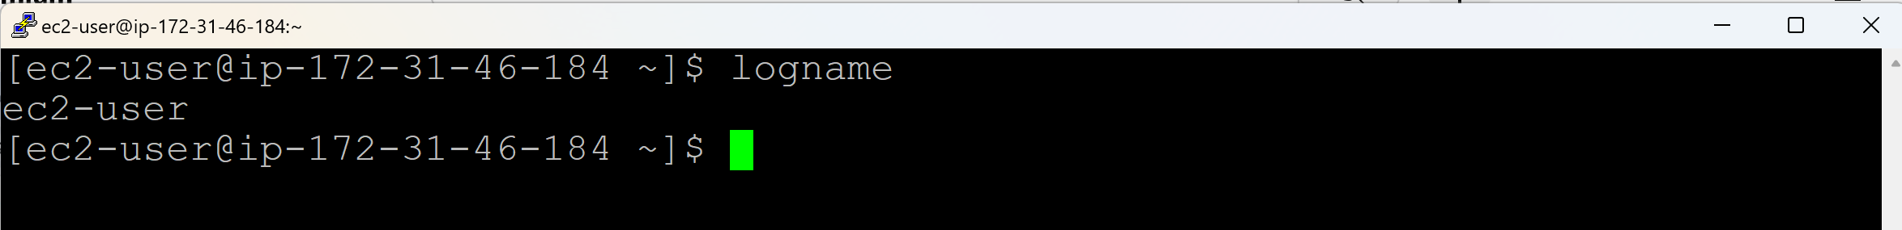

**whoami command:**

whoami (who is currently working)

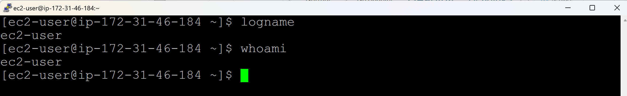

**Switch User:**

sudo su (Switch user to the root user with current user’s environment)

exit (Switch back to previous user)

sudo -i (Switch user to root user with root user environment)



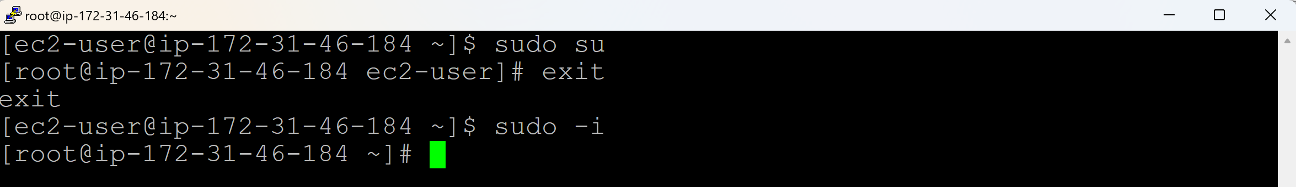

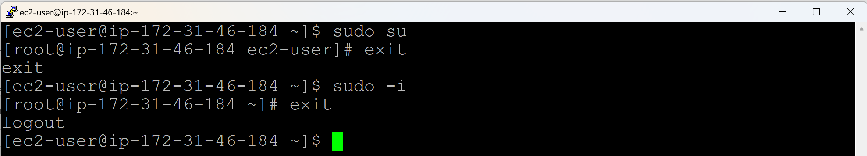

**$** - normal user

**#** - root user

**Present Working Directory:**

pwd

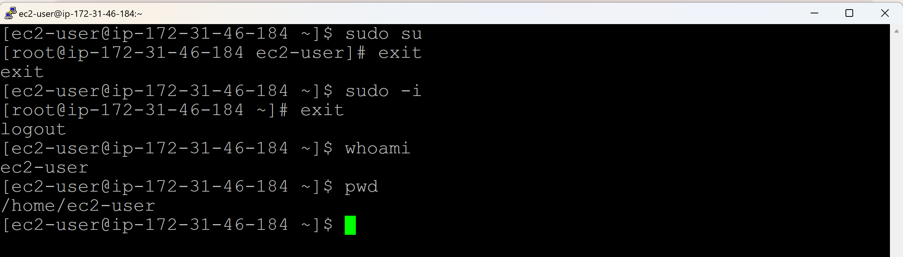

**uname command:**

uname (Gives us the OS/Kernerl name)

uname -a (Gives us the complete system architecture information)

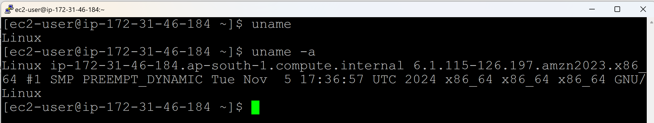

**Day 10 (head, tail, wc)**

**Display Commands:**

**head <filename>**

* To display the top 10 lines of the file by default. **cat <filename> | head**

**head -5 <filename>**

* To display the first 5 lines of the file. **cat <filename> | head -n 2**

**tail <filename>**

* To display the last 10 lines from the bottom of the file. **cat <filename> | tail**

**tail -10 <filename>**

* To display the last 10 lines of the file. **cat <filename> | tail -n 5**

**tail -f <filename>**

* Continuoulsy follow/monitor the file.

‘f’ refers to follow.

Ctrl+C to come out of the file monitoring.

**wc**

* Number of words can be counted (wc -w <filename>)
* Number of lines can be counted (wc -l <filename>)
* Number of characters can be counted (wc -m <filename>)

‘wc’ refers to word count

**Assignment:**

**How to display the 121th line from error.log file?**

head -121 error.log | tail -1

(or) cat -n error.log | head -121 | tail -1

(or) cat error.log | head -121 | tail -1

(or) cat error.log | tail -20 | head -1

**How to display the 18th line from test01 file?**

head -18 test01 | tail -1

(or) cat -n test01 | head -18 | tail -1

(or) cat test01 | head -18 | tail -1

(or) cat test01 | tail -12 | head -1

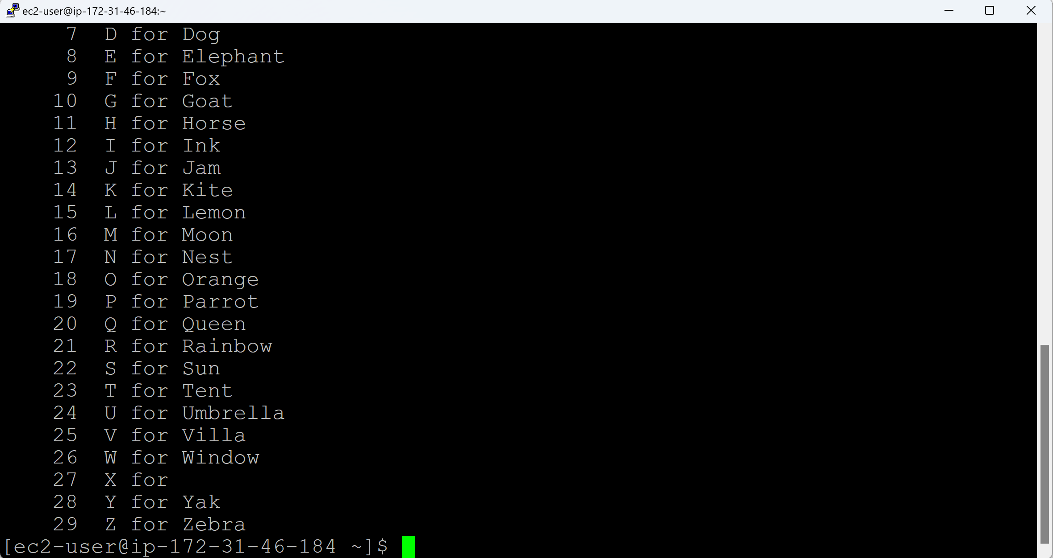

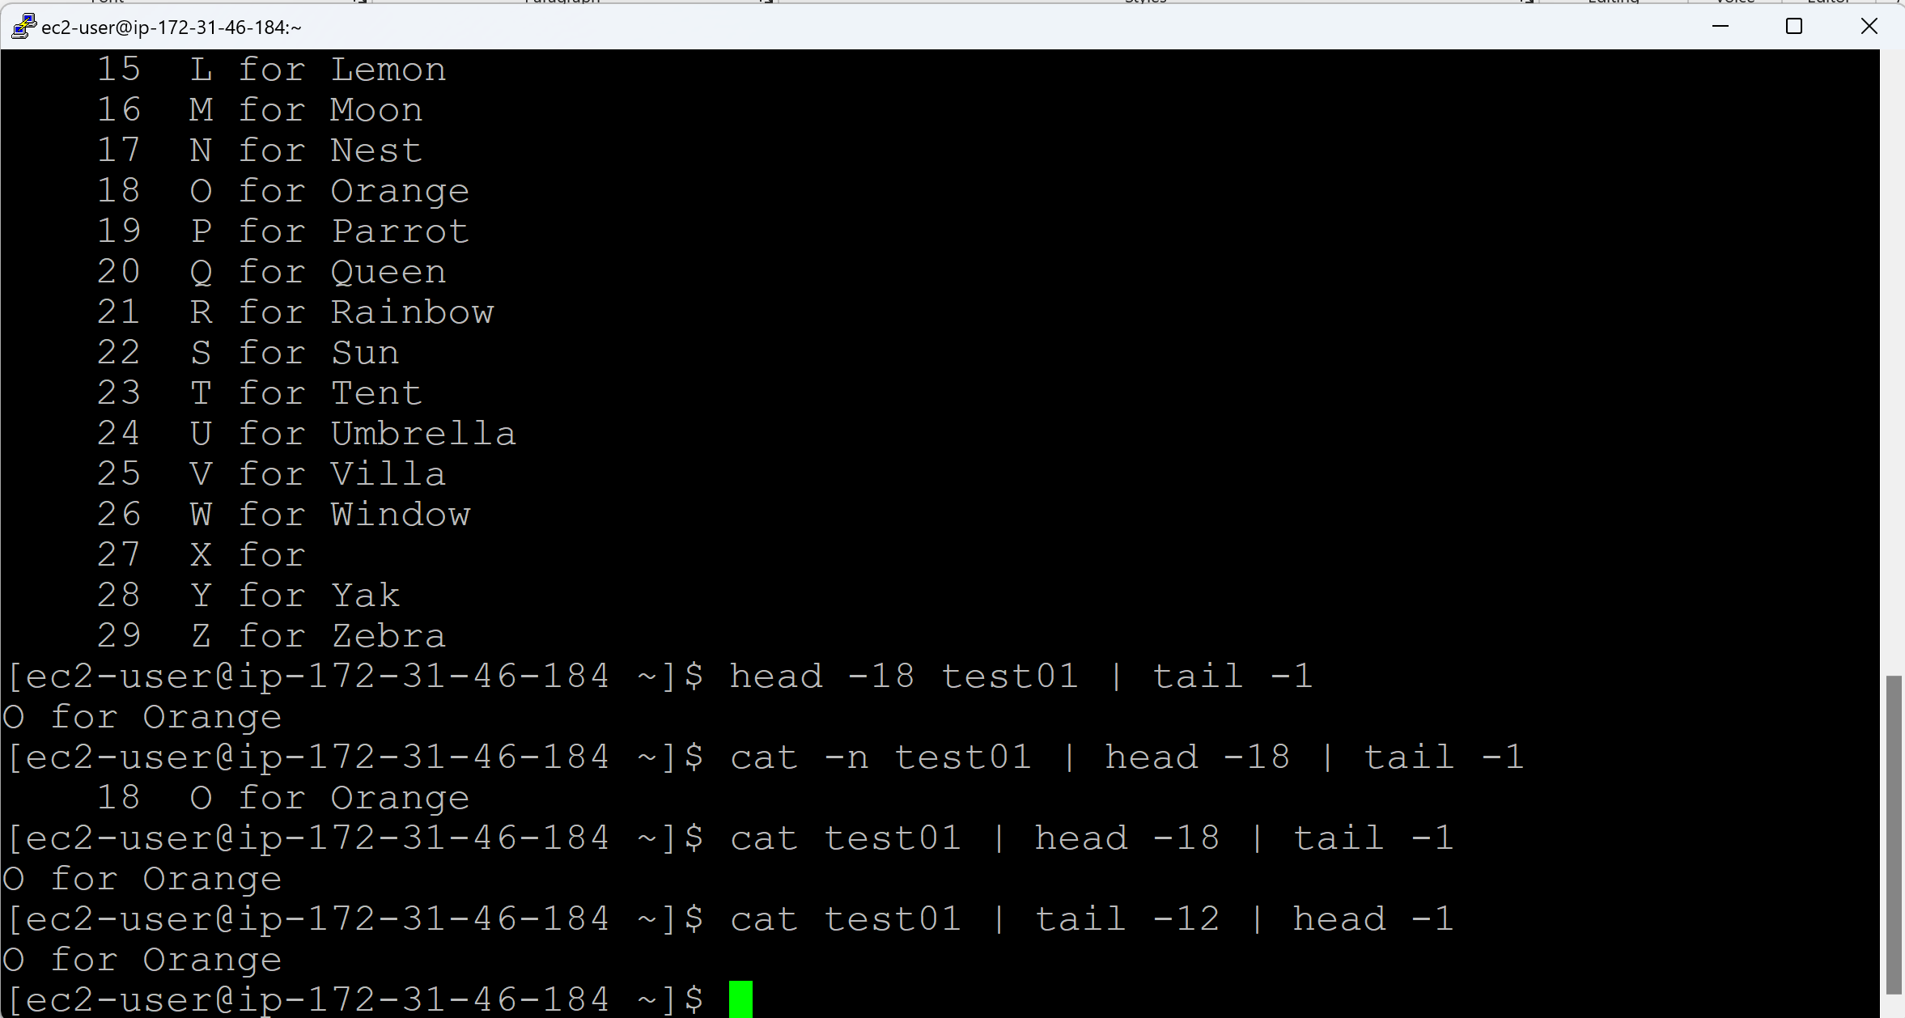

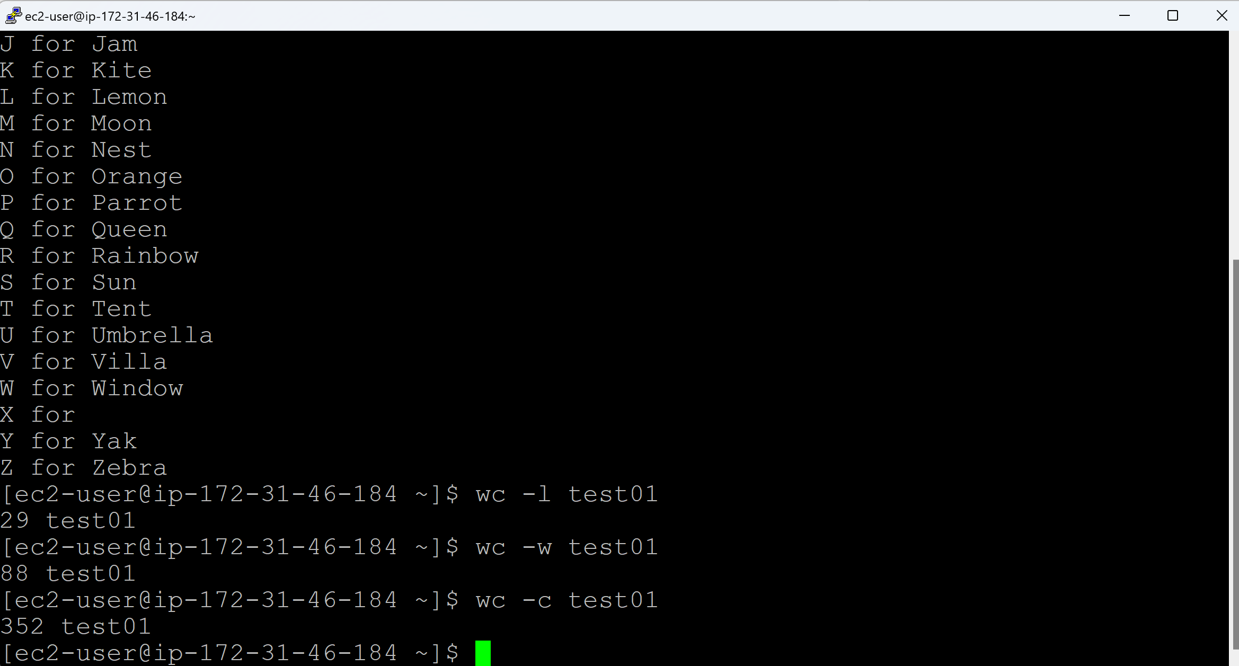

**Day 11 (grep)**

**grep command: (It is just like Ctrl+F command in Window)**

‘grep’ refers to global regular expression print

grep <word> <filename>

(or) cat <filename> | grep <word>

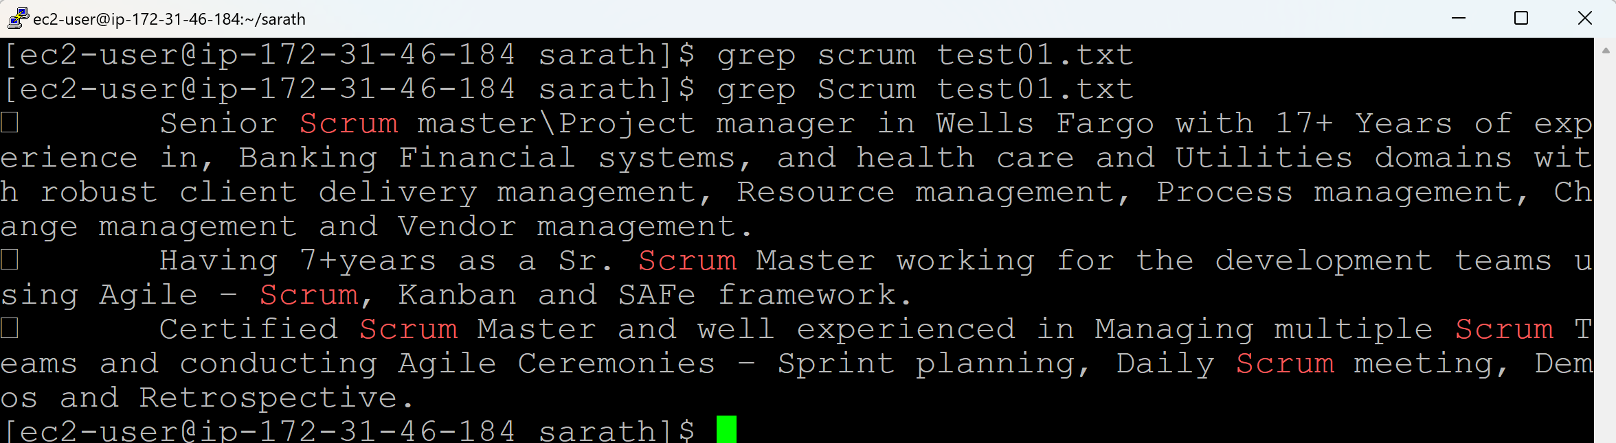

grep -i <word> <filename>

(or) cat <filename> | grep -i <word>

‘i’ refers to ignore case-sesitive

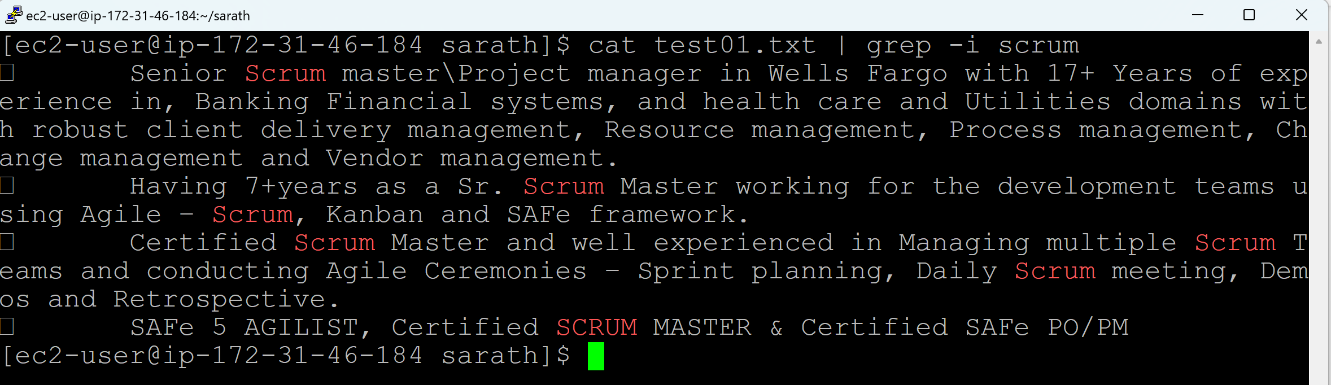

grep -i -r <word> <directoryname>

‘i’ refers to ignore casesesitive

‘r’ refers to recursive (It will seach all the files under a directory)

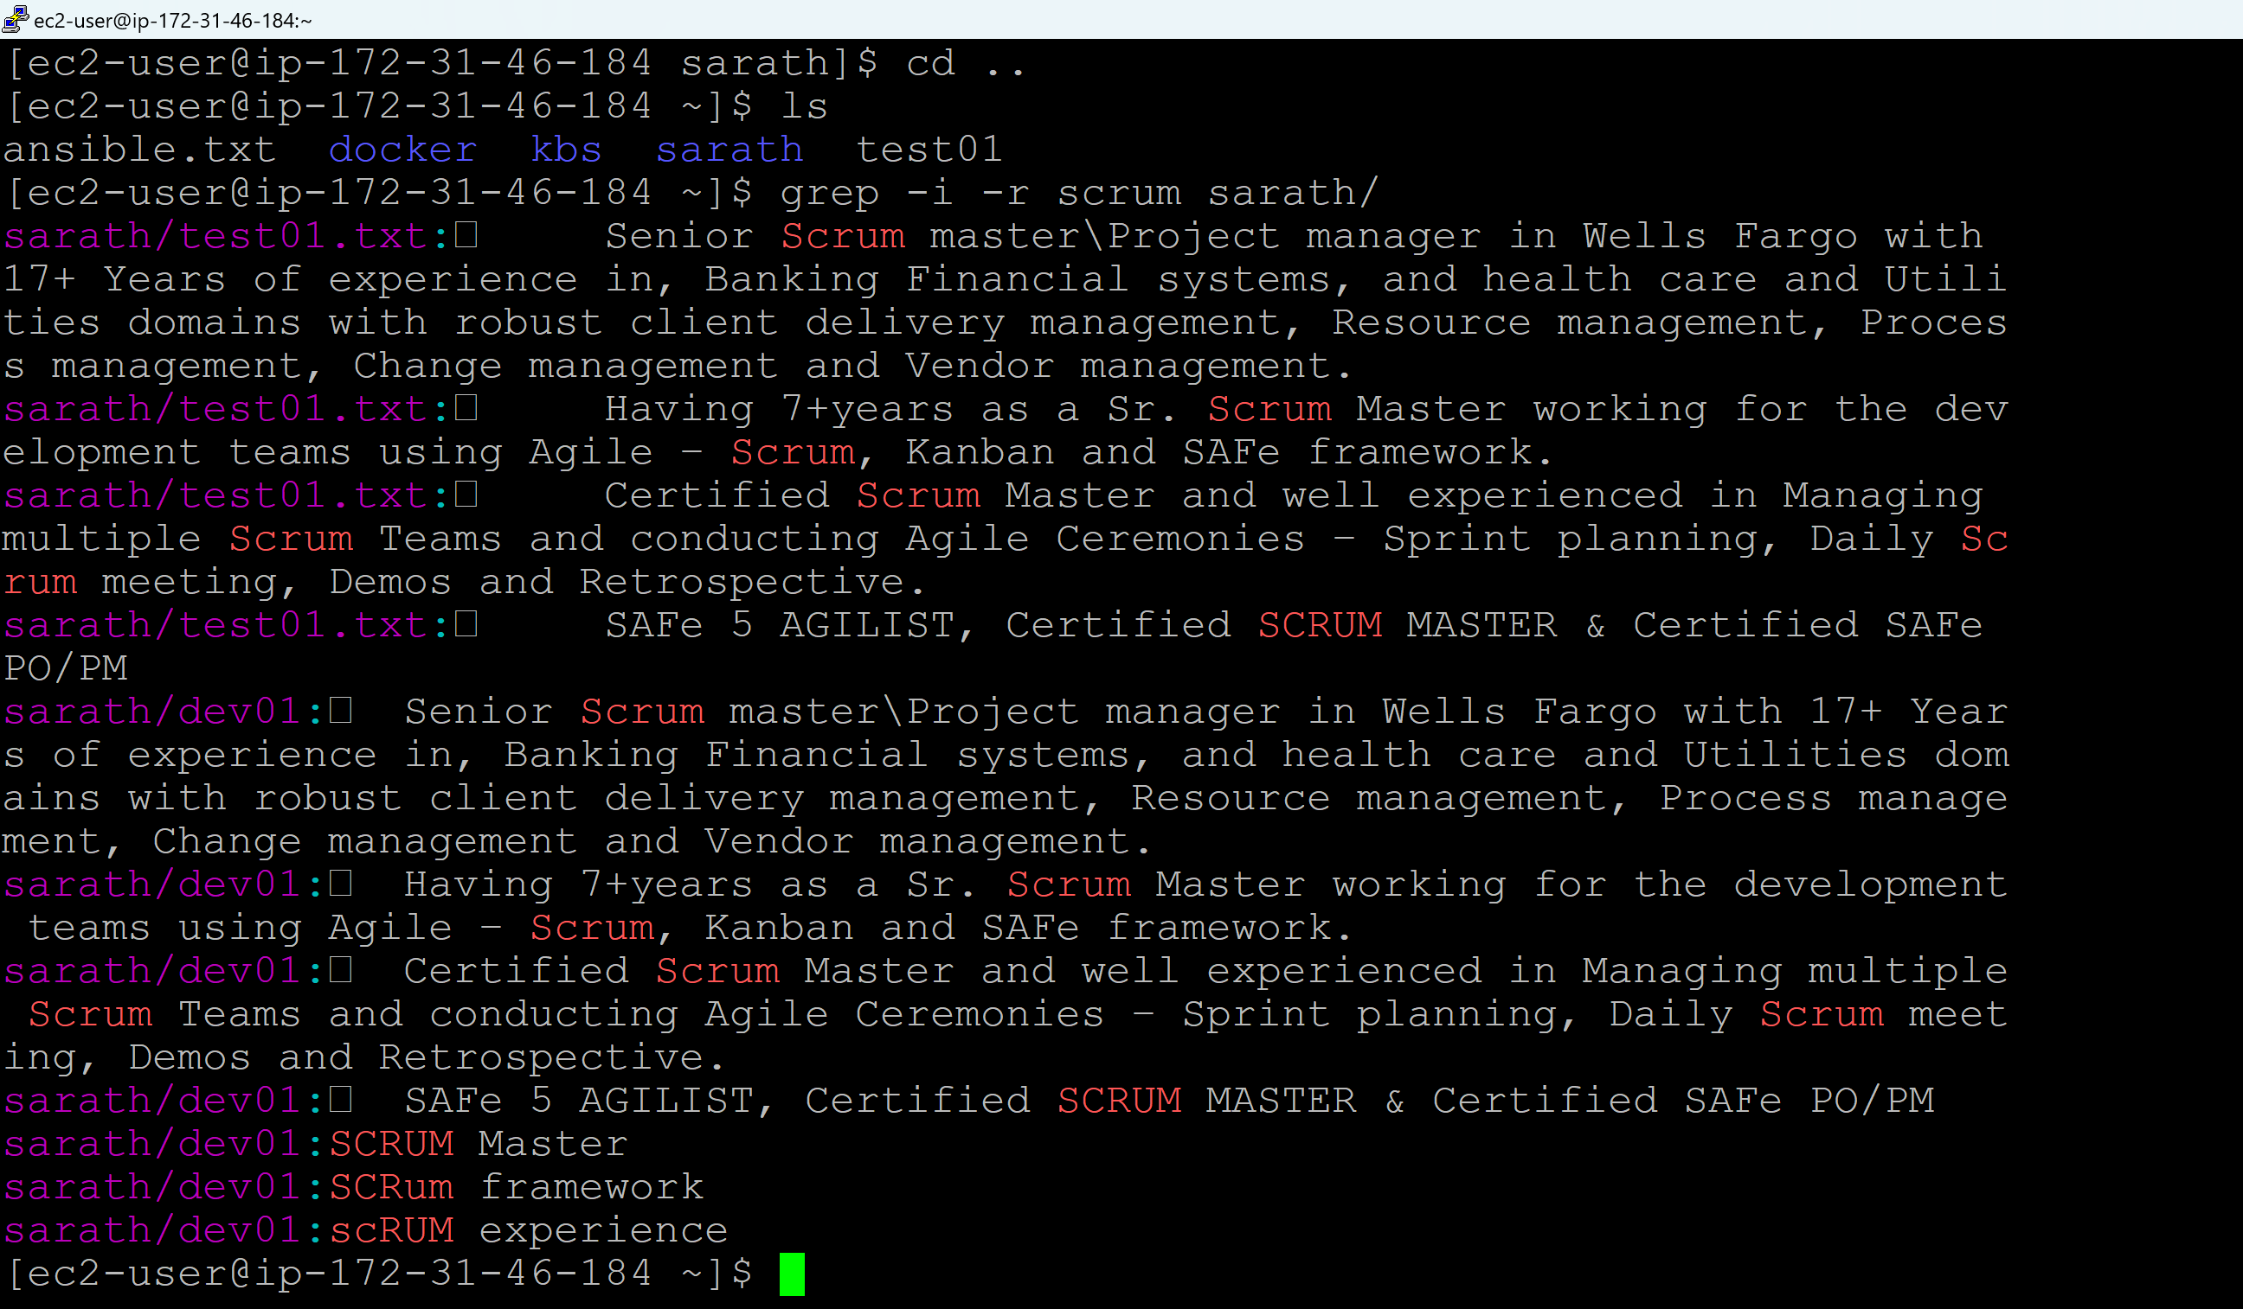

grep -i -r -c <word> <directoryname>

‘i’ refers to ignore casesesitive

‘r’ refers to recursive (It will seach all the files under a directory)

‘c’ refers to count the number of matching lines

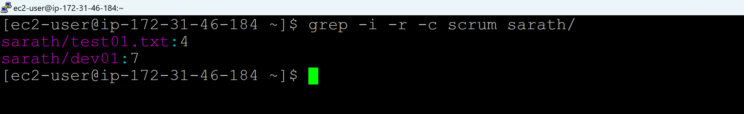

grep -i -l -r <word> <directoryname>

‘i’ refers to ignore casesesitive

‘r’ refers to recursive (It will seach all the files under a directory)

‘l’ refers to list the filenames with matching lines in a directory

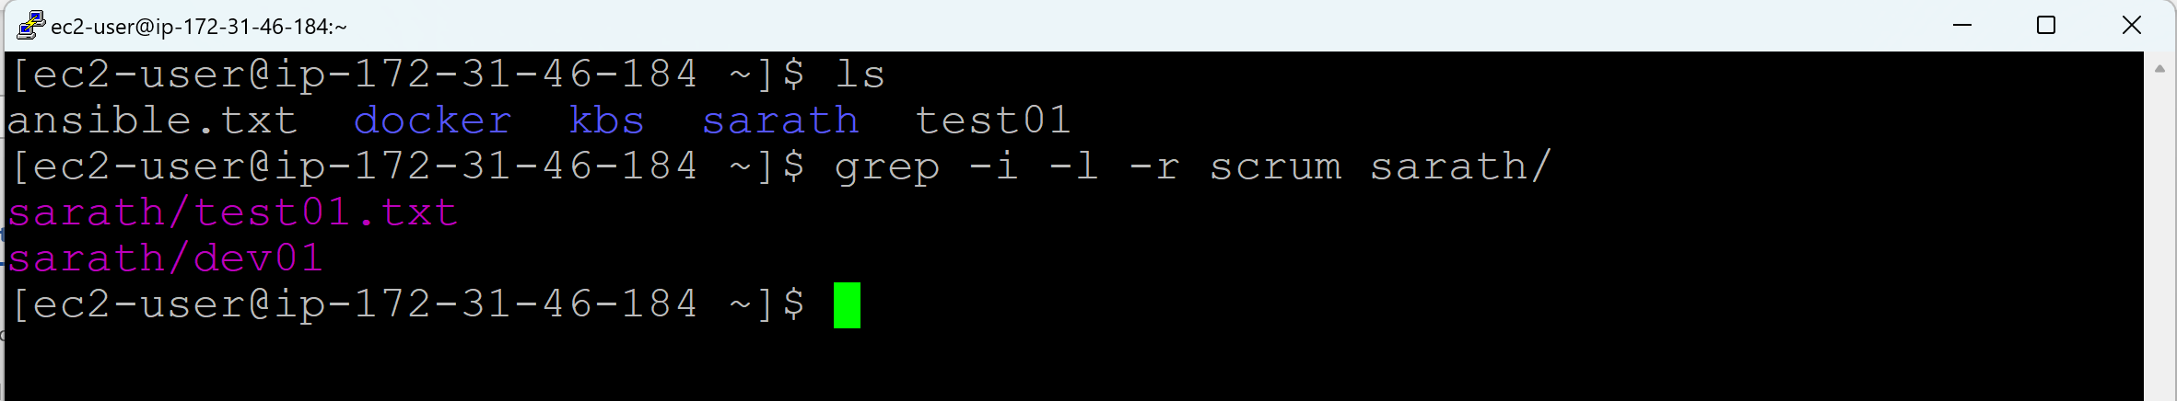

grep -n -i -r <word> <directoryname>

‘i’ refers to ignore casesesitive

‘r’ refers to recursive (It will seach all the files under a directory)

‘n’ refers to display line numbers of matching lines

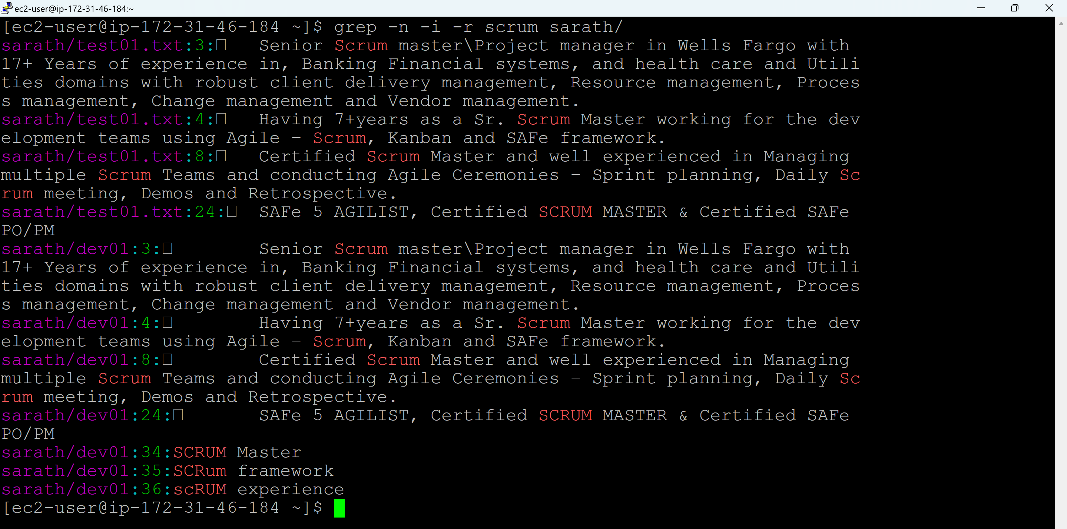

grep -i -r -v <word> <directoryname>

‘i’ refers to ignore casesesitive

‘r’ refers to recursive (It will seach all the files under a directory)

‘v’ refers to invert match to display lines that do not match the pattern

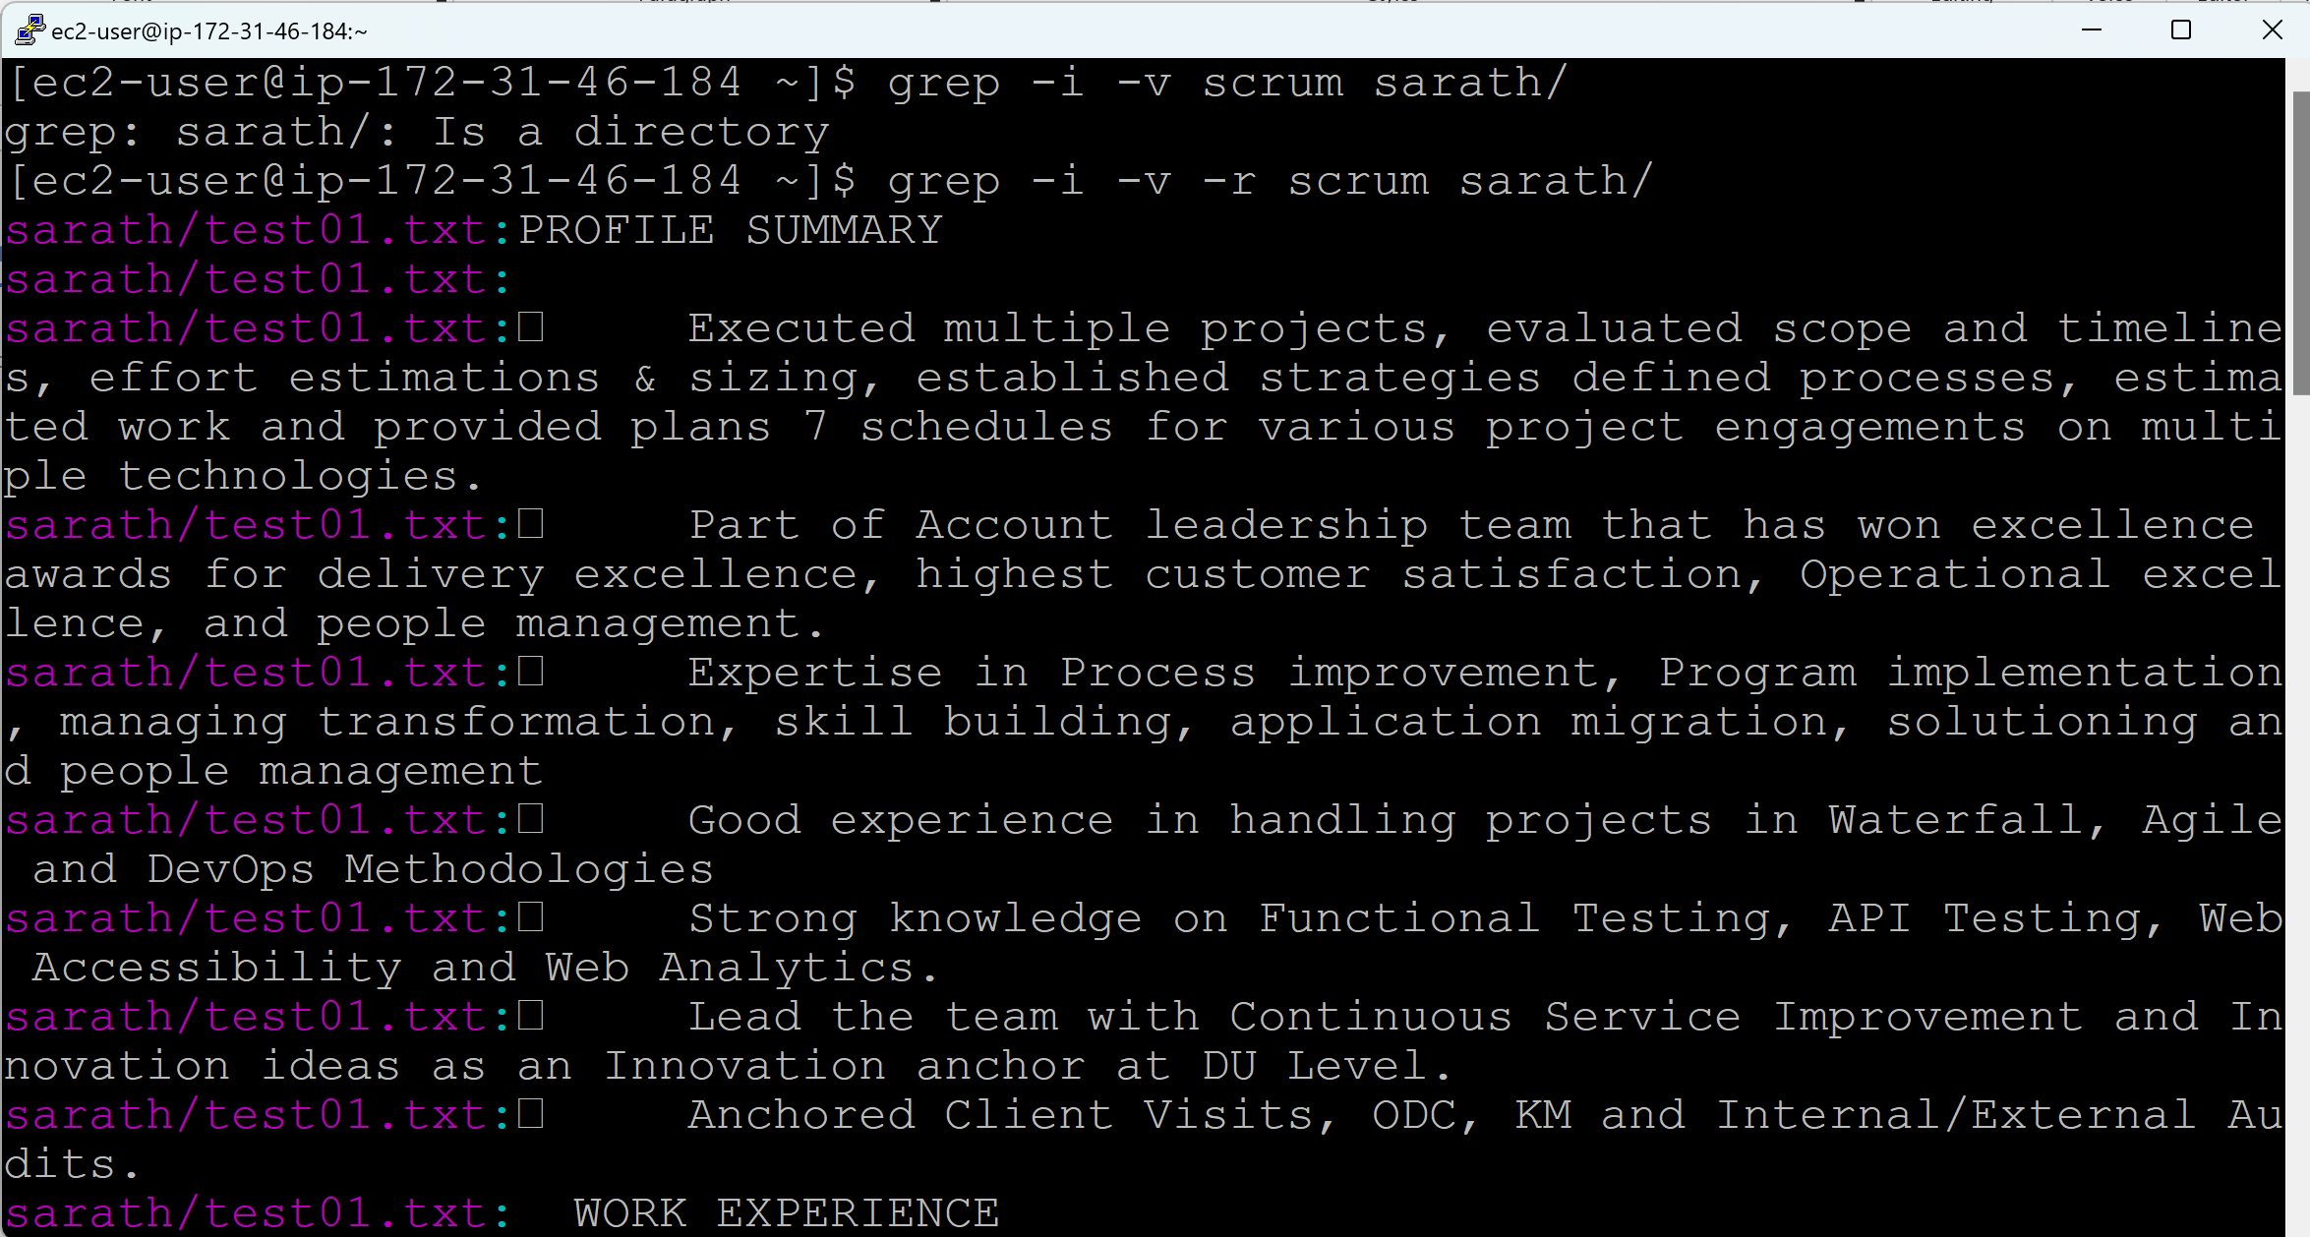

ls -l | grep ^- (To display the files)

ls -l | grep ^d (To display the directories)

^ refers to beginning of the line

$ refers to end of the line

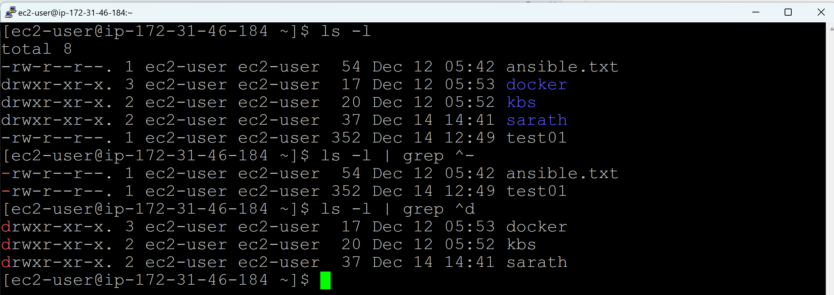

ls -l | grep ^- | wc -l (Count the lines with filenames starts with -)

ls -l | grep ^d | wc -l (Count the lines with directories stats with d)

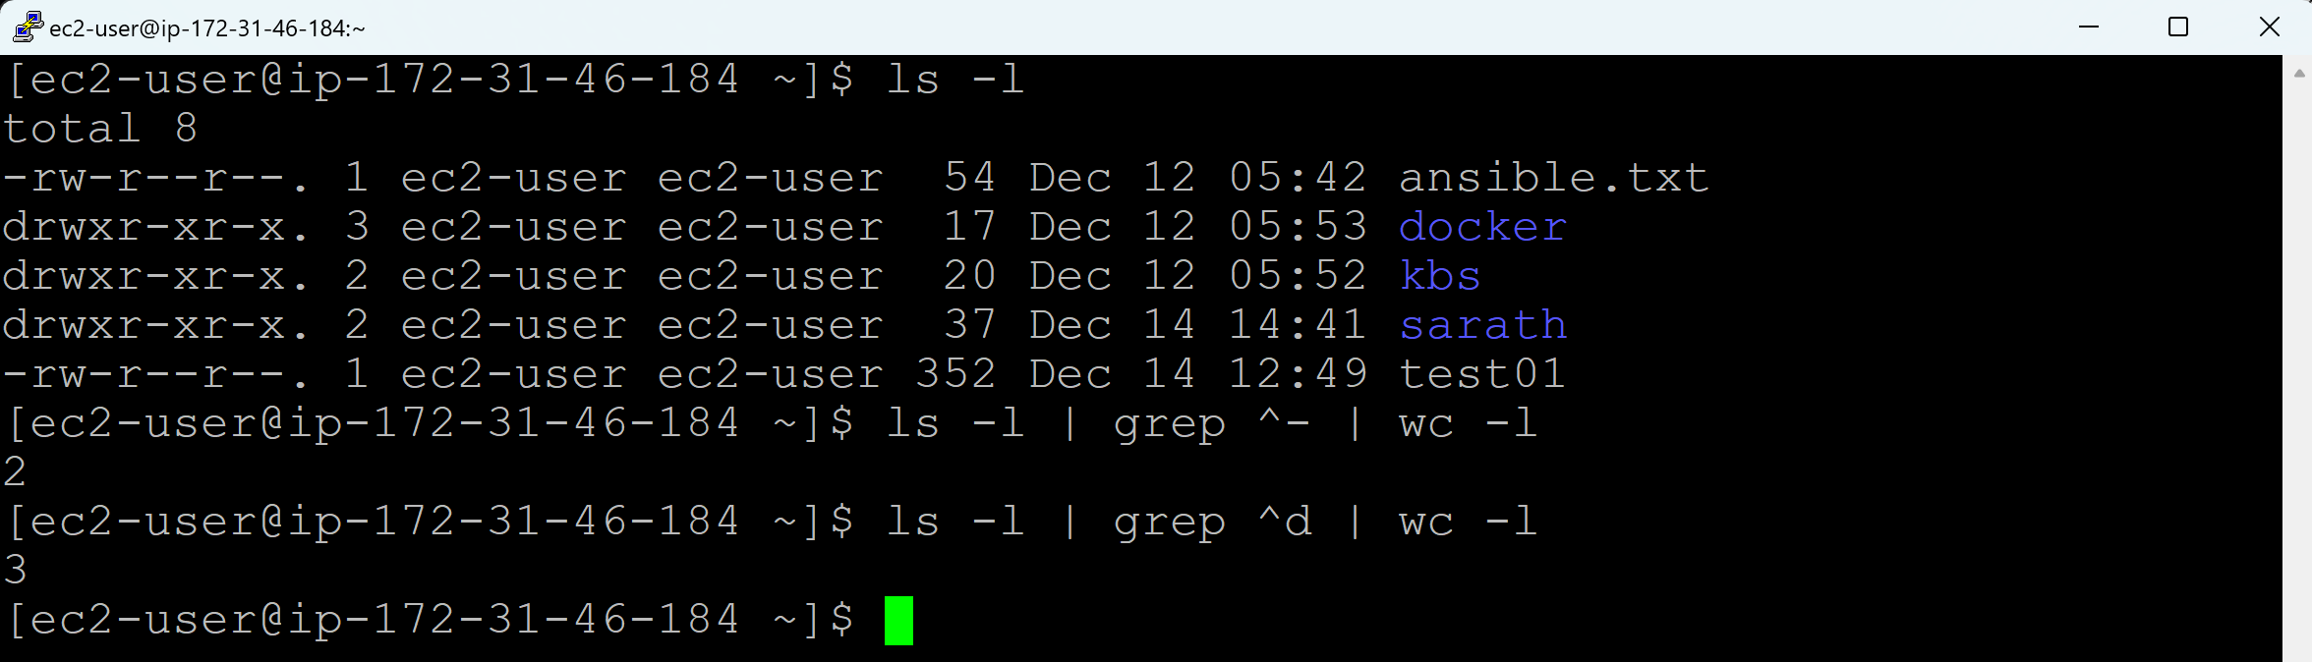

**Real time use cases:**

Errors in log file

httpd (apache) process

port number availability

400, 402, 404, 200, 500 errors

Connections estabilishment

User level logs

**Day 12 (chmod)**

**File/Directory Permissions:**

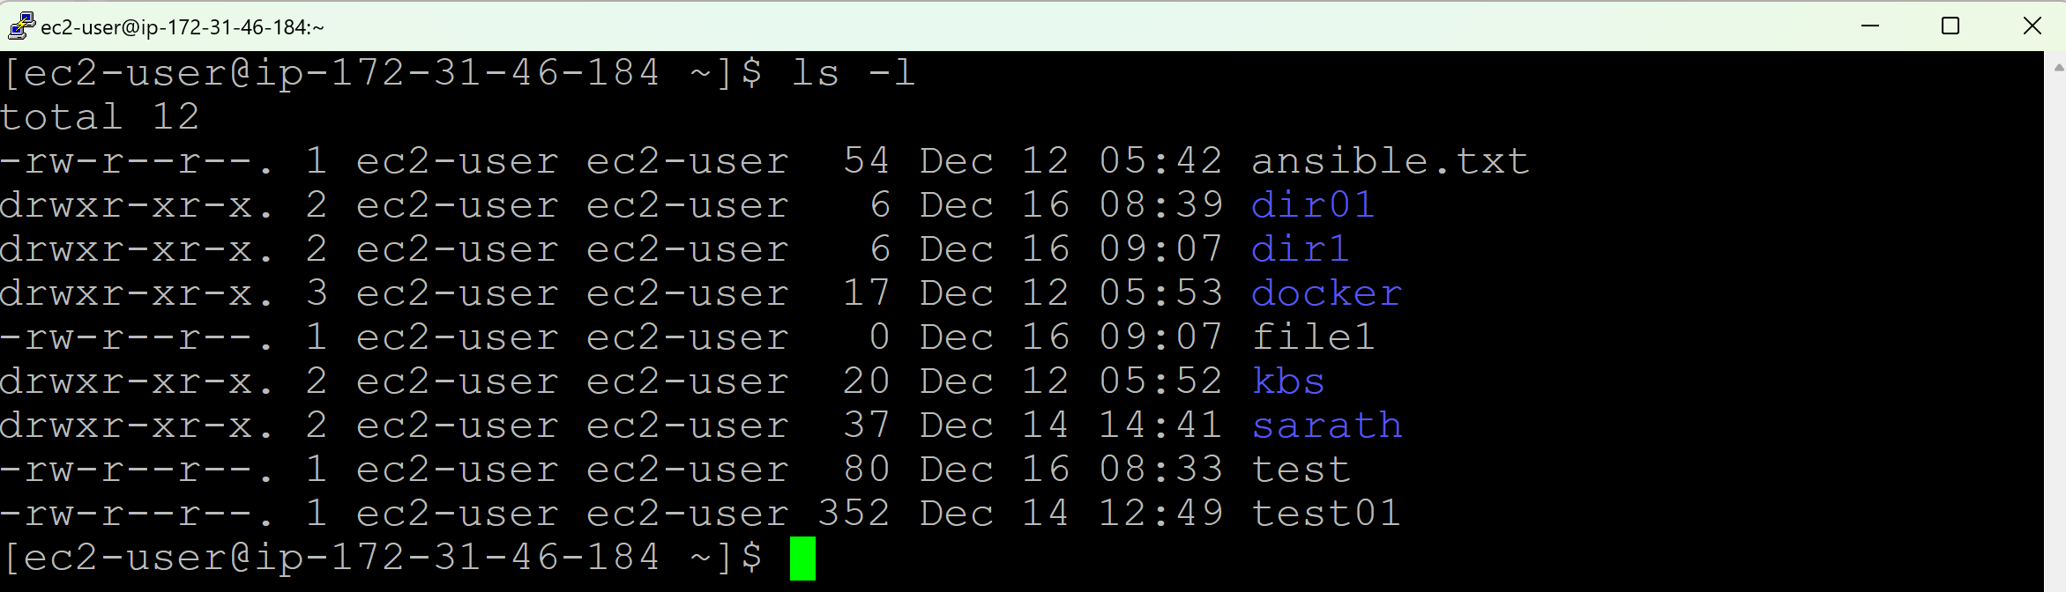

**File:**

rw-r--r--. 1 ec2-user ec2-user 54 Dec 12 05:42 ansible.txt

**Directory:**

rwxr-xr-x. 2 ec2-user ec2-user 06 Dec 16 08:39 dir01

Each file or directory has 3 types of permissions for three groups of users:

1. Type of Permissions:
   1. Read (**r**): Permission to read the file or directory contents. = **4**
   2. Write (**w**): Permission to modify the file or add/remove files in a directory = **2**
   3. Execute (**x**): Permission to execute the file or access the directory = **1**
2. Permission Groups:
   1. User / Owner (u): The user who owns the file
   2. Group (g): Other users in the file’s group
   3. Others (o): Everyone else

**File** must be having only 2 types of **permissions**:

* **Read**
* **Write**

**Directory** must be having 3 types of **permissions**.

* **Read**
* **Wrtie**
* **Execute**

By default, owner must be having read (r = 4) & write (w=2) permissions for a file. (4+2=6)

And, owner must be having read (r=4), write (w=2) and execute (x=1) permissions for a directory. (4+2+1=7)

The default permissions, when a file is created:

rw-r--r--

rw- r-- r--

4+2 4 4

6 4 4

**644**

The default permission, when a directory is created:

rwxr-xr-x

rwx r-x r-x

4+2+1 4+1 4+1

7 5 5

**755**

The default Umask value is **022**

We can change the default Umask value.

Go to /etc where we have all configuration files; there we can change this value.

Usually, when a file is created, a permission will be applied with 666 and then Umask (022) value will be applied to it. 666-022=**644**

Similary, when a directory is created, a permission will be applied with 777 and then Umask(022) value will be applied to it. 777-022=**755**

We can change the permmission in 2 ways:

1. Symbolic (Changing the permission by using u, g, o along with r, w and x letters)
2. Absolute method (Changing the permissions by using numbers)

**Absolute method:**

**Changing the permissions of a file:**

**User – Full Permissions (rw), Group – No permissions, Others - No permissions**

**chmod 600 <filename>**

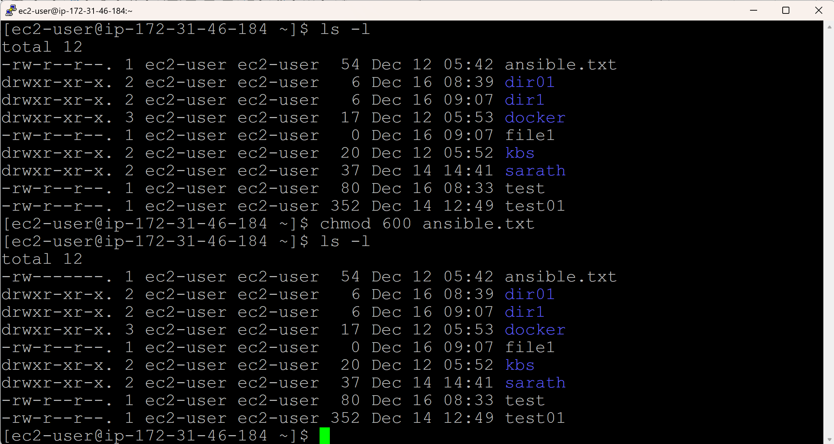

**User - Full Permissions (rw), Group – Full Permissions (rw), Other - Full Permissions (rw)**

**chmod 666 <filename>**

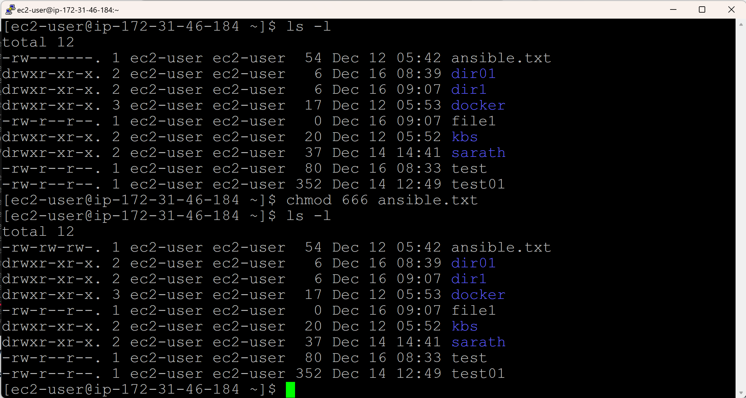

**Changing back to default permissions for a file:**

**chmod 644 <filename>**

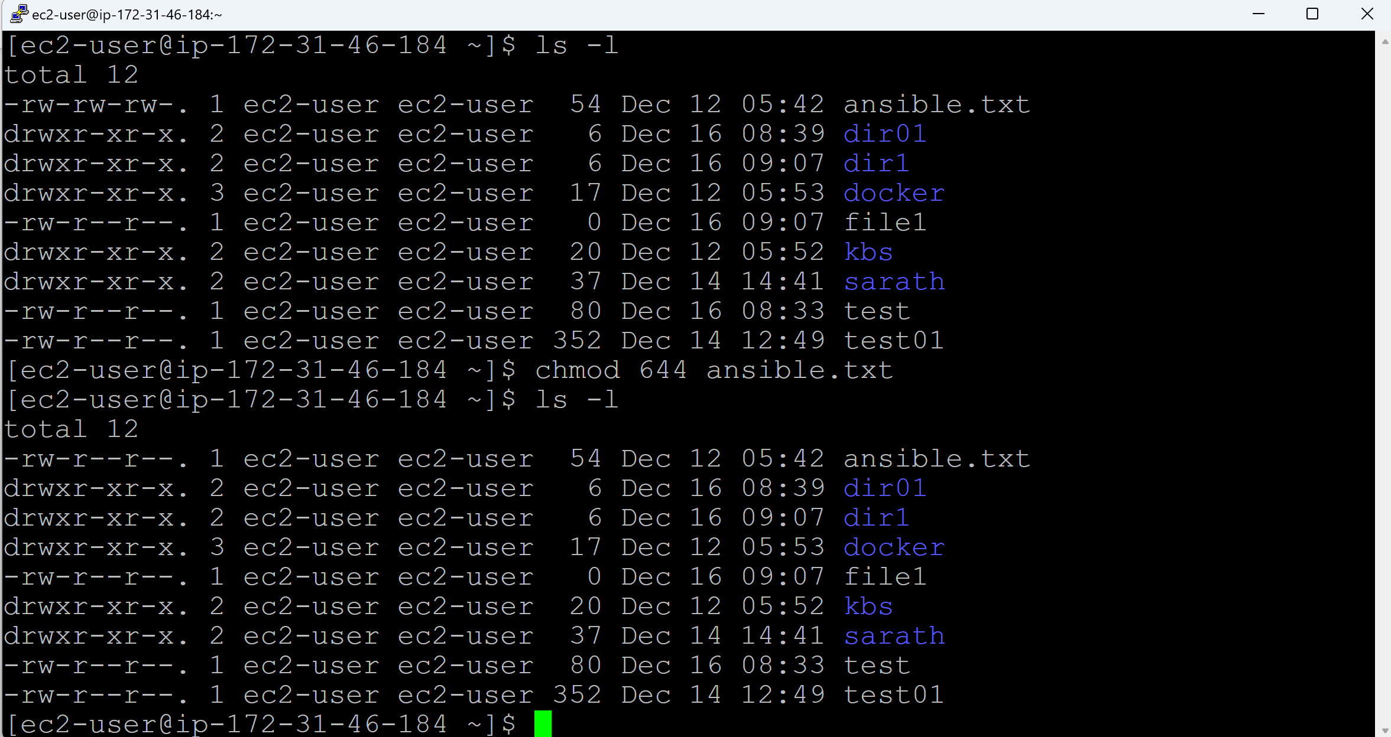

**Changing the permissions of a directory:**

User – Full Permissions (rwx), Group – Full Permissions (rwx), Other - Full Permissions (rwx)

**chmod 777 <directoryname>**

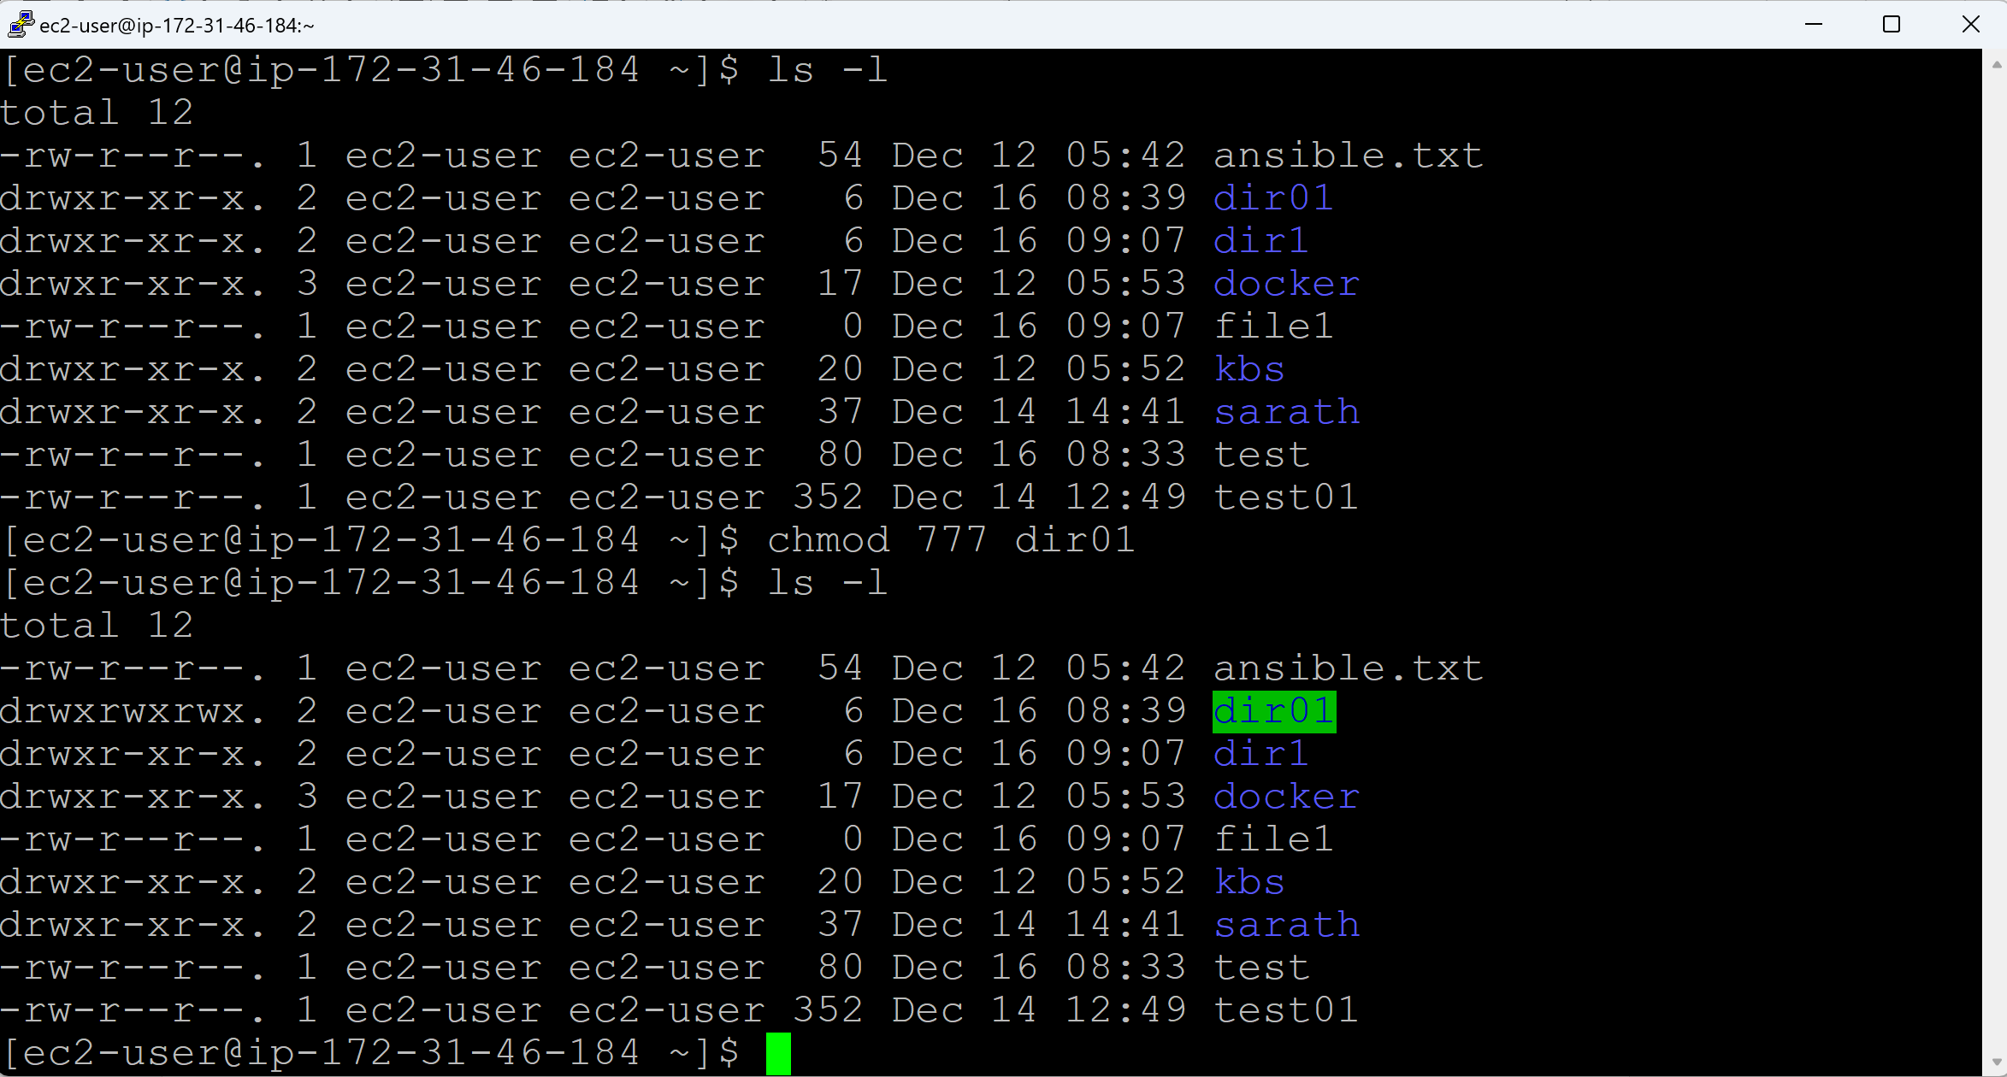

**Changing back to default permissions for a directory:**

**chmod 755 <directoryname>**

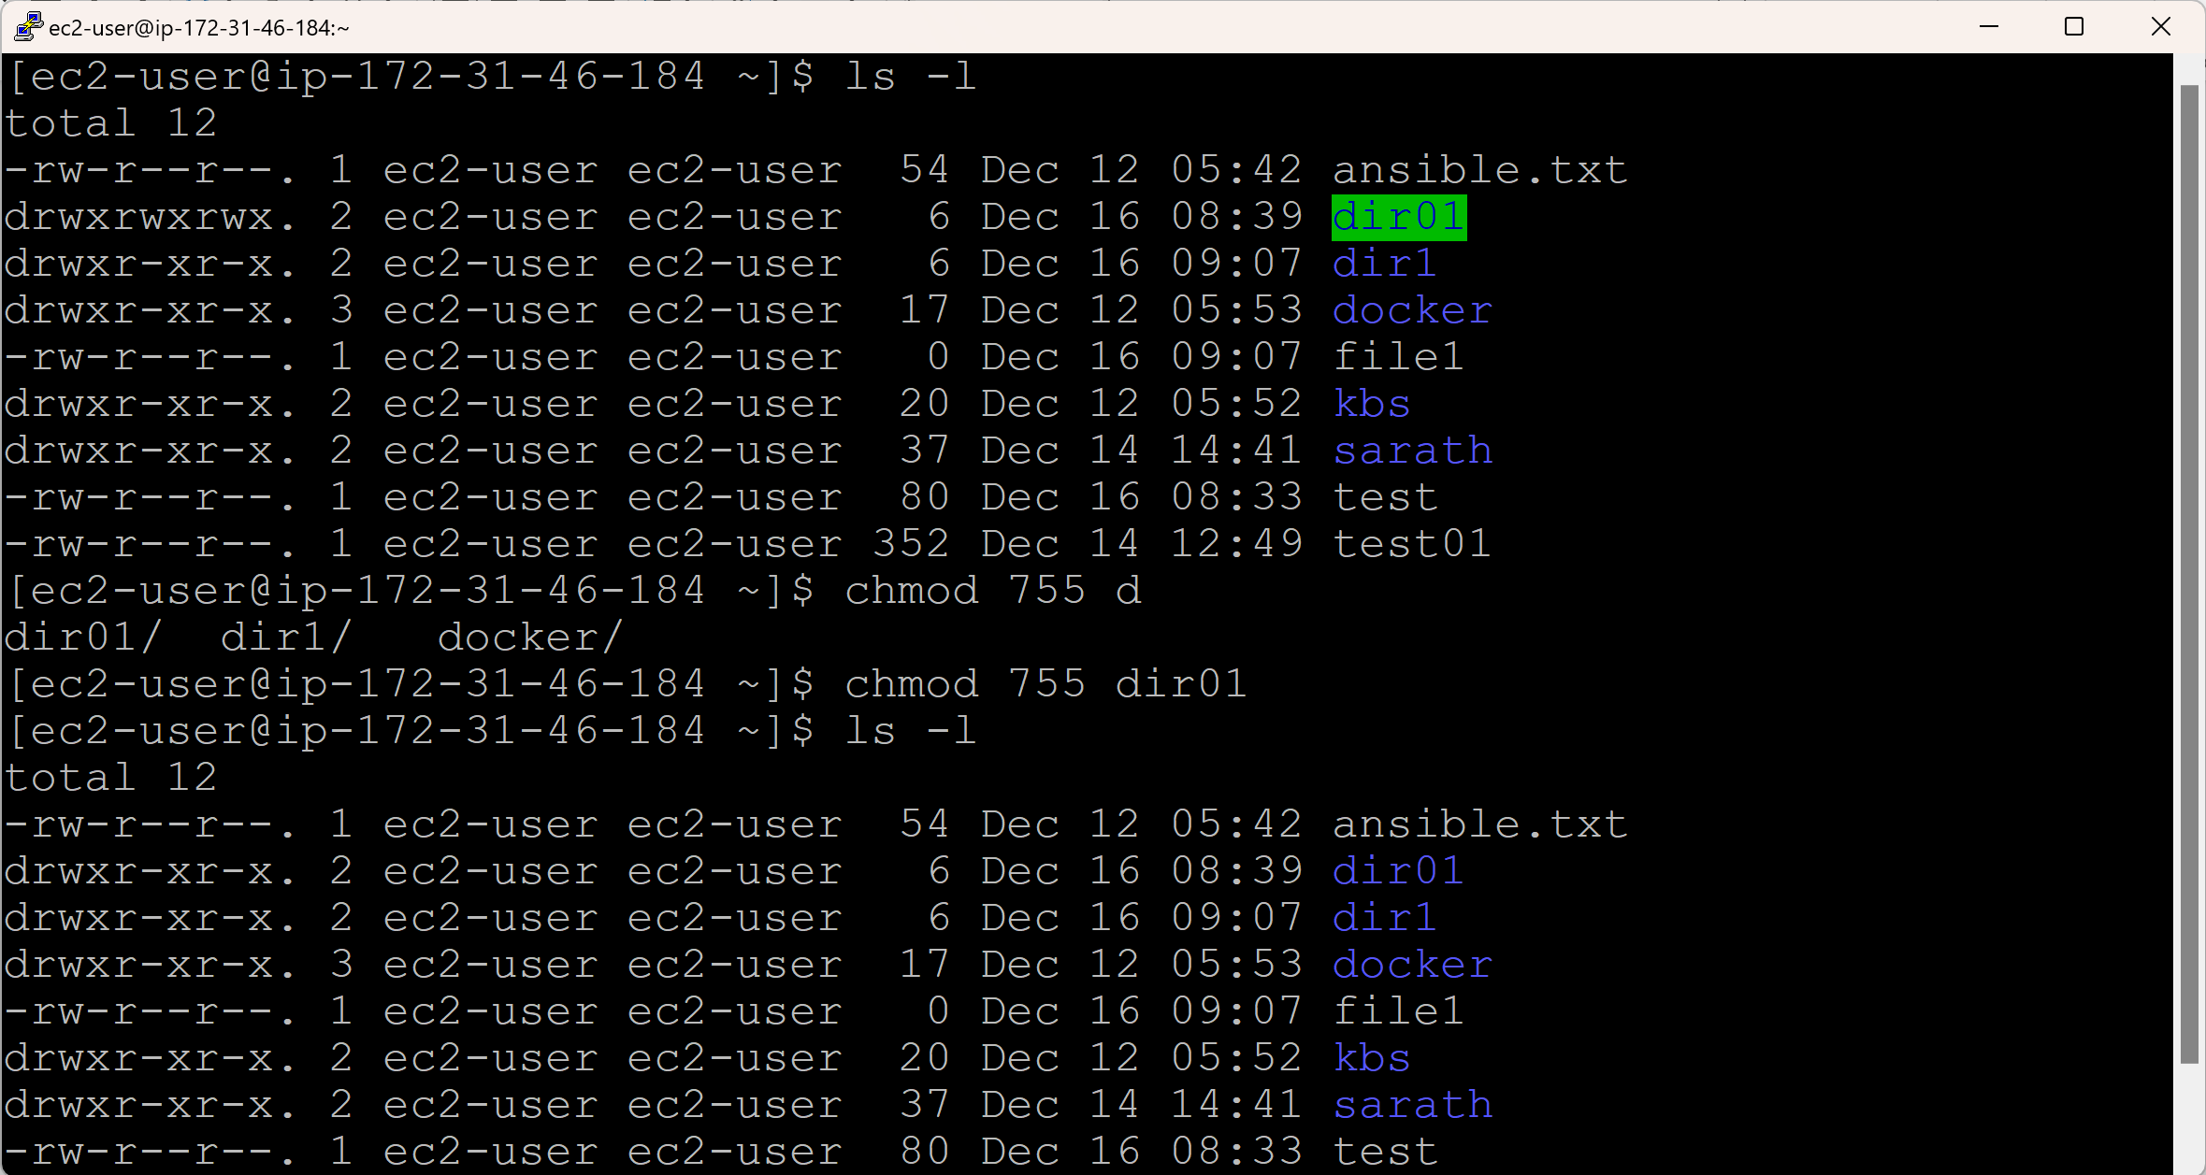

**Symbolic Method:**

**Changing the permissions of a file:**

**User – Full Permissions (rw), Group – No permissions, Others - No permissions**

**chmod g-r,o-r <filename>**

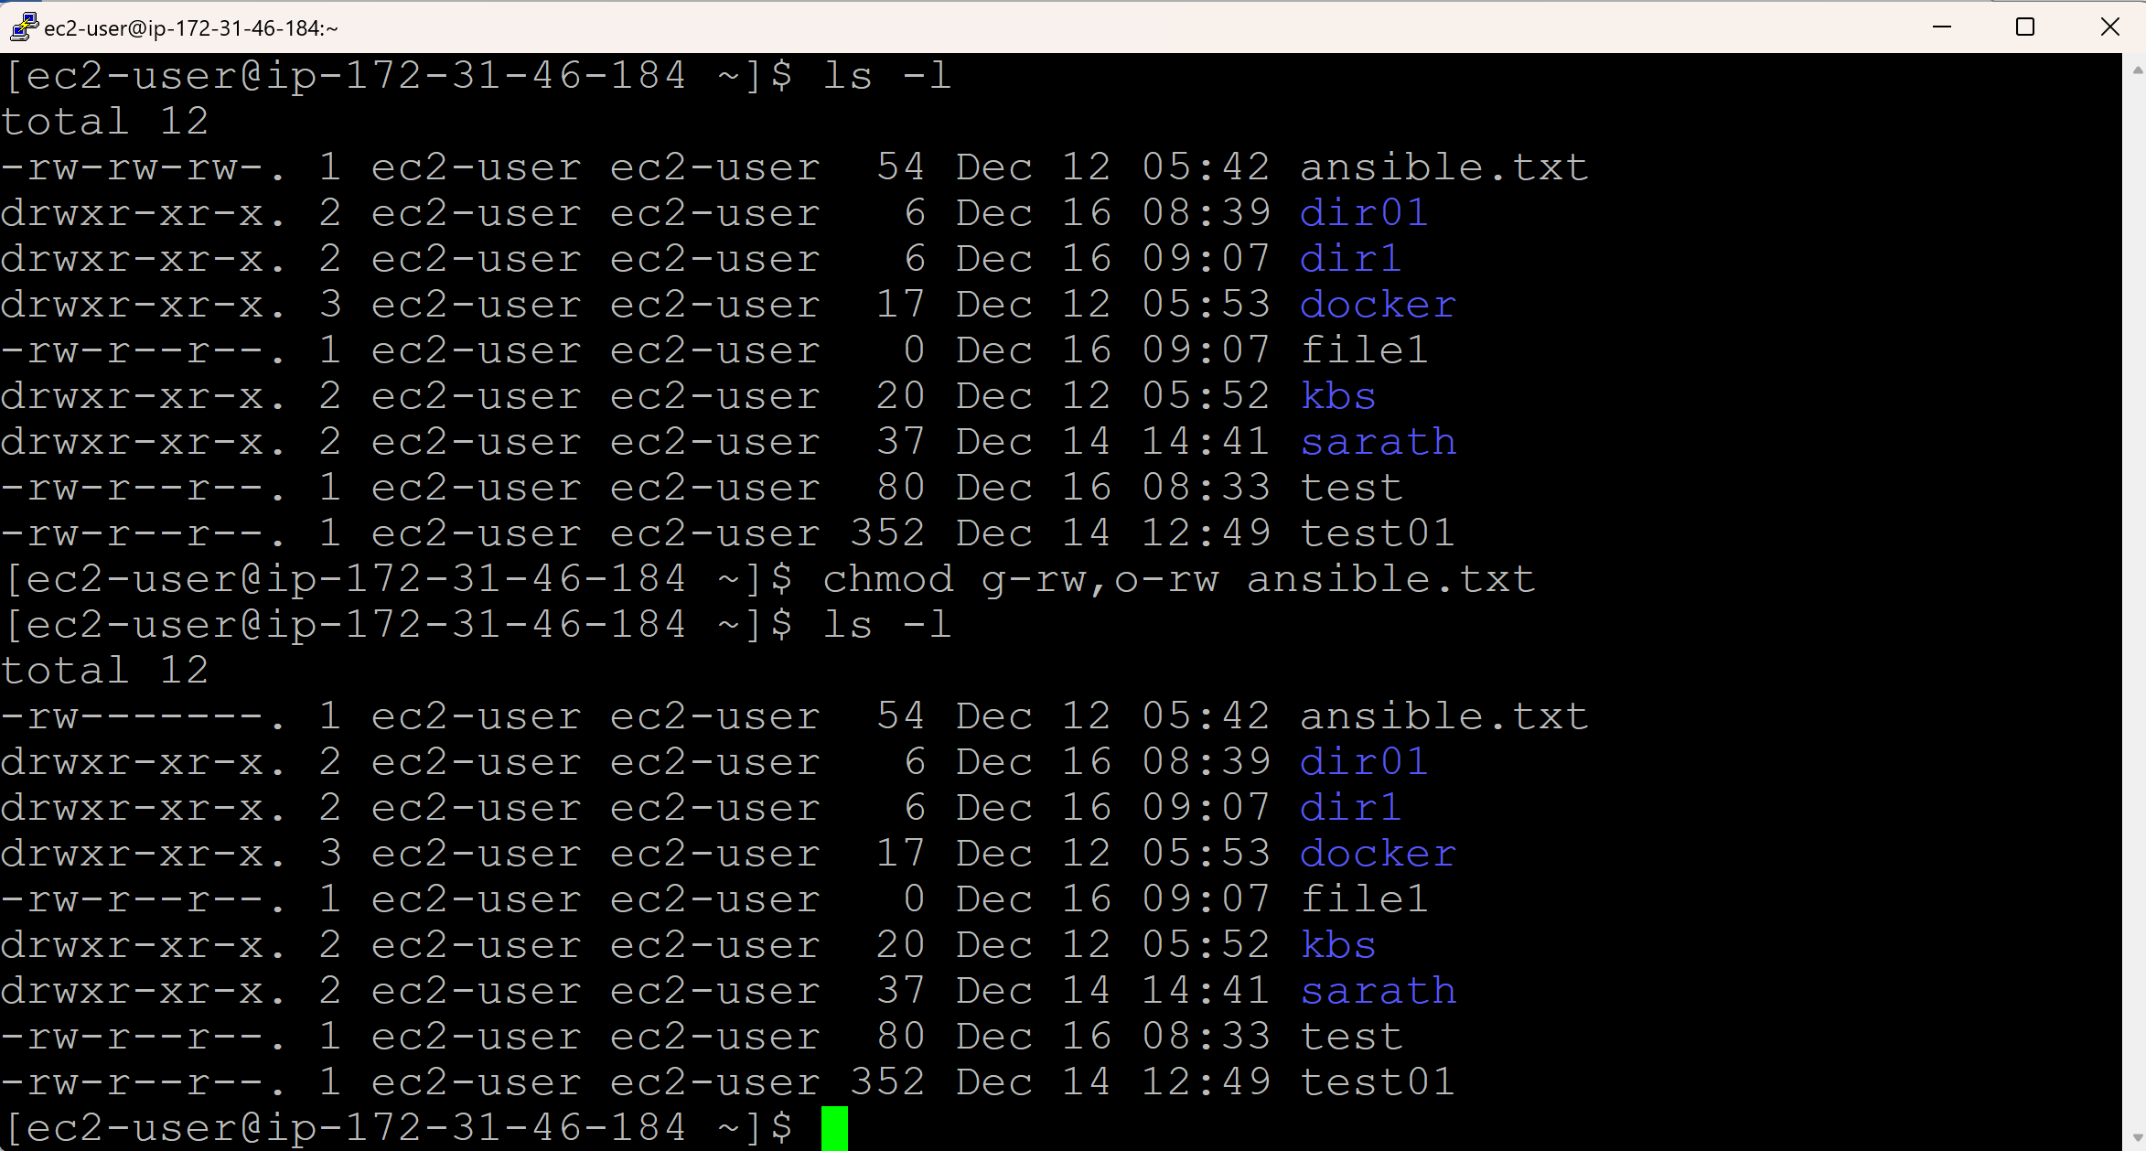

**User - Full Permissions (rw), Group – Full Permissions (rw), Other - Full Permissions (rw)**

**chmod g+rw,o+rw <filename>**

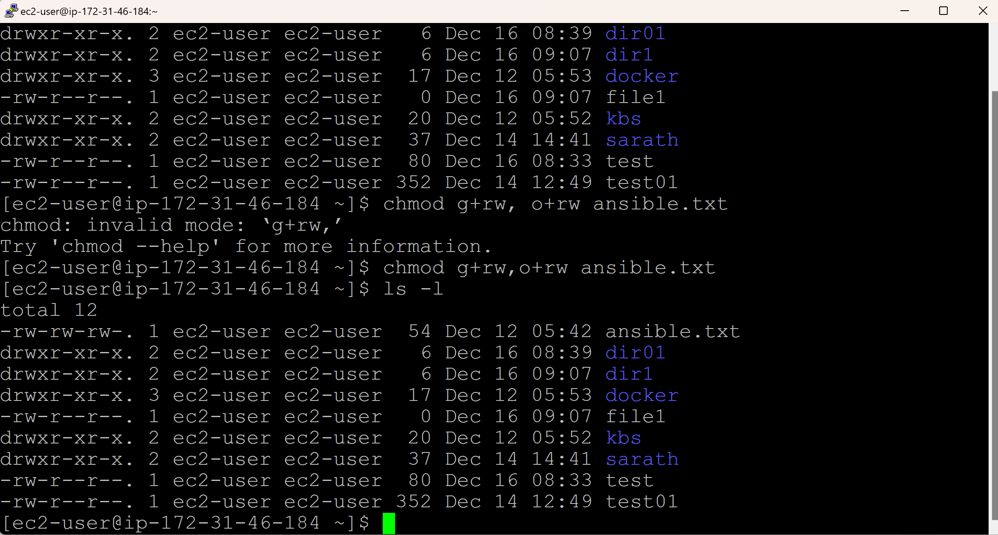

**Changing back to default permissions for a file:**

**chmod g-w,o-w <filename>**

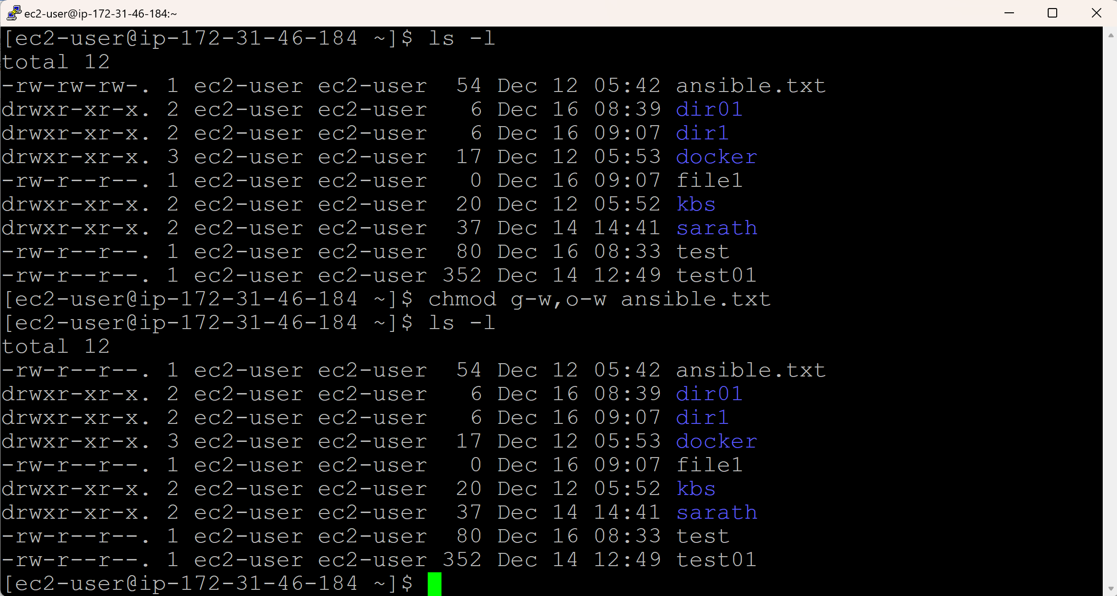

**Changing the permissions of a directory:**

User – Full Permissions (rwx), Group – Full Permissions (rwx), Other - Full Permissions (rwx)

**chmod g+w,o+w <directoryname>**

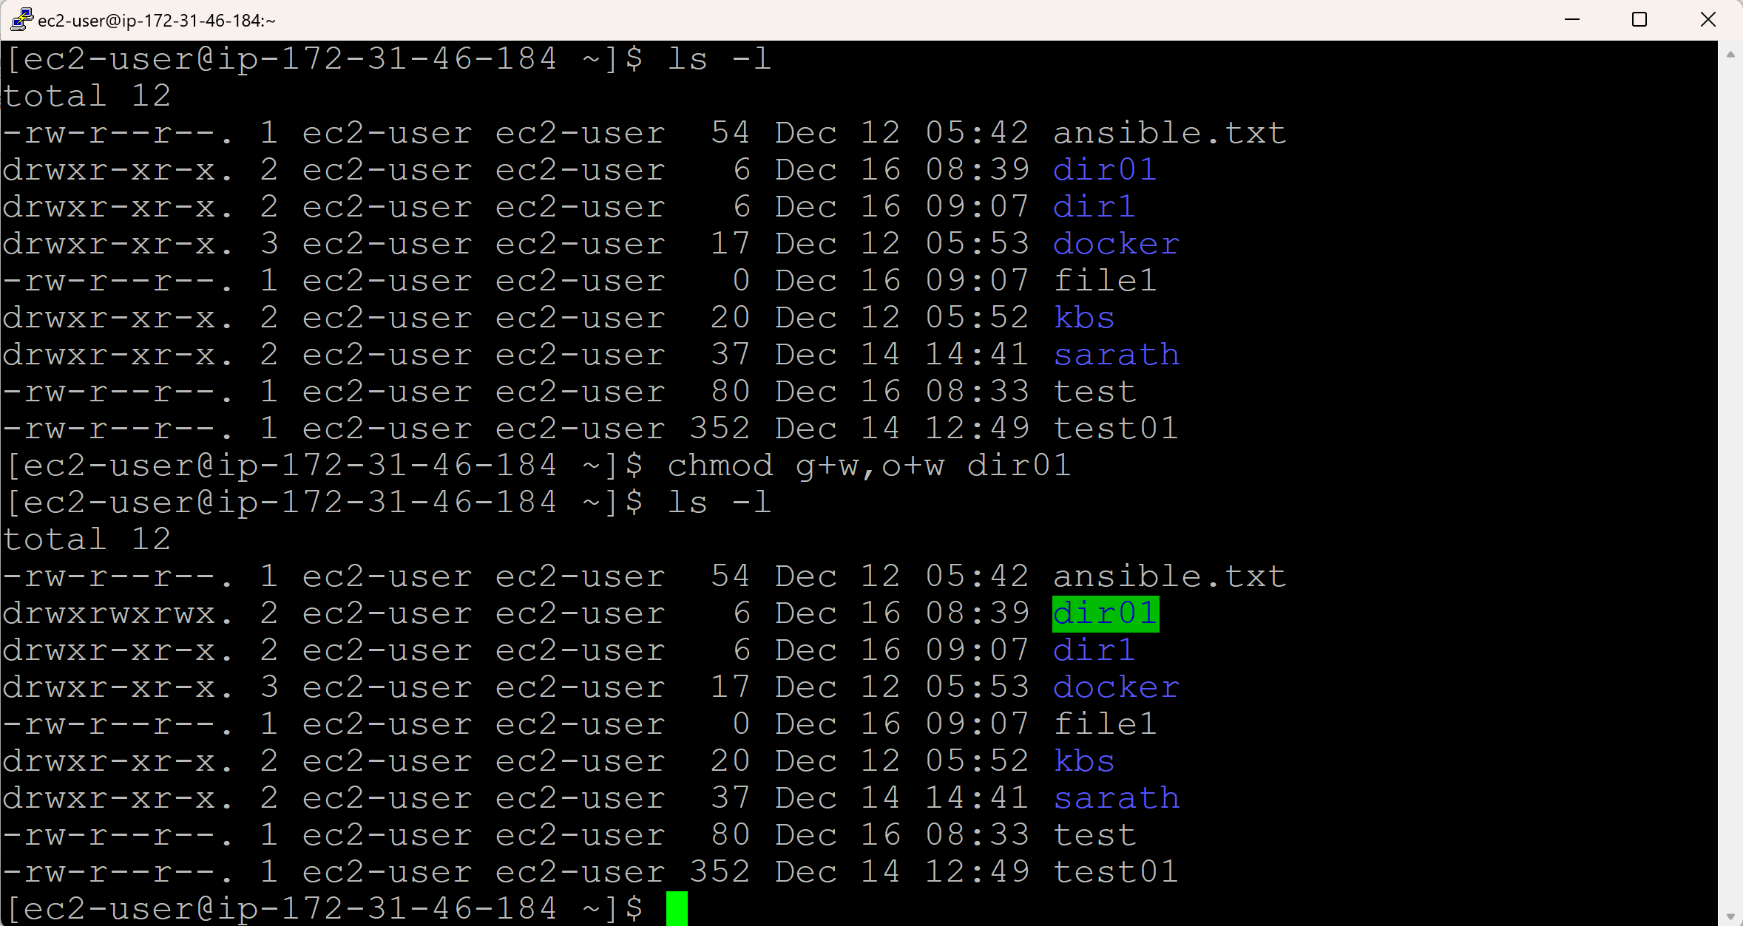

**Changing back to default permissions for a directory:**

**chmod g-w,o-w <directoryname>**

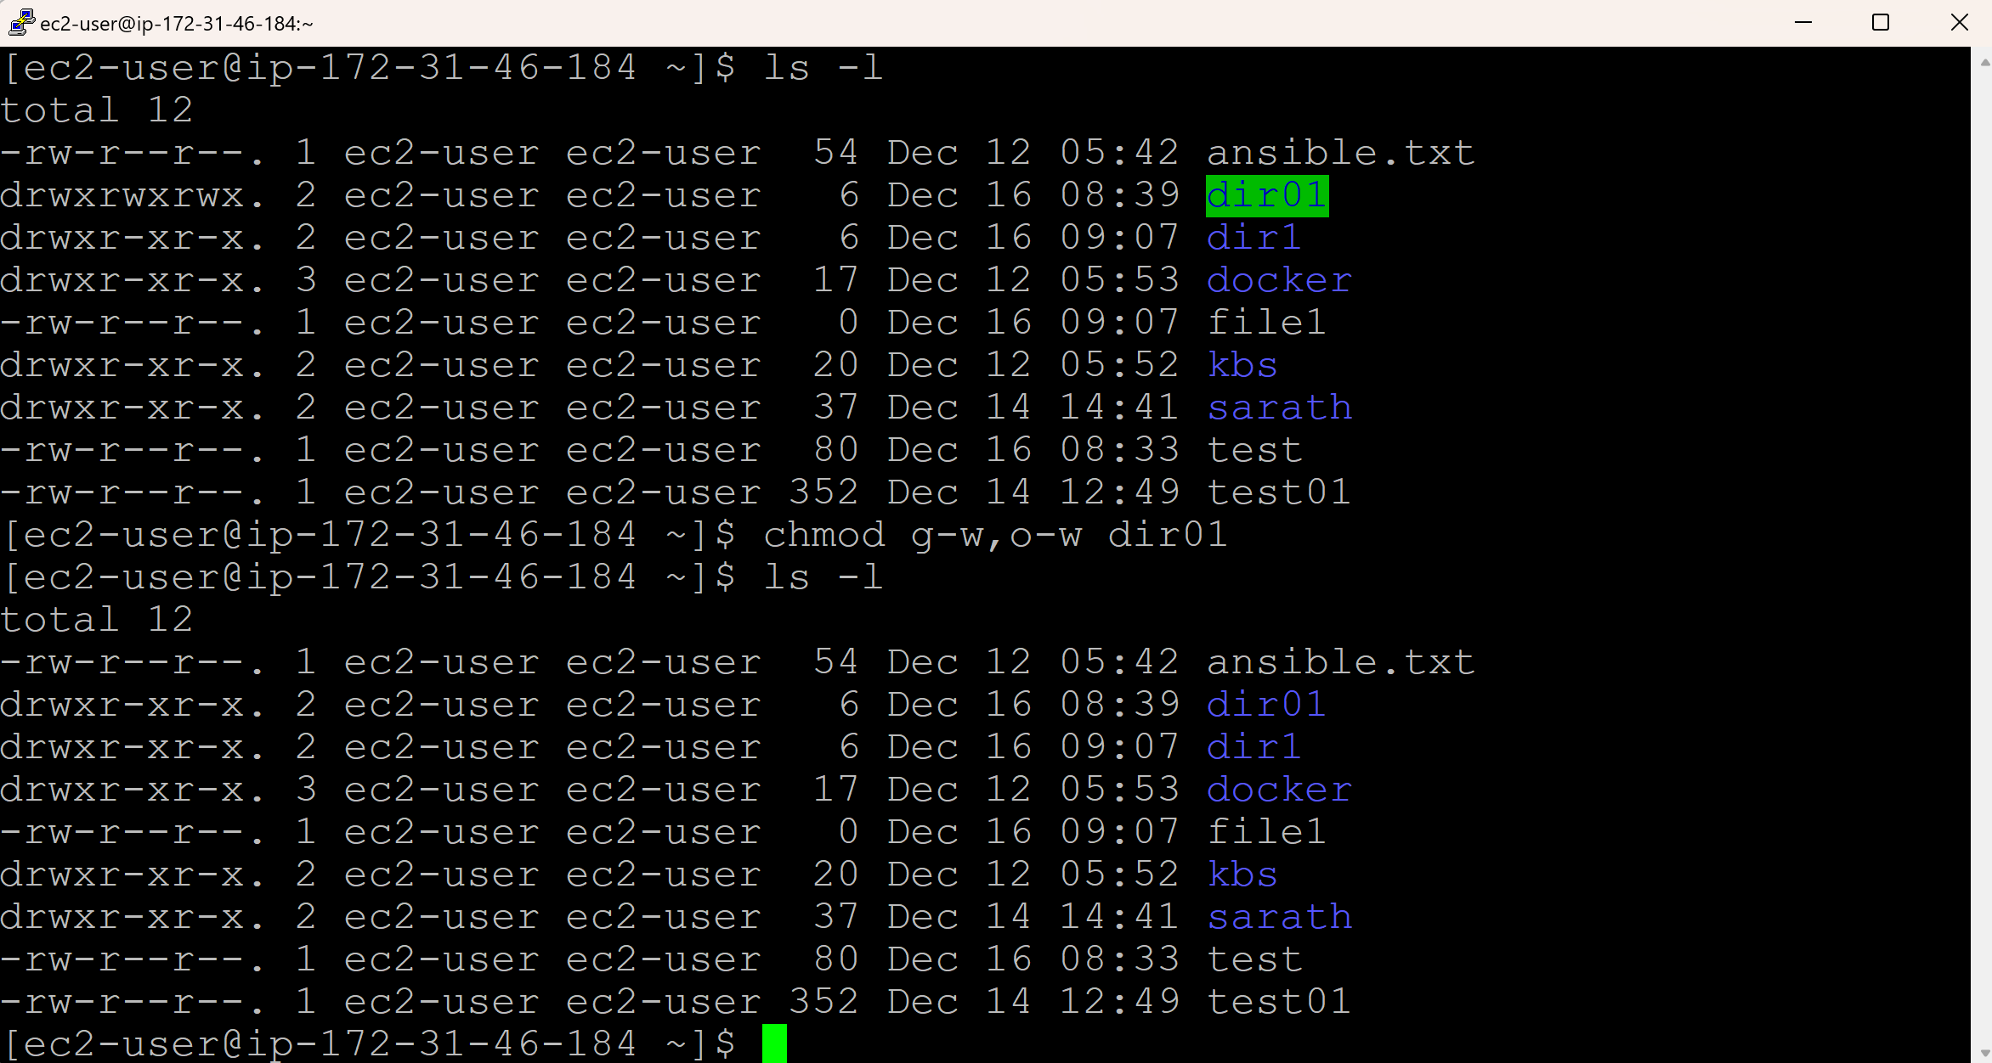

**Assignment:**

There is directory called “Photos” and it contains ten files: file01 to file10. Write a command to get full/all permissions to all the files in directory without opening each and every file.

1. Create a directory: mkdir Photos

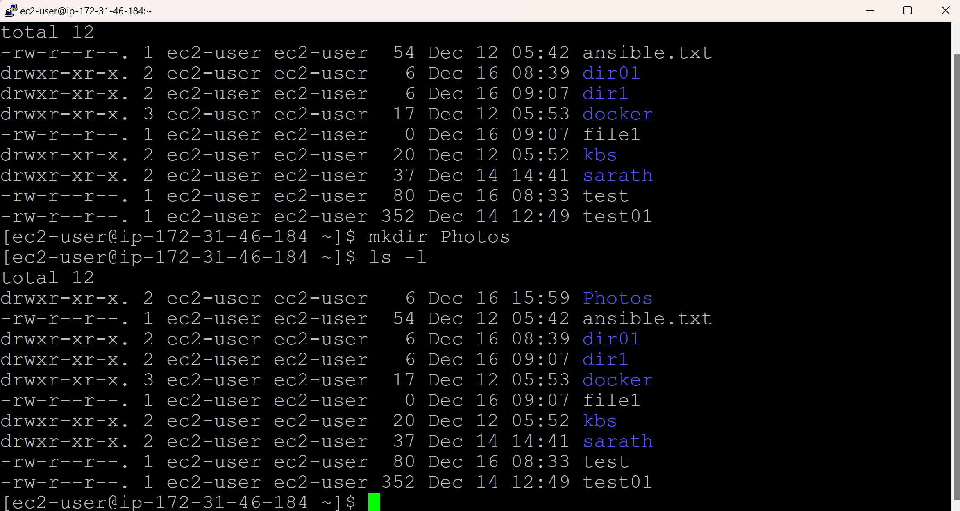

1. Change directory to Photos: cd Photos

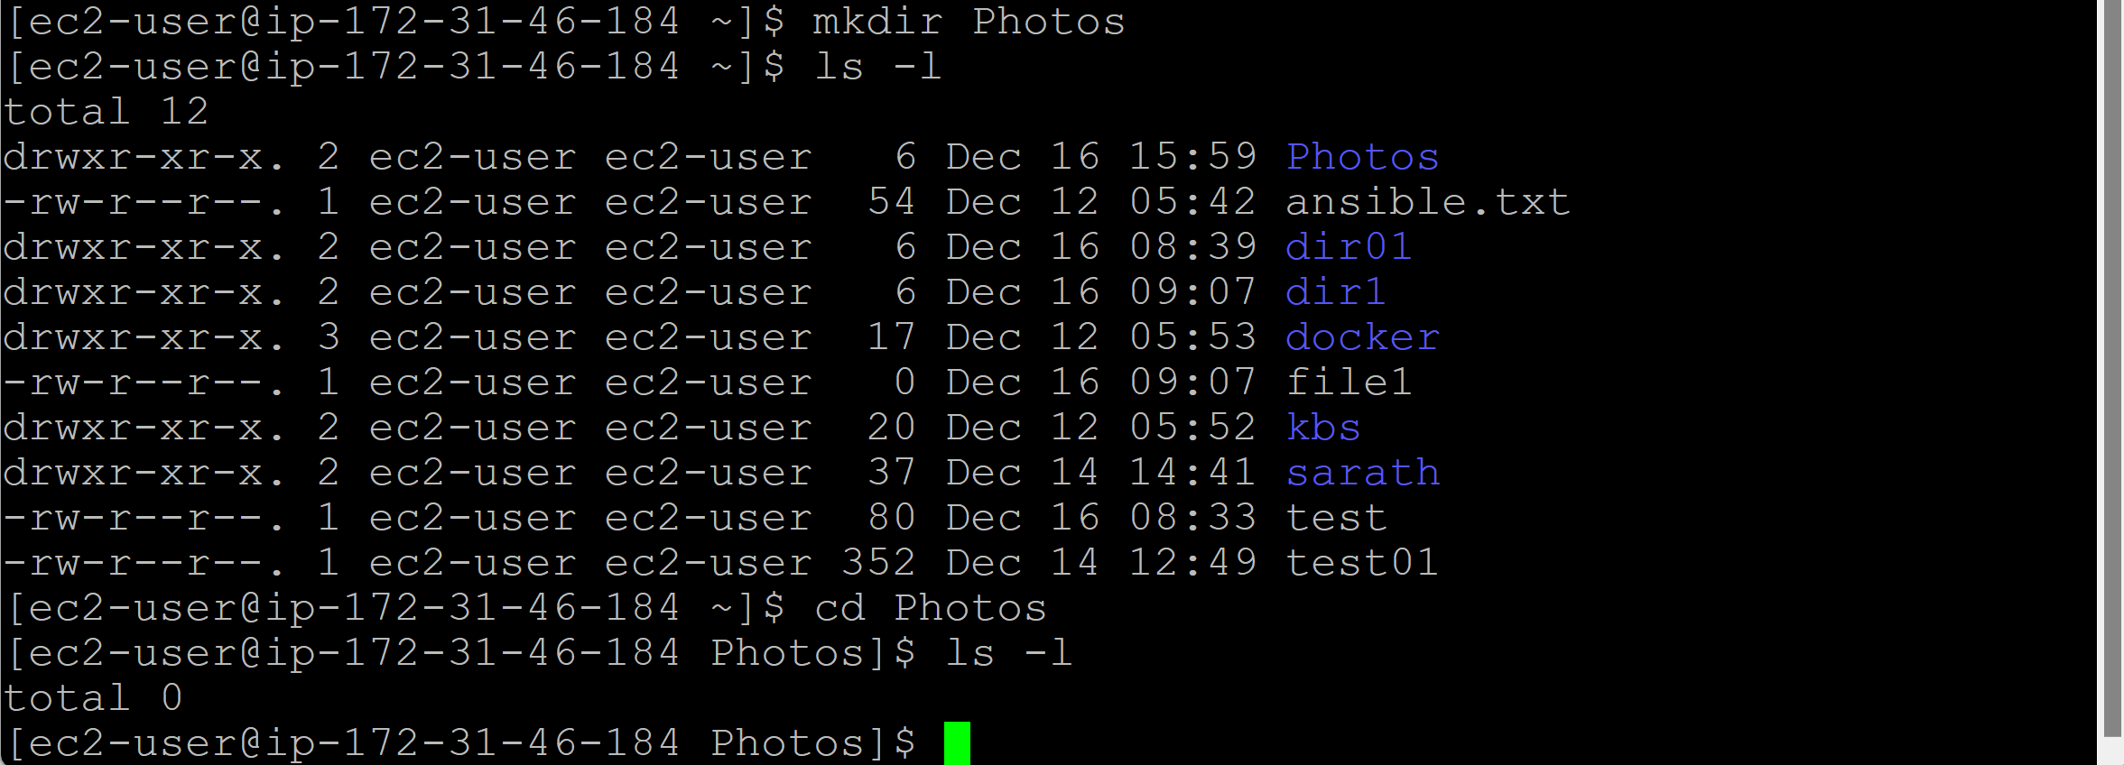

1. Create 10 files: touch Photos{01..10}

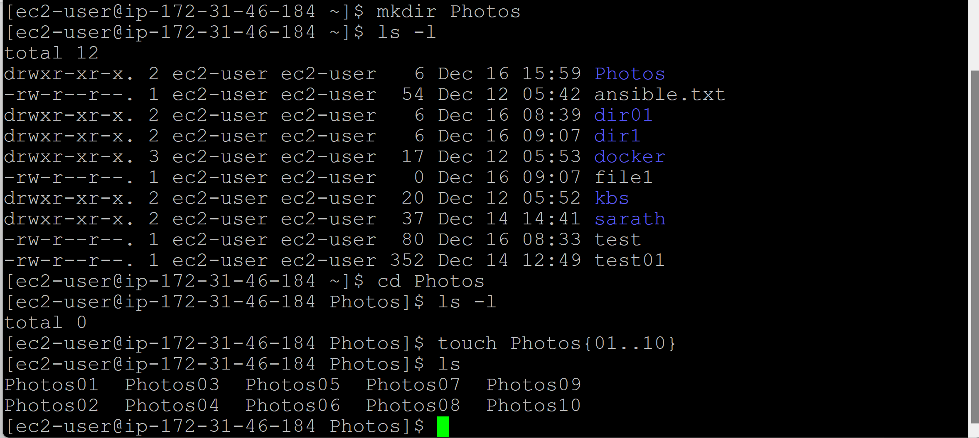

1. Come back to the original directory: cd ..
2. Now apply full permissions to the directory: chmod -R 777 Photos

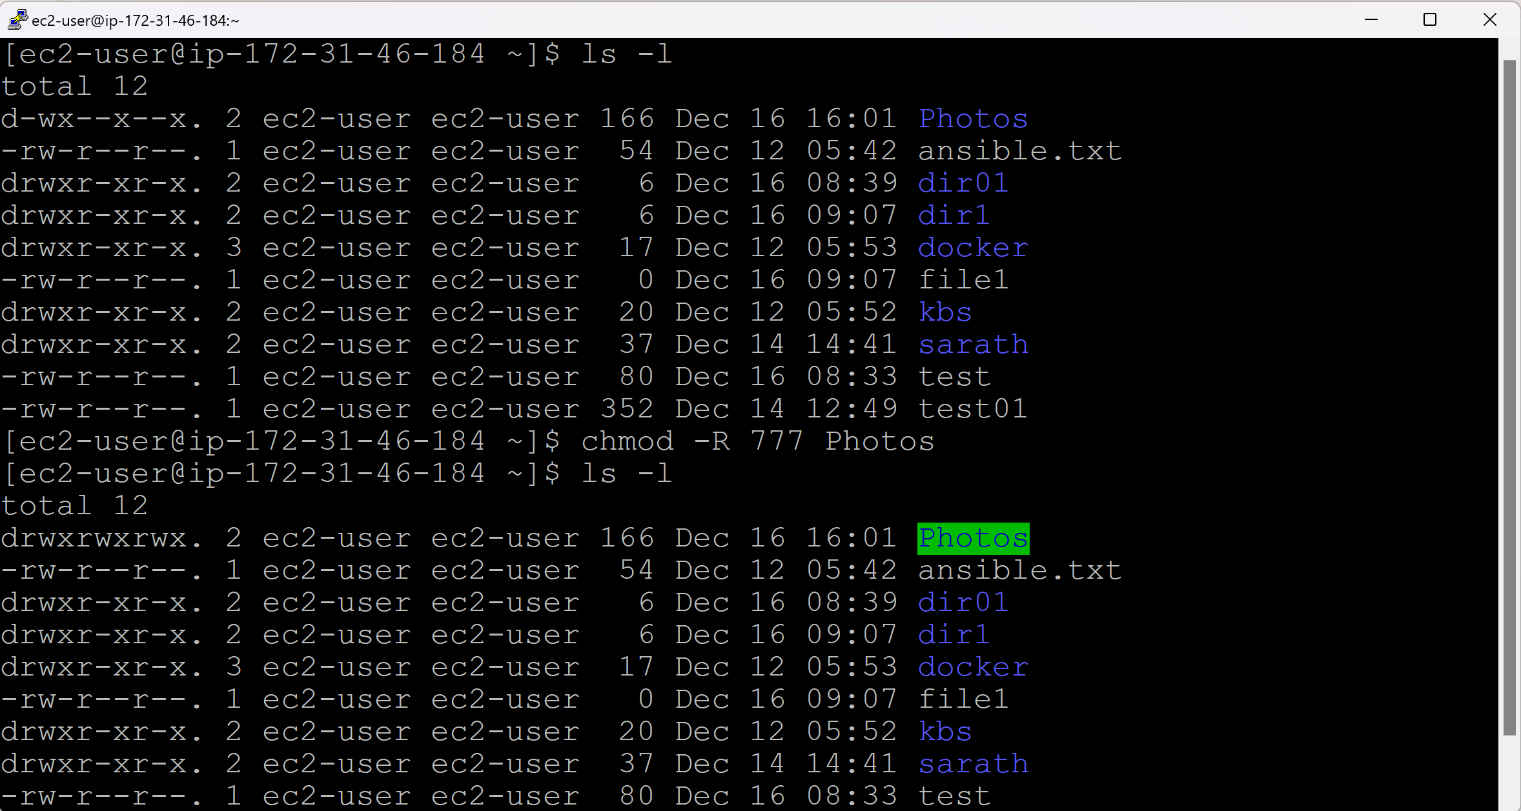

1. Change the directory to Photos: cd Photos
2. Verify for the full permissions of the files: ls -l

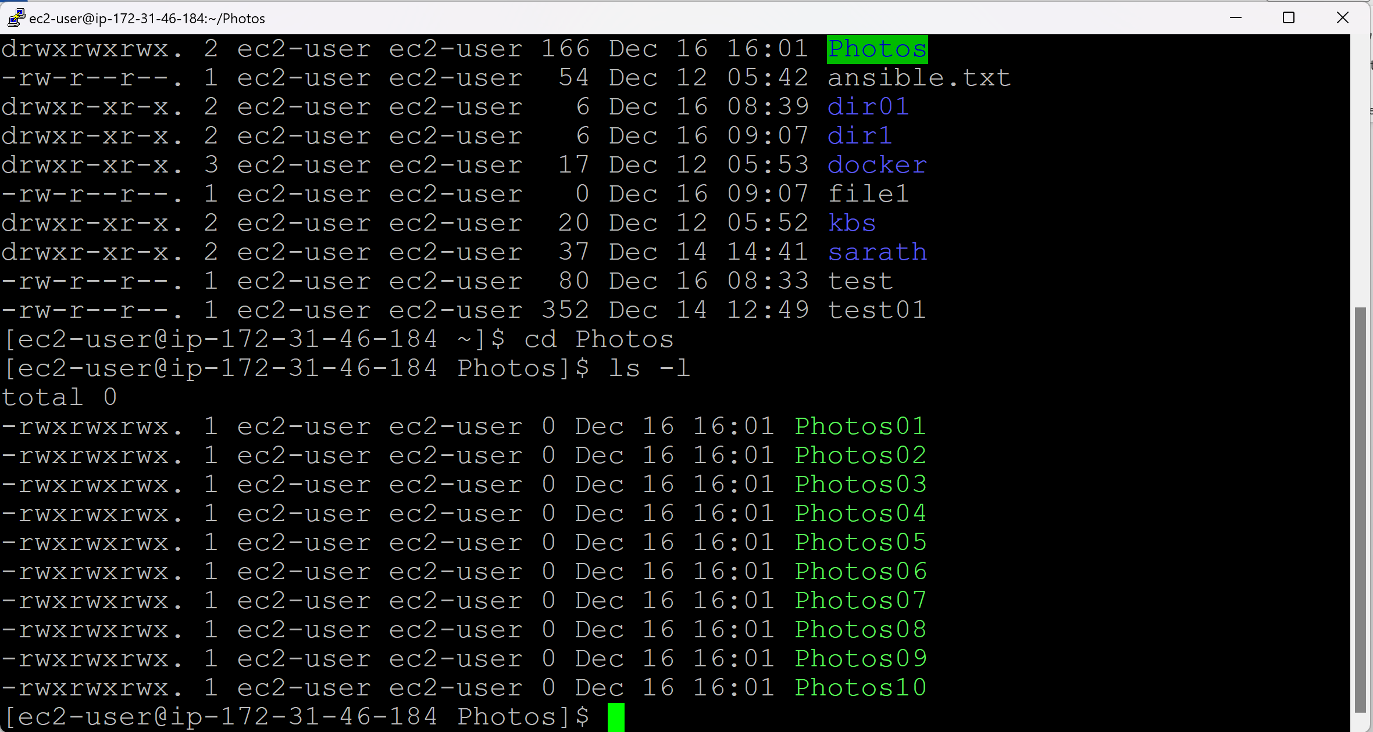

**Day 13 (find)**

* File command is used to search and locate the list of files and directories based on conditions.
* Conditions are like:
  + Perm (e.g., find the full permissions file, read only file)
  + Type (e.g., find the files only, do not search for directories)
  + Date (e.g., find the files that are modified in last 30 days)
  + Size (e.g., find the files less than 10MB size)

**Syntax:** find <path> -name <filename> -conditions(like Type or size or mtime or ctime)

Assume that we have a file with name findsarath in /opt directory and we don’t know where exactly the file is located.

find / -name findsarath

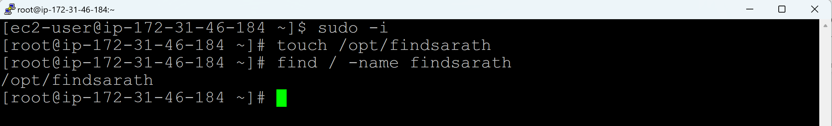

And if you are not sure whether filesarath is a file or a directory

find / -name findsarath -type d (d refers to directory)

find / -name findsarath -type f (f refers to file)

/ refers to entire location like a C drive in Windows

. refers to current location.

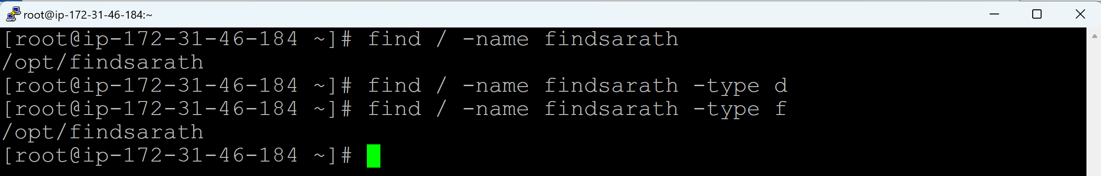

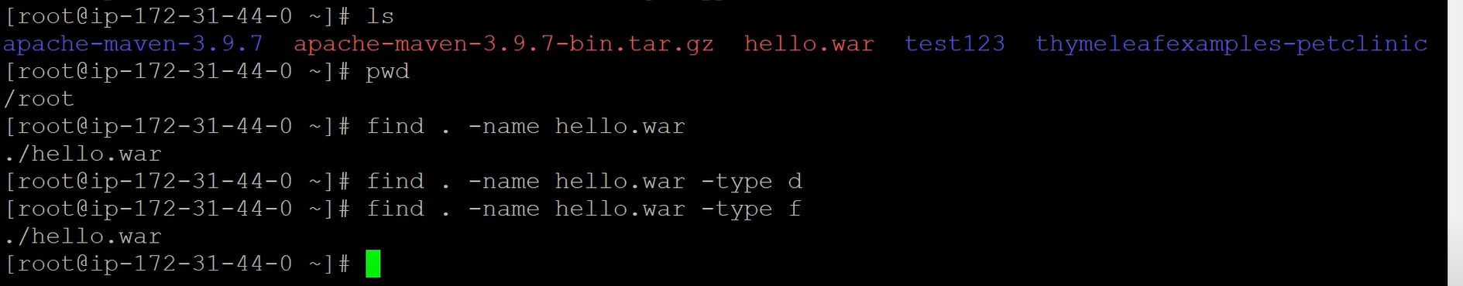

**Real time scenario 1:**

In real time, multiple tmp files will be created randomly. In this case, file extension (.tmp) is same.

Display all the files end with .tmp or .war or .log

find / -type f -name “*.war”

find / -type f -iname “*.war” (i refers to igonre casesensitive)

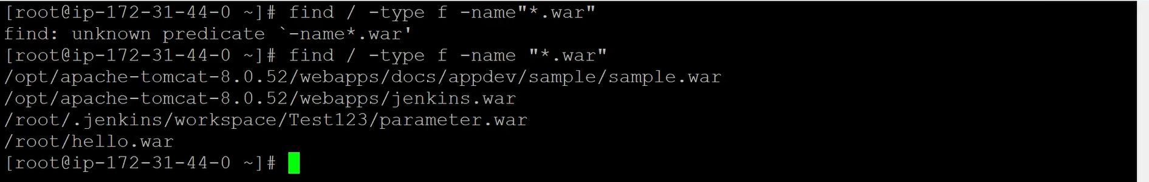

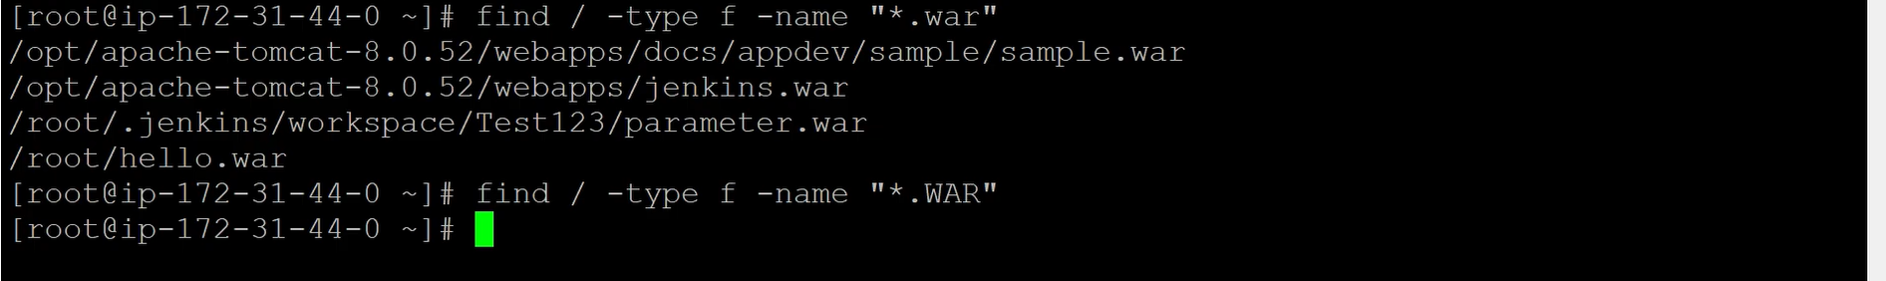

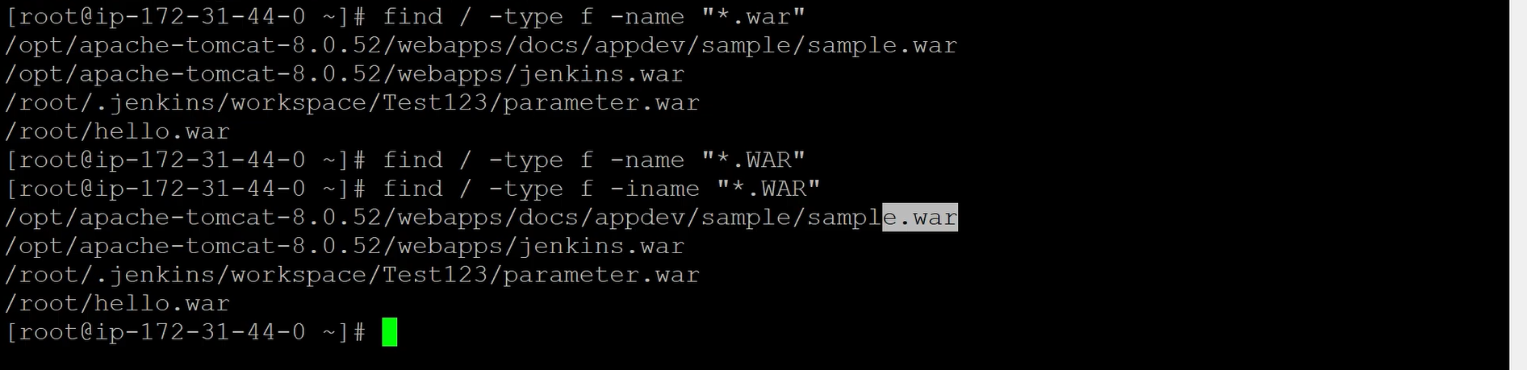

**Real time scenario 2:**

When we are using one application, some empty files will be created randomly.

Display all the empty files.

find /opt -type f -empty

(or) find . -type f -empty

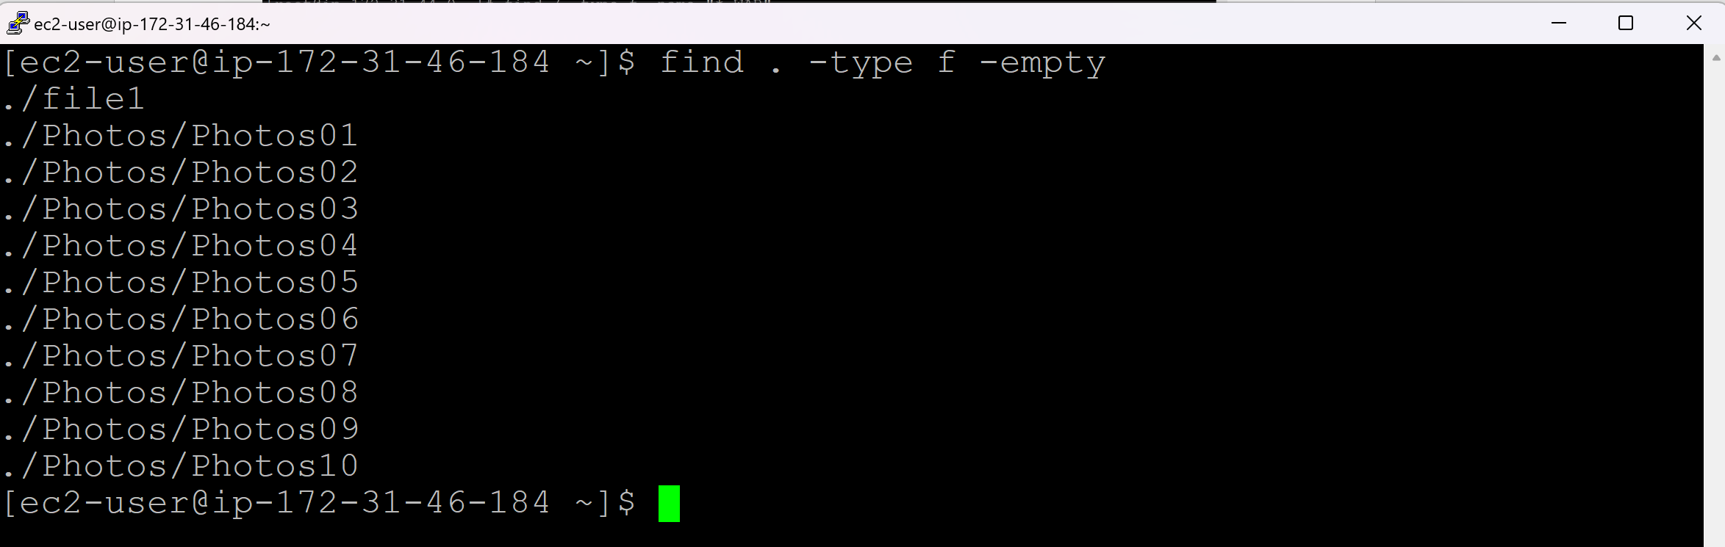

Remove the empty files:

find . -type f -empty | rm -r *

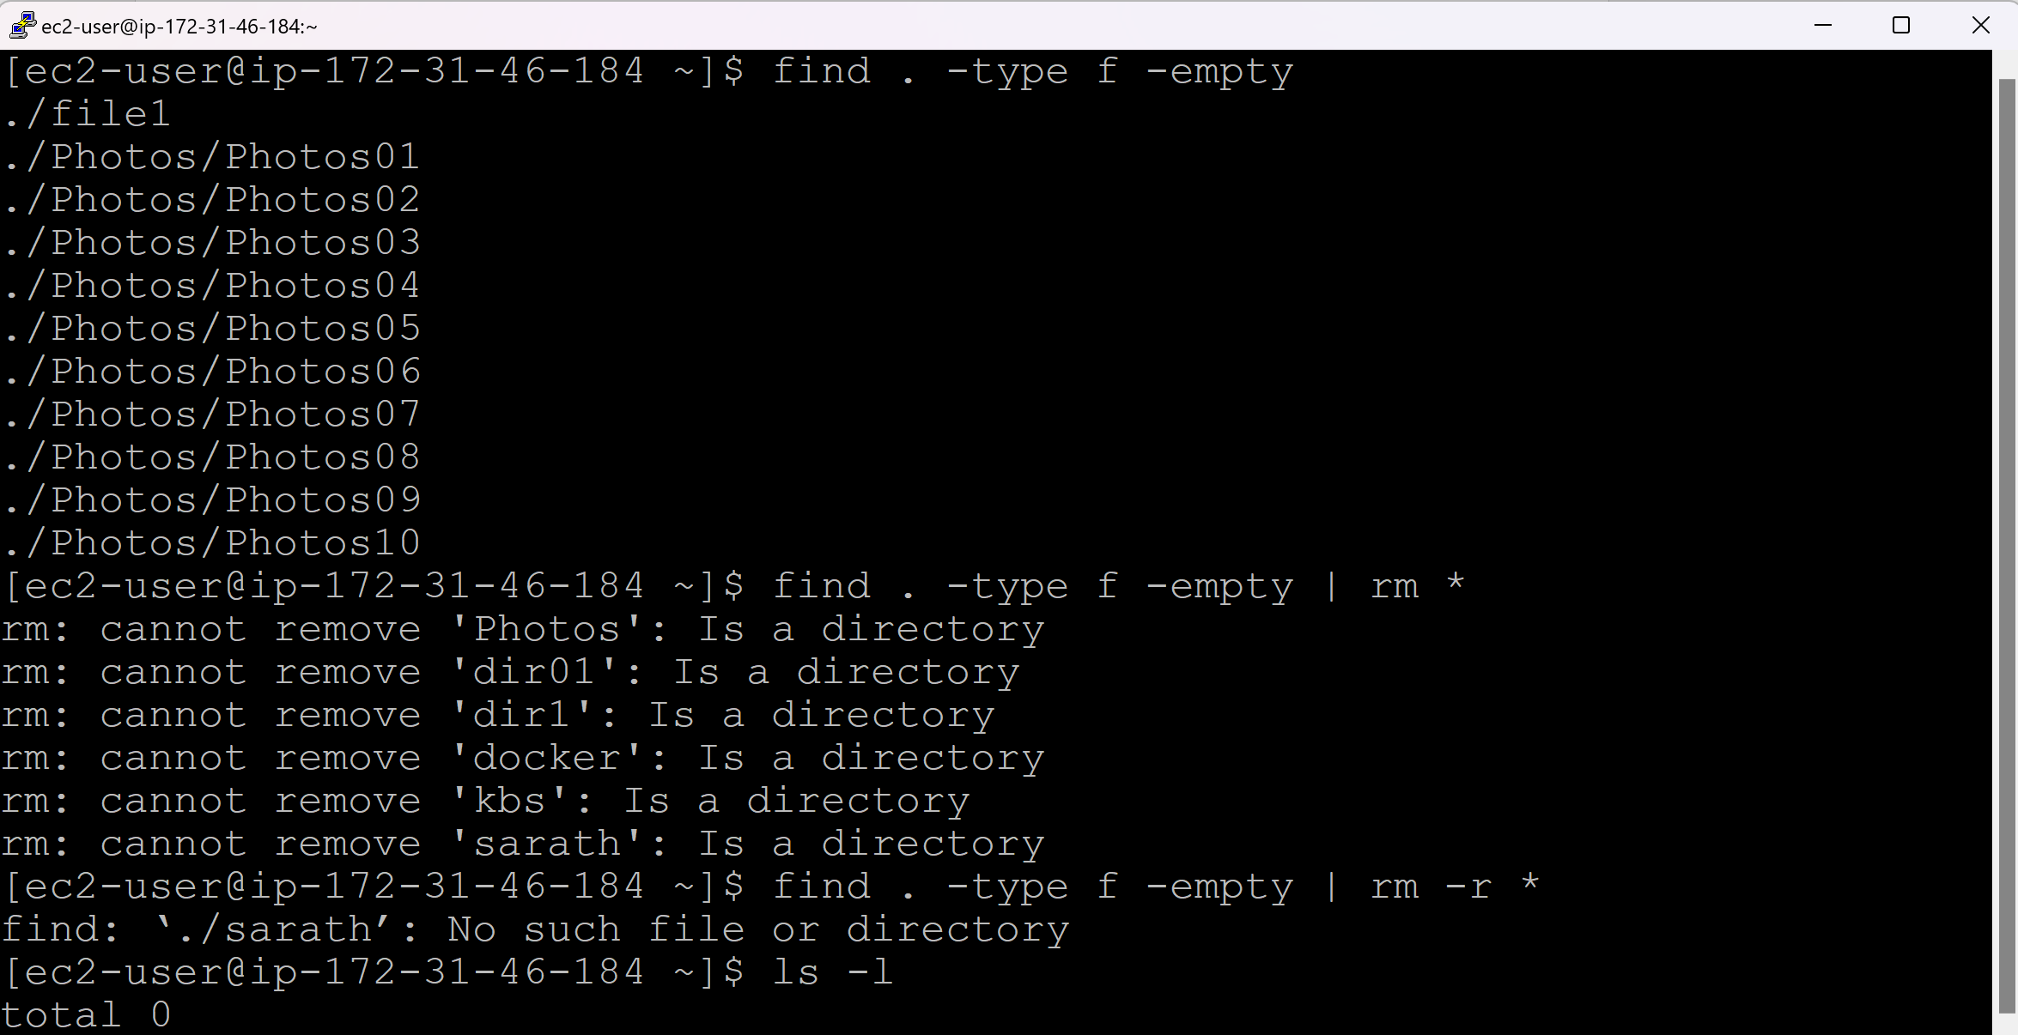

**Perm:**

find . -type d -perm 755

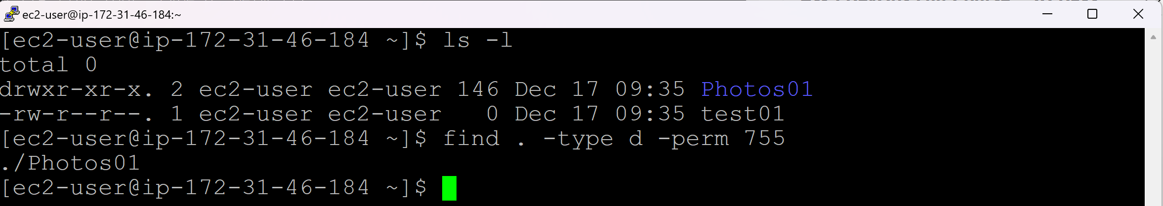

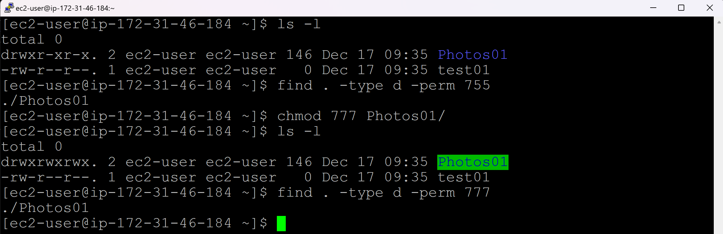

find .type d ! -perm 777 (Display the directories other than full permissions)

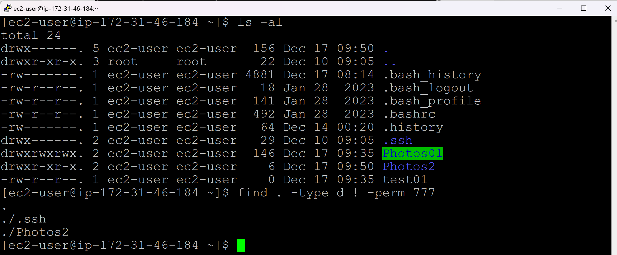

**Size:**

find . -size 0M (Display 0MB size files)

find . -size +50M (Display more than 50MB size files)

find . -size +10M -size -100M (Display more than 10MB and less than 100MB size files)

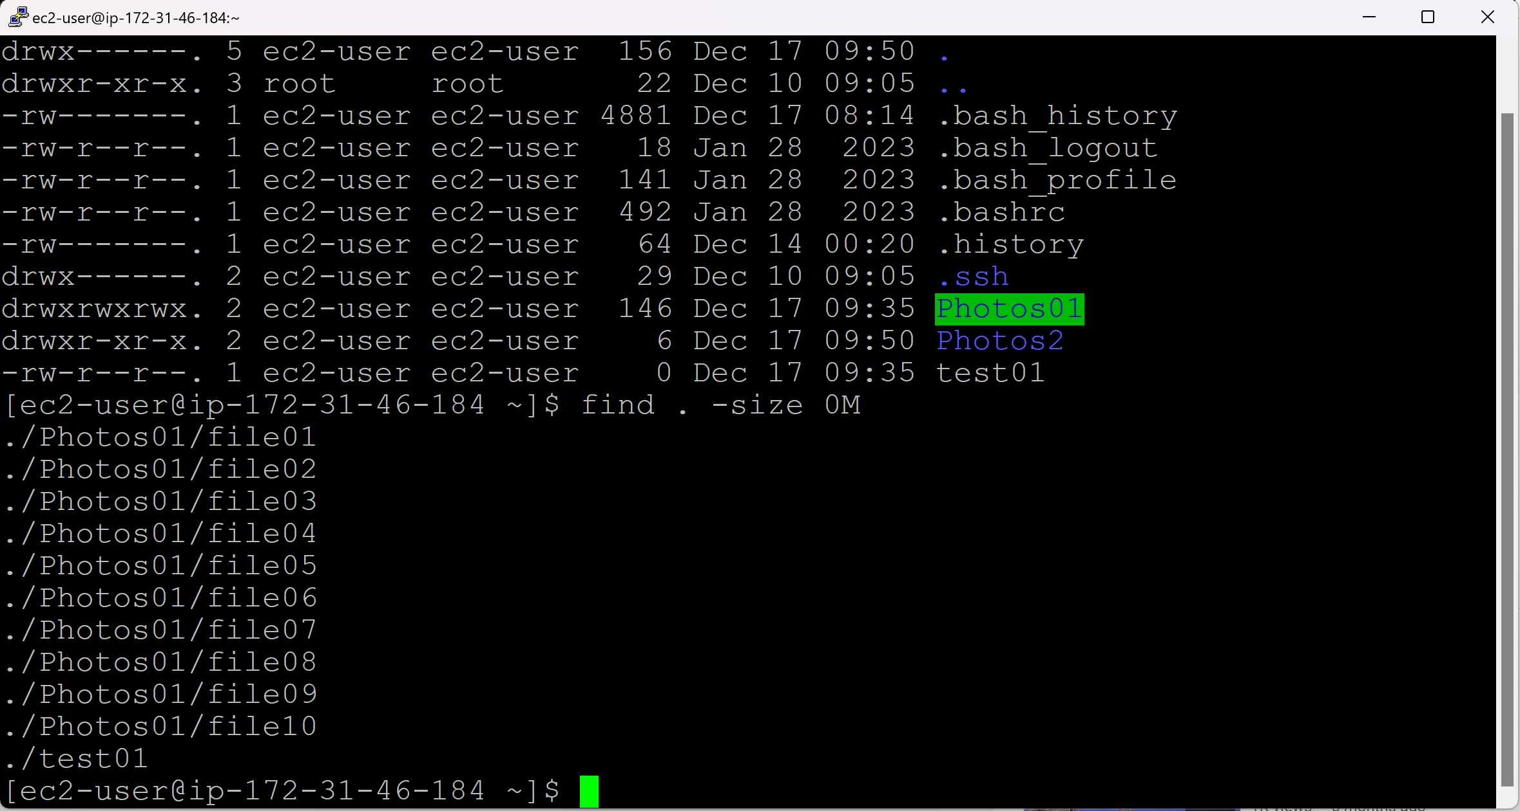

**Time:**

find / -mtime -7 (Display the files which are modified in last 7 days)

find . -mmin -30 (Display the filles which are modified in last 30 mins)

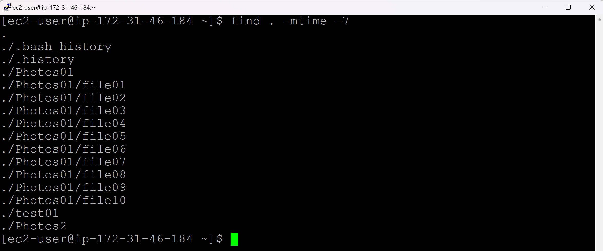

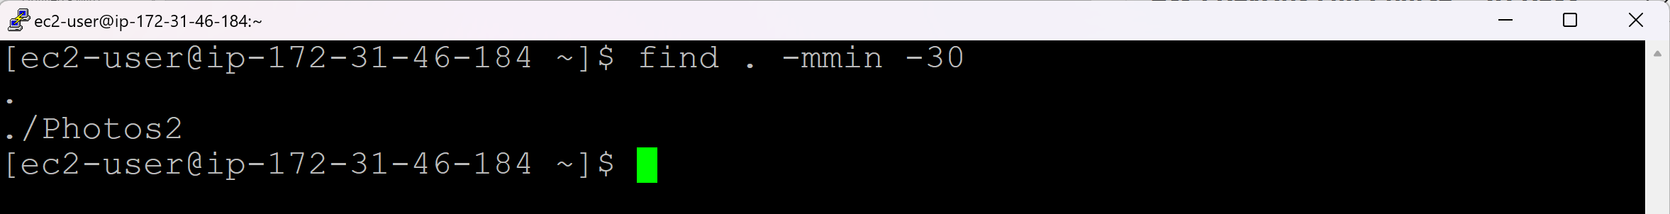

**Remove the files:**

find / -name vtech.txt -type f -print -exec rm -rf {} \;

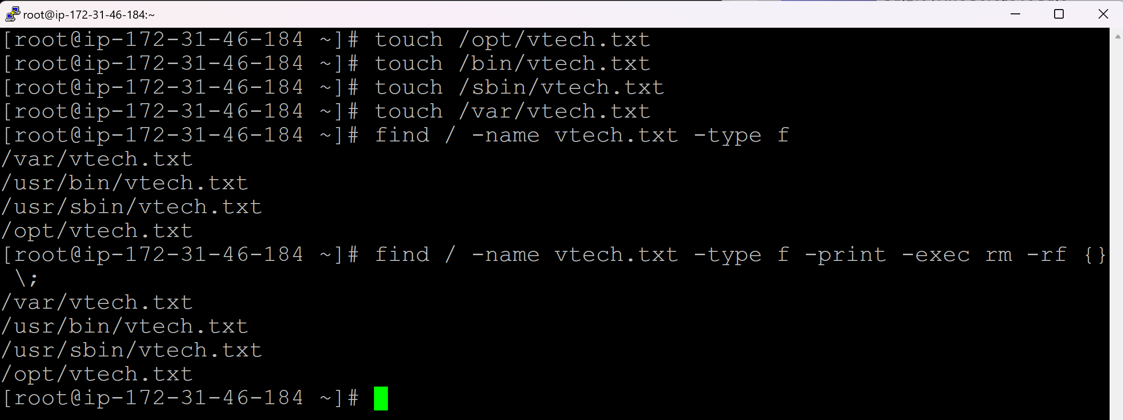

**find /**:

* Start searching from the root directory (/).
* This means it will search **all directories and subdirectories** on the system.

**-name vtech.txt**:

* Look for files with the exact name vtech.txt.
* This is case-sensitive. If you need case-insensitivity, use -iname instead.

**-type f**:

* Limits the search to **files only** (f stands for files).
* It ensures directories or other file types (like symbolic links) are not considered.

**-print**:

* Prints the full path of each file found.
* Useful to see which files are matched before deletion.

**-exec rm -rf {} \;**:

* -exec: Allows running a command (rm in this case) on each file found.
* rm -rf {}:
  + rm: Remove files.
  + -r: Recursive removal (useful if directories are accidentally matched, though -type f avoids this here).
  + -f: Force removal without prompting for confirmation.
  + {}: Placeholder for each file found by find.
* \;: Terminates the -exec command.

**Day 15 (Service & Crontab)**

**Service:**

* Service refers to background process.
* If we run any task or function, process will be generated.
* They are of 2 types:
  + Background
  + Front
* In Linux, we have default process / service always run in background: SSHD (Secure Shell Demon)
* When the Lunix server is started, SSHD service runs automatically.
* If SSHD service is stopped, then no one will be able to loing to Linux server.
* There are other services also available:
  + crond
  + httpd
  + mysqld
* The service command requires **superuser (root)** privileges to manage system services like crond.
* By default, the **ec2-user** in AWS does not have direct root privileges but can execute commands with sudo.

sudo service sshd status (To check, if the service is running)

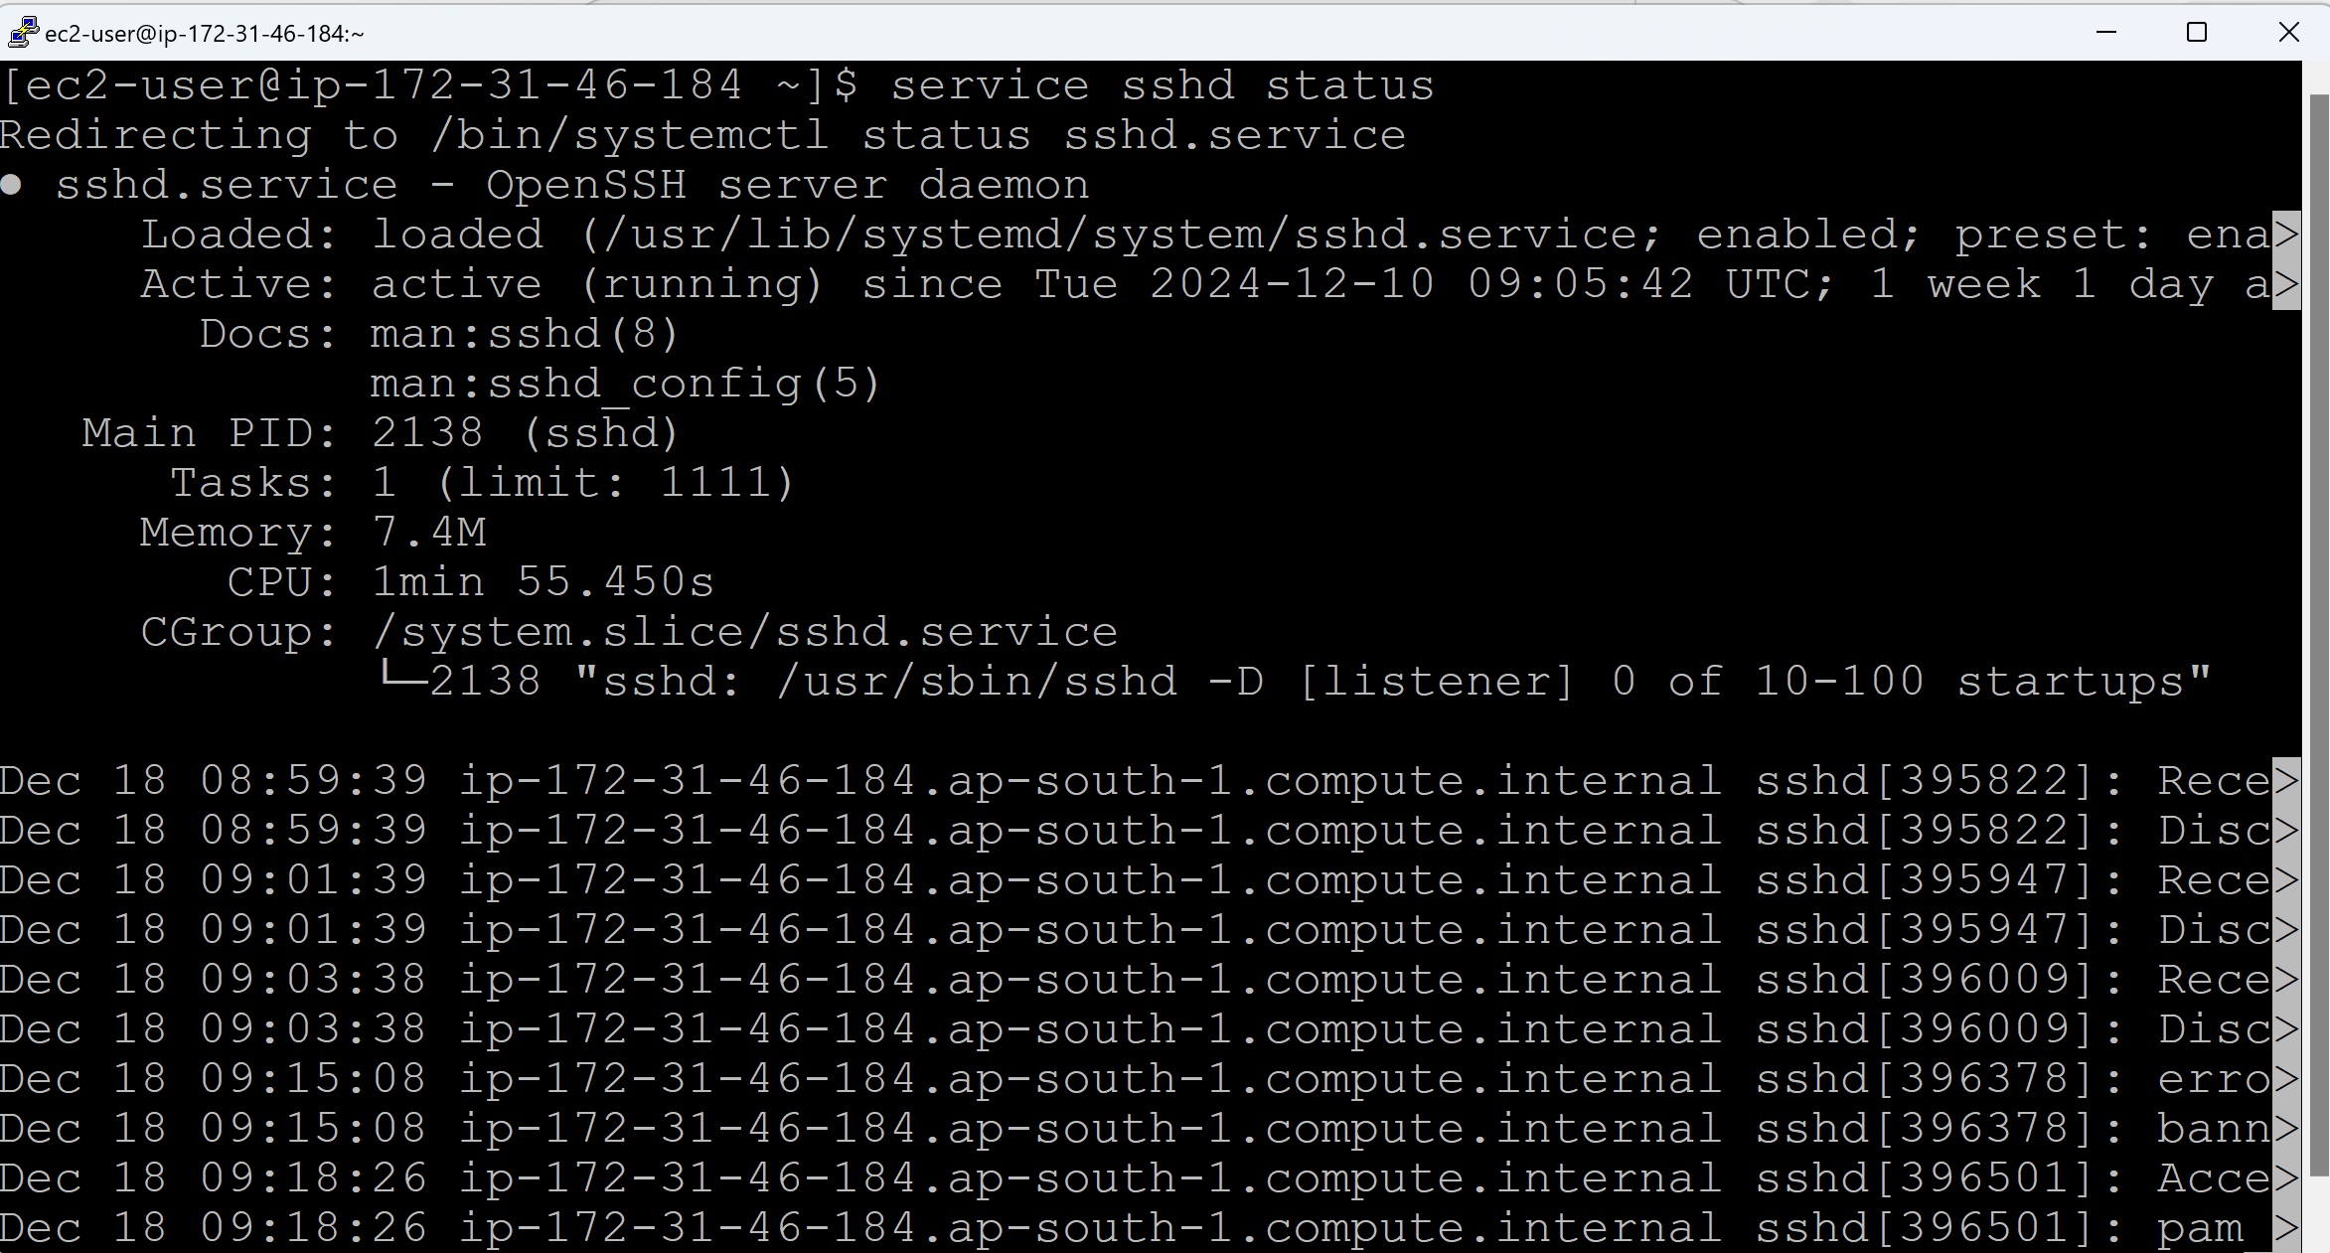

sudo service crond status (or) sudo systemctl status crond

sudo service crond stop (or) sudo systemctl stop crond

sudo service crond start (or) sudo systemctl start crond

If you want to restart any service, it should be in start/active status.

sudo service crond restart (or) sudo systemctl restart crond



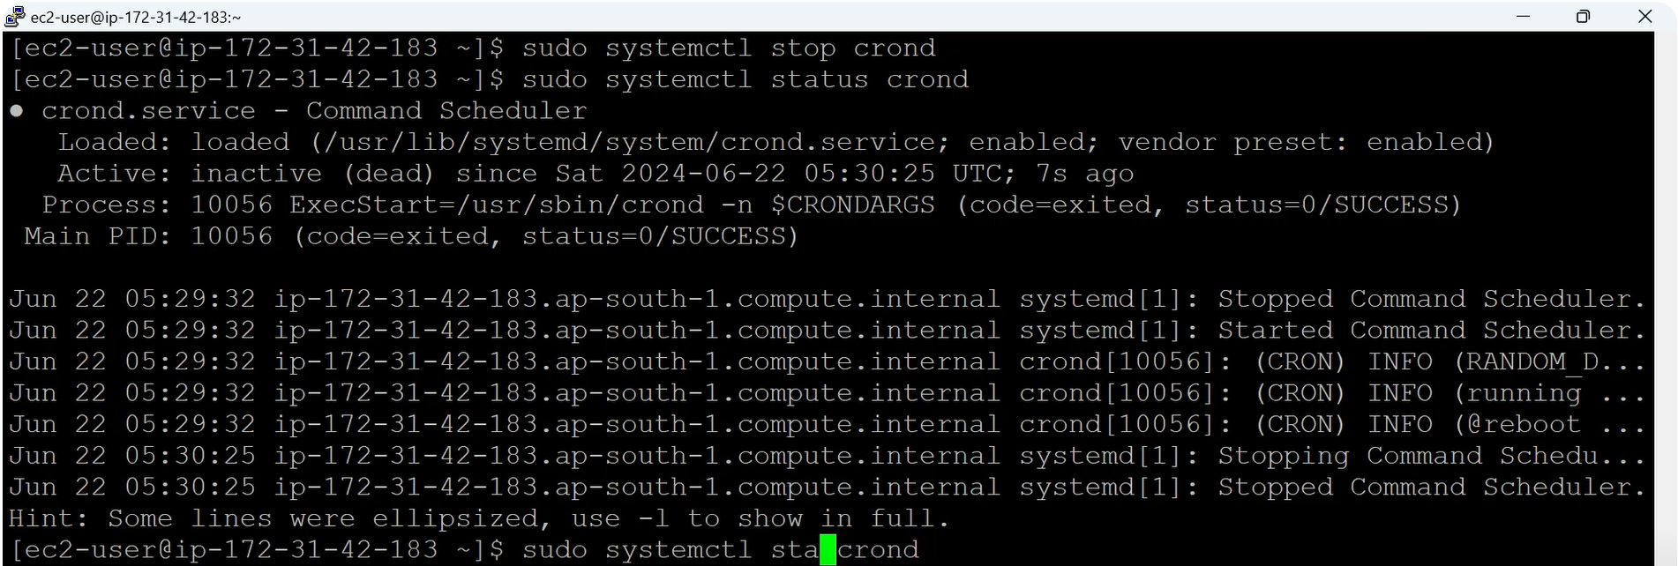

**Crontab:**

* Crontab is a schedular or alarm
* We have 5 stars in crontab
  + * => Minutes => 0-59
  + * => Hours => 0-23
  + * => Day of the month => 1-31
  + * => Month of the year => 1-12
  + * => Day of the Week => 0-6 (Sun – Sat)

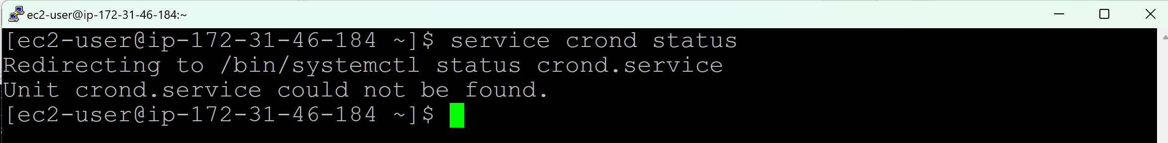

To install crond, use below command

yum install cronie -y

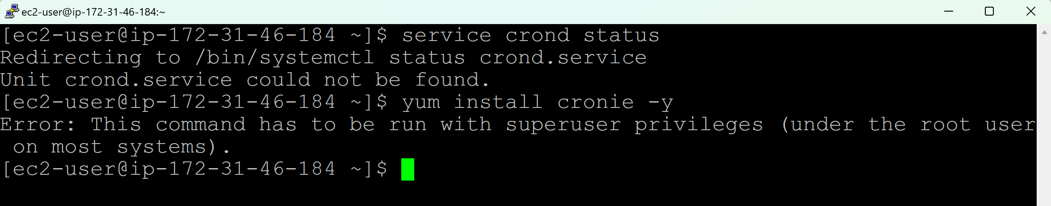

sudo yum install cronie -y

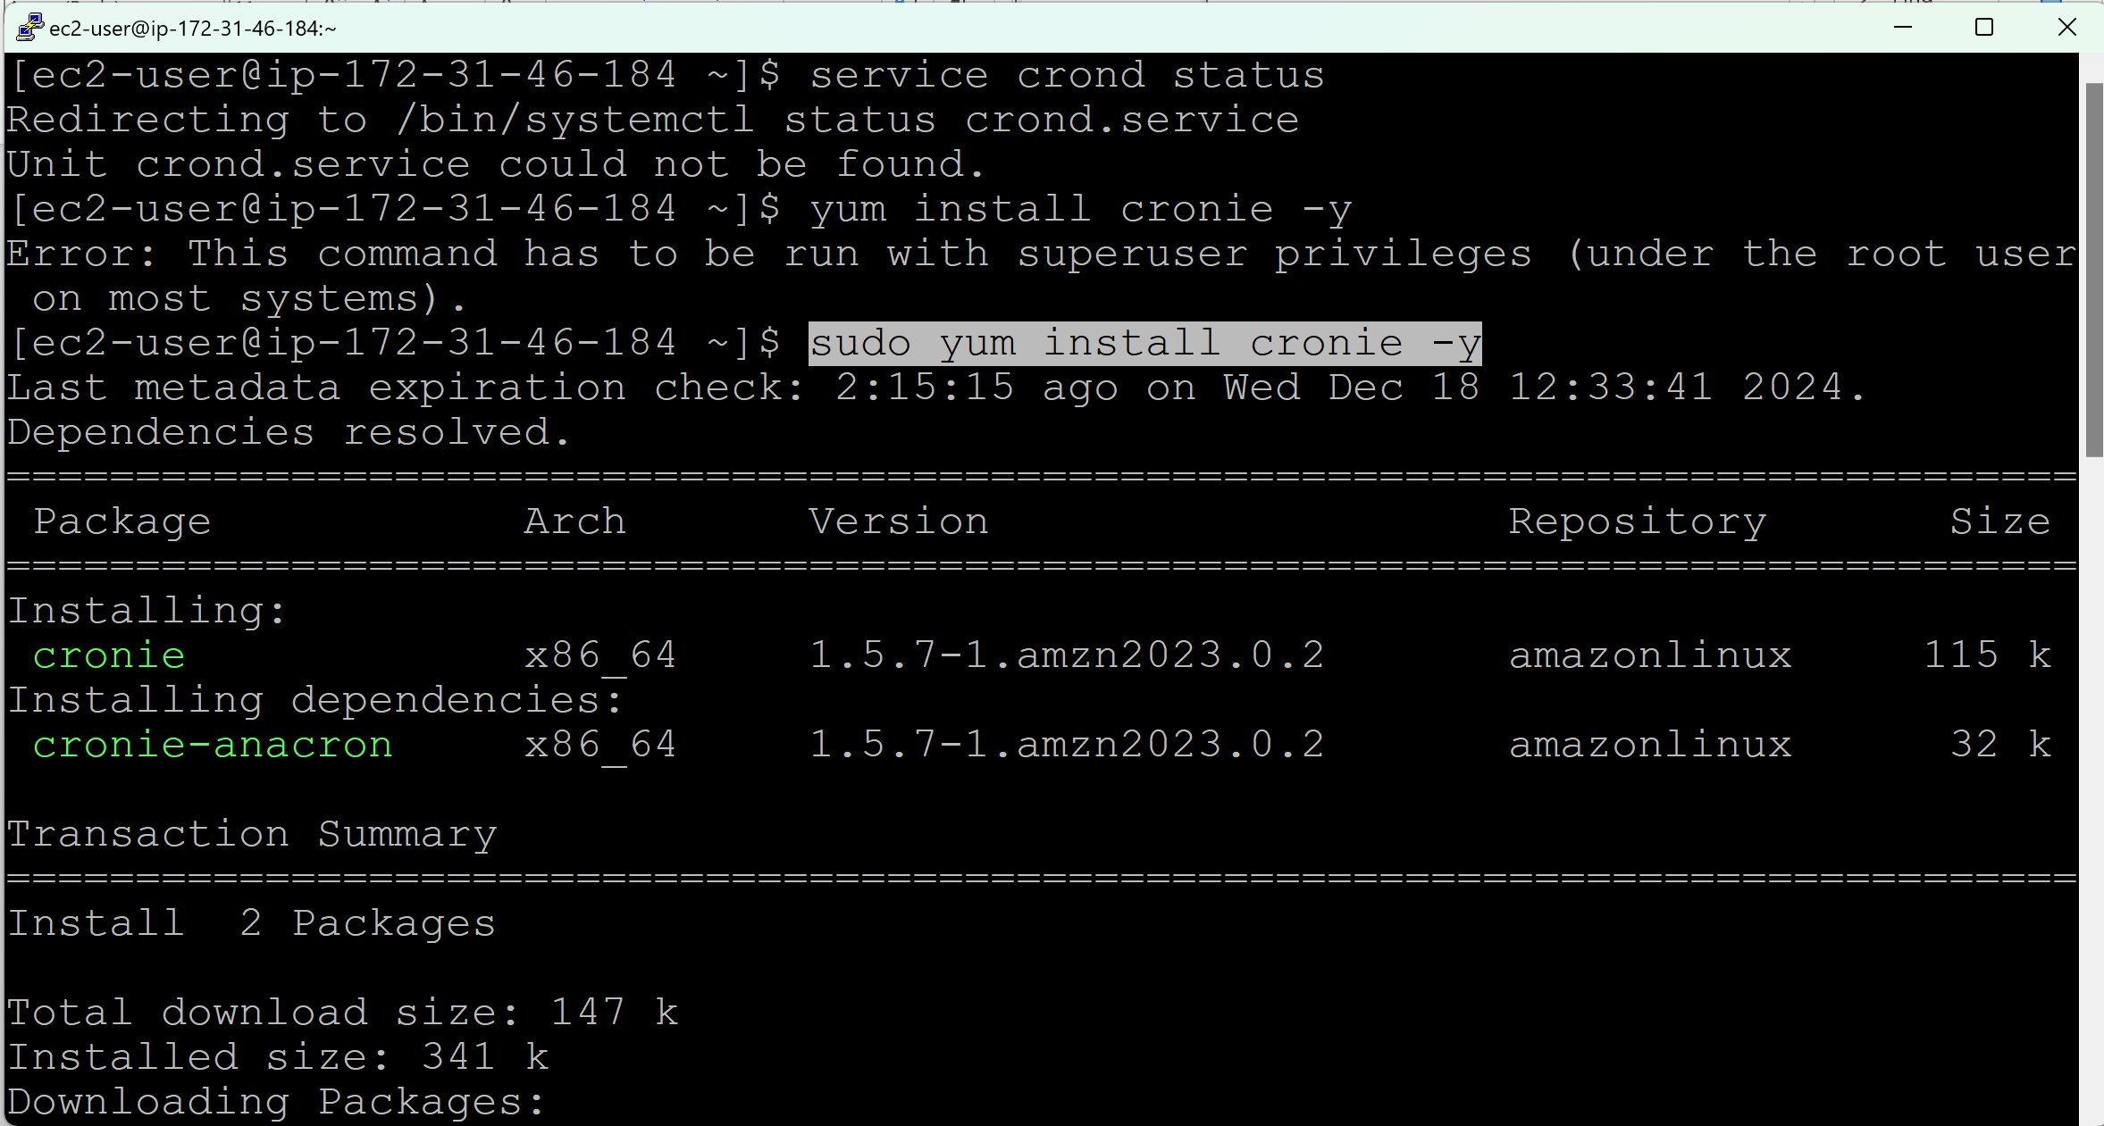

service crond status

sudo service crond start

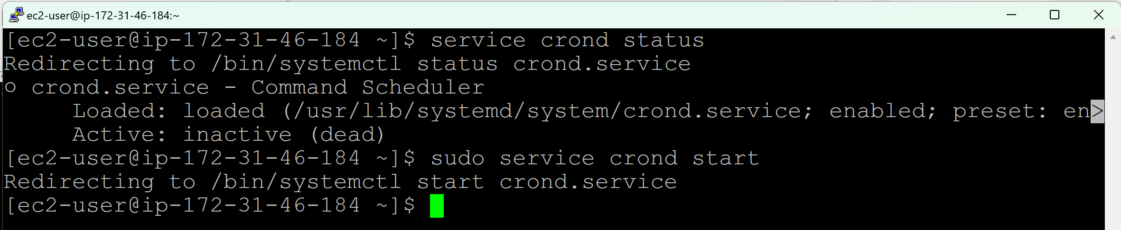

service crond status

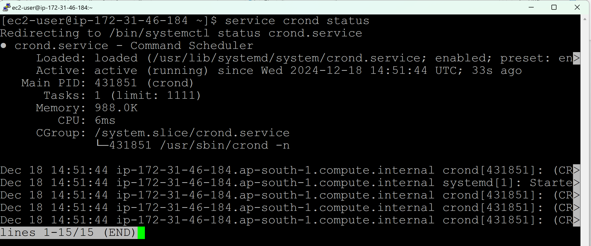

Check, if any crontab jobs are available for ec2-user or root user

crontab -l

sudo crontab -l

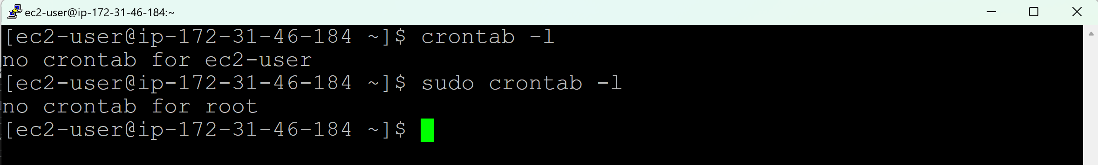

There are no cron jobs or crontab for ec2-user and root user.

**Create a cron job or crontab:**

crontab -e (e refers to edit)

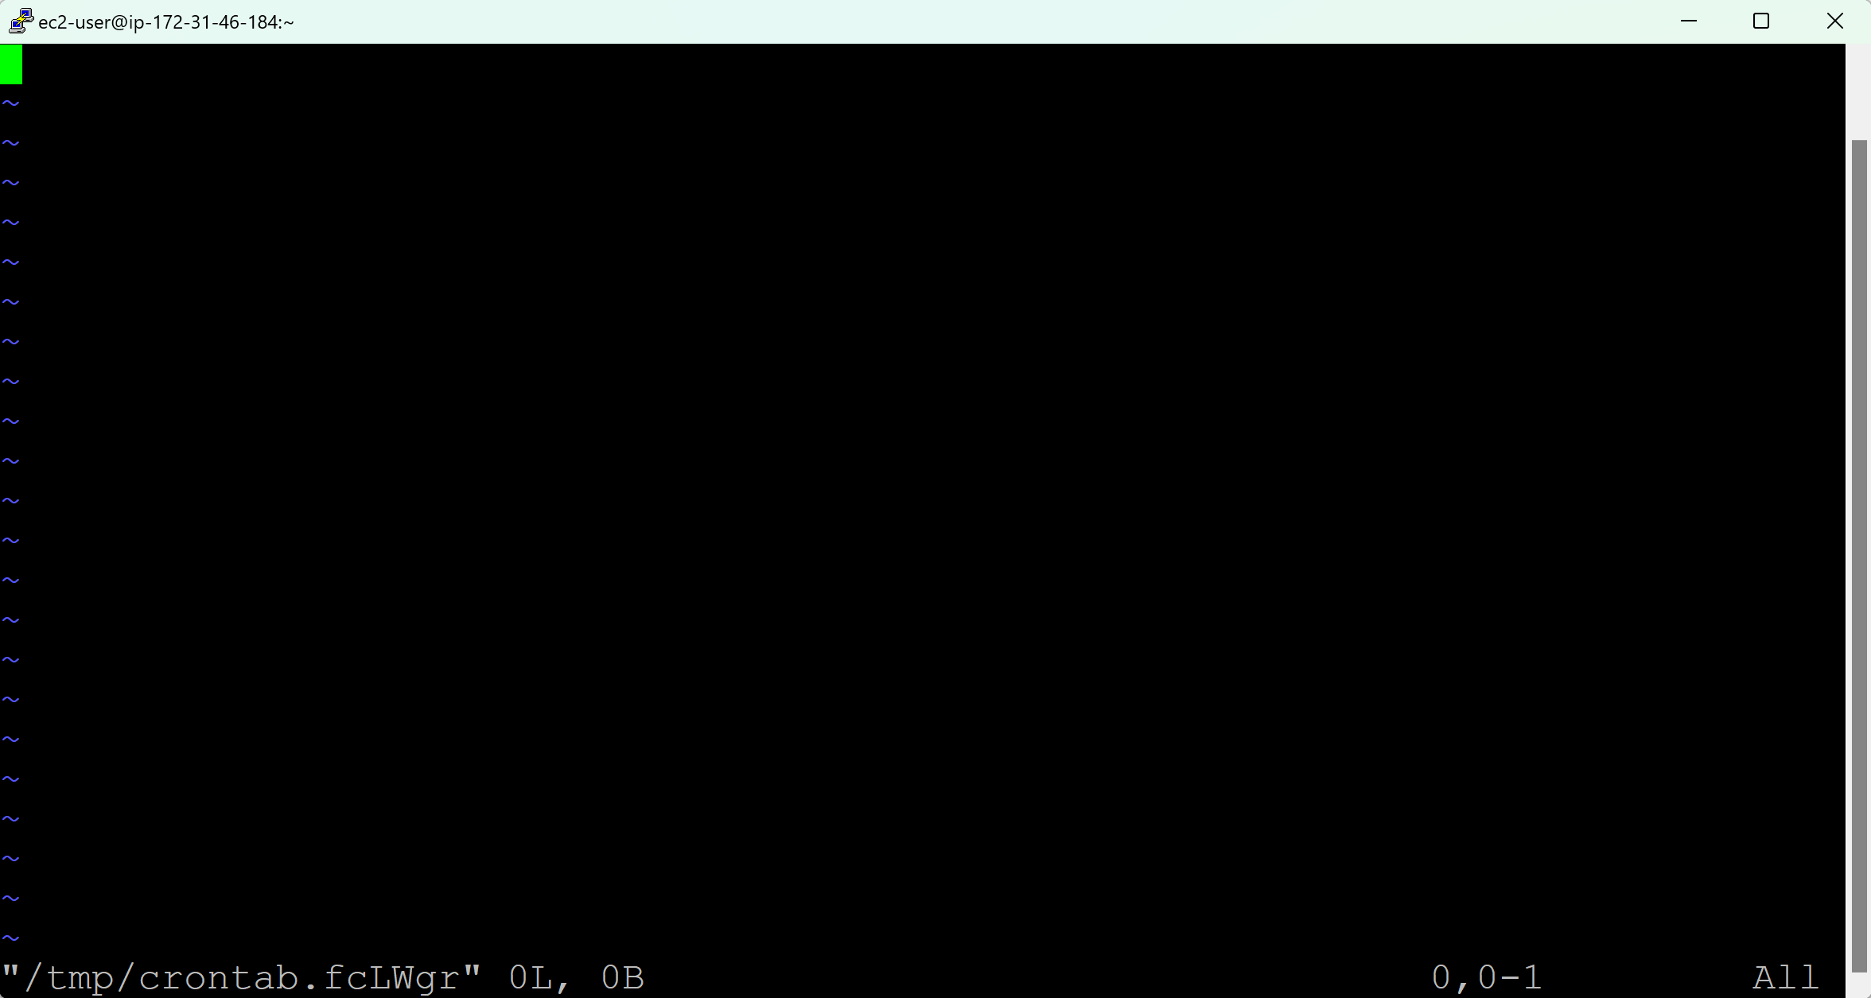

**Example, Take a backup of /etc/passwd for every minute**

Go to Insert mode

* * * * * sudo cp /etc/passwd /opt/passd.bkp

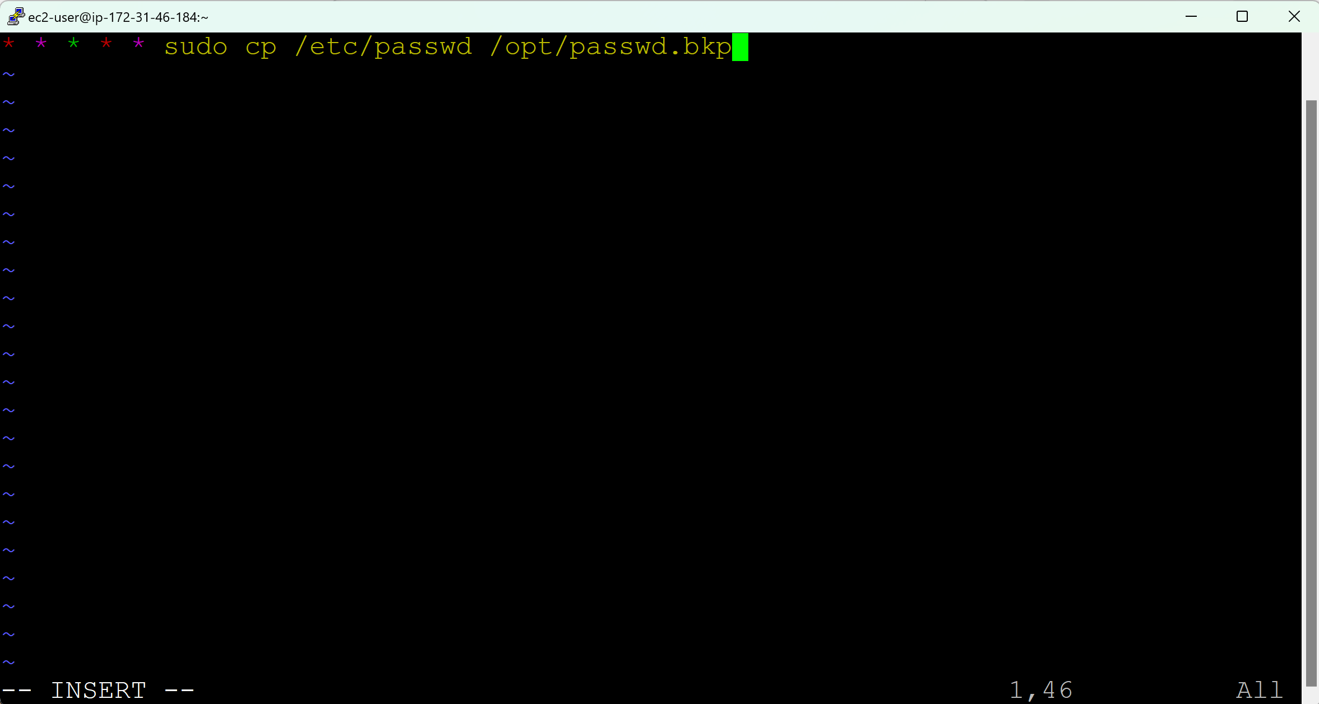

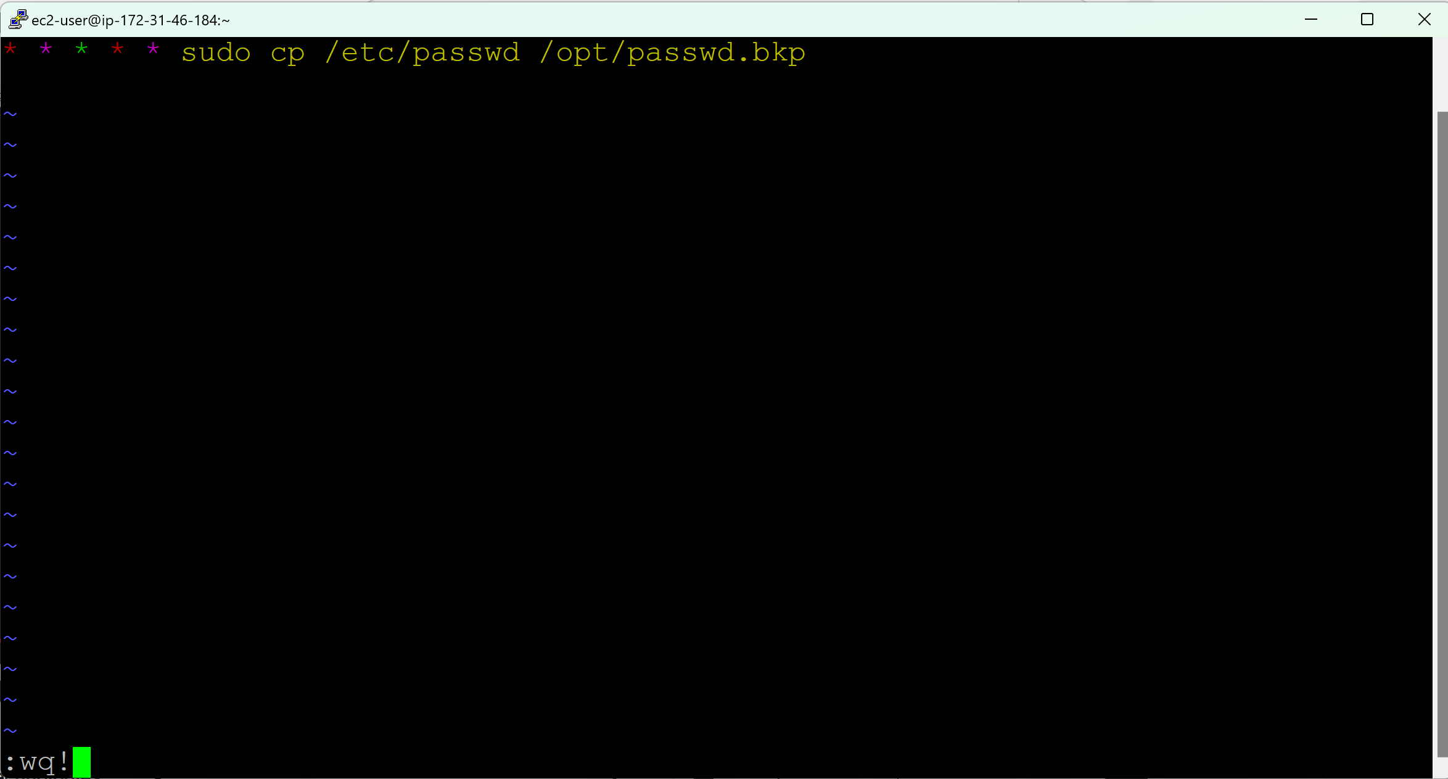

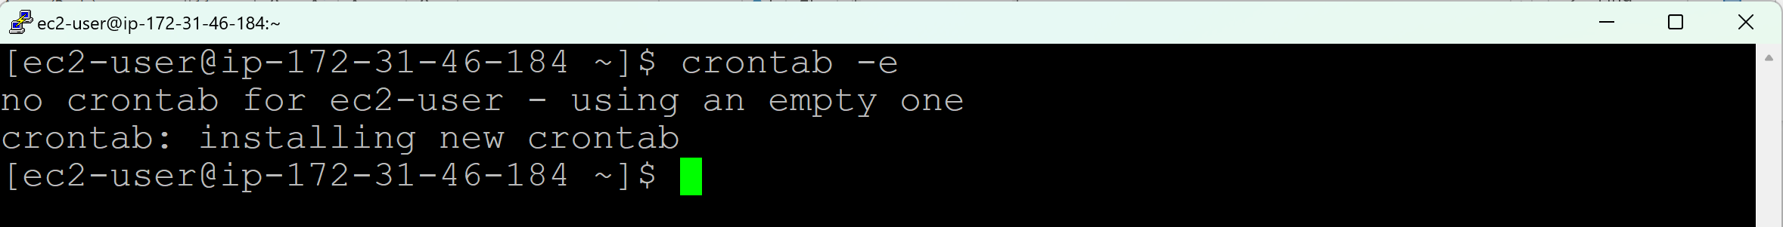

**Change directory to /opt/**

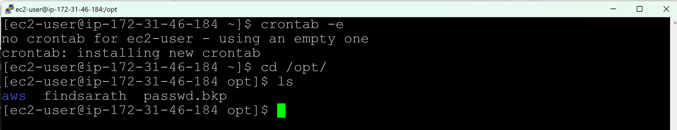

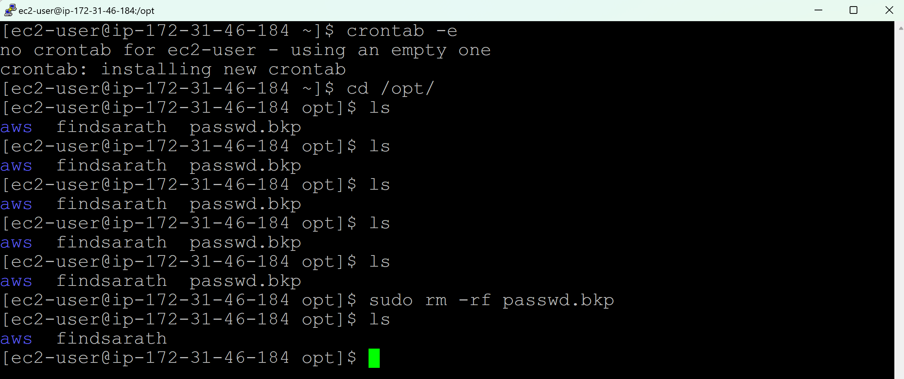

Remove the passwd.bkp file and again wait for 1 minute and do ls

sudo rm -rf passwd.bkp

**-rf** => Force removal without prompting for confirmation 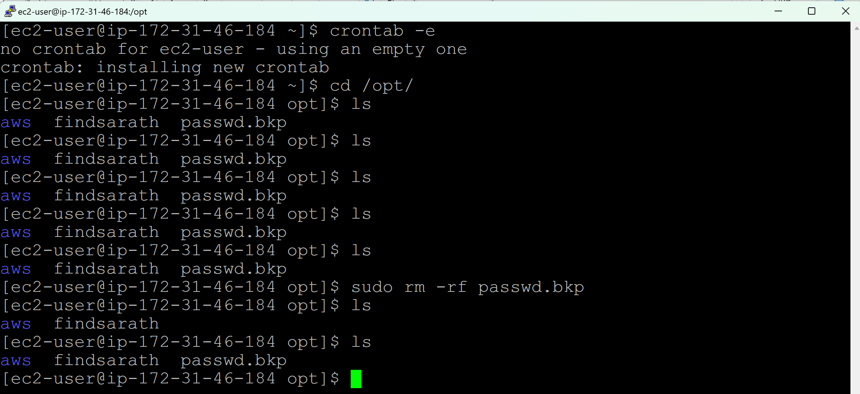

*/5 * * * * => To run the job for every 5 mins

*/10 * * * * => To run the job for every 10 mins

0 */2 * * * => To run the job for every 2 hours

**Shell Scripting:**

It is a group of commands

Execute a Shell script using crontab:

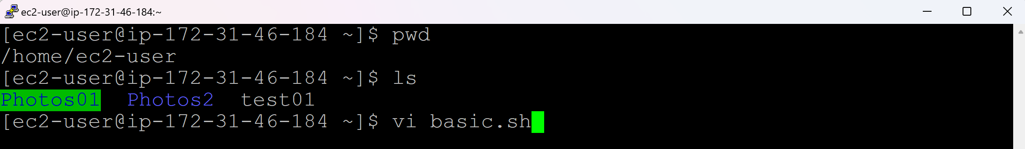

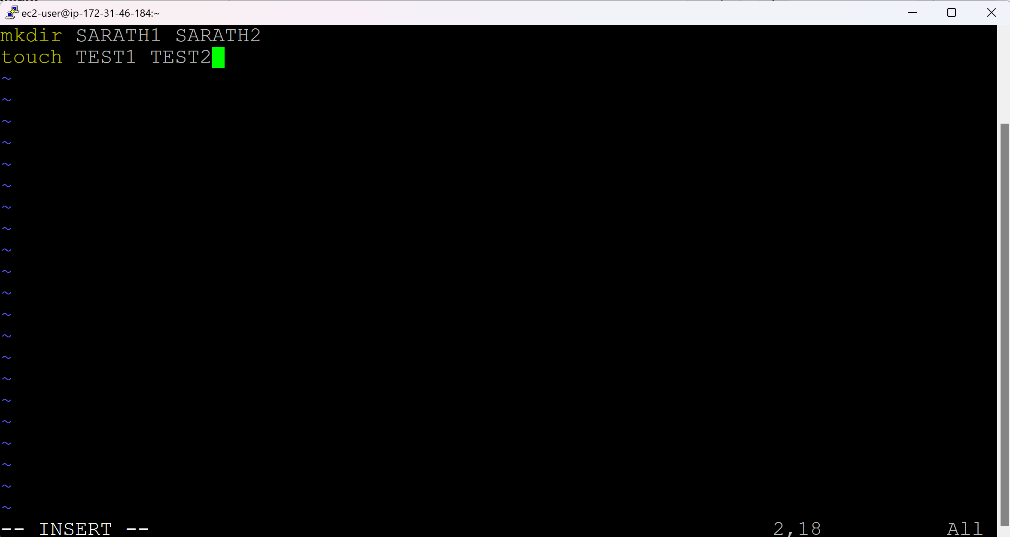

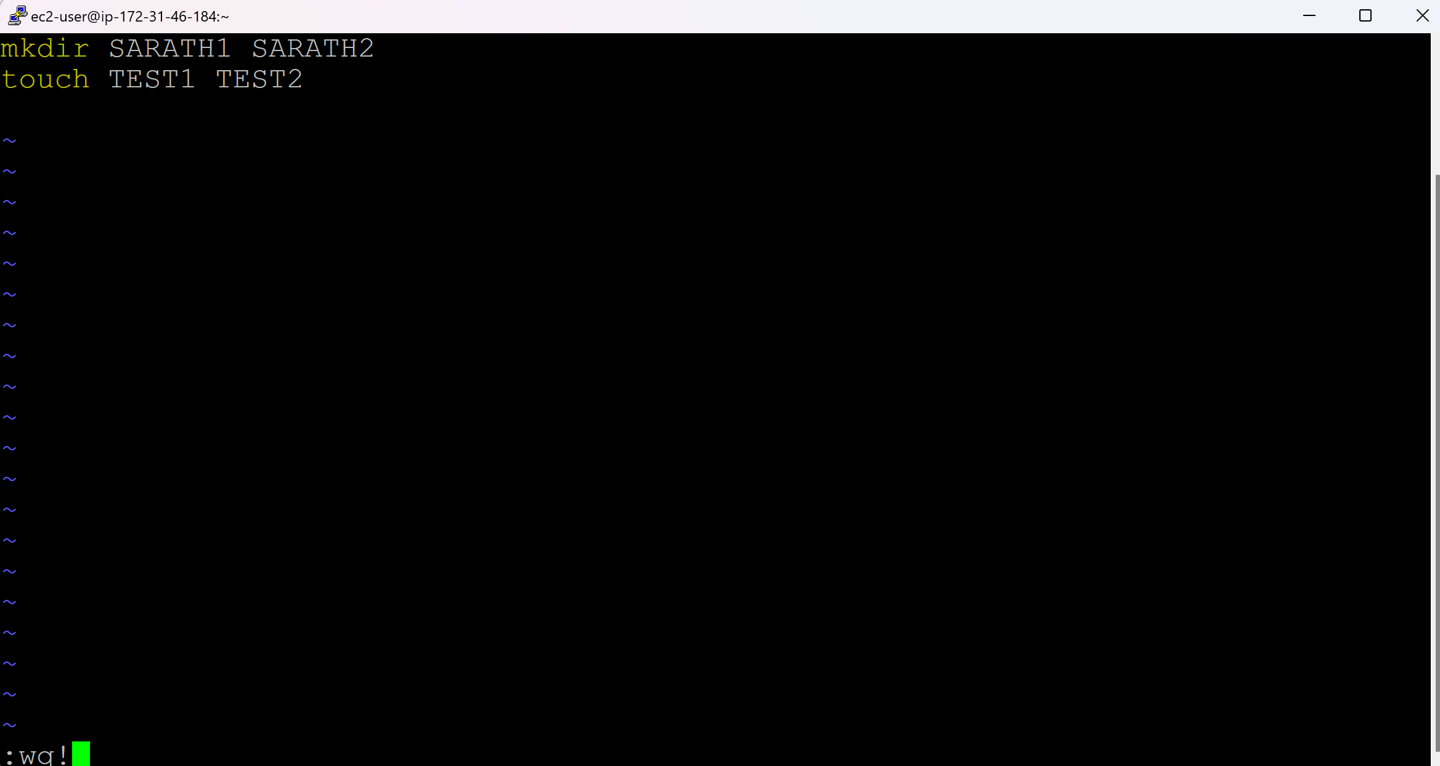

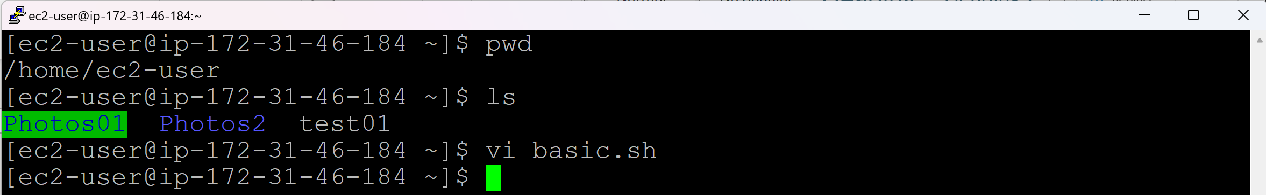

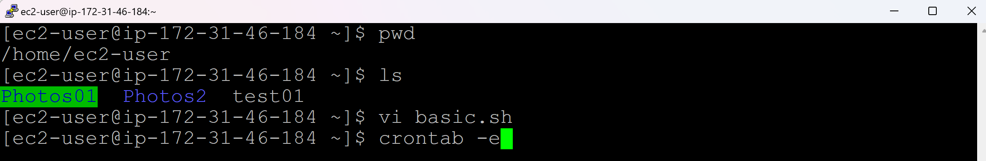

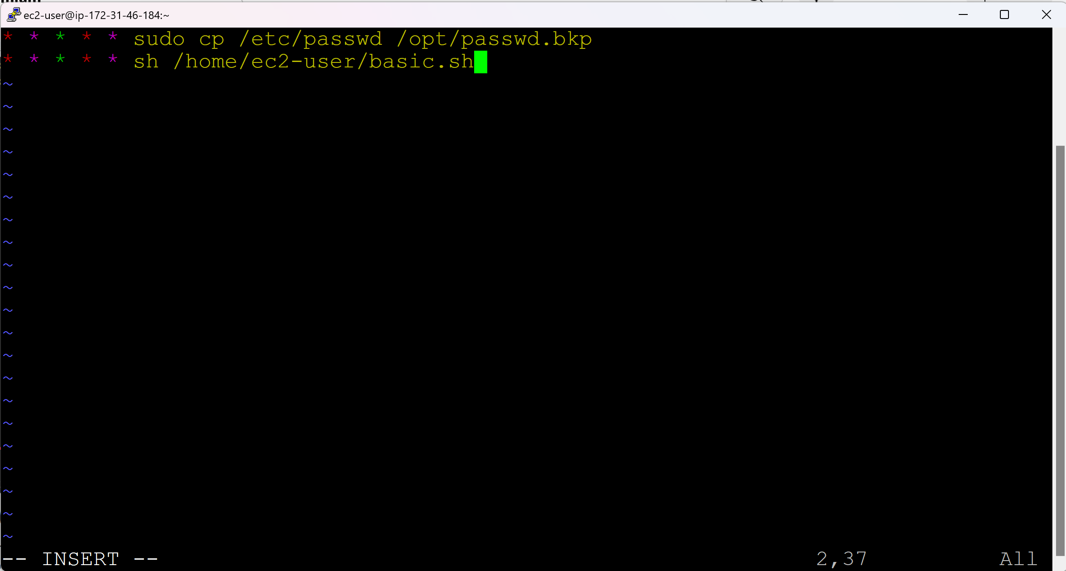

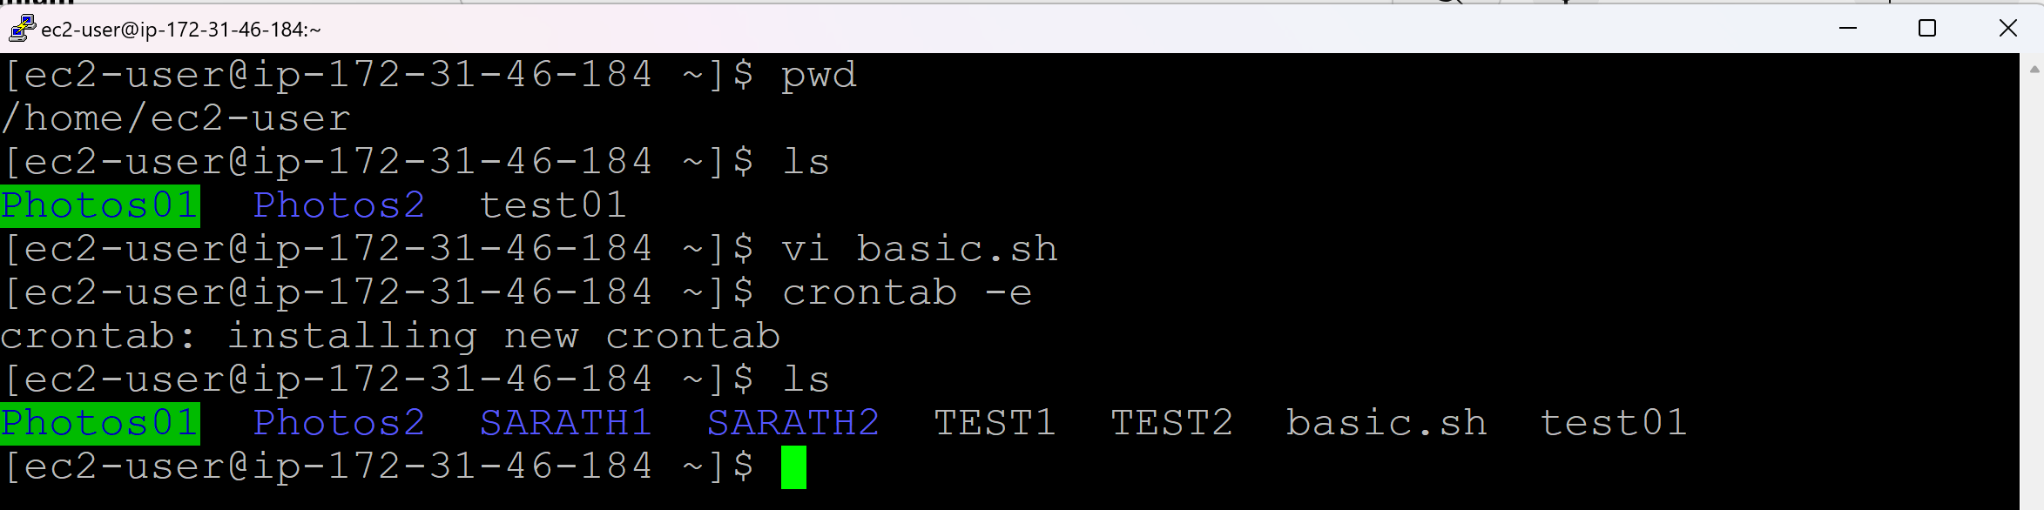

Remove the newly created directories and files

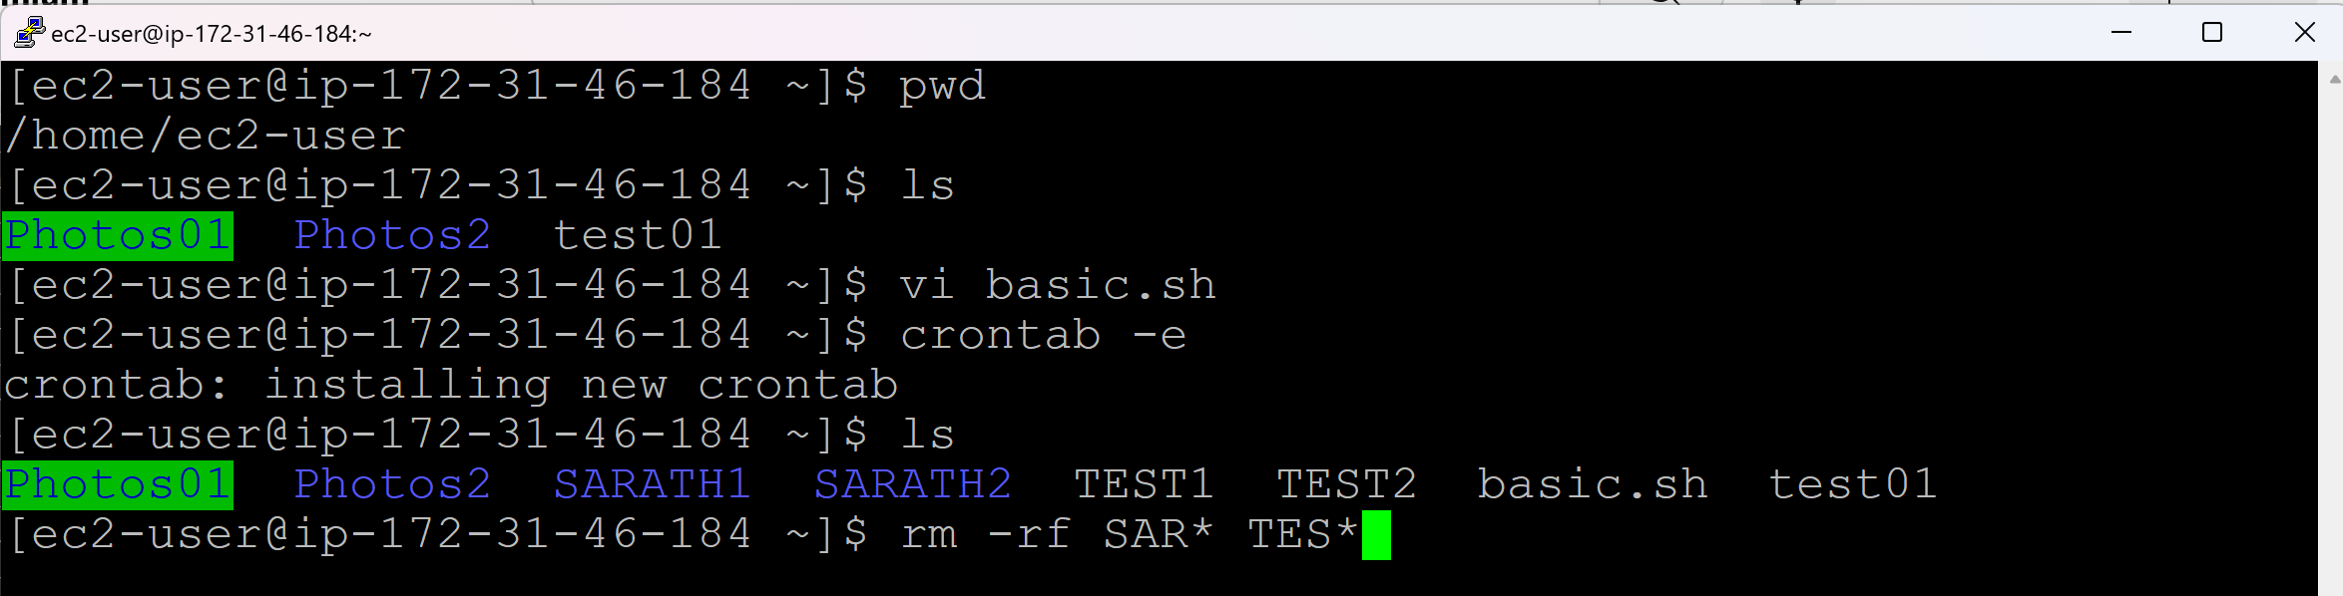

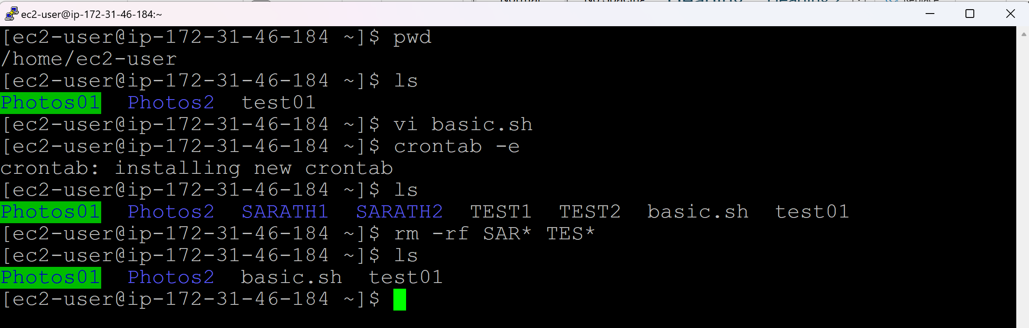

And check after one min

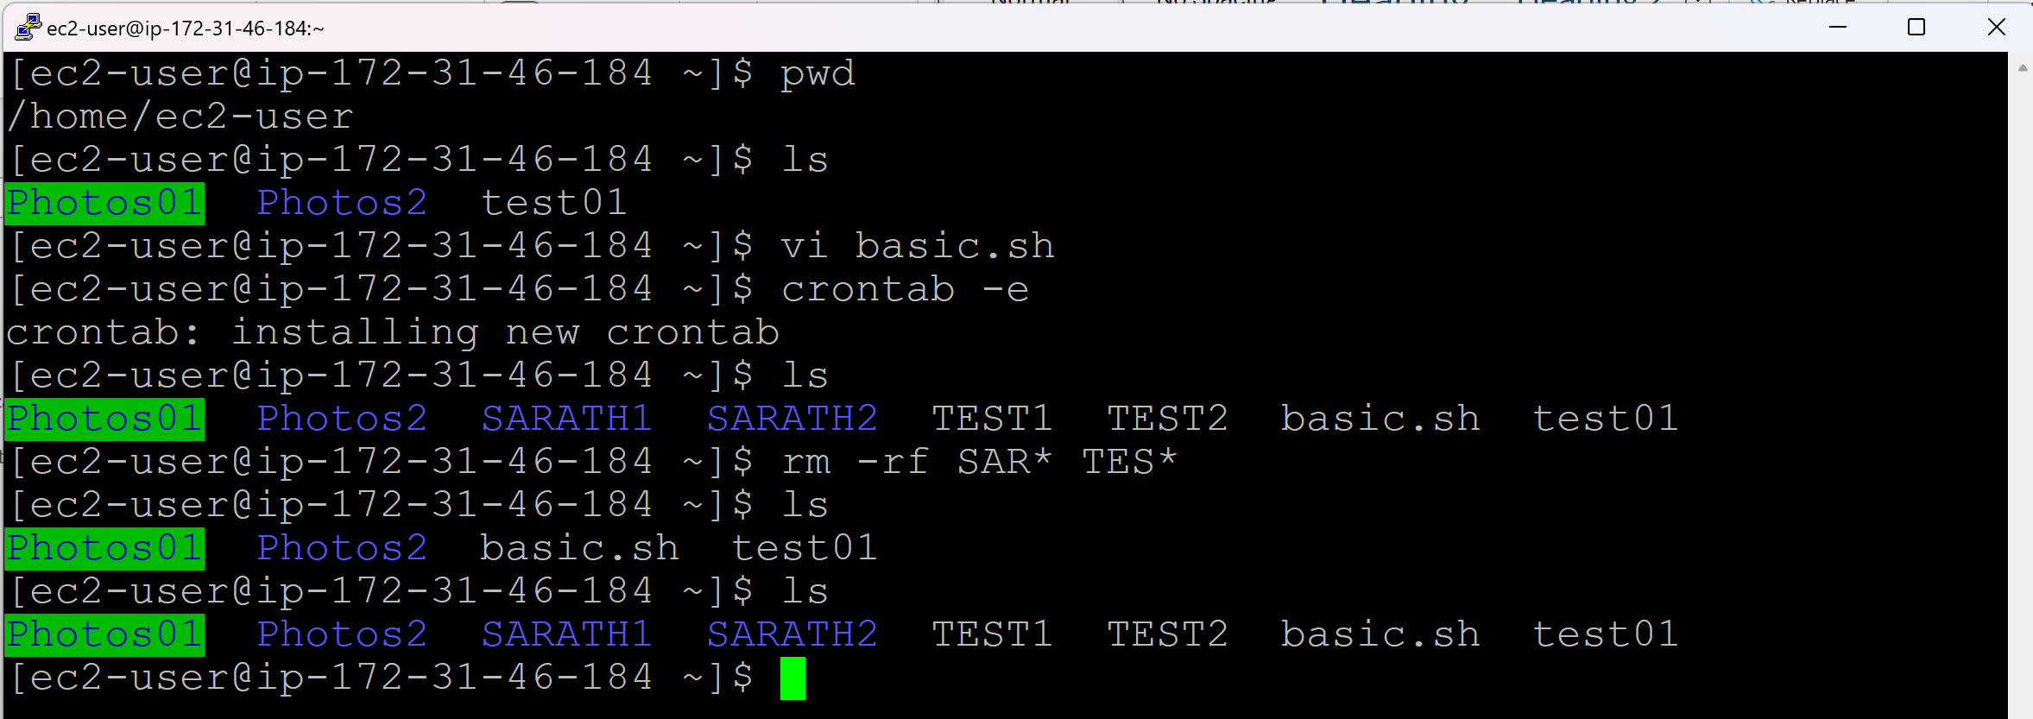

**To run cron job everyday moring 5AM:**

0 5 * * *

**To run cron job every Monday at 3PM:**

0 15 * * 1

Sunday => 0

Monday => 1

Tuesday => 2

Wednesday => 3

Thursday => 4

Friday => 5

Saturday => 6

**To run cron job every first day of the Month at midnight:**

0 0 1 * *

**To run cron job Mon-Fri at 1AM:**

0 1 * * 1-5

**Day 16 (Package Management – rpm / yum)**

* Package/Software/Application/Product
* Installing a Software or Deleting a Software or Updating a Software => All comes under Package Management

**To install any software in Redhat family (Amazon Linux, Centos):**

<softwarename>.rpm

vlc.rpm

**There are 2 methods to install a sofware in Redhat family:**

rpm method

yum method

rpm => Redhat Package Manager

yum => Yellow dog Update Modifier

**To install any software in Ubuntu:**

<softwarename>.deb

deb => debian

* If we want to install 3rd party applications, we will go with rpm method. We have to install dependencies in rpm method
* If we want to install in-built softwares/applications, we will go with yum method. Yum will install the dependencies in yum method.

**There are 2 methods to install a software in Ubuntu:**

deb method (Same as rpm)

apt method (Same as yum)

**Installing tree.rpm software:**

* Go to browser
* Search for “tree rpm centos 7”
* Click on the link “RPM resource tree(x86-64)
* Copy the link address of CentOS
* Right click in Putty

wget <url>

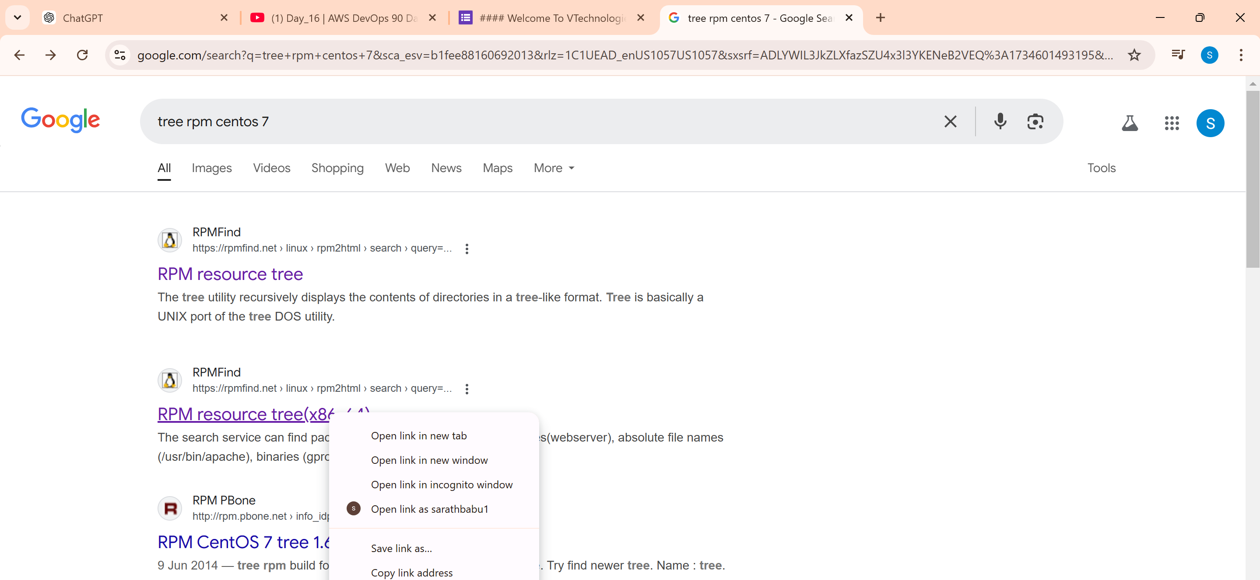

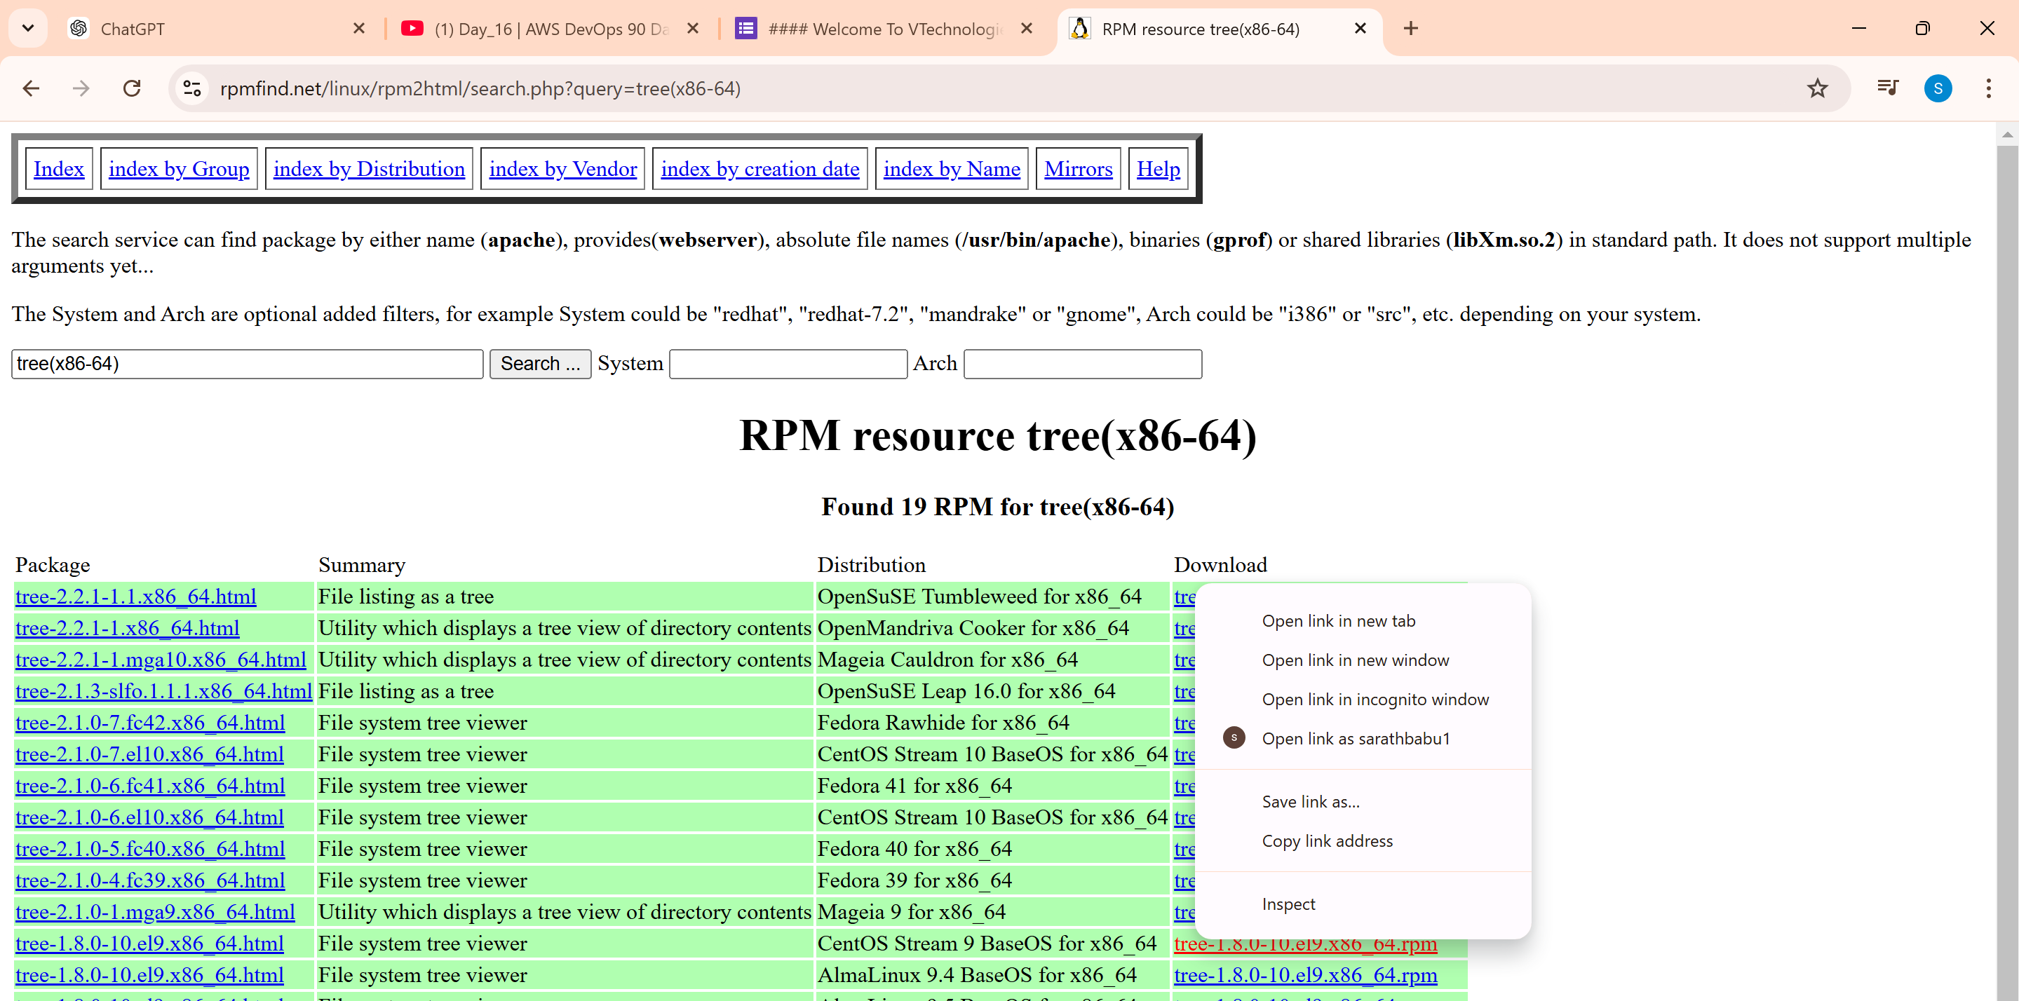

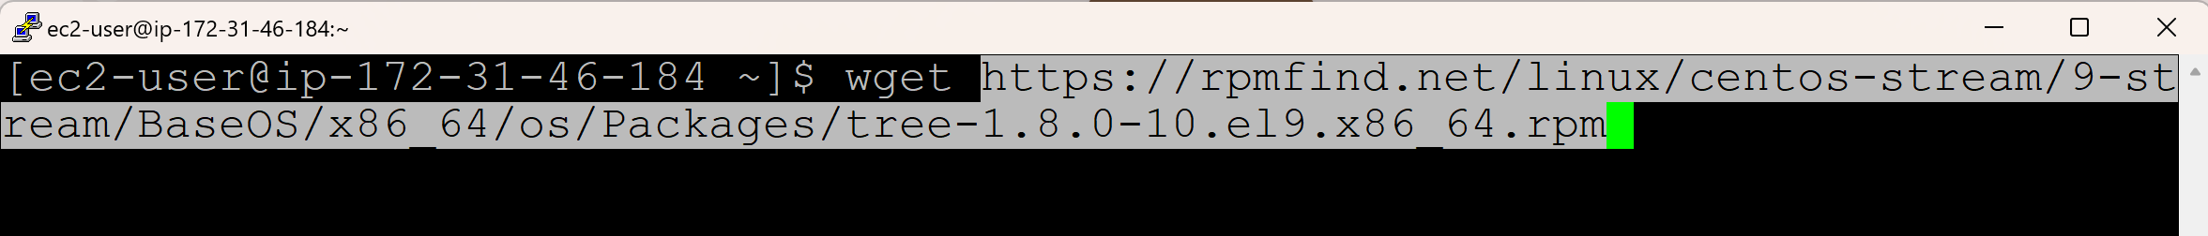

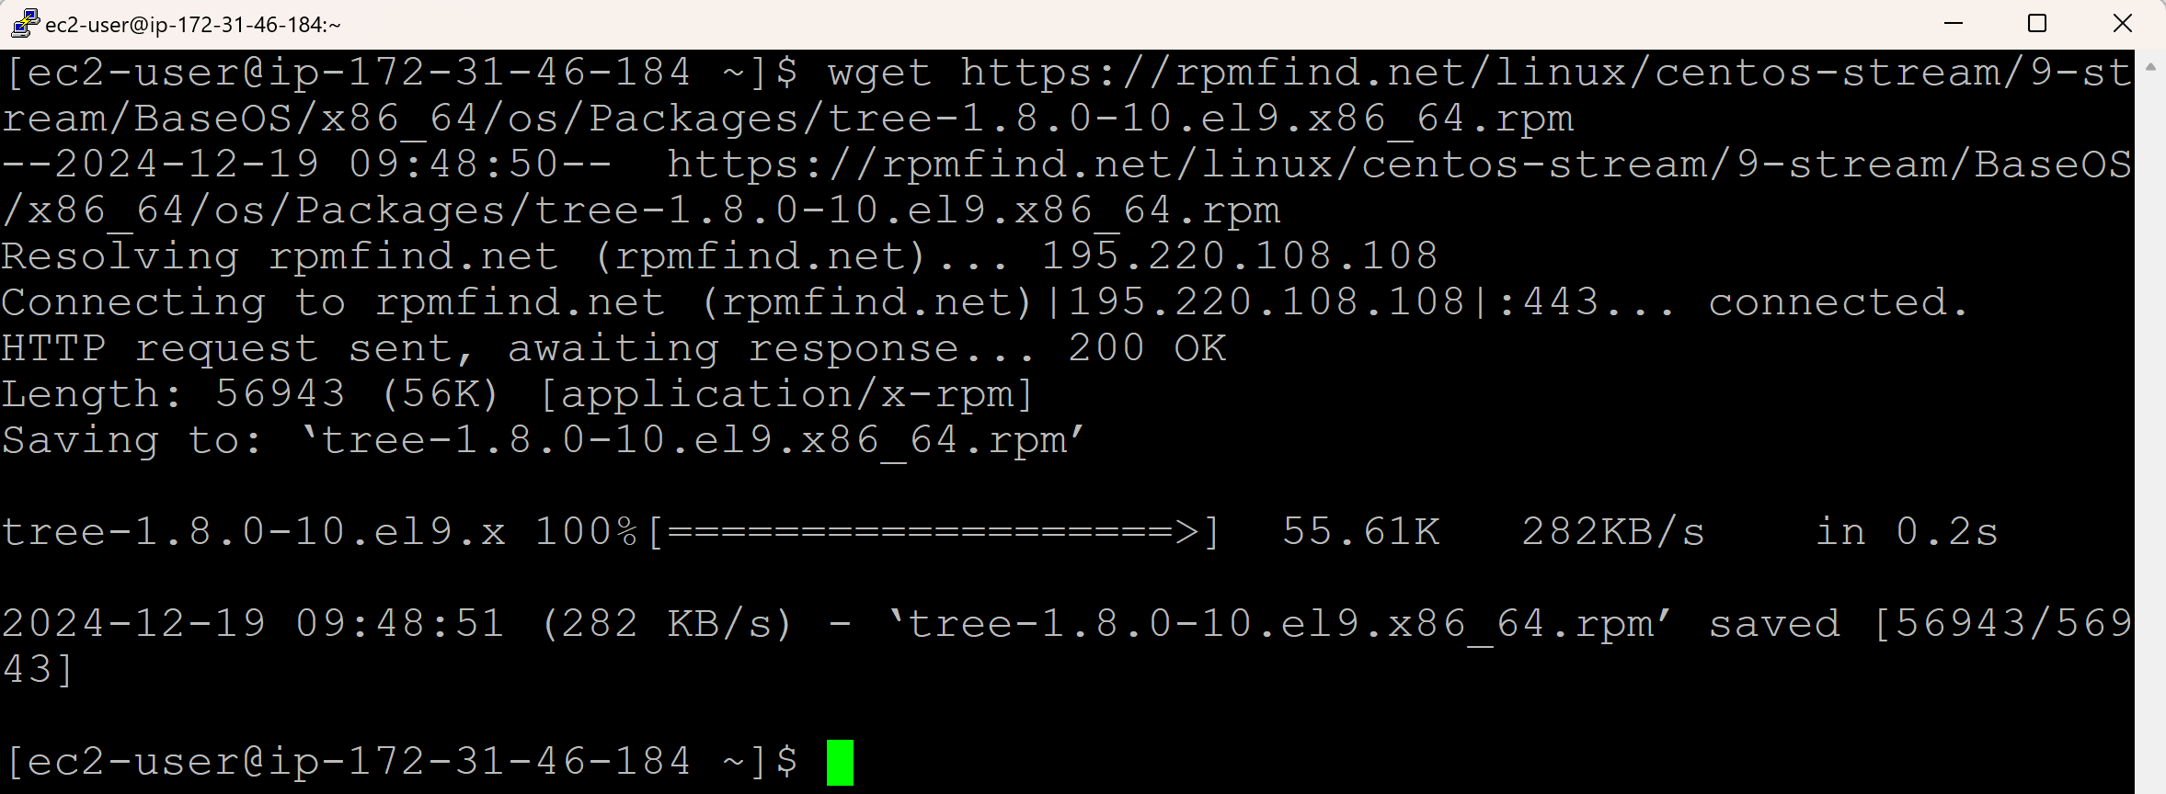

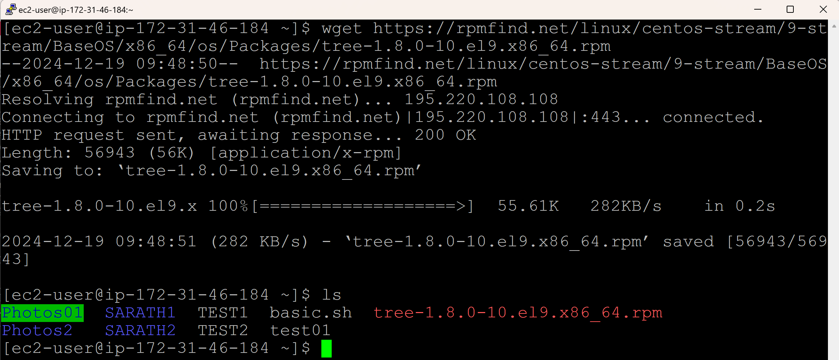

**To check, if tree is installed:**

tree -v

-v => version

-i => install

-u => update

-e => erase/remove

-qa => Query for All

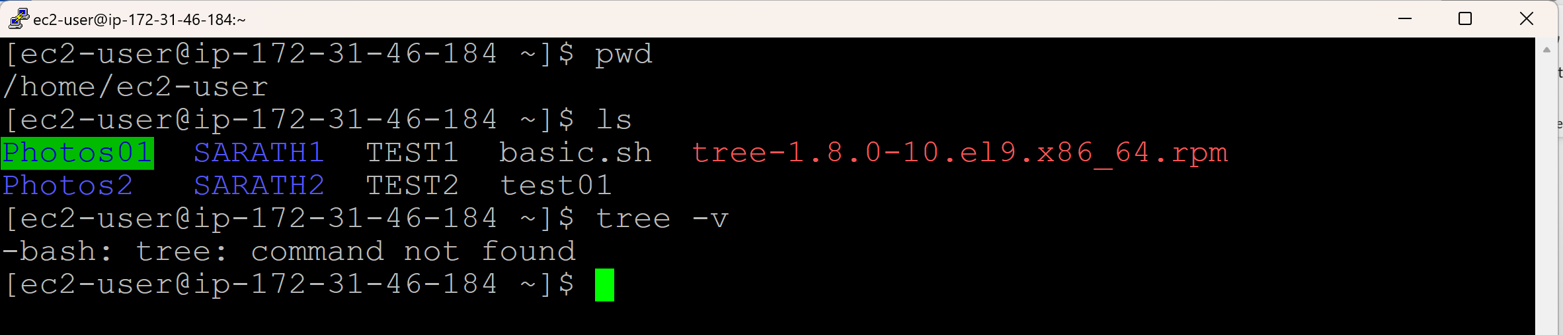

**Installing a software (tree) using rpm command:**

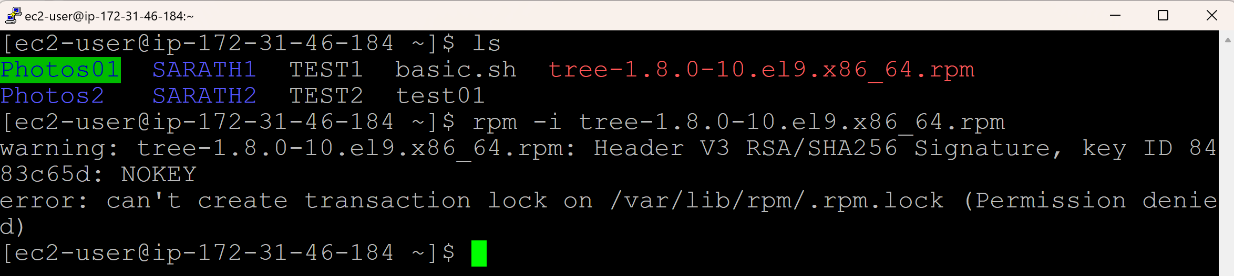

sudo rpm -i <downloadedfile>

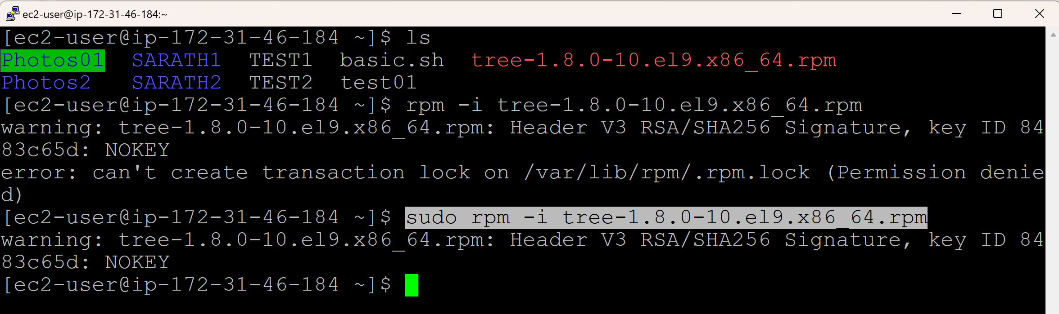

**Check, if tree is installed**

tree -v

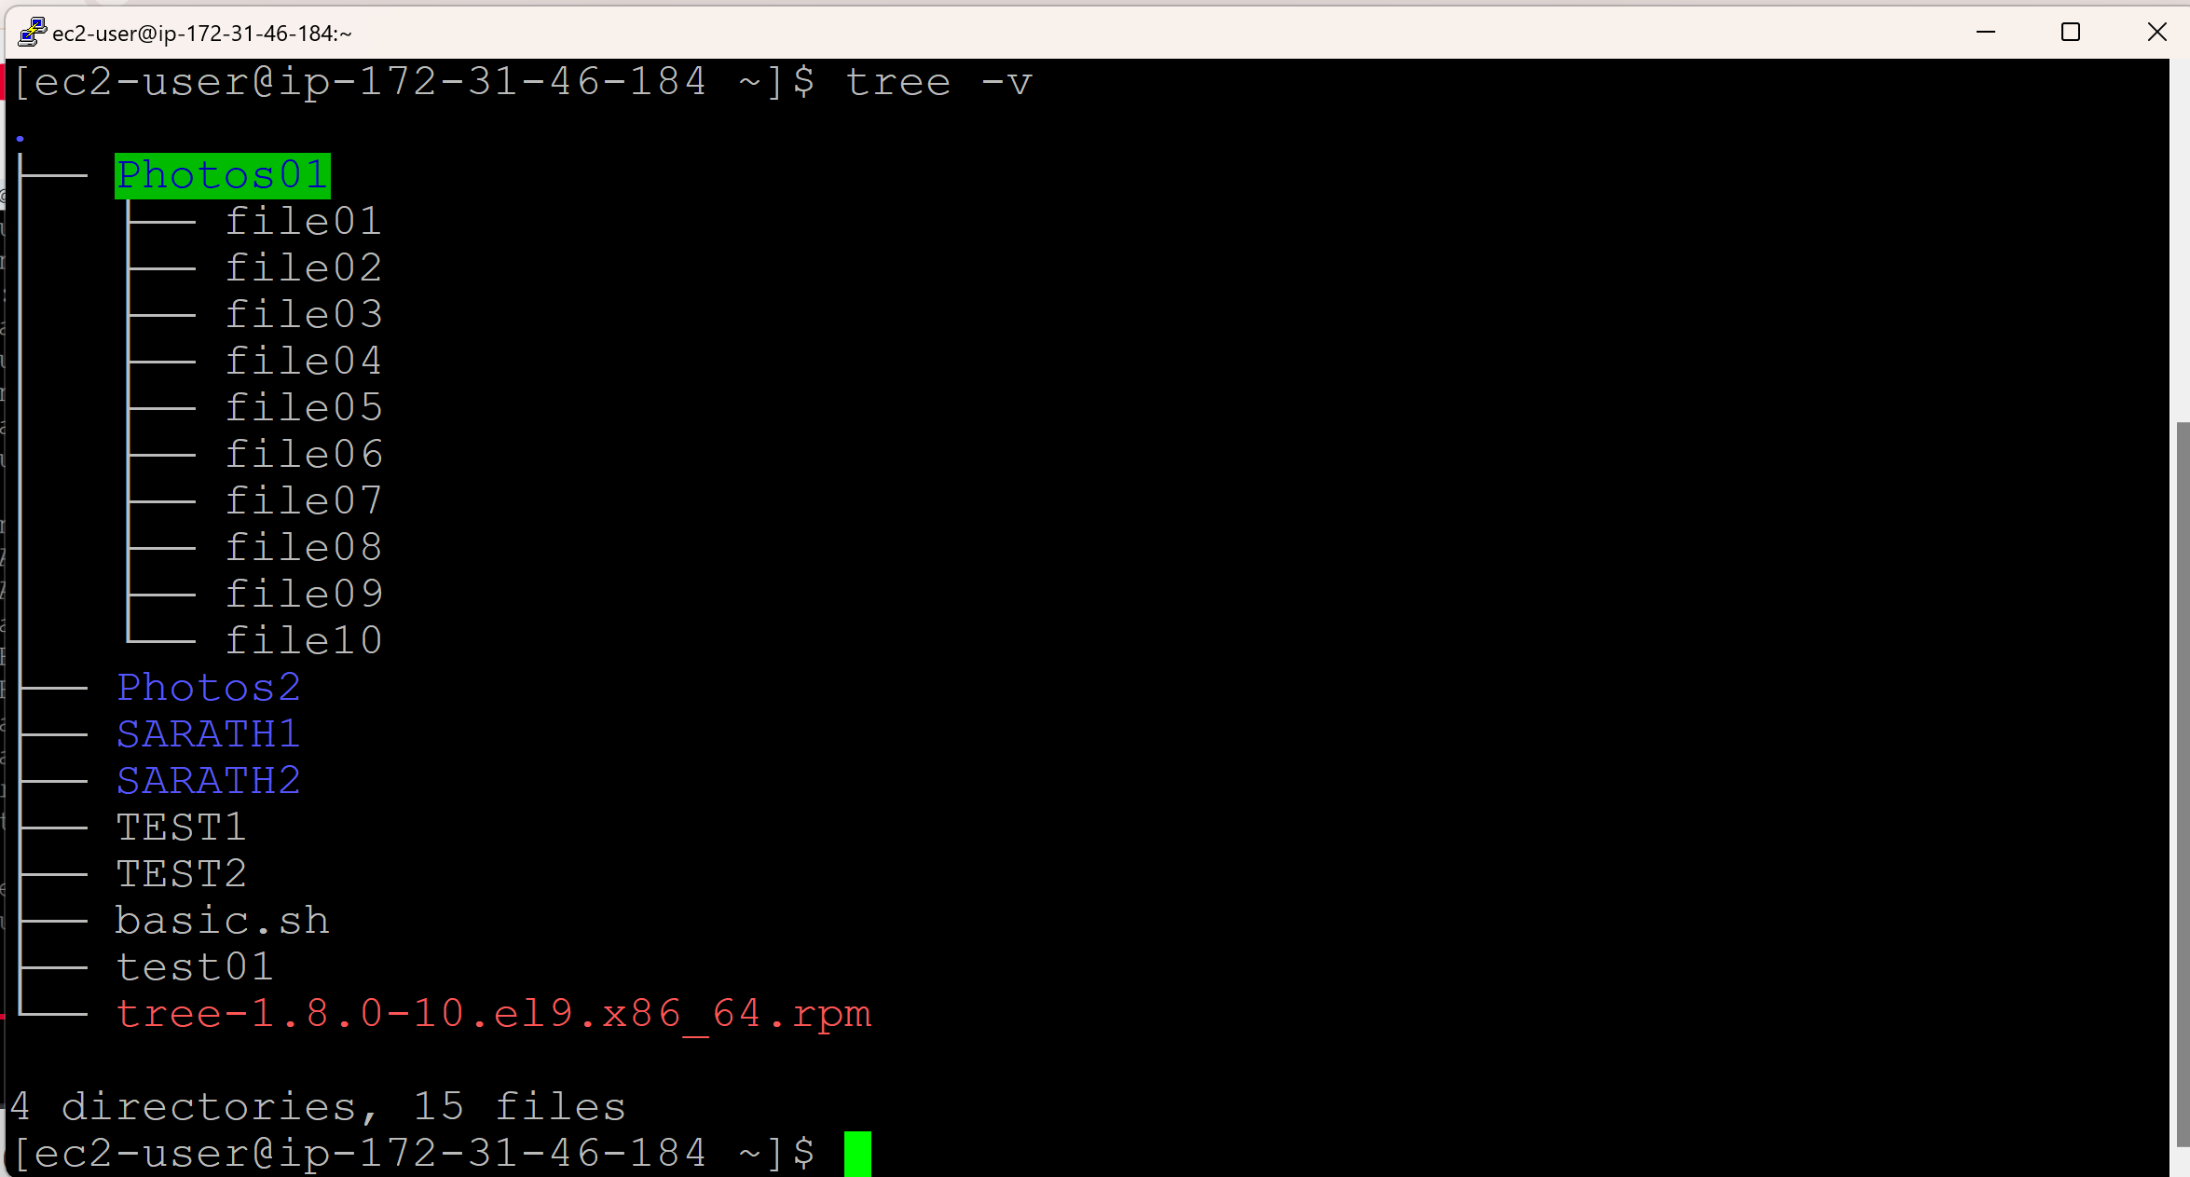

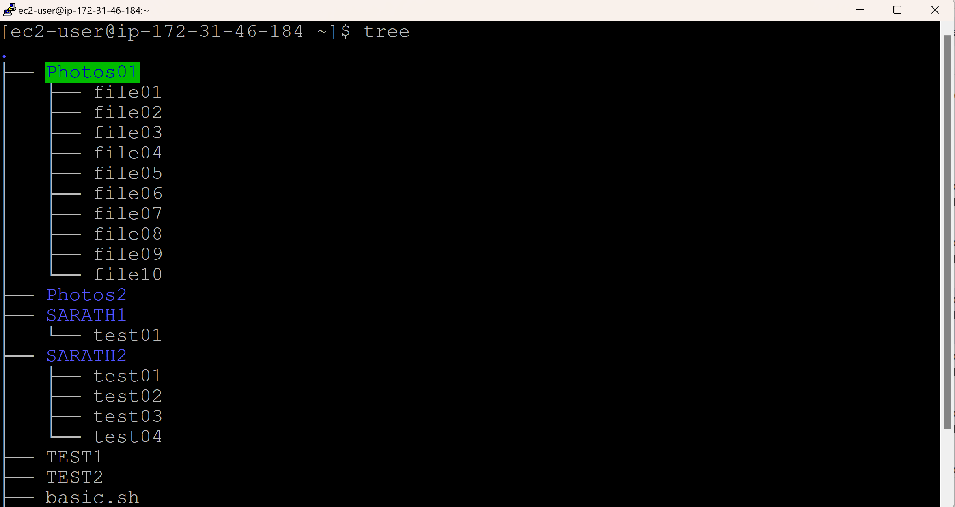

**Uninstall tree:**

sudo rpm -e tree



**Check, if tree software is available:**

tree

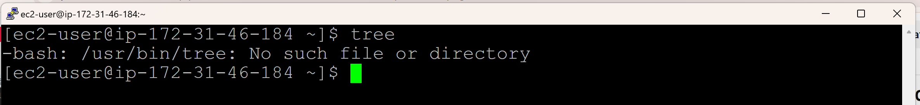

**Checking for all the available packages in Linux:**

rpm -qa

q refers to Query

a refers to All

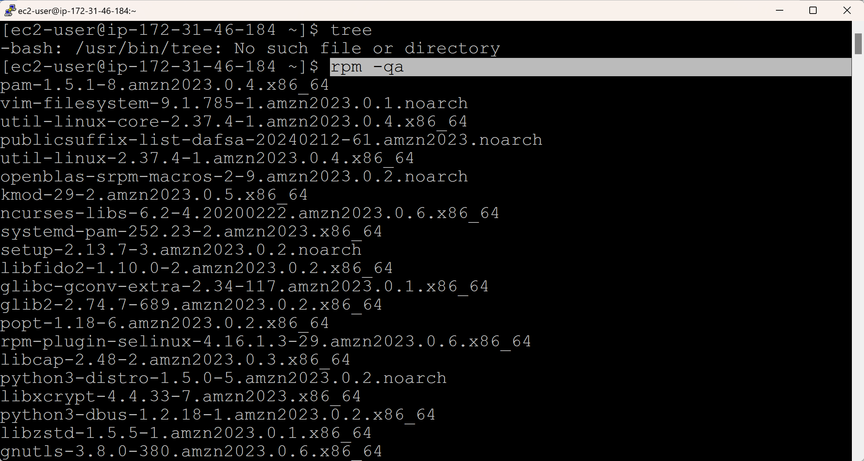

**Installing a software (git) using yum method:**

sudo yum install git

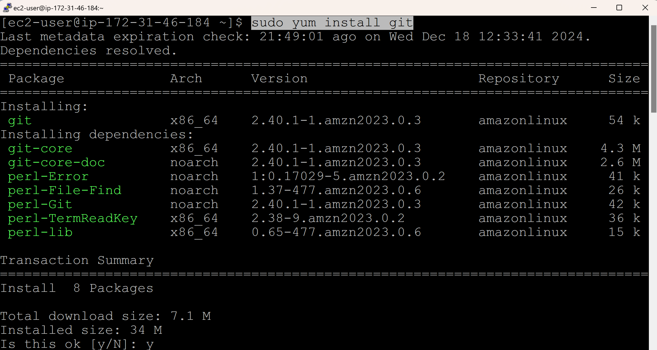

**To check, if git is installed**

git --version

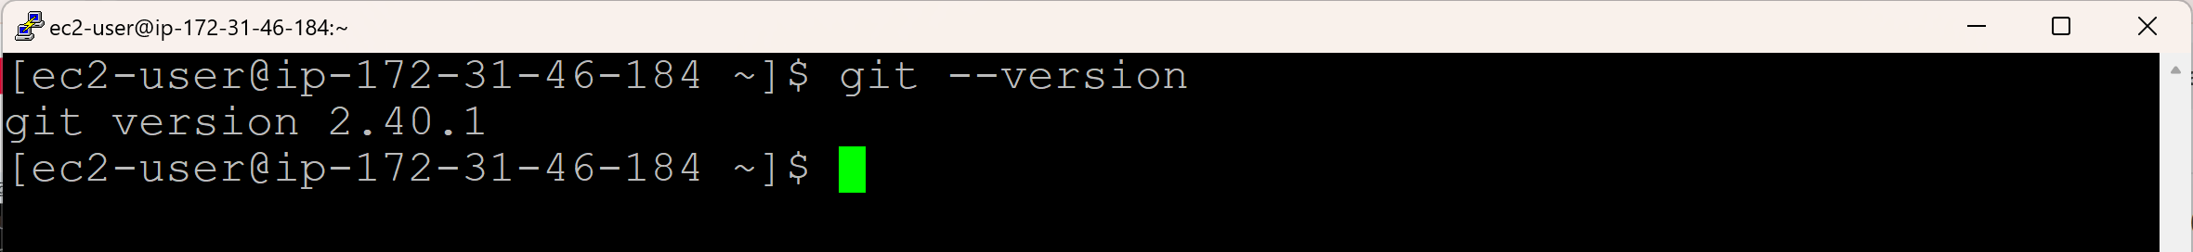

**Remove/Uninstall git**

sudo yum remove git* (* is required to remove the dependencies as well)

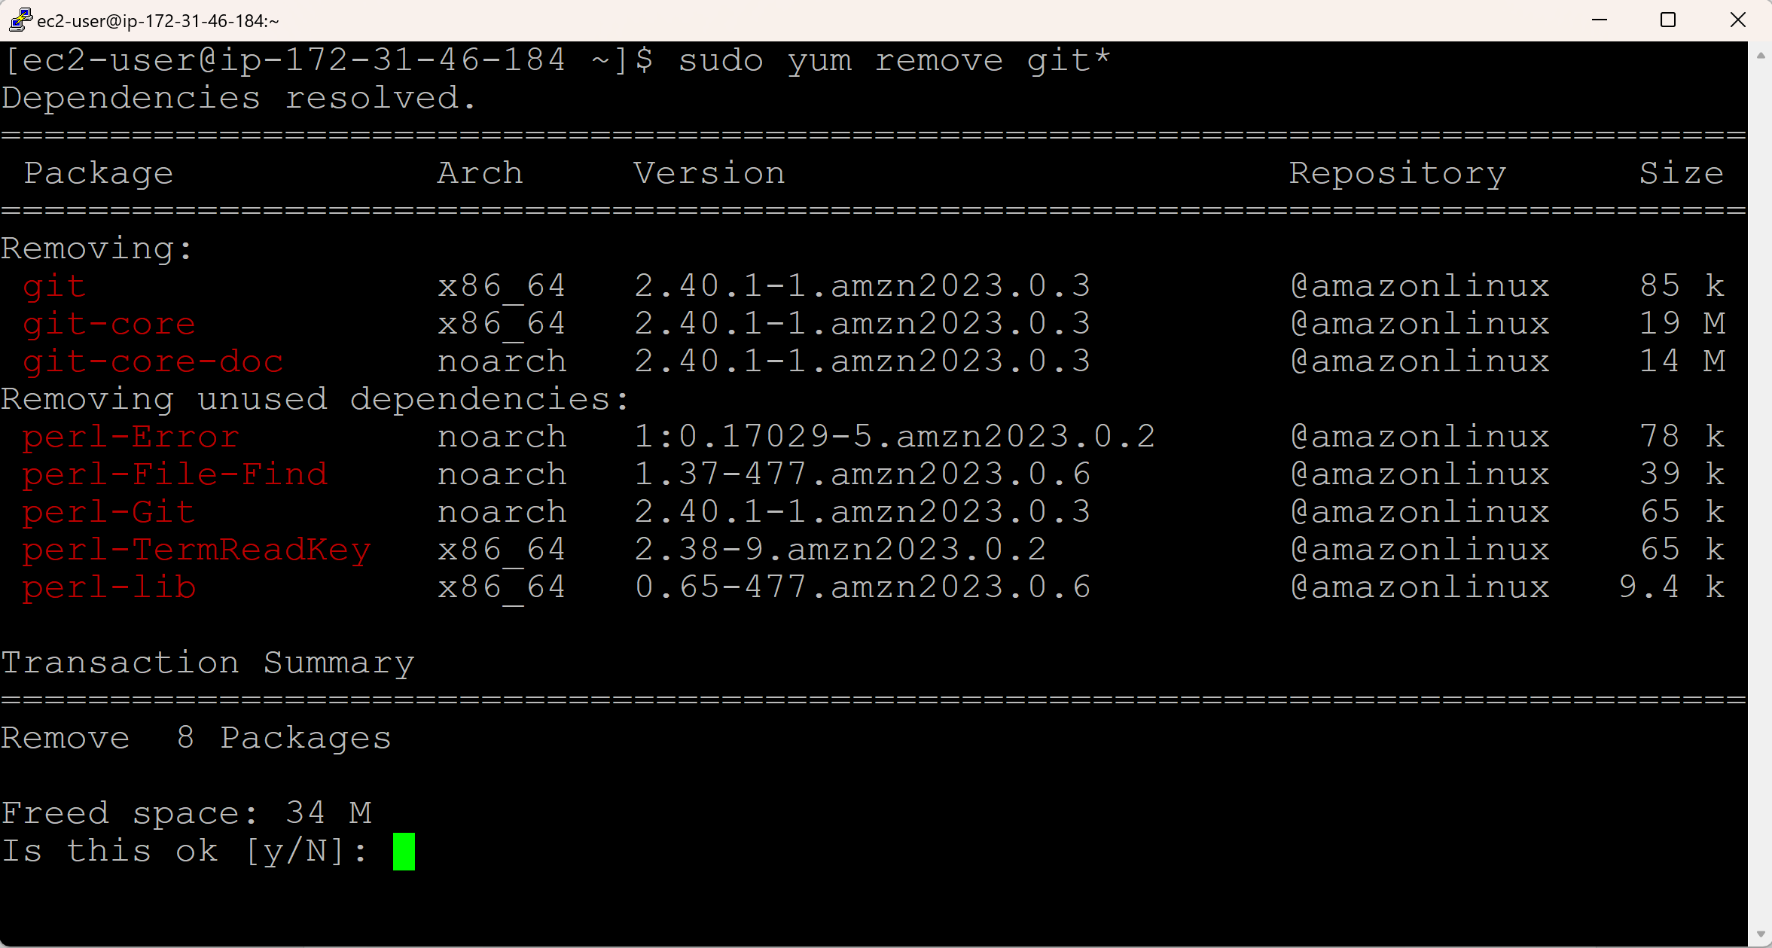

**To check, if git is removed/uninstalled**

git --version



**Giving Yes ‘Y’ confirmation in the command while installing a software:**

sudo yum install git -y

It will not ask you the confiramtion for y or N

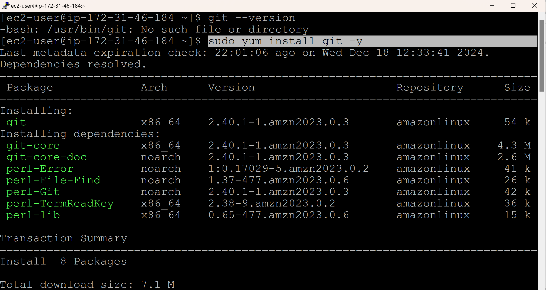

**To Update the software using yum method:**

sudo yum update git -y

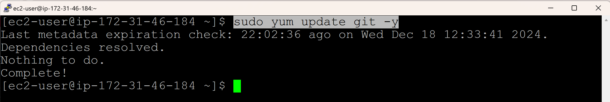

**Day 17 (User Management)**

* User Creation
* User Deletion
* Updating the User (Replace User with another User)
* User Management can be achieved with **root** user.
* We have 2 types of dafault users in Linux:
  + ec2-user
  + root
* All the users information is available in **/etc/passwd**
* All the users password information is available in **/etc/shadow**

**To check the user:**

whoami

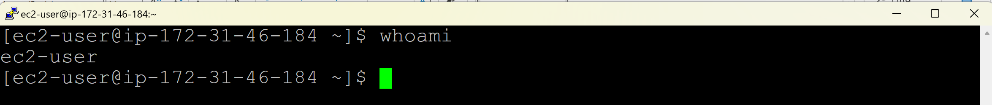

**Switch to root user:**

sudo -i

whoami

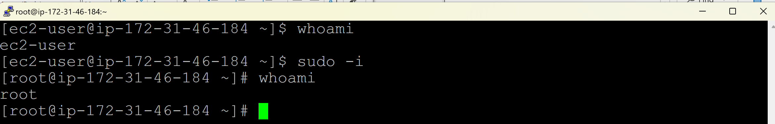

**Open the all users information file /etc/passwd**

cat /etc/passwd

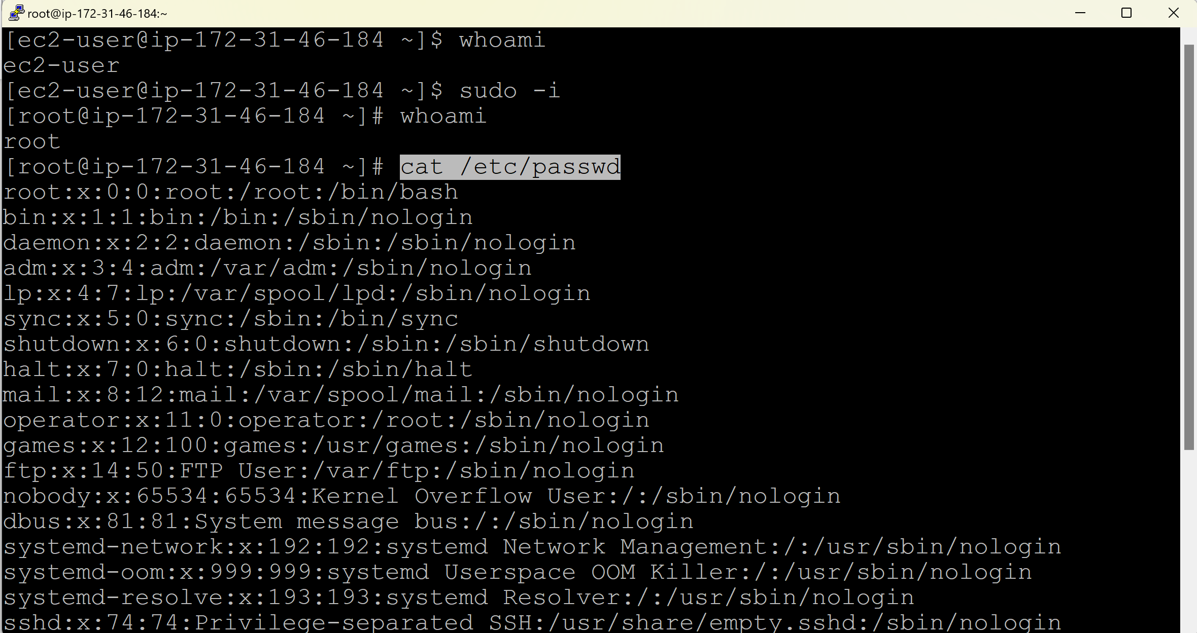

**Open the all users password information file /etc/shadow**

cat /etc/shadow

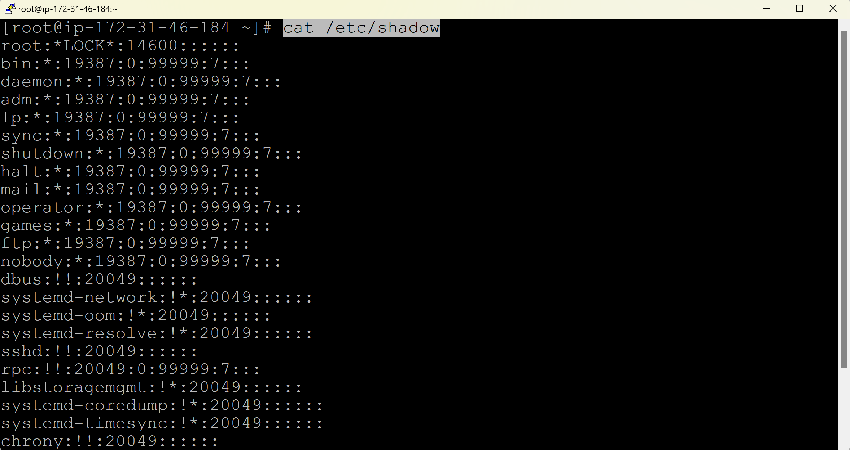

**Create a new user:**

Useradd <username>

useradd ansible

cat /etc/passwd



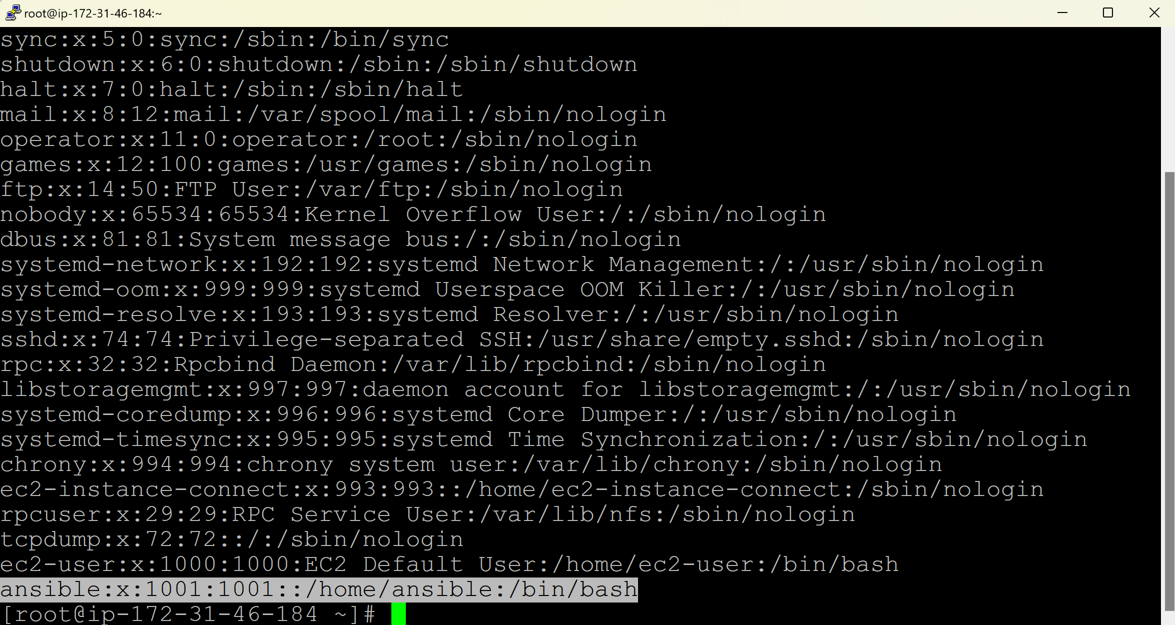

ansible:x:1001:1001::/home/ansible:/bin/bash

ansible => username

x => any comment

1001 => User ID

1001 => Group ID

/home/ansible => home directory for the newly created user ansible (E.g. There is a home directory /home/ec2-user for the user ec2-user)

/bin/bash => default shell

**Delete the user:**

userdel <username>

userdel ansible



cat /etc/passwd

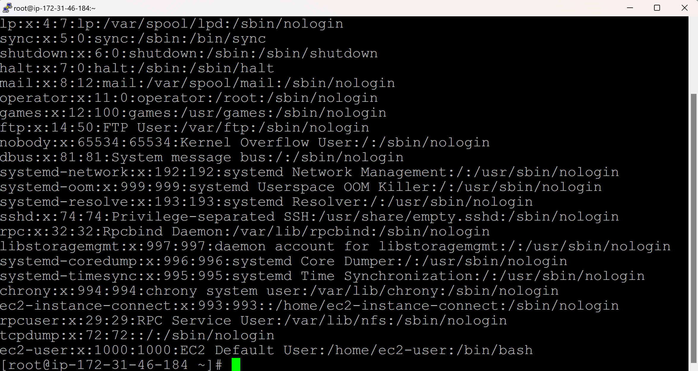

cd /home/

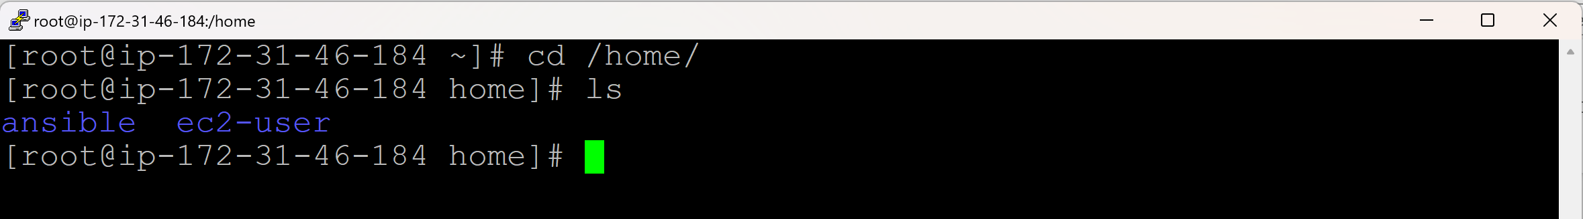

ls

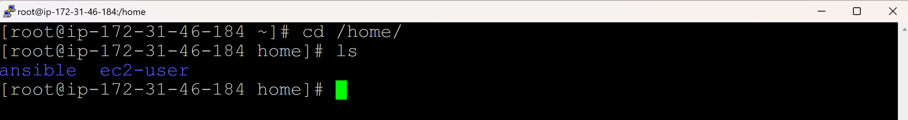

User ansible is deleted, but ansible user’s home directory is not deleted.

rm -rf ansible/

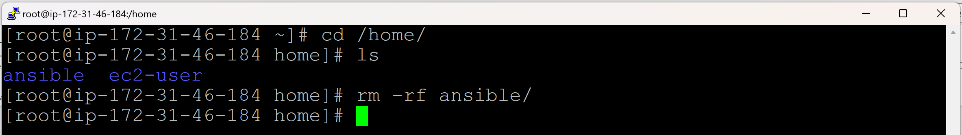

**Create one more user:**

useradd test

ls

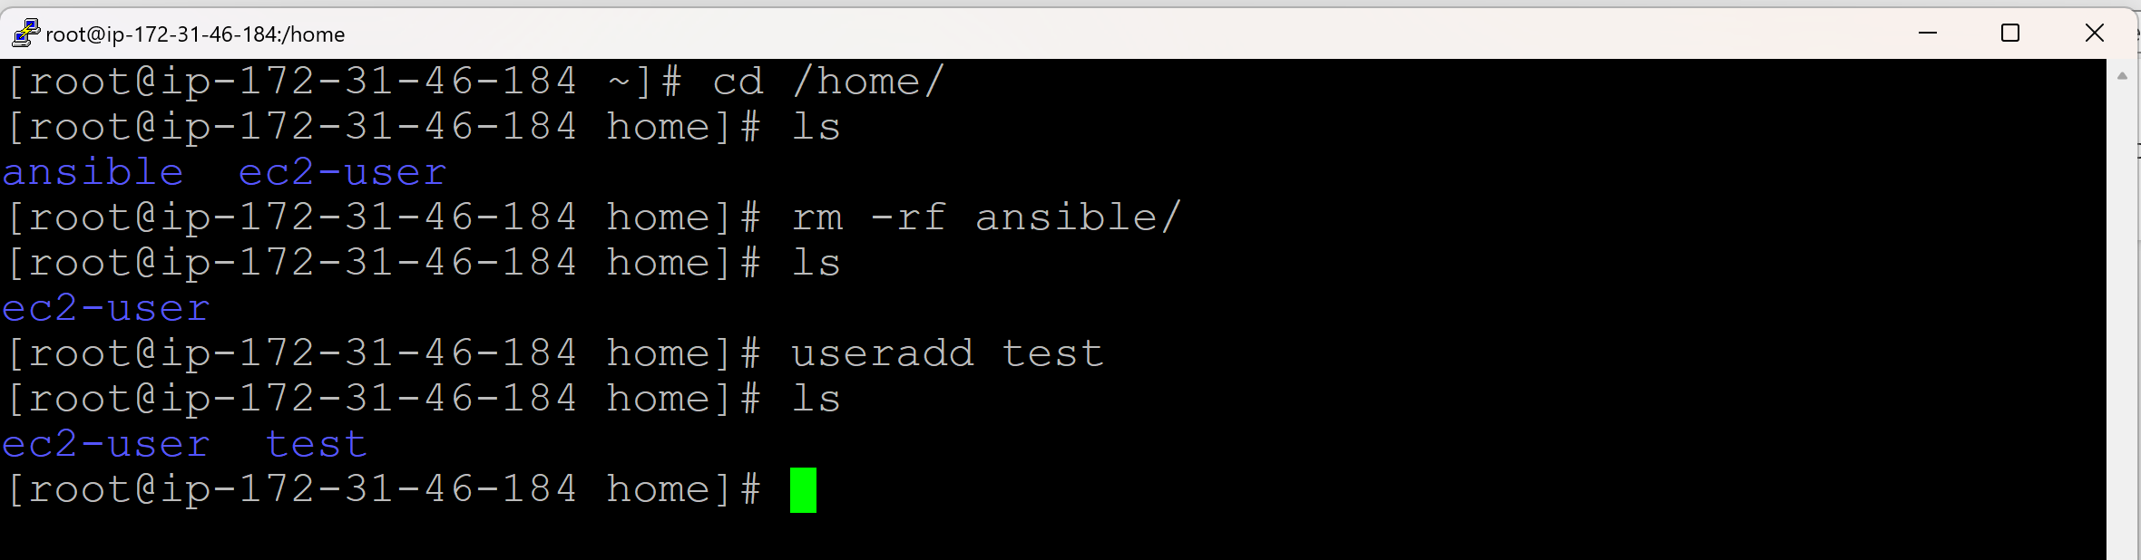

**Delete user and its home directory:**

userdel -r <userame>

userdel -r test

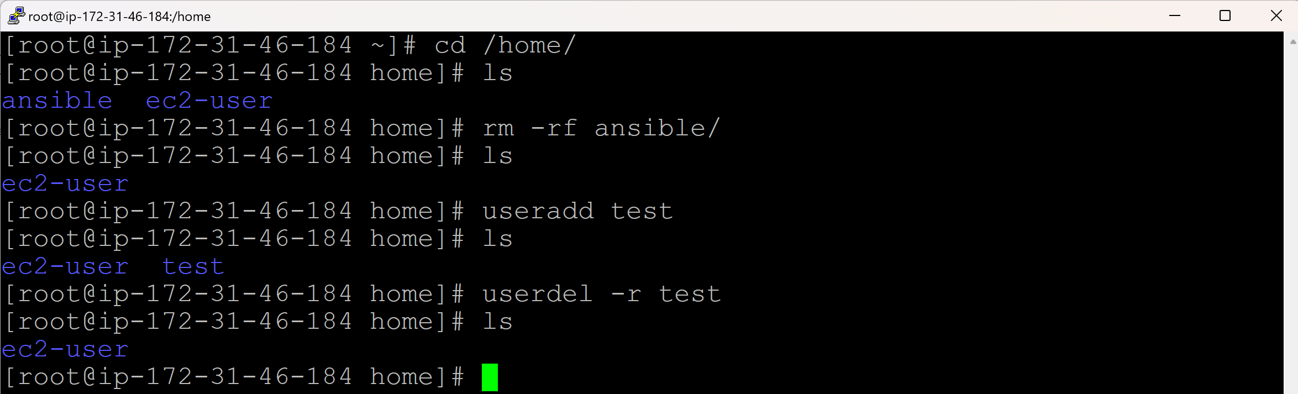

**Create an user with custom details (own userid, groupid, directory):**

* All the information of group names is available in **/etc/group**

cat /etc/group

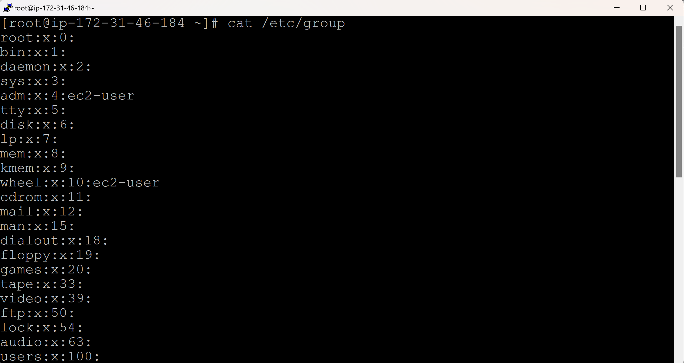

**Create custom User Group:**

groupadd -g <groupid> <groupname>

groupadd -g 3344 devops



**Check for the created User Group:**

cat /etc/group

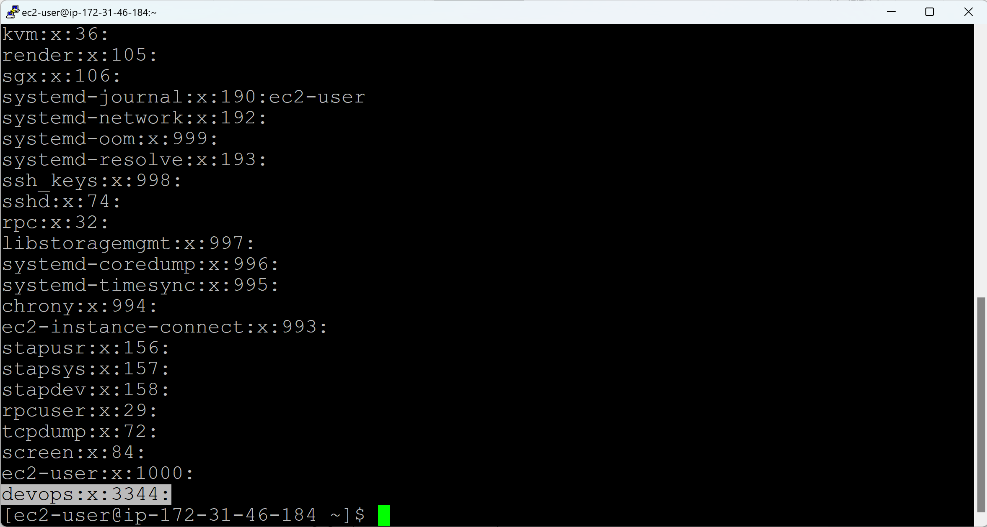

**Create custom User:**

useradd -u <userid> -g <groupid> -c “XXXX” -d <customdirectory> -s <customshell> -m <directory>

useradd -u 1122 -g 3344 -c “Sarathbabu” -d /opt/Docker/ -s /bin/zsh -m Docker

u => user

g => group

c => comment

d => custom directory (/opt/Docker/)

/opt/ => directory

Docker/ => username

s = custom shell (/bin/zsh)

-m Docker => If Docker directory is there, it will skip, else it will create Docker directory.

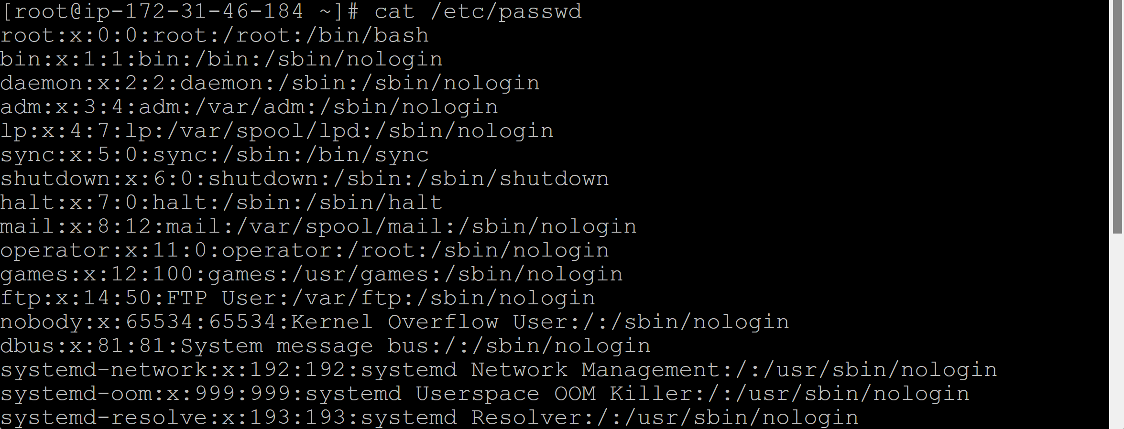

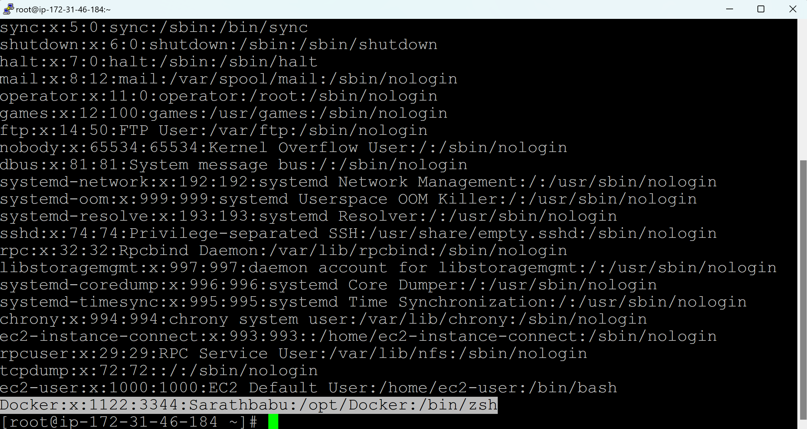

**Check, if Docker is created in the custom directory:**

cd /opt/

ls

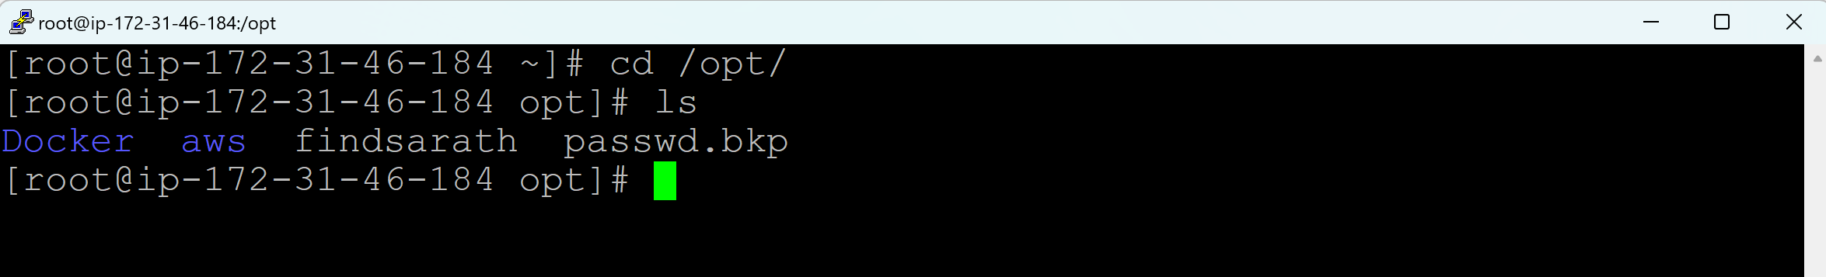

**Update user details (userid):**

usermod -u <newuserid> <username>

usermod -u 1100 Docker



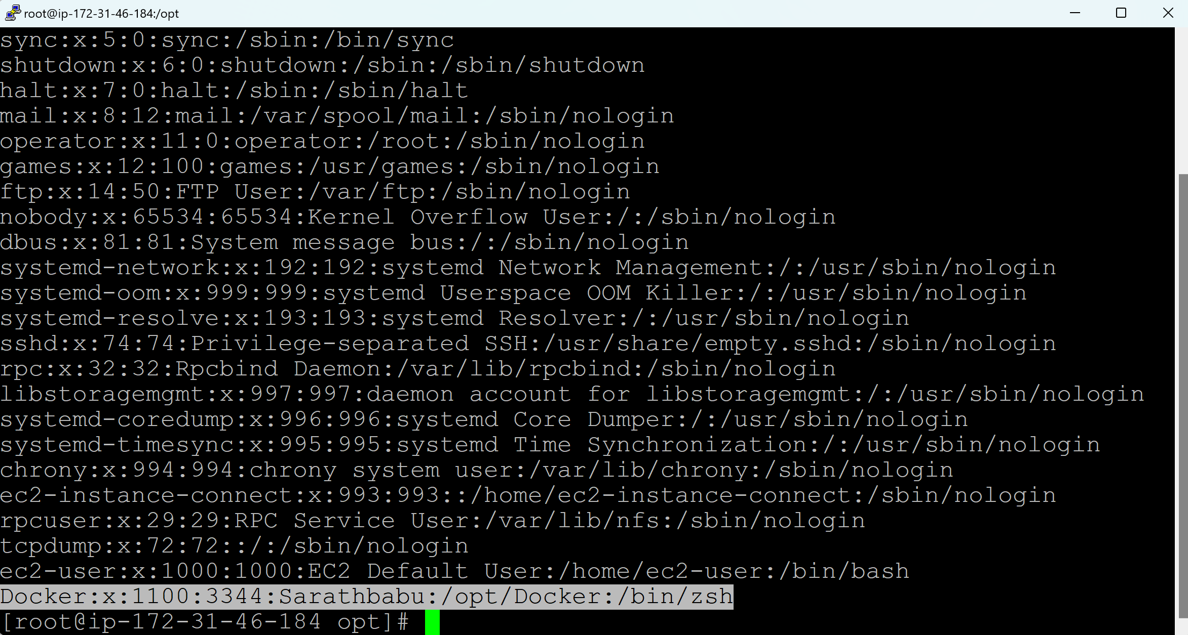

**Update user details (Username):**

usermod -l <newusername> <oldusername>

usermod -l k8s Docker



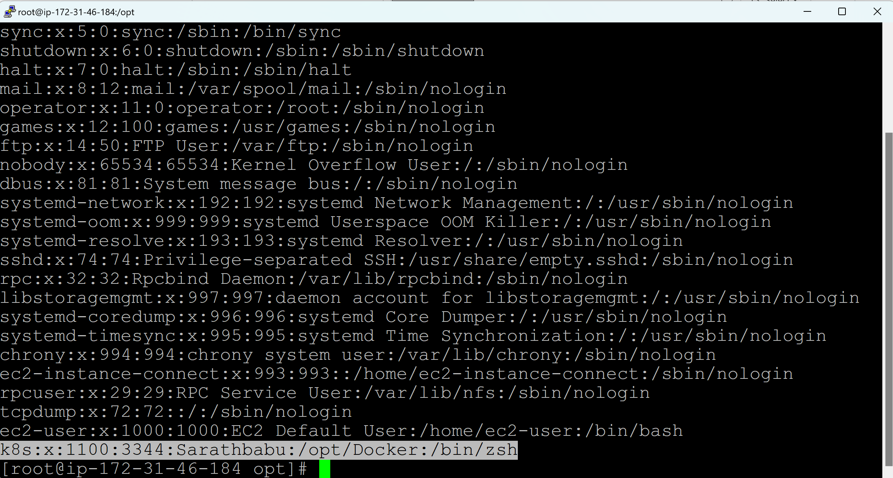

**Change age of the User / Set expiry date for the user:**

chage -E <YYYY-MM-DD> <username>

chage -E 2025-01-31 k8s

**Check the details of the expiry date of the user:**

chage -l <username>

chage -l k8s

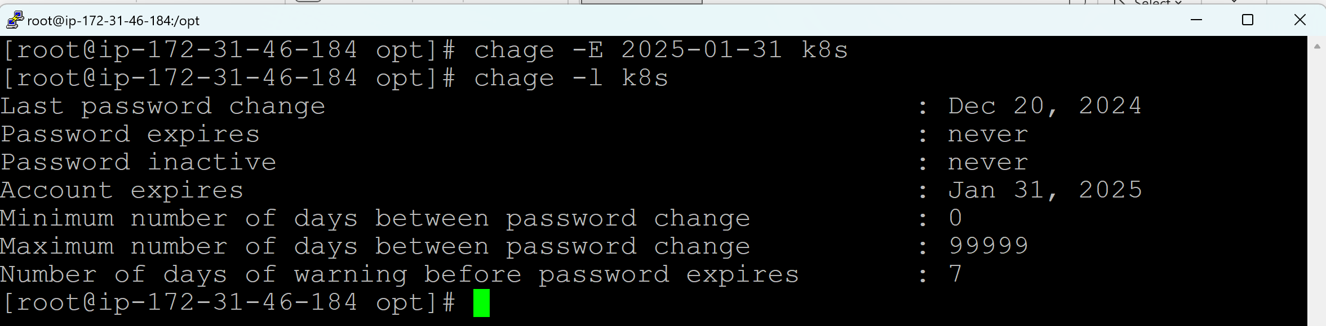

**Change ownership of the User only:**

chown <newownername> <filename>

chown ec2-user Jenkins

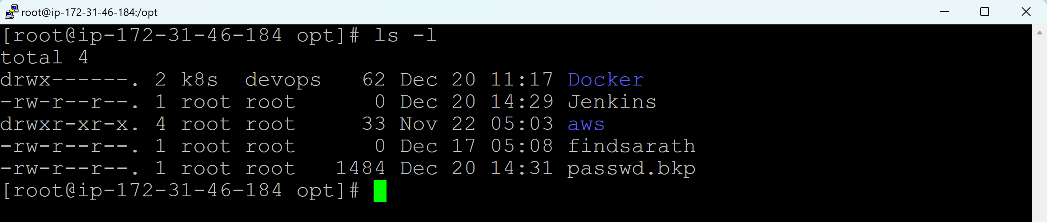

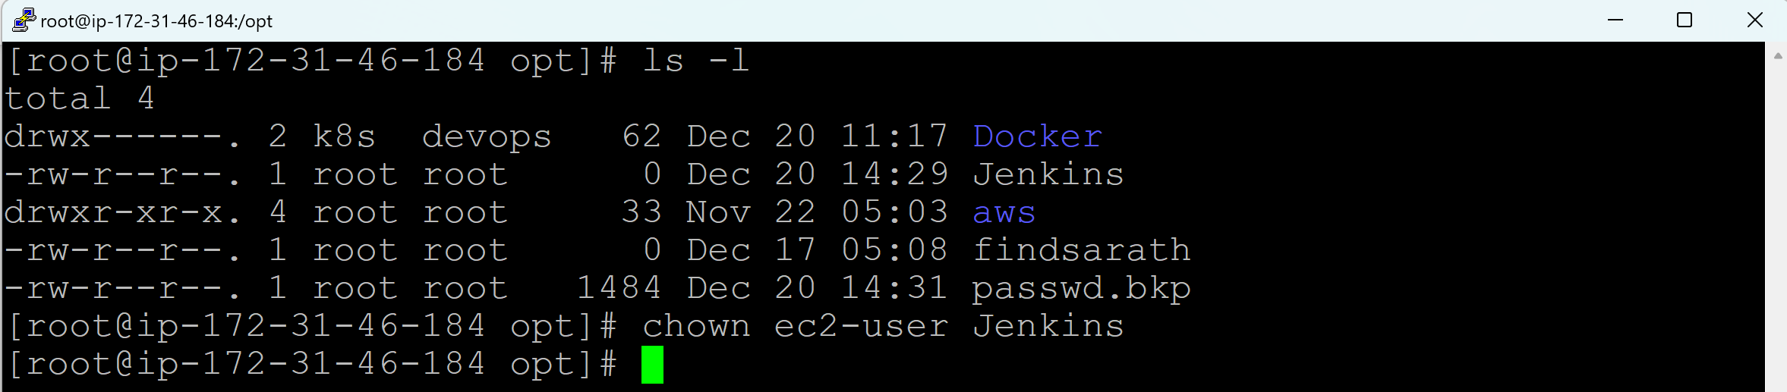

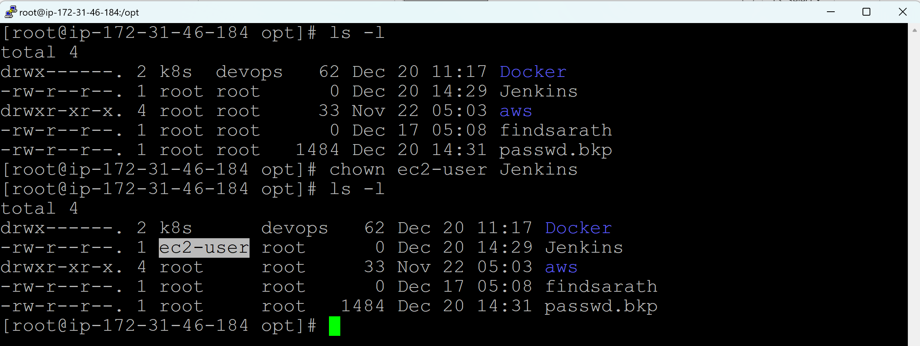

**Change Owneship of the User and Group:**

chown <newownername>:<newgroupname> <filename>

chown ec2-user:devops passwd.bkp

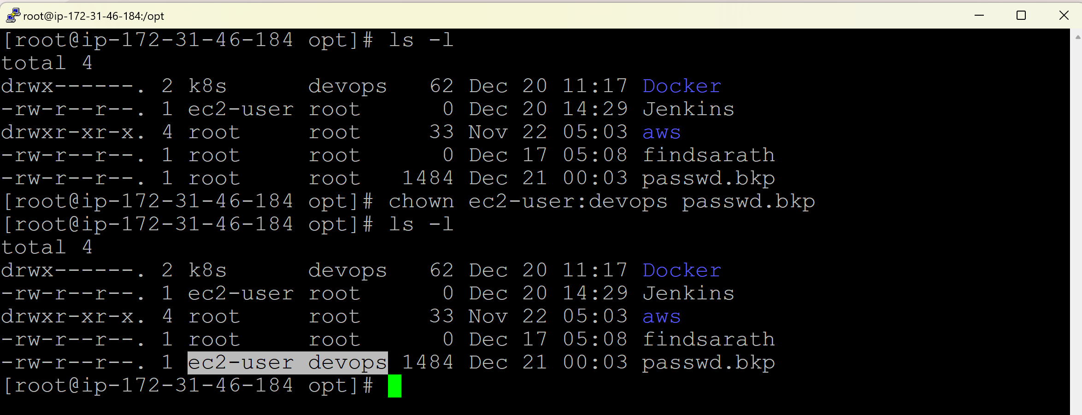

**Change Owneship of the Group only:**

chown :<newgroupname> <filename>

chown :devops Jenkins

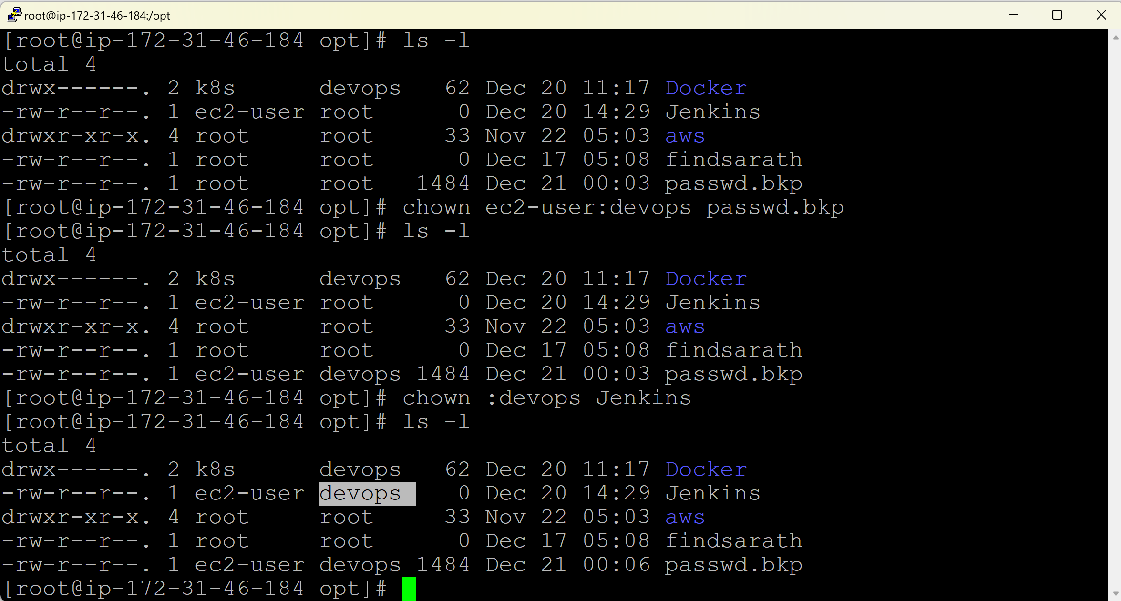

**Day 18 (SSH Protocol)**

* SSH – Secure Shell
* It is a protocol used to securely connect a remote server or remote computer over a network.
* SSH Clients – PuTTY, MobaXterm, Gitbash, WSL, SCH Client
  + We are connecting Linux (Target/Remote server) from Windows OS (local server) with the help of these SSH Clients.
  + We must be having .ppk file to connect from Windows to Linux Server.
* SSH Protocol – Telnet, Rlogin, Ssh
  + We can connect from one Linux box to another Linux box with the help of SSH Protocols.
  + We don’t have to install it in Windows as it is a default one is Linux server.
  + We must be having .pem file to connect from one Linux server to another Linux server.
* RDP Protocol
  + We can connect from one Windows OS to another Windows OS with the help of RDP (Remote Desktop) Protocol.
  + We don’t have to install it in Windows as it is a default one in Windows.
* We need IP address, username (ec2-username) and key (.ppk file) to connect to Linux server from Windows OS using PuTTY

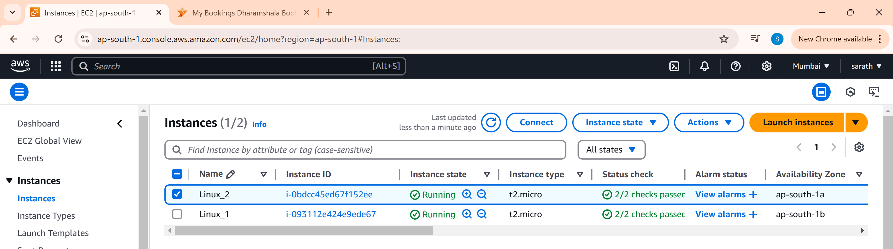

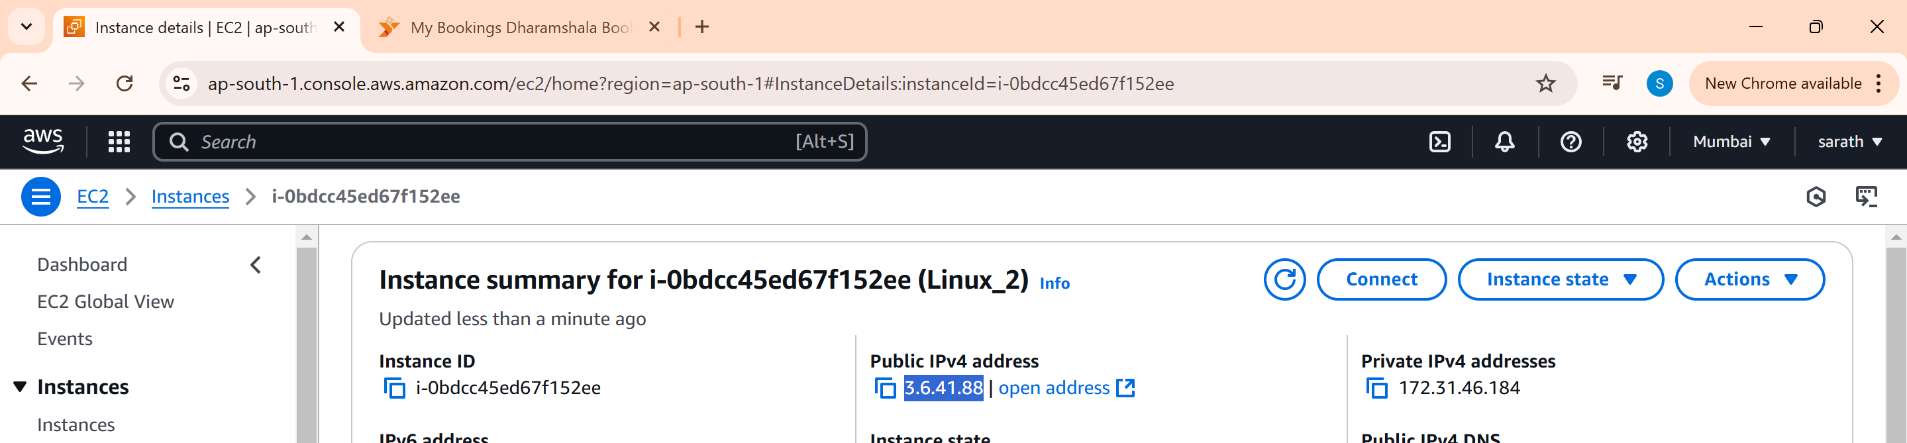

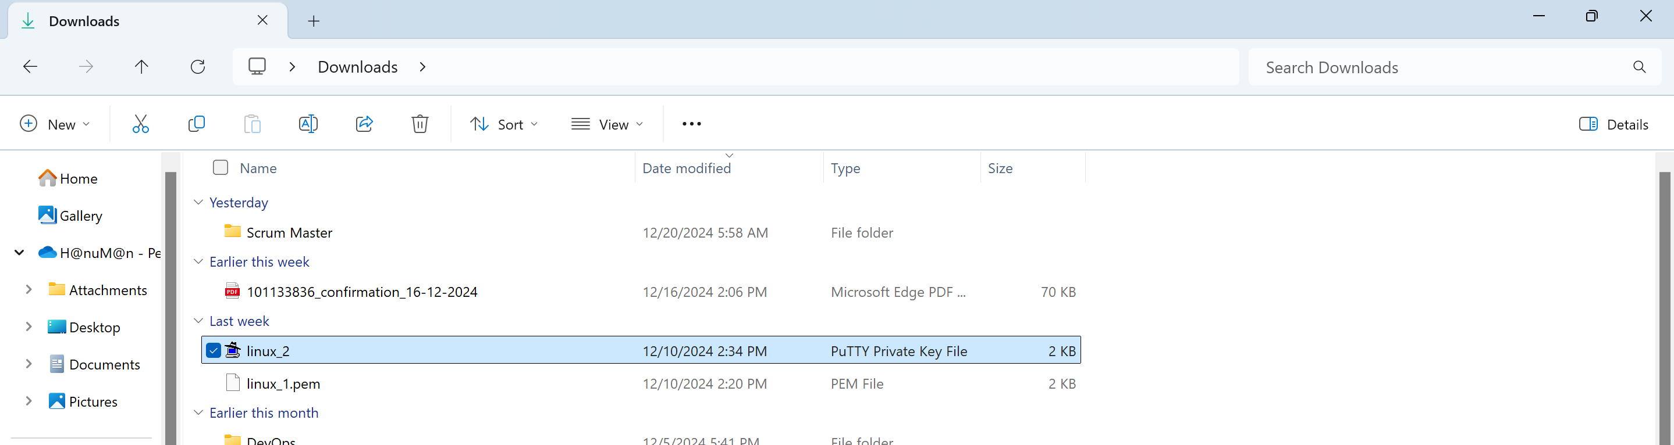

Open PuTTY

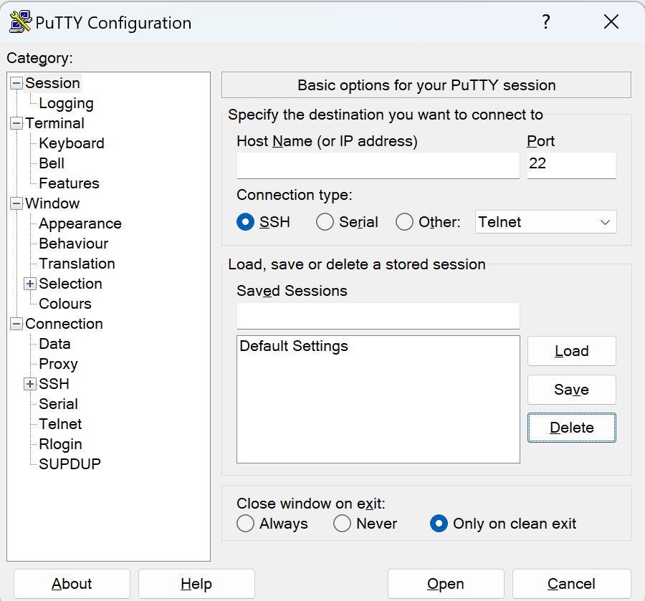

Enter IP address

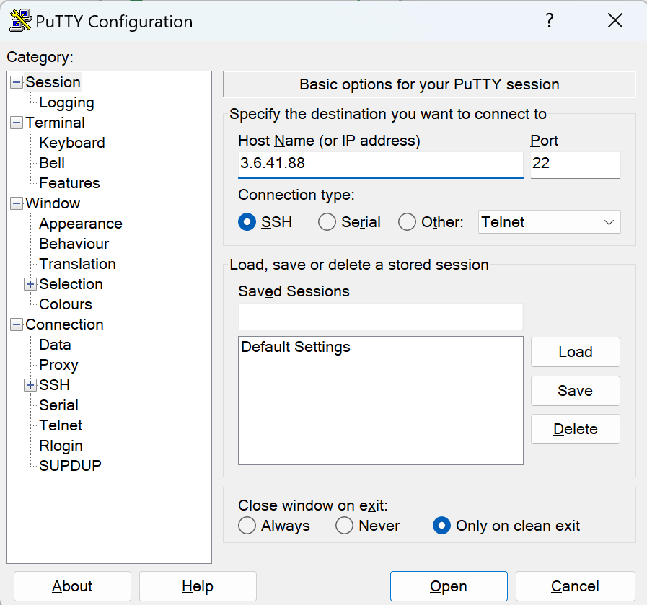

To upload the .ppk file, Go to Connection > SSH > Auth > Credentials

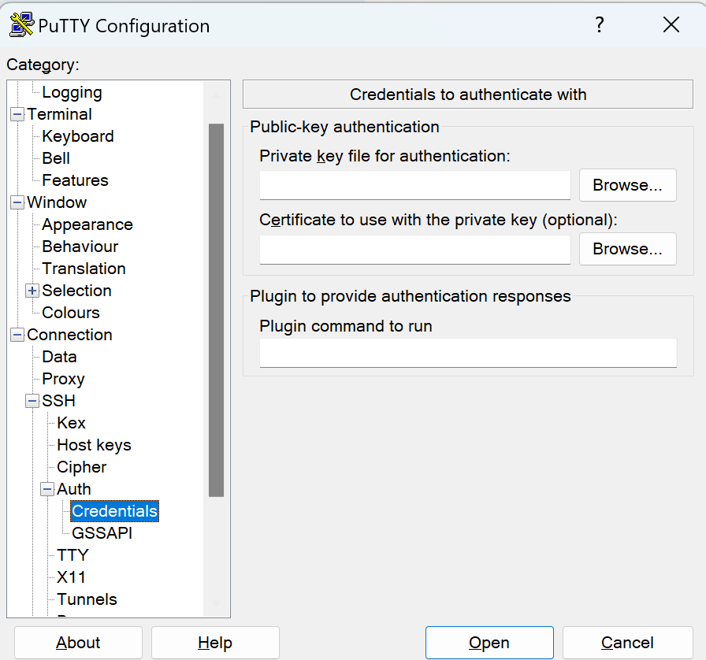

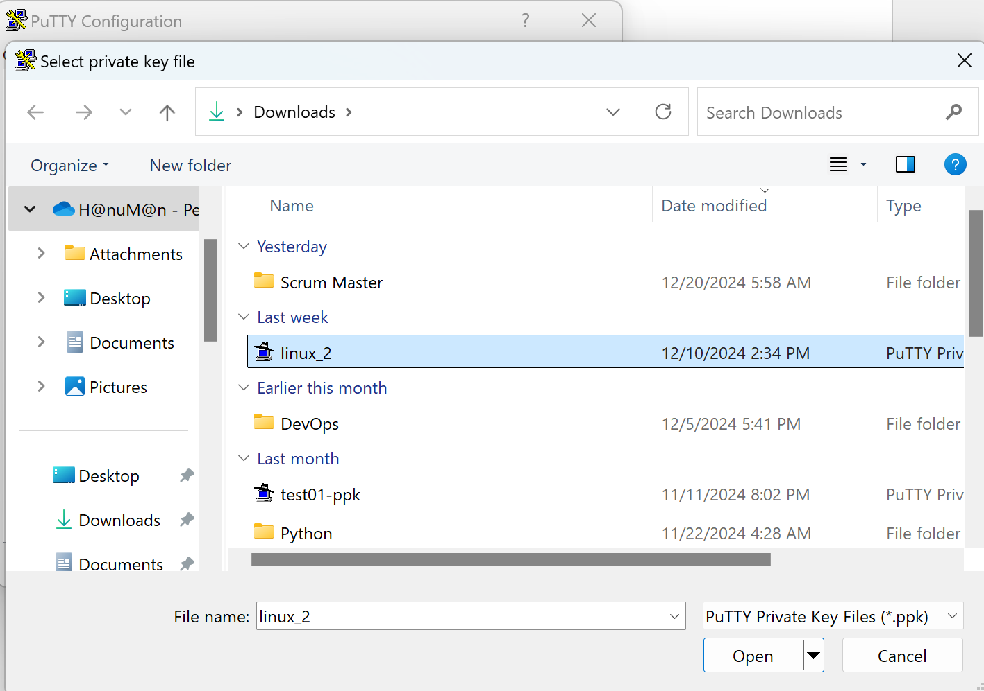

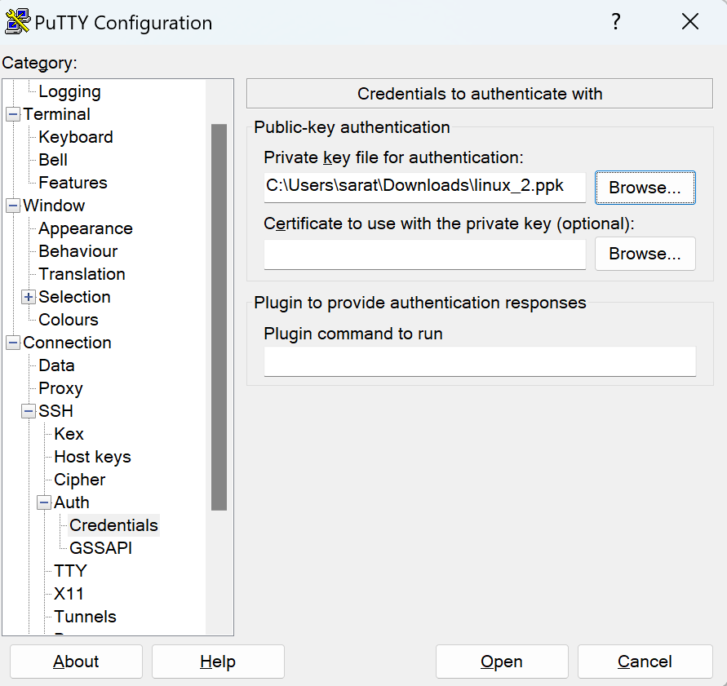

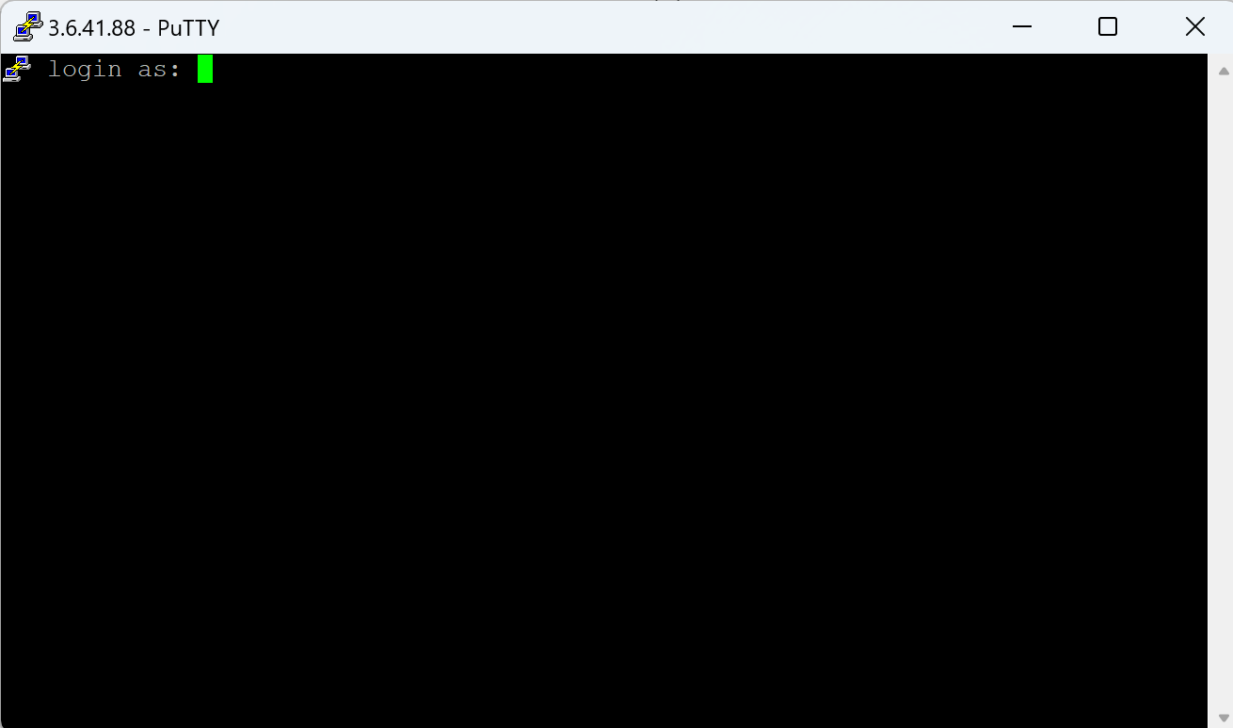

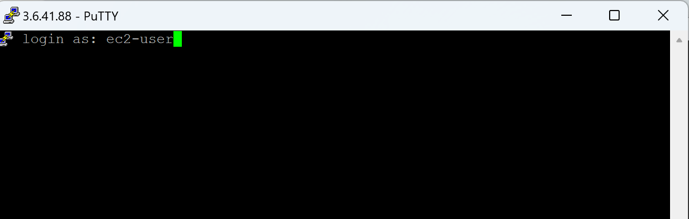

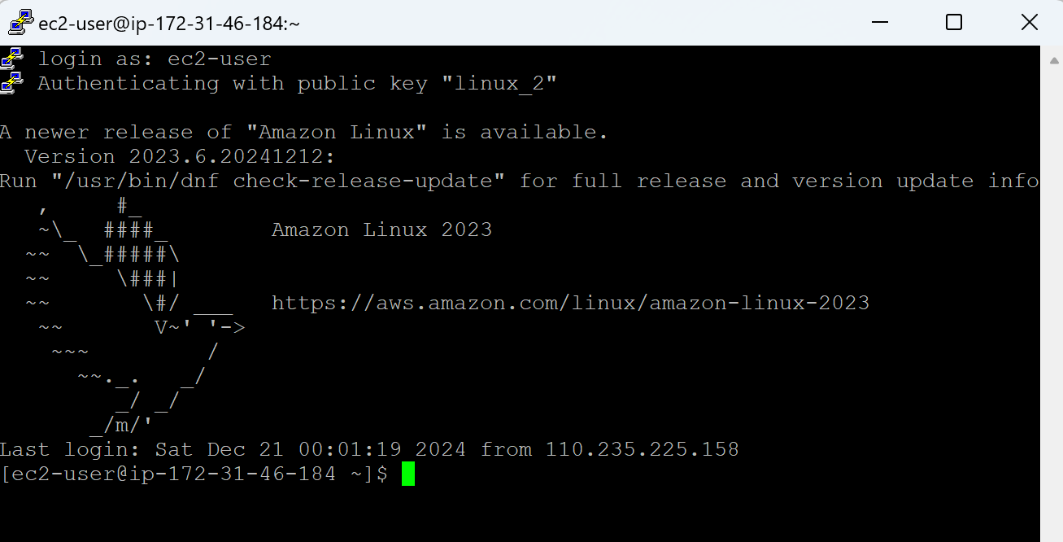

* From this Linux server (Linux_2), We want to connect to another Linux server (Linux_1)
* We need Linux_1 server details: IP address, username (ec2-username) and key (.pem file) to connect.
* We must keep Linux_1 server’s .pem file in Linux_2 server, then only we can connect to Linux_1 server from Linux_2 server.
* We need WinSCP tool (Windows Secure Copy) to copy files from Windows to Linux and vice versa.
* Download, Install & Open WinSCP tool

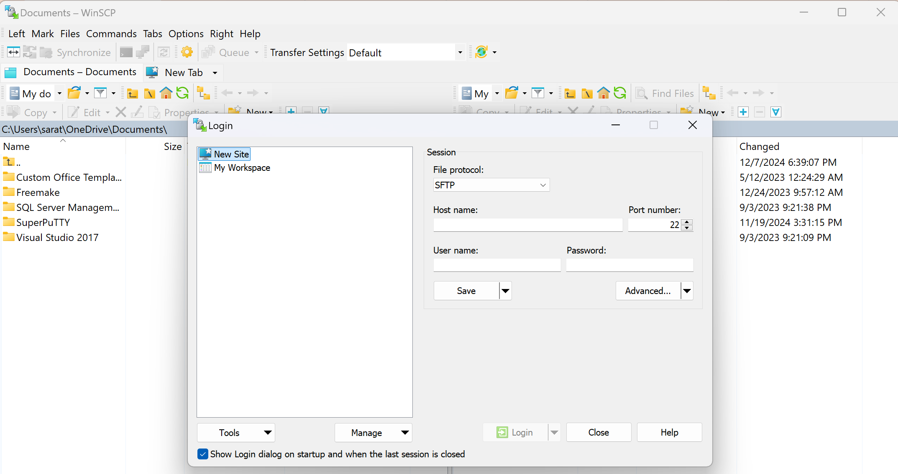

* Enter Linux_2 Server details

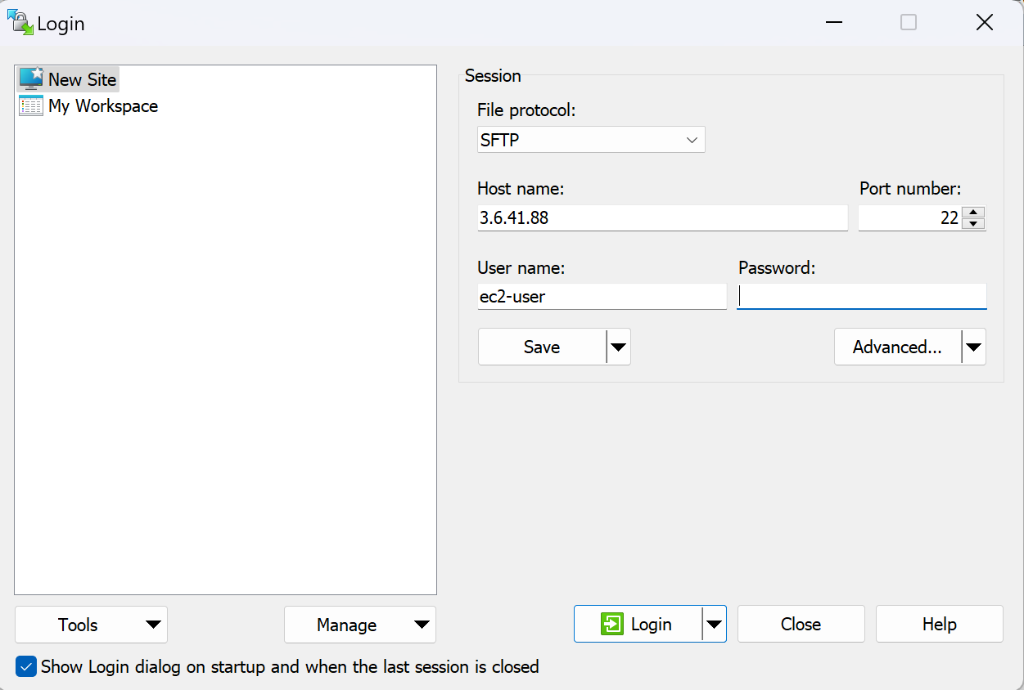

* Since we don’t have Password and we have only Key, Go to ‘Advanced’ > Authentication > Browse for the .ppk file > Upload the file > Click on OK > Clikc on Login

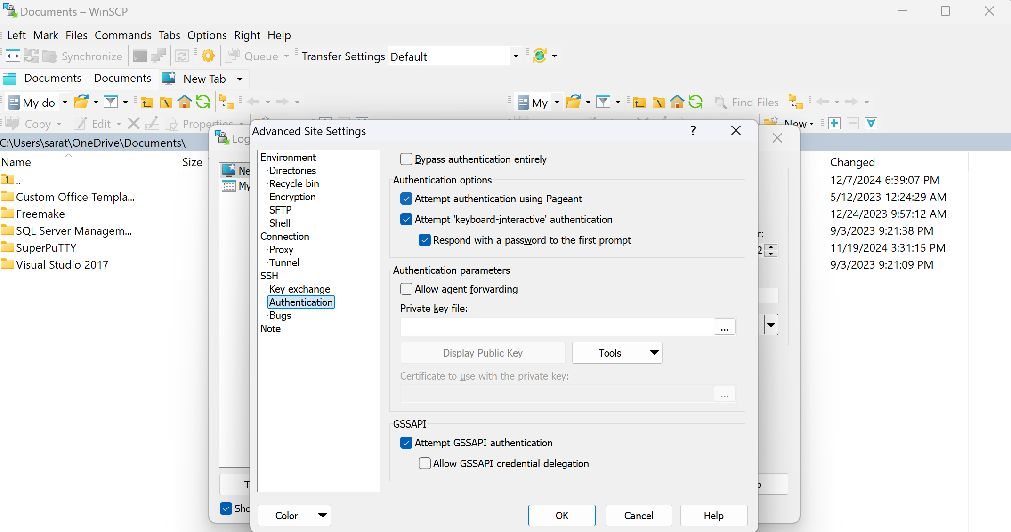

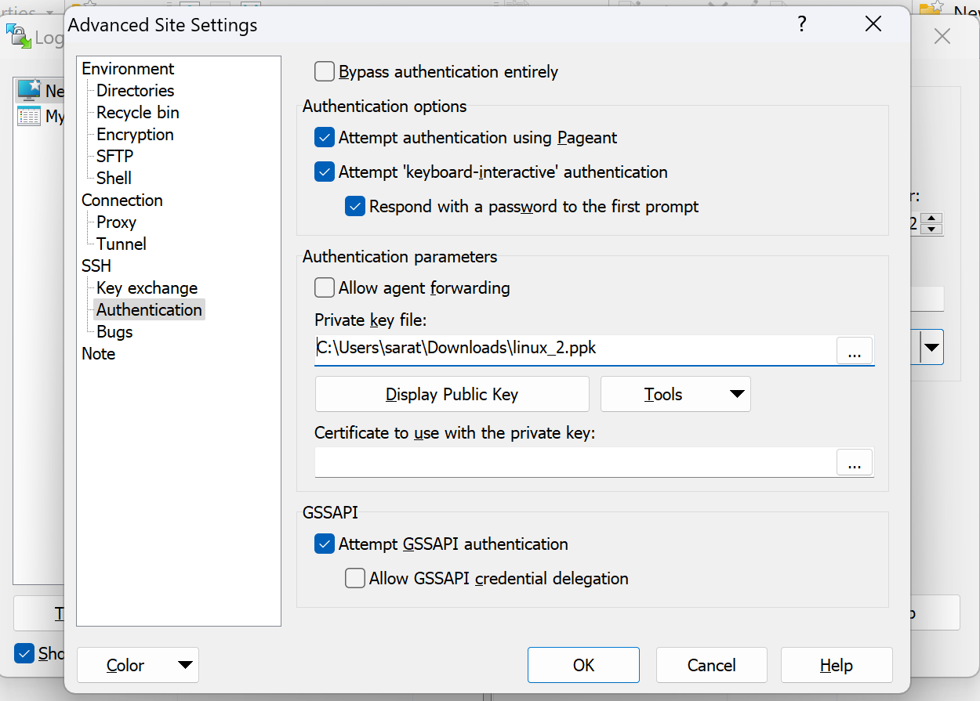

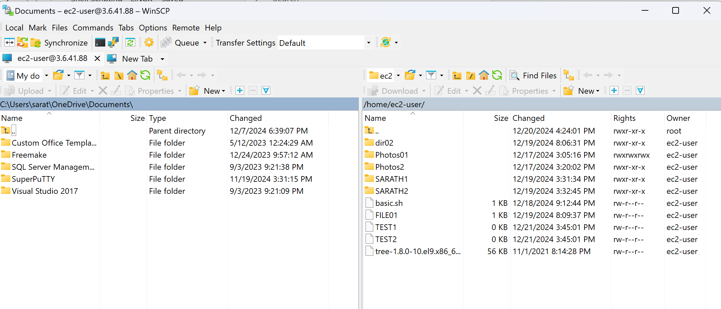

* Leftside one is Windows and Right side one with Linux_2 Server
* Go to Downloads on the left side pan > Search for the Linux_1 server’s .pem file

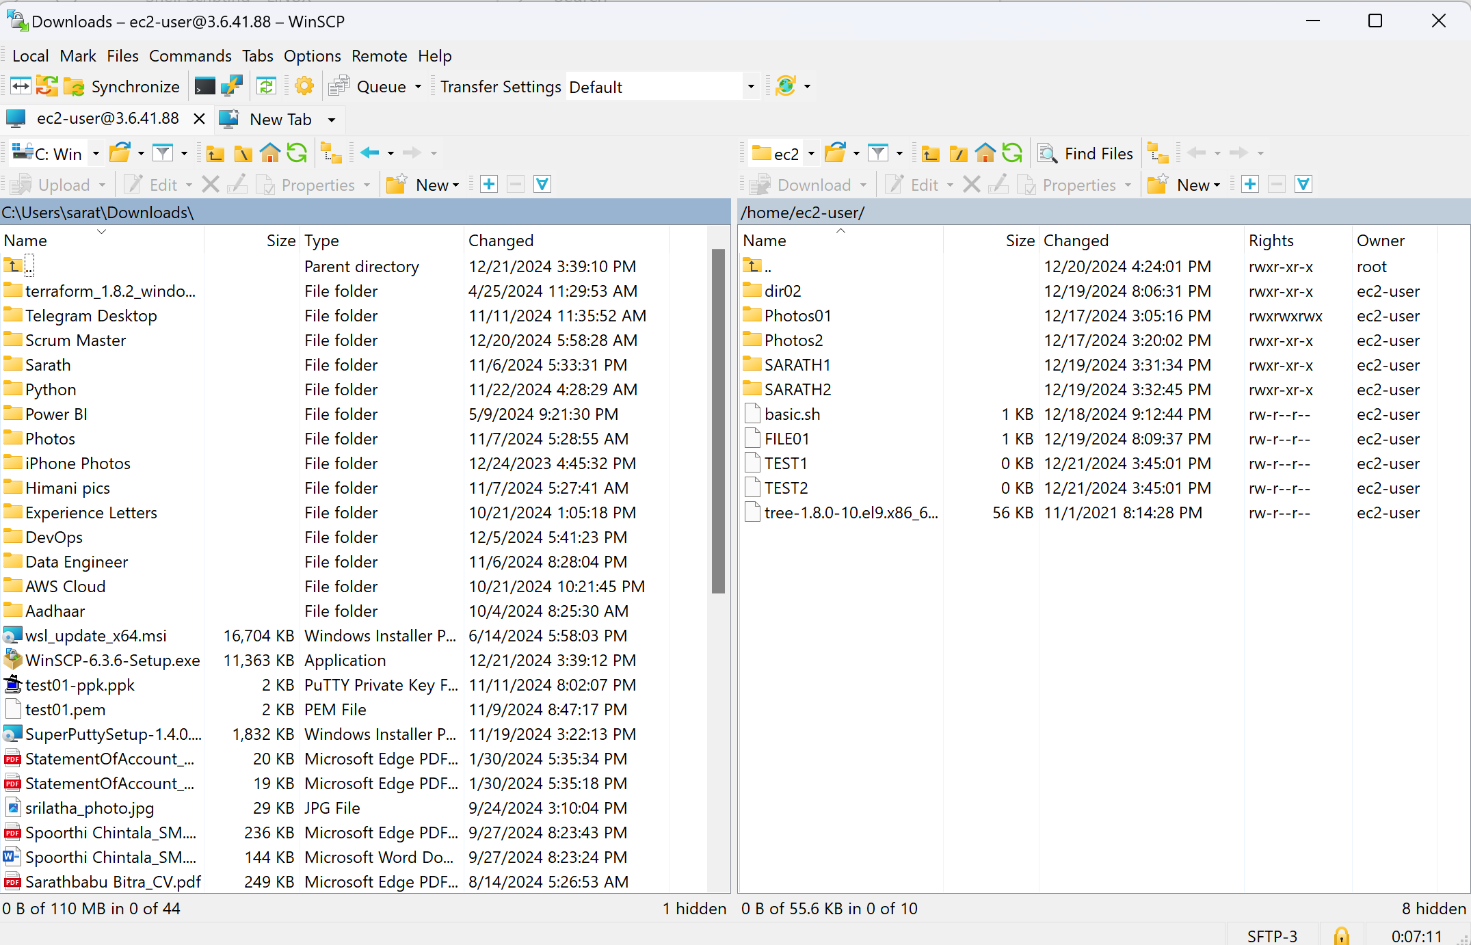

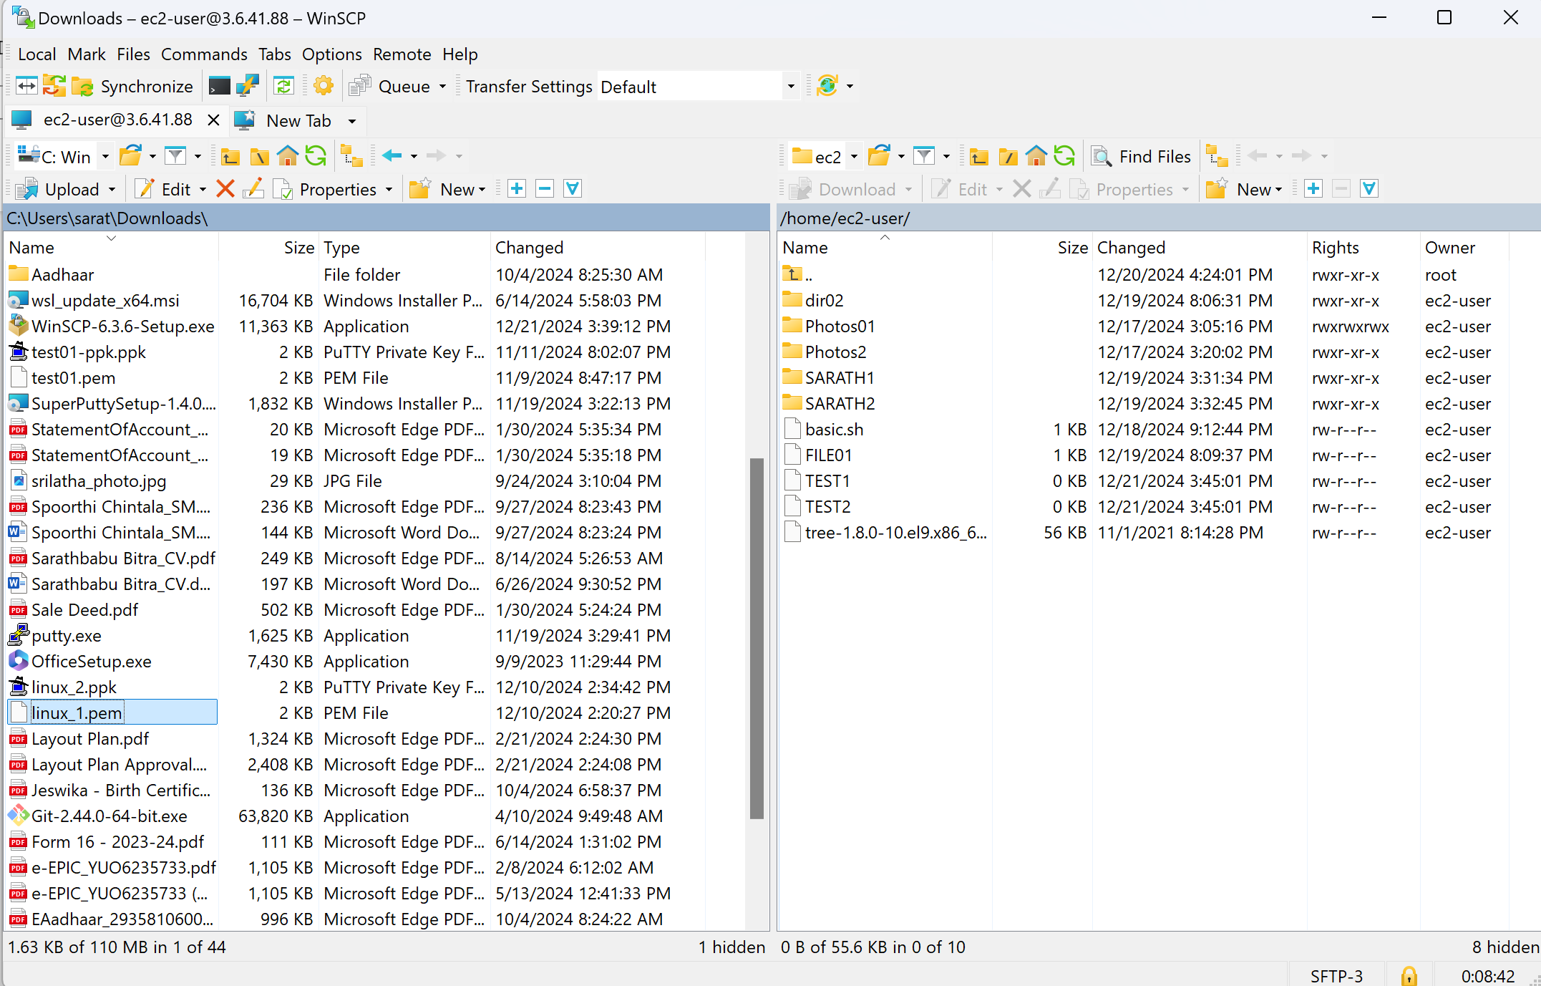

* Drag and Drop towards right side pan

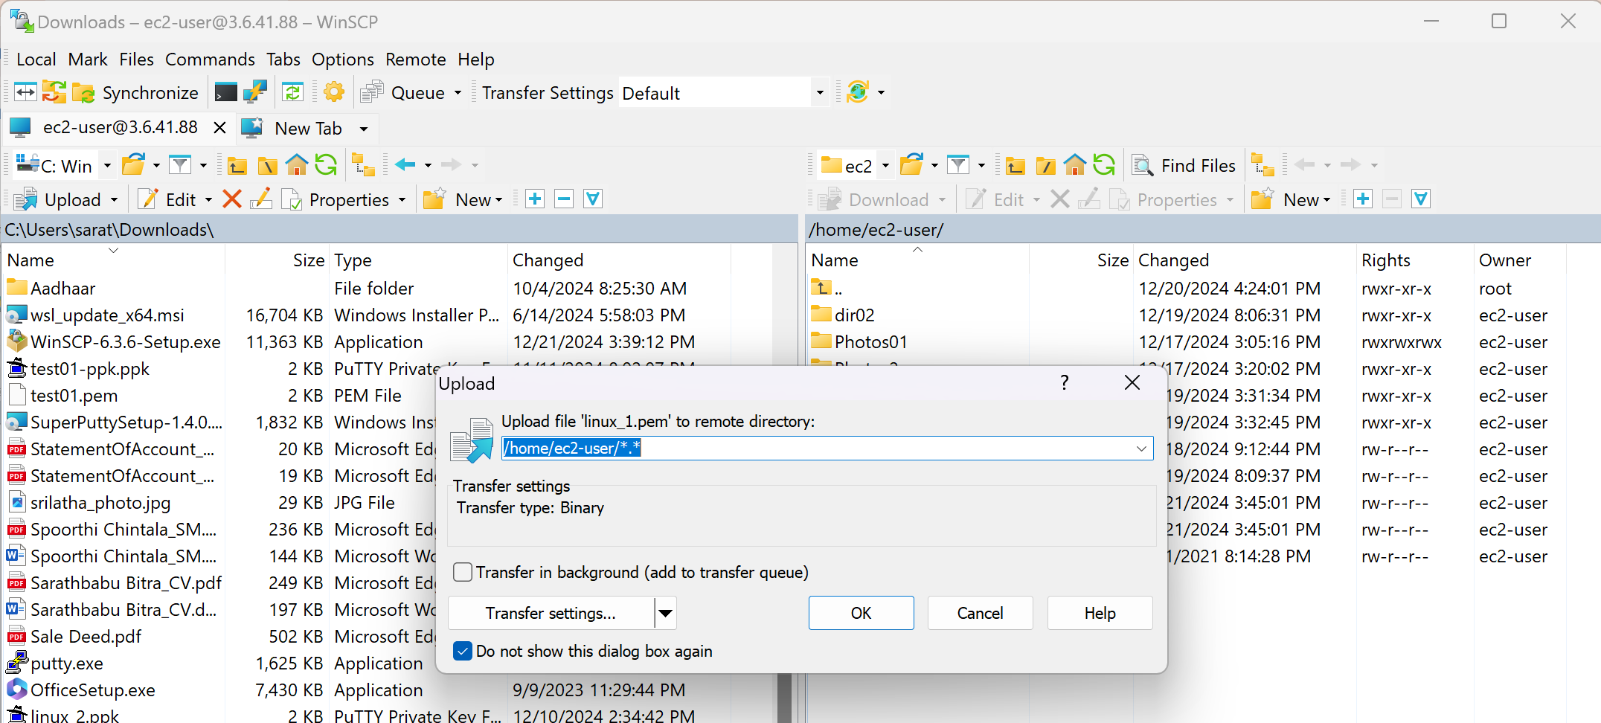

* Click on OK

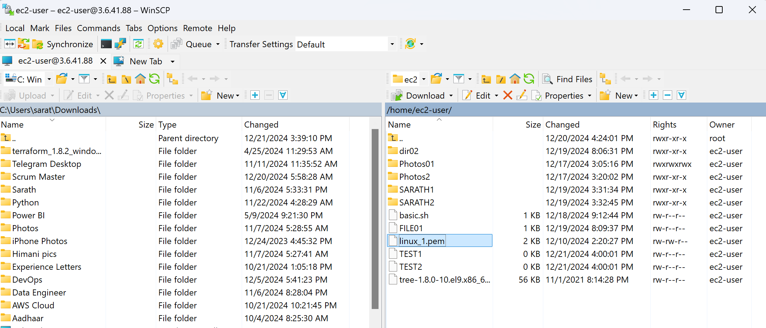

* Now login to Linux_2 server and search for the files

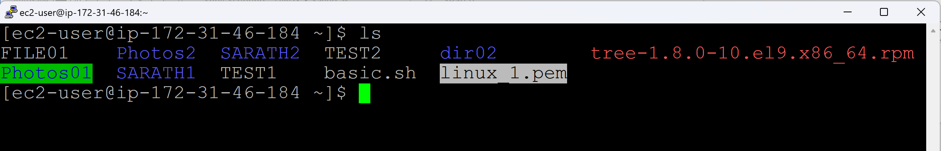

**Connect to Linux_1 server using ssh protocol:**

ssh -i <pathofpem> username@Linux_1serverIP

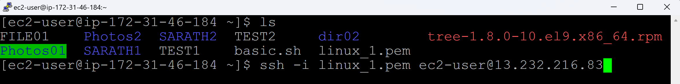

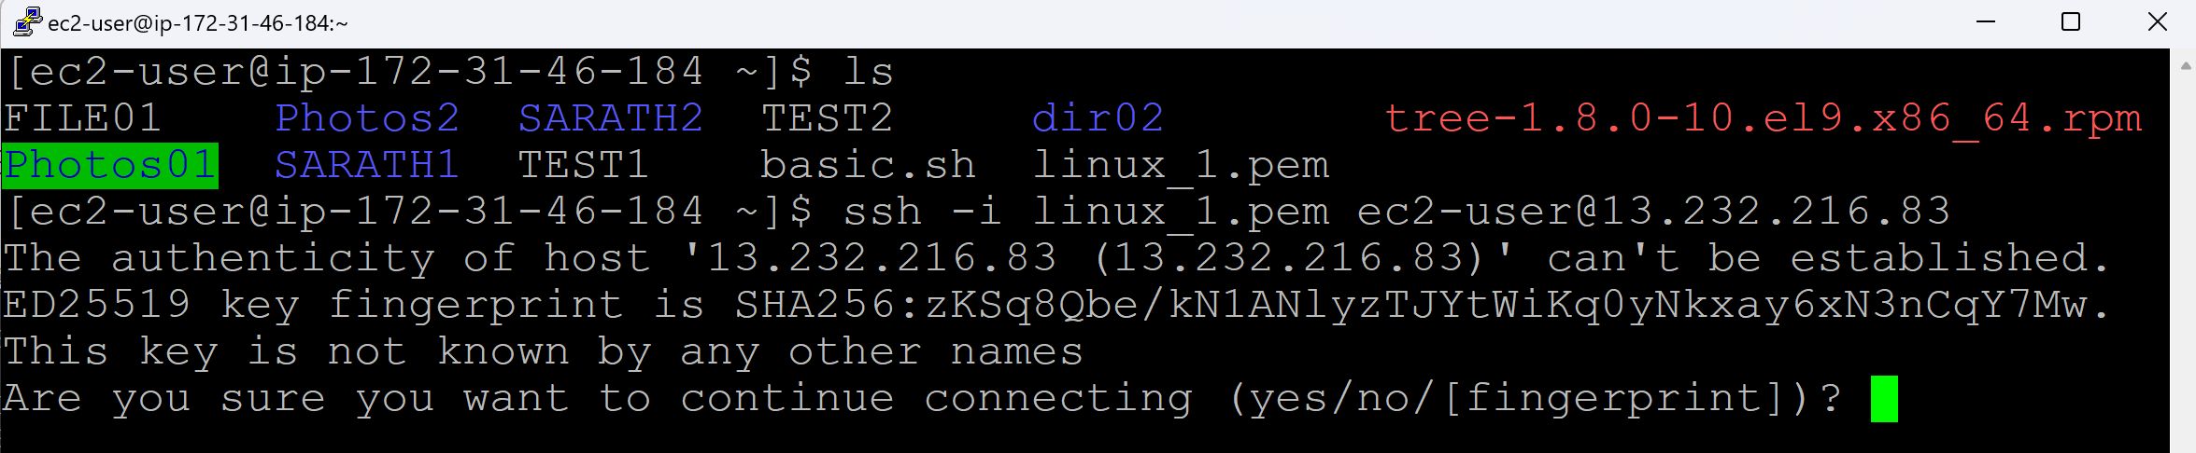

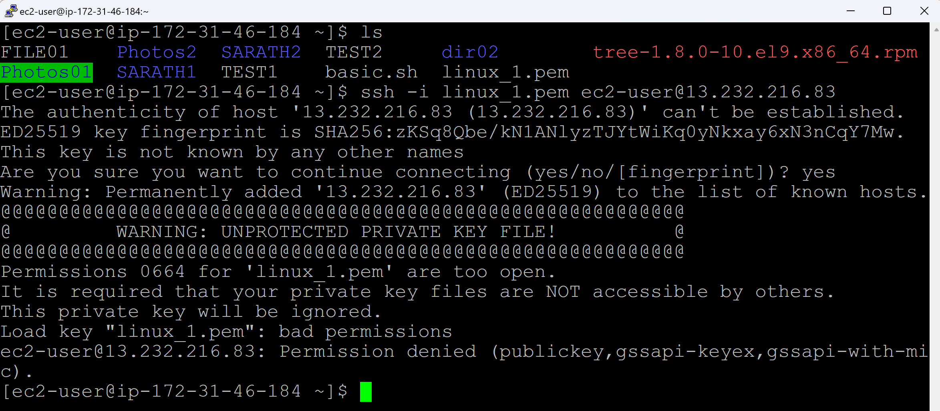

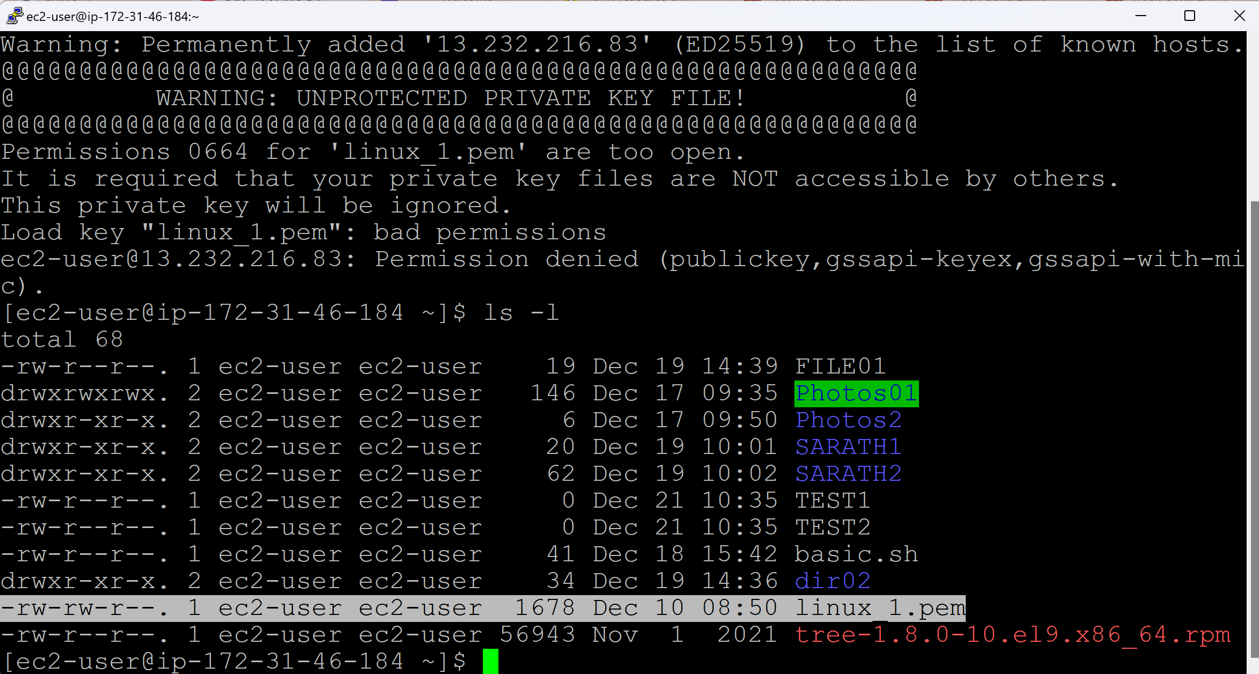

It must be having only read permission

chmod 400 <.pem file>

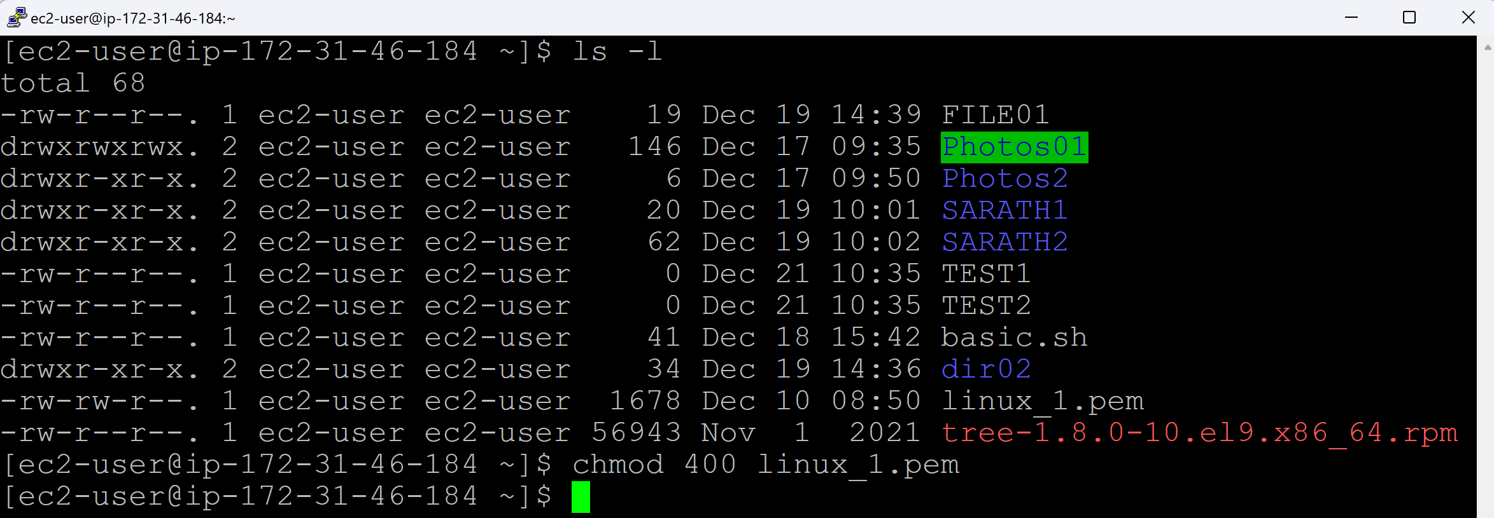

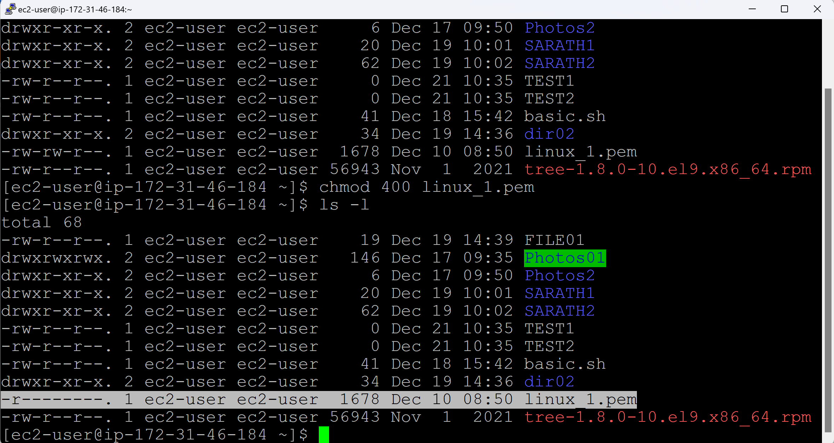

Now rerun the same command

ssh -i <pemkey> username@Linux_1serverIP

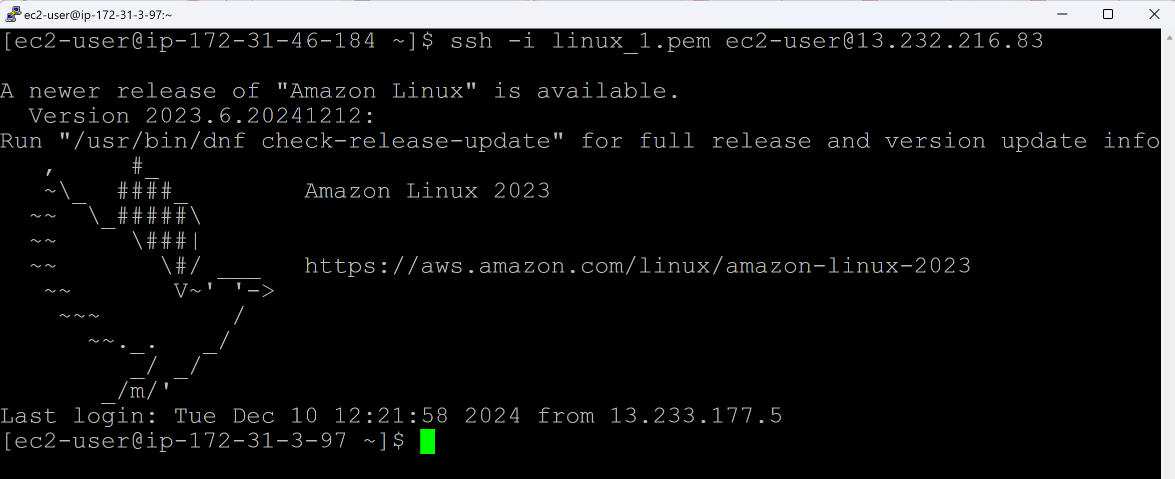

To go back to the previous server (Linux_2)

exit

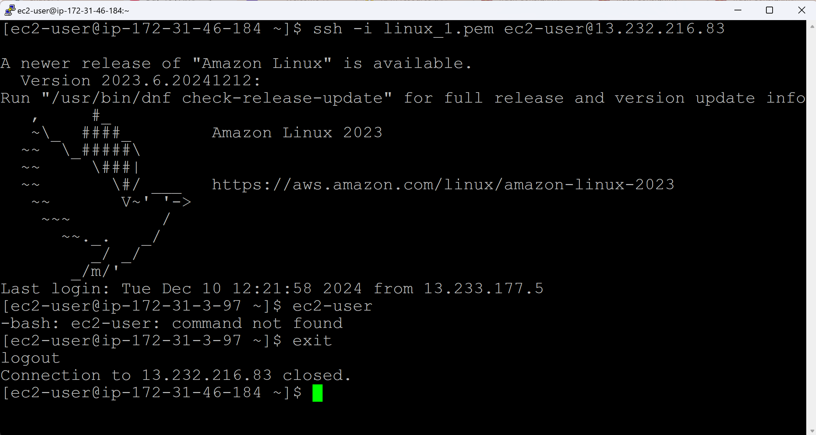

**Port Number:**

* Port Number is a numerical identifier in network that helps direct trafic to the correct service or application running on a server.

SSH port number = 22

FTP port number = 20 & 21

Telnet = 23

HTTP = 80

HTTPS = 443

Tomcat = 8080

Jenkins = 8080

Sonarcube = 9000

Nexus = 8081

Ansible = 22

**Day 19 (Password Key Authentication / Trust Relation / Keys Transfer)**

* This concept will be used in Git
* This concept will be used in Jenkins
* This concept will be used in Ansible

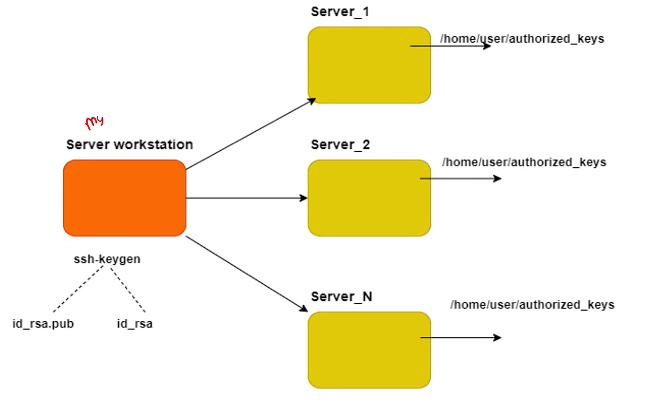

Connect to Linux_2 Server



Create keys in Linux_2 Server:

Check, if there is .ssh directory in Linux_2 Server

ls -a

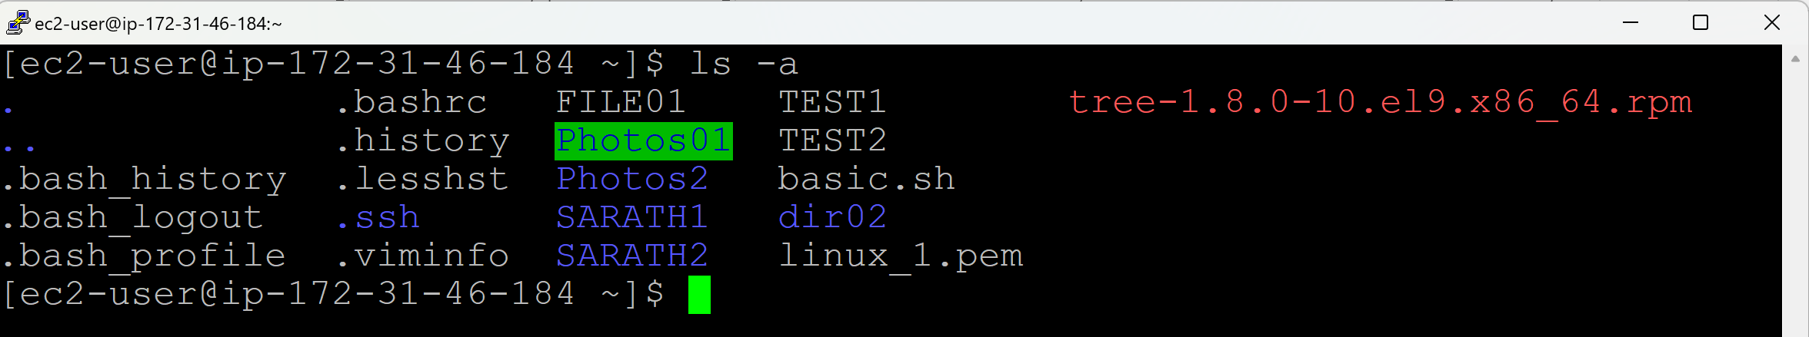

Check for the files in .ssh directory

cd .ssh/

ls

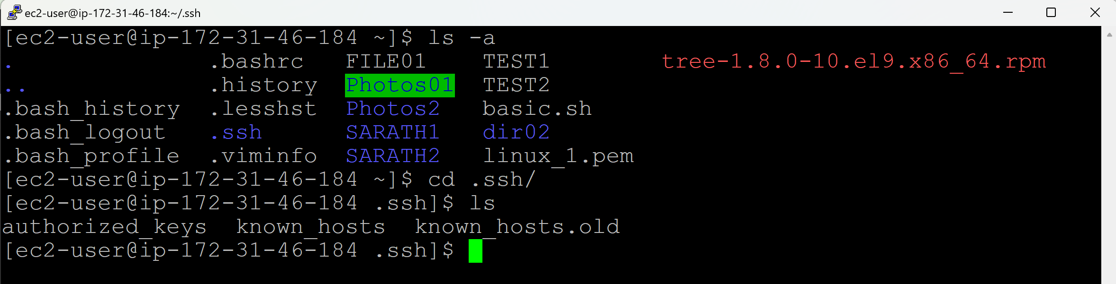

Generate keys:

ssh-keygen

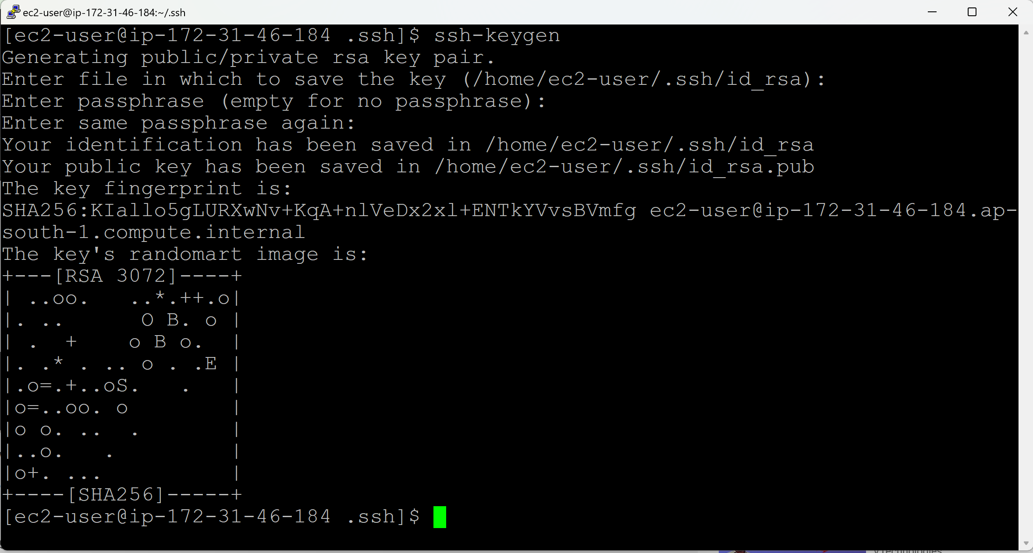

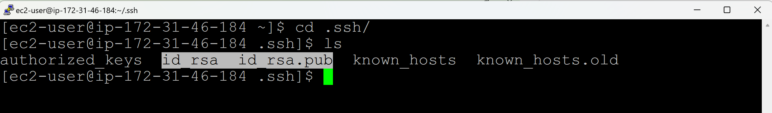

Open the public key file

cat id_rsa.pub

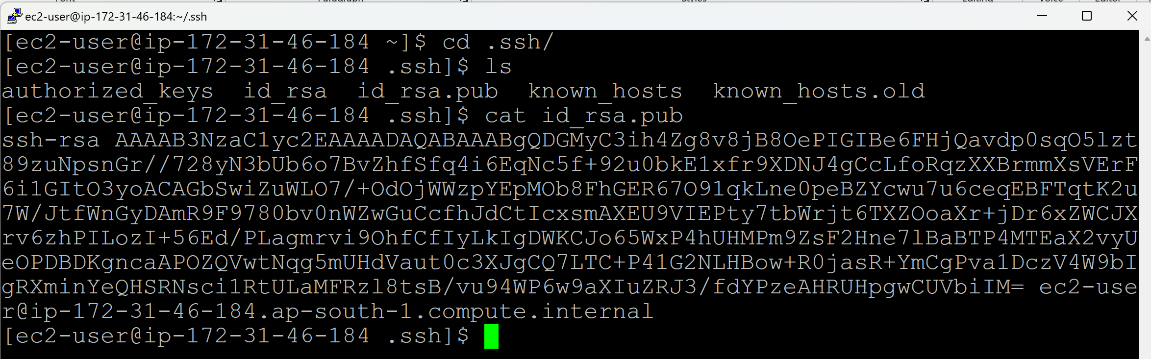

Copy the key

Connect to the Linux_1 Server through AWS Console

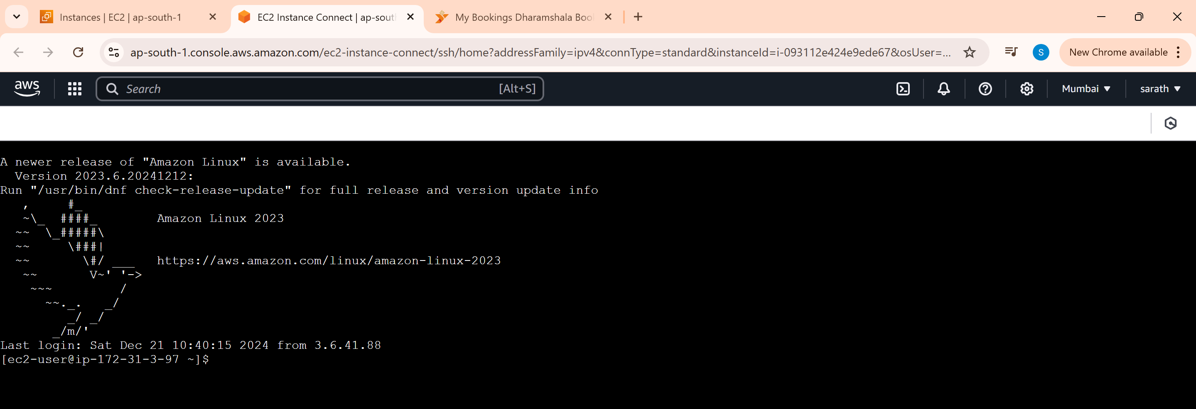

To view the hidden files/directories

ls -a

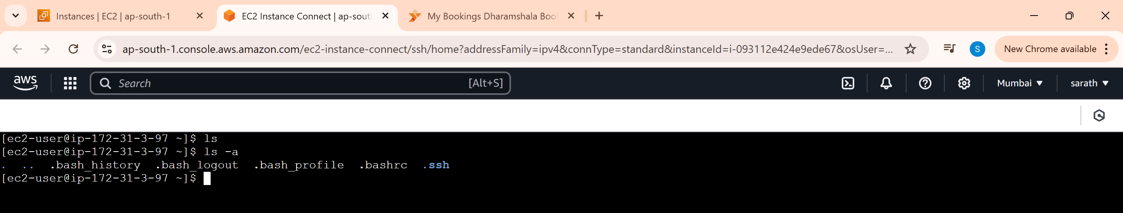

Go to .ssh/

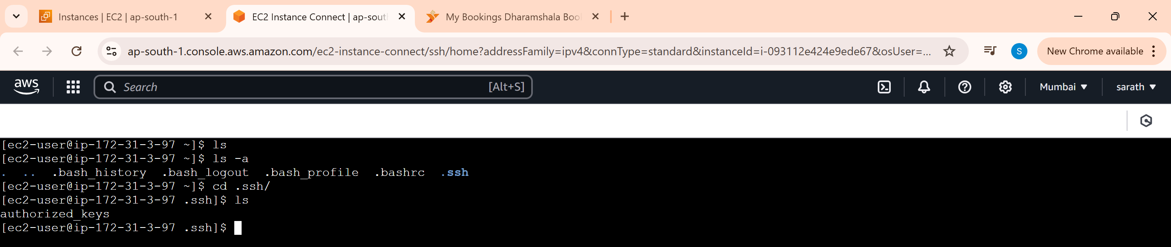

Open the file in Vim editor mode

vim authorized_keys

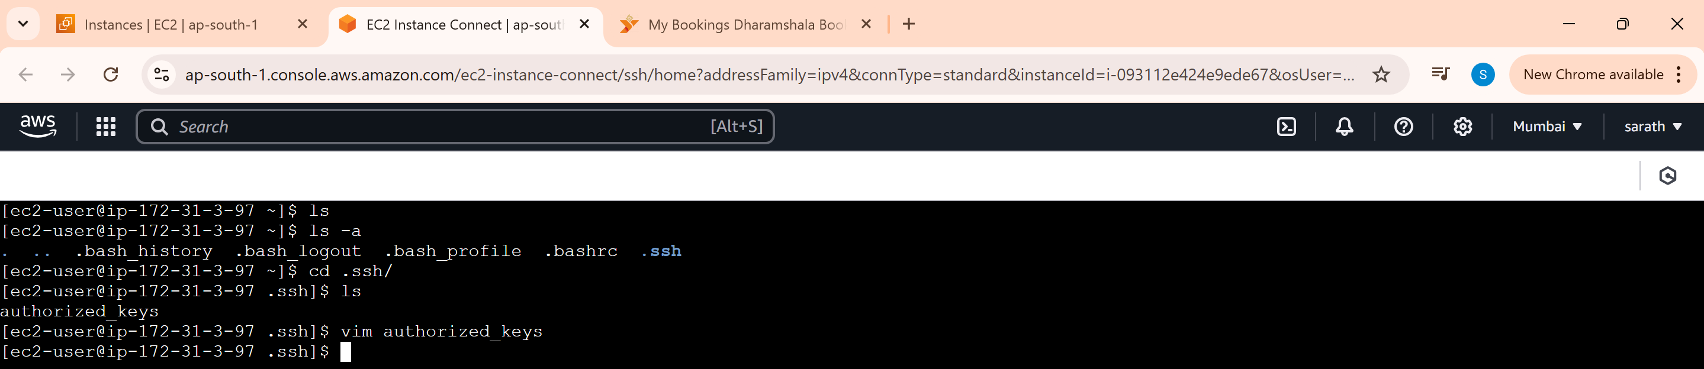

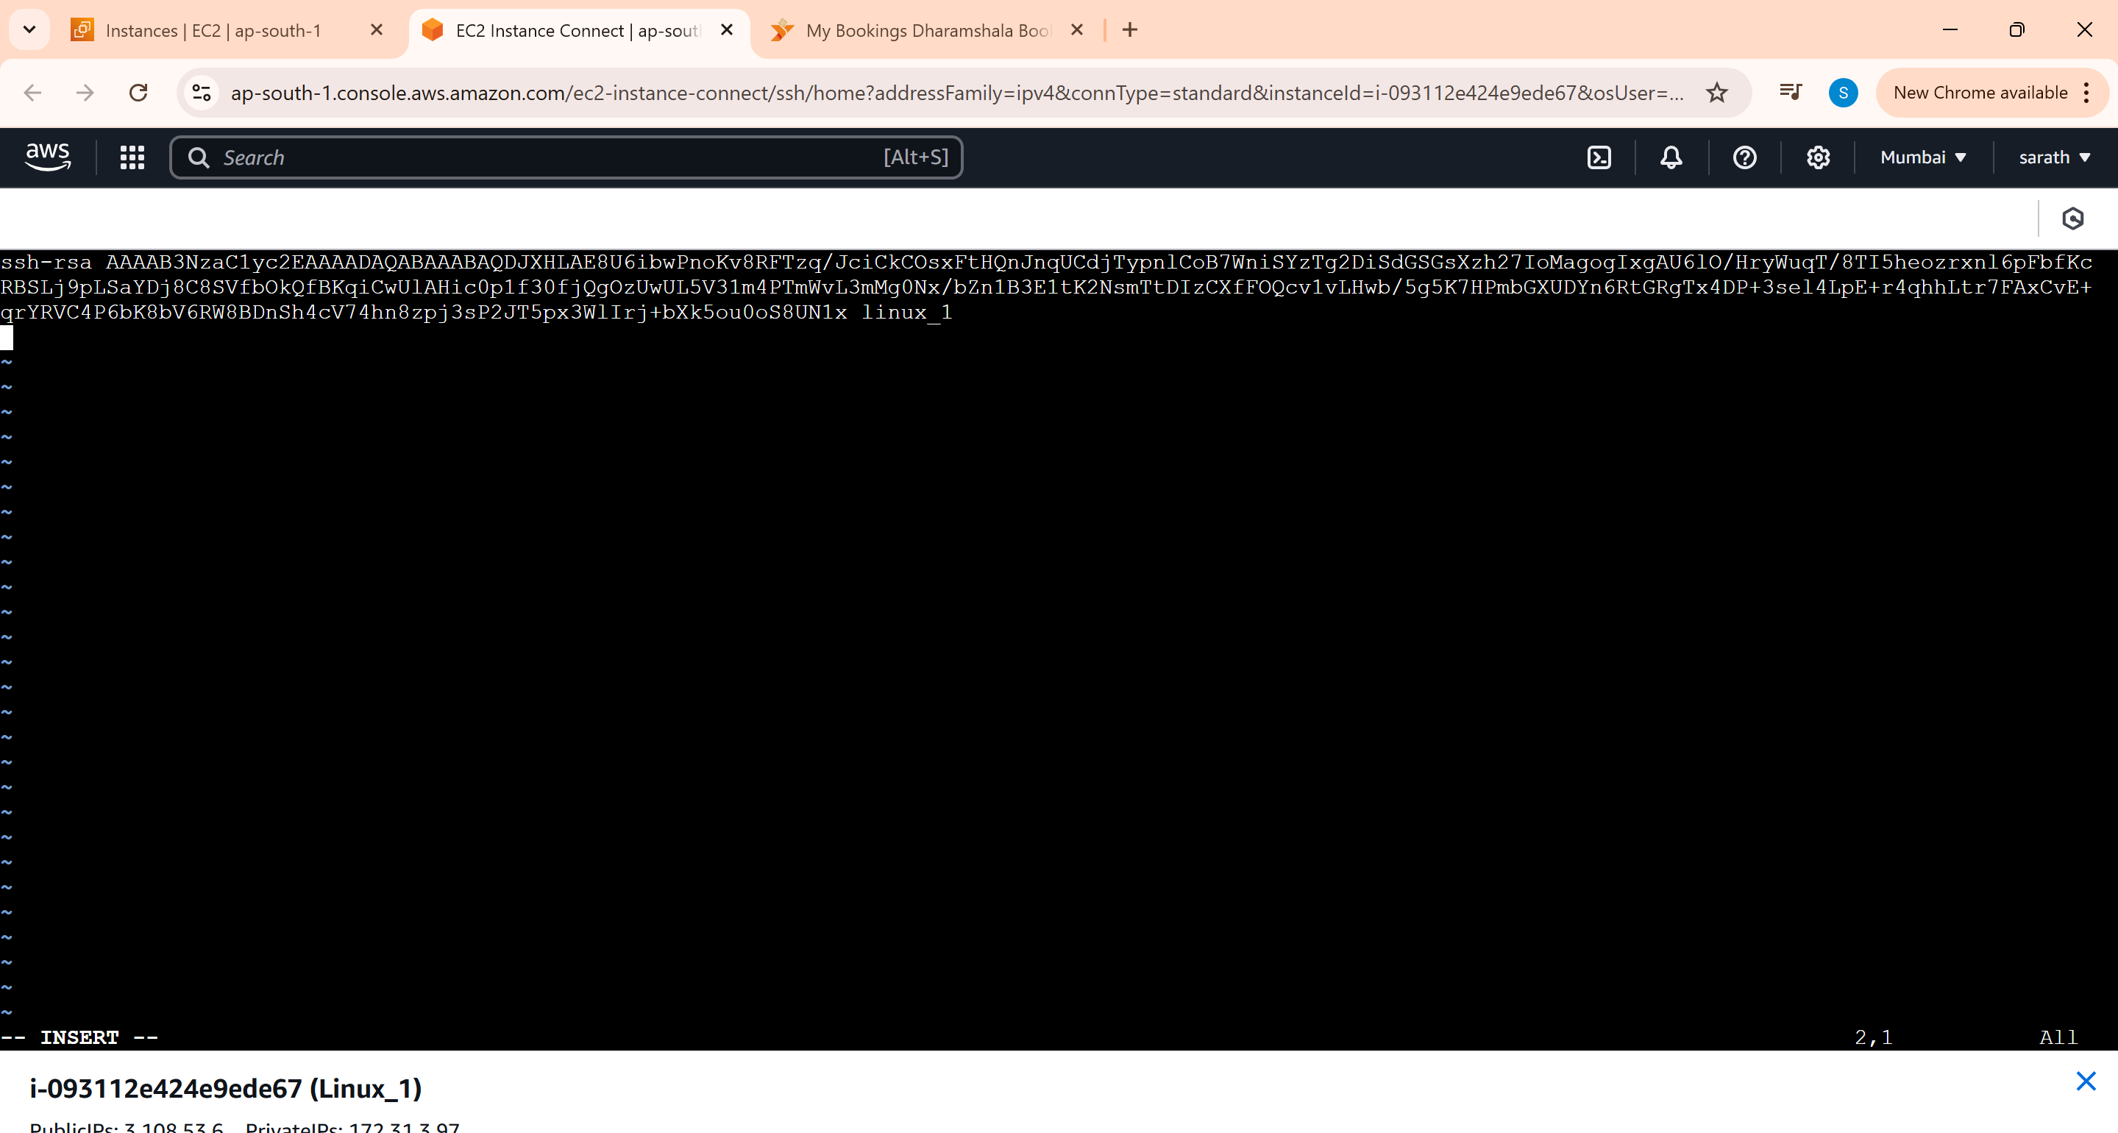

Paste the key which was copied from the Linux_2 server in a fresh line

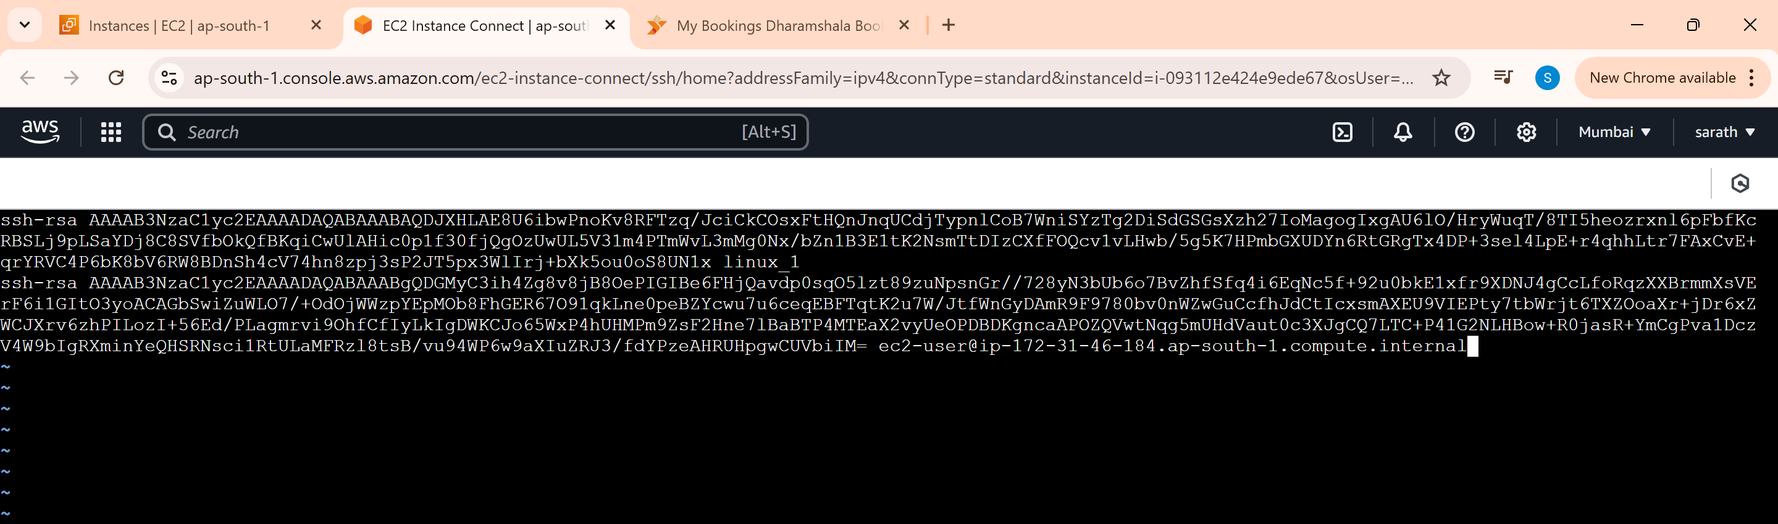

Restart the service in Linux_2 server

sudo service sshd restart

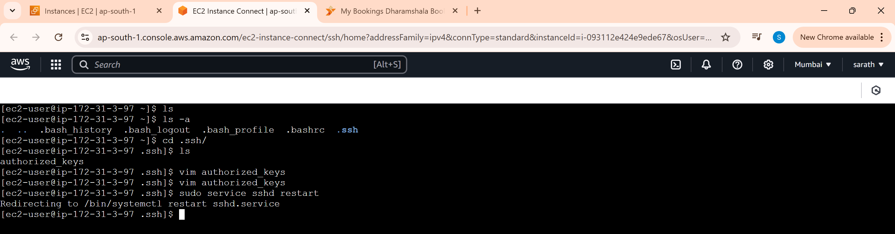

Restart the service in Linux_1 server

sudo service sshd restart

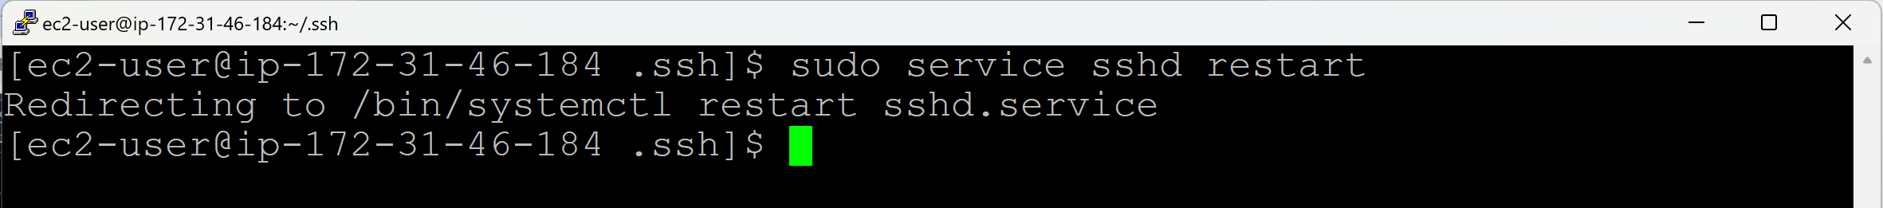

Run the command without key

ssh username@otherserveripaddress

ssh ec2-user@3.108.53.6

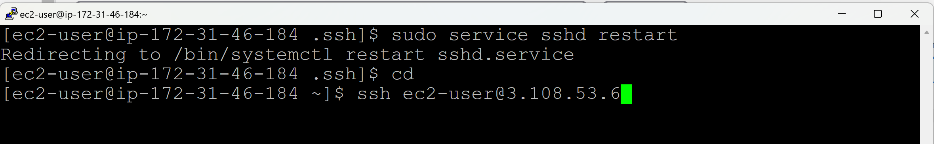

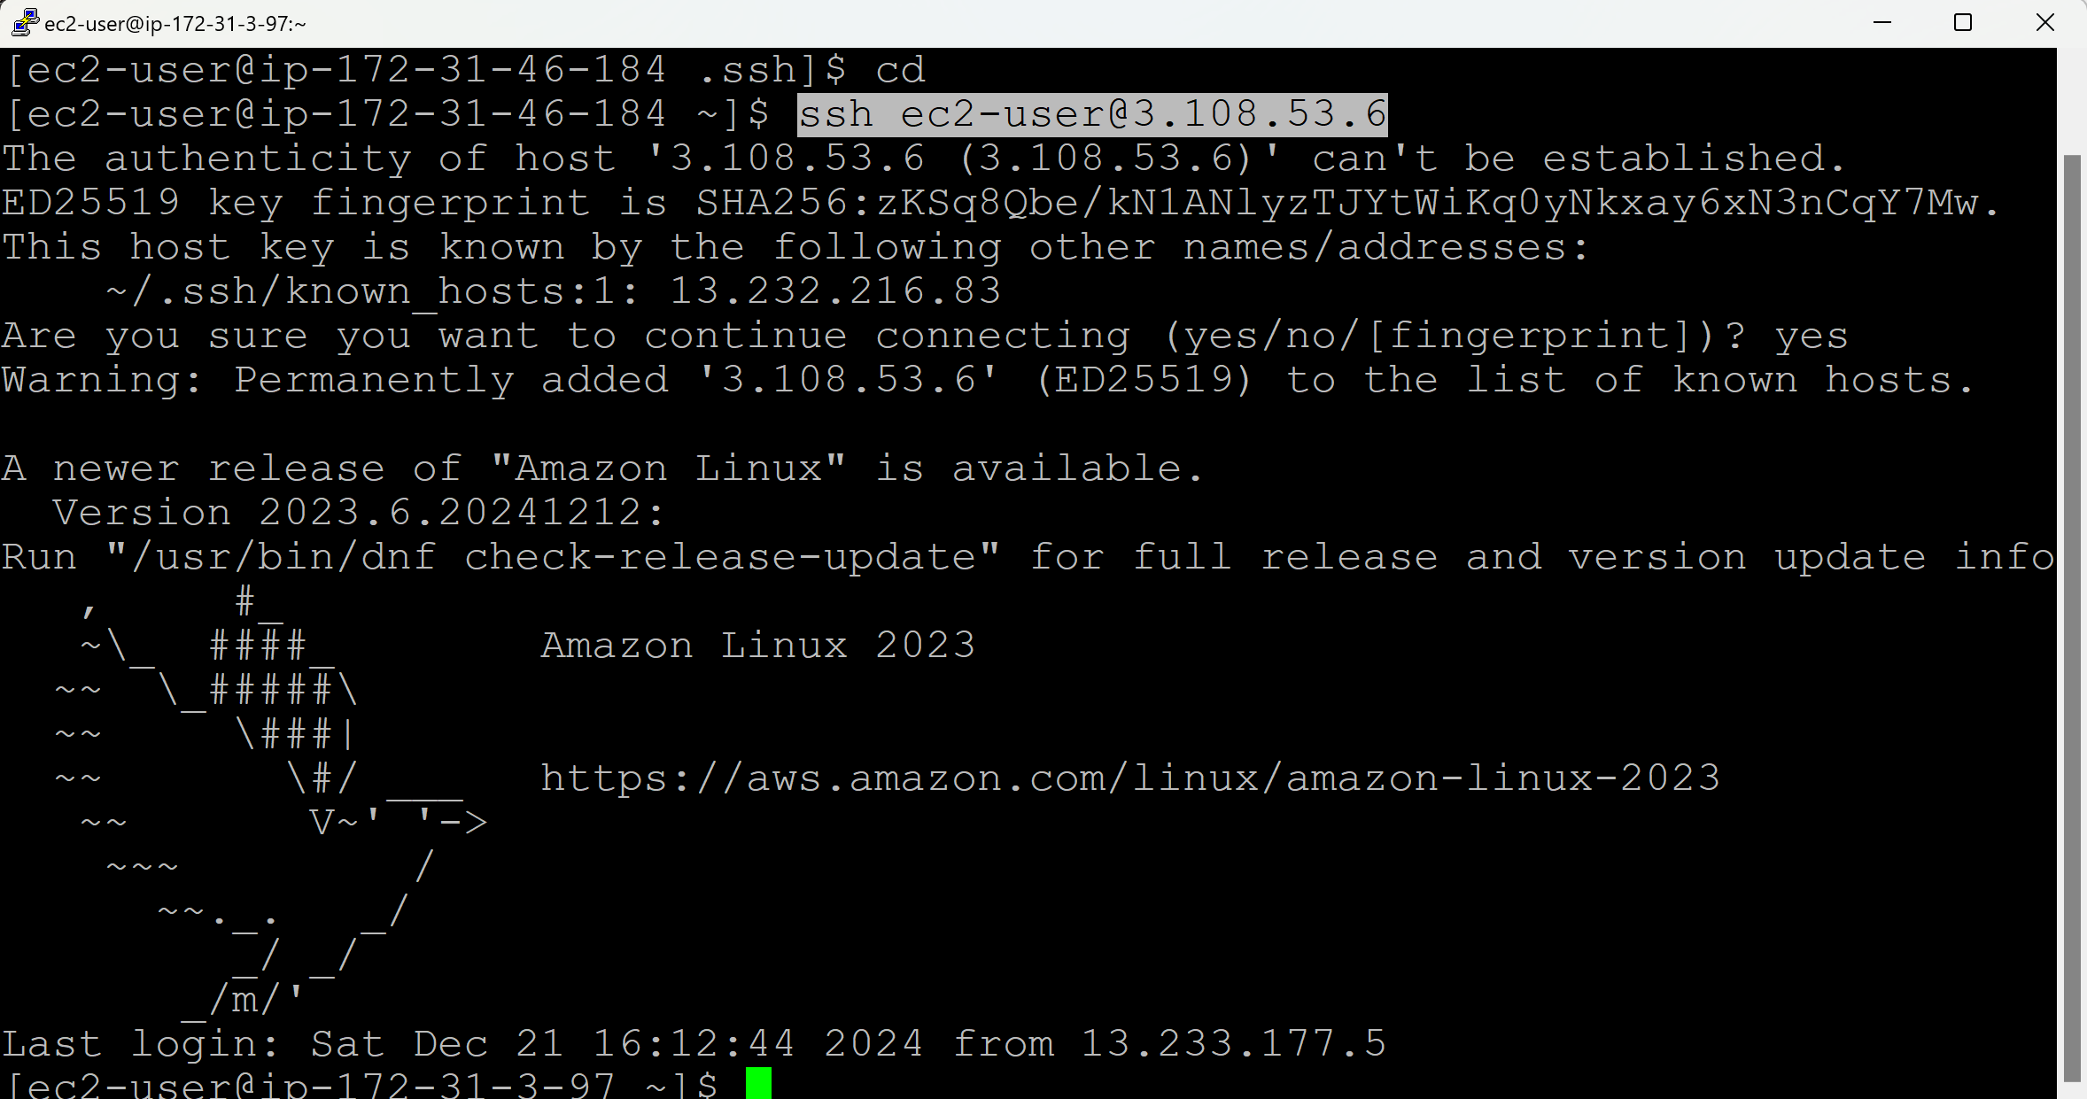

**Day 20 (scp, ps, kill)**

**scp** – Secure Copy

**cp** – It will copy the files/directories within the server level

**winscp** – It will copy the files/directories from Windows server to Remote Linux server

**scp**:

* scp stands for secure copy.
* It is used to securely copy the files/directories beteween local and remote systems over an SSH connection.
* scp command operations must be performed in local server only, not in remote server.
* Keys Transfer / Trust Relation / Password Key Authentication must be perfomed first before performing scp.

**Copy files and directories from Local Server to Remote Server when we are working on Local Server:**

* Take 2 Linux servers
* Linux_2 (Local Server) & Linux_1 (Remote Server)
* First Connect to Remote Server (Linux_1)

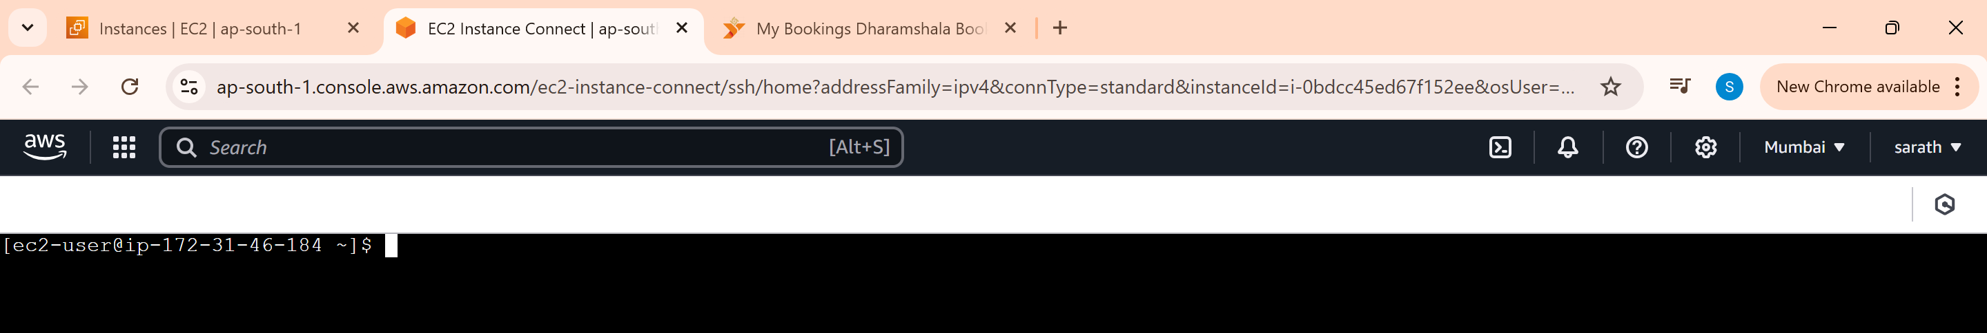

* Connect to Local Server (Linux_2)



* Create one file and one directory in Local Server Linux_2

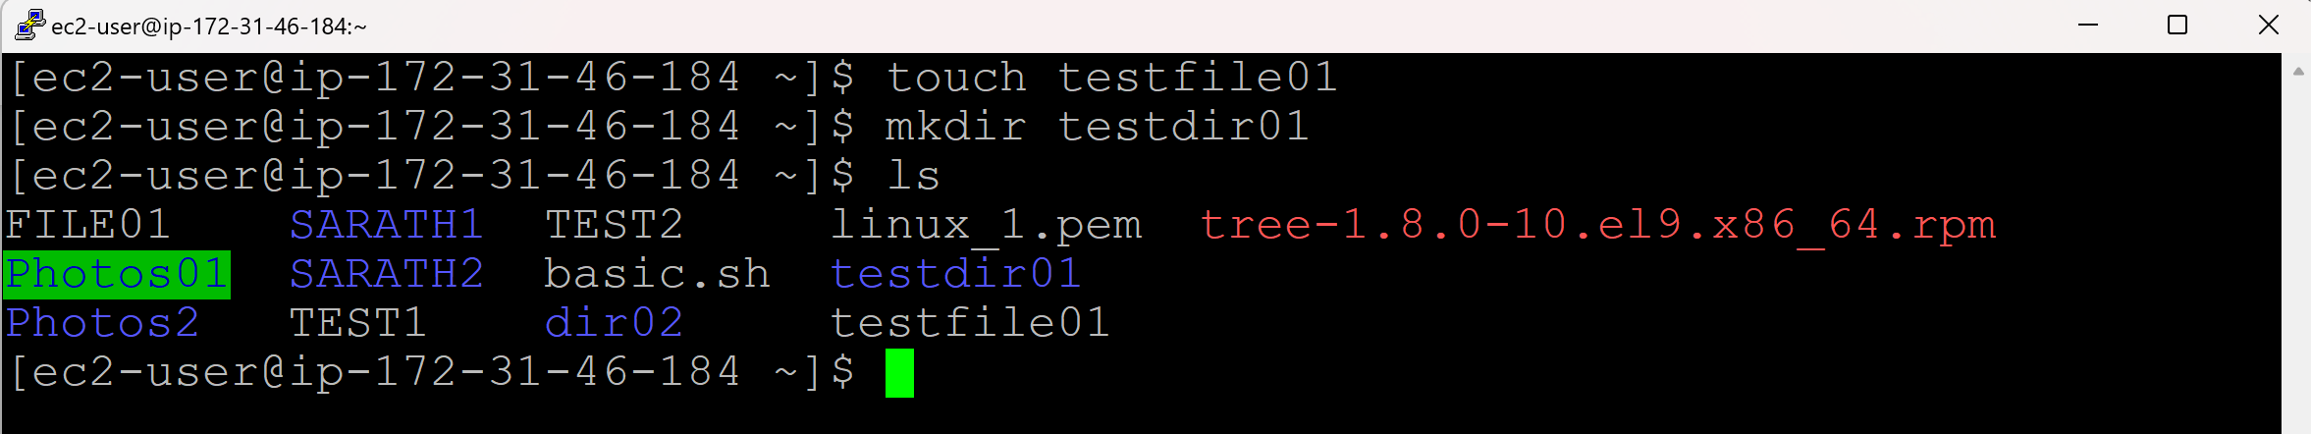

* Copy the newly created file to Remote Server (Linux_1)

scp <sourceIPaddress:filelocation> <destinationIPaddress:filelocation>

*(since the source (file) is in local server and we are running the commands from local server. So, there is no need to mention the IP address of the source and directly mention the file name.)*

scp <filename > <RemoteserverIPAddress>:<locationwheretocopy>/

scp testfile01 13.233.115.22:/home/ec2-user/

(or)

scp <locationofthefile> <RemoteserverIPAddress>:<locationwheretocopy>/

scp /home/ec2-user/testfile01 13.233.115.22:/home/ec2-user/



* Go to Remote Server (Linux-1) and check for the file

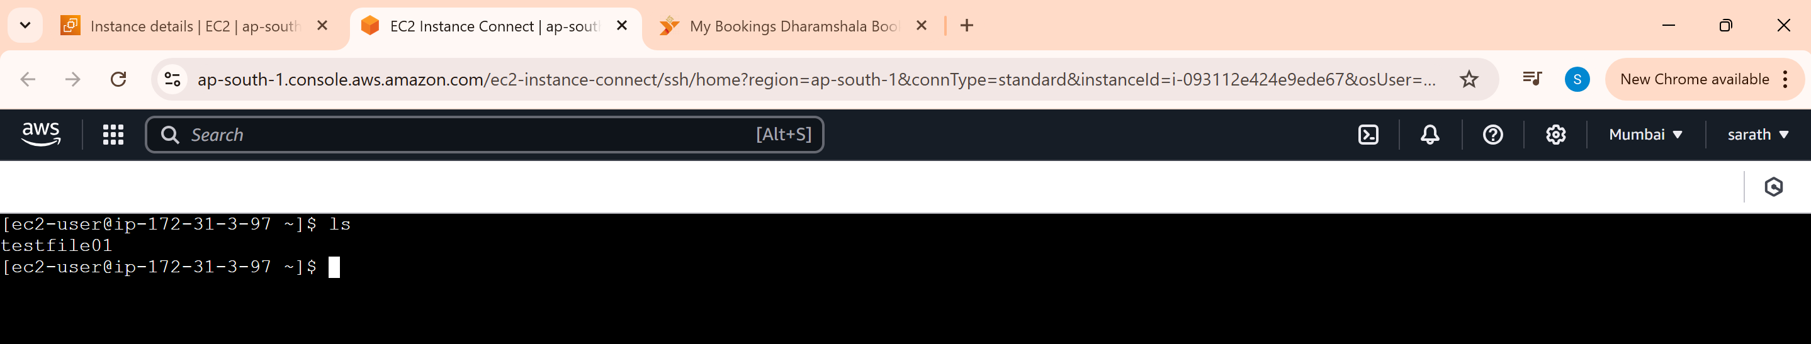

* Copy the newly created file to Remote Server (Linux_1)

scp <filename> <RemoteserverIPAddress>:<locationwheretocopy>

scp </home/ec2-user/filename> <RemoteserverIPAddress>:<locationwheretocopy>

scp testfile01 13.233.115.22:/home/ec2-user

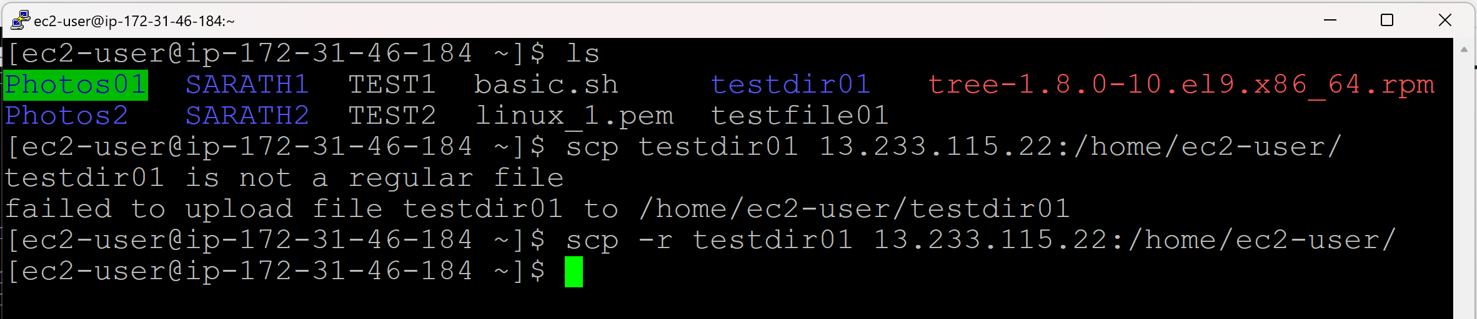

* Go to Remote Server (Linux-1) and check for the directory

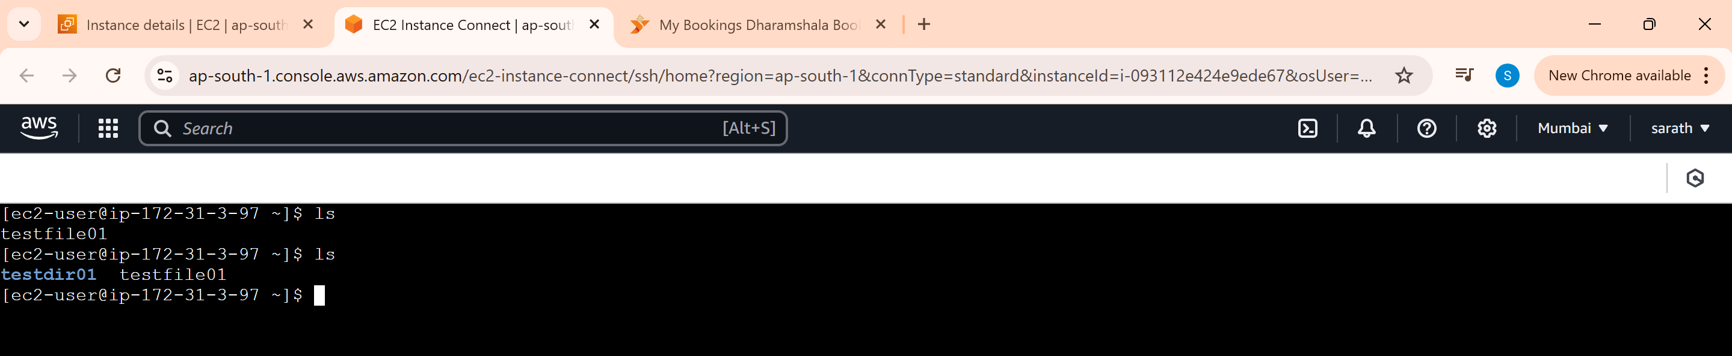

**Copy files and directories from Remote Server to Local Server when we are working on Local Server:**

* Create one file and one directory in Remote Server (Linux_1)

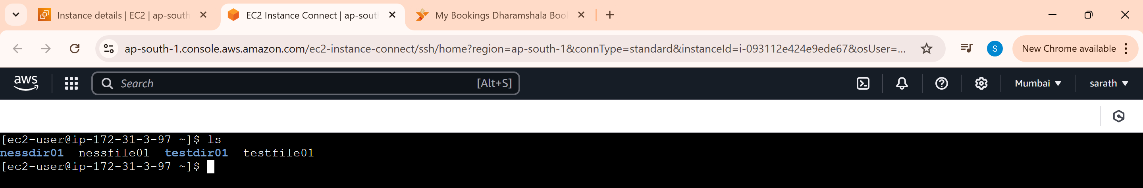

* Copy the newly created file in Remote Server (Linux_1) to Local Server (Linux_2)

scp <sourceIPaddress:filelocation> <filelocation>

*(since the source (file) is in remote server and we are running the commands from local server. So, we must mention the IP address of the source and no need to mention the destination IP address.)*

scp <RemoteserverIPAddress>:<locationofthefile>/ <Localserverlocationwheretocopy>

scp 13.233.115.22:/home/ec2-user/nessfile01 /home/ec2-user/

scp 13.233.115.22:/home/ec2-user/nessfile01 .

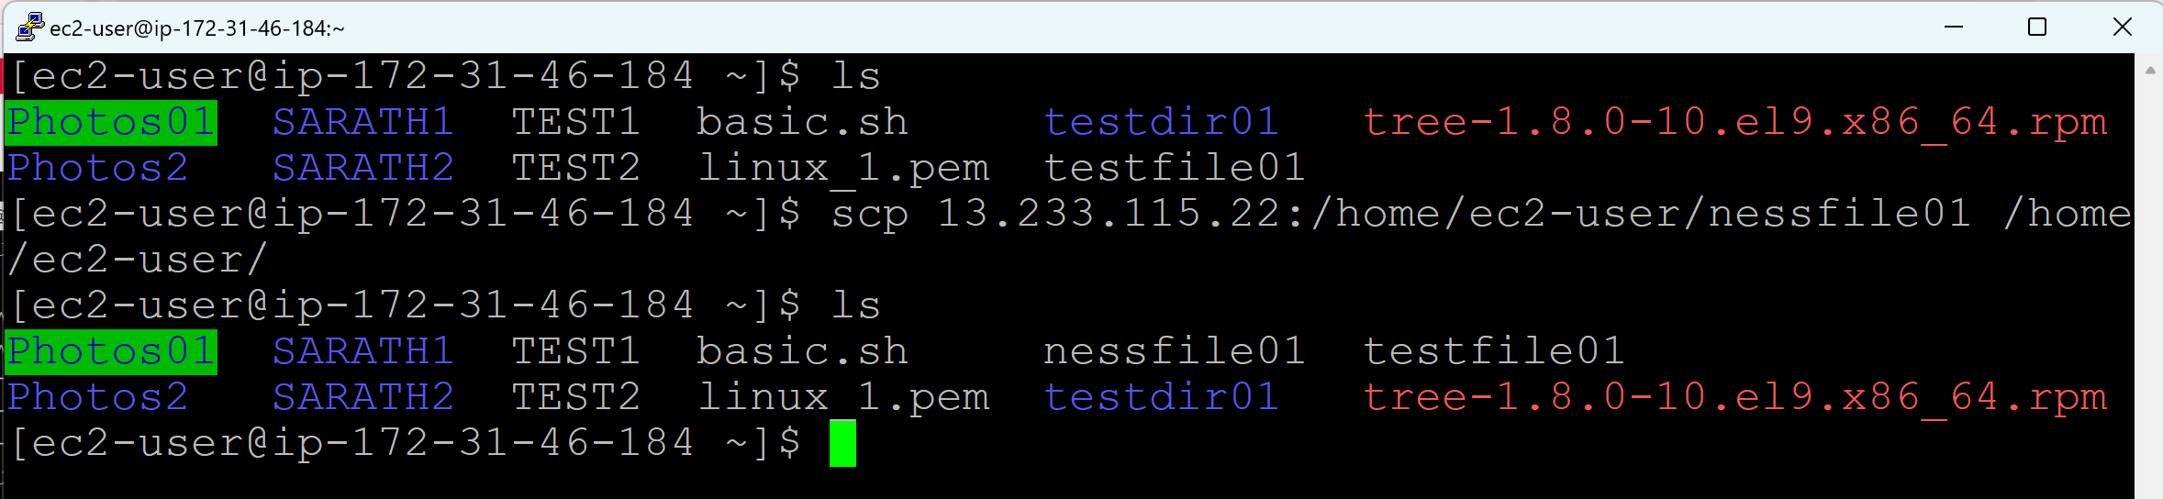

**Process (ps):**

* A process (ps) command is used to display the information about running processes.
* It provides a snapshot of the current processes, their IDs, resource usage, and other details.
* Front end processes & Back end processes
* Every command or every task will create a process id

**Front end processes:**

ps

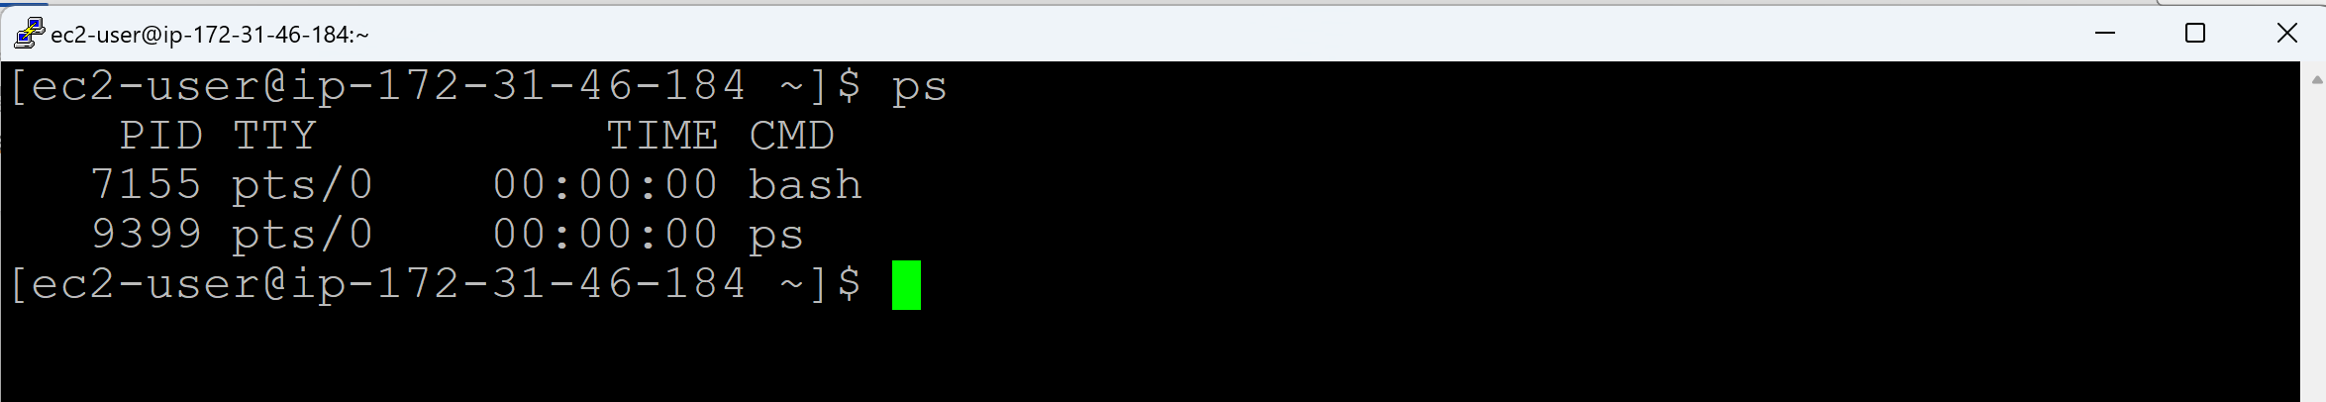

* Since we opened PuTTY (bash), one process ID has been created
* Since we run a command ps, one process ID has been created

**Back end processes:**

ps -e

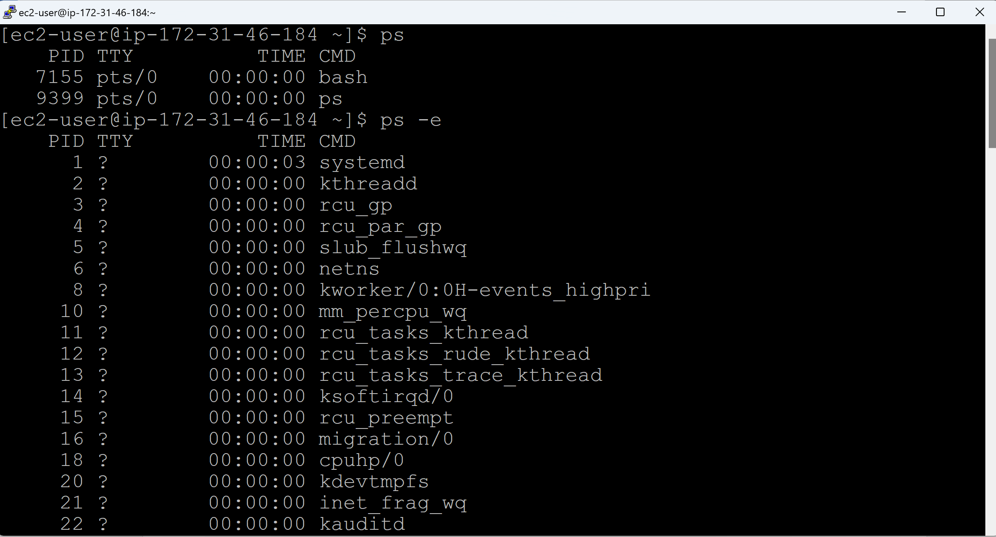

ps -ef (f refers to full details)

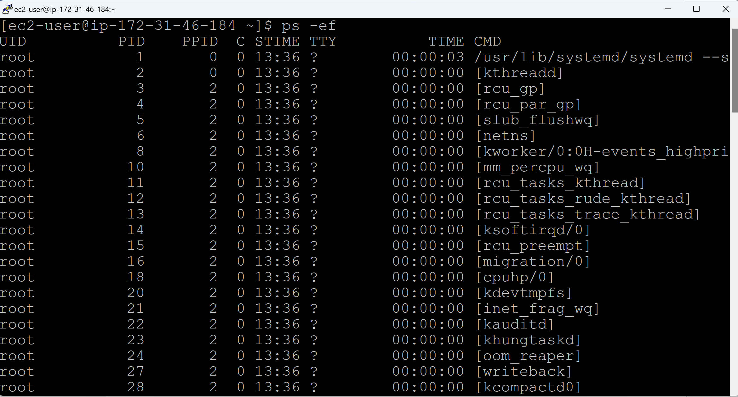

**To view CPU usage, Memory Usage, etc.:**

ps aux

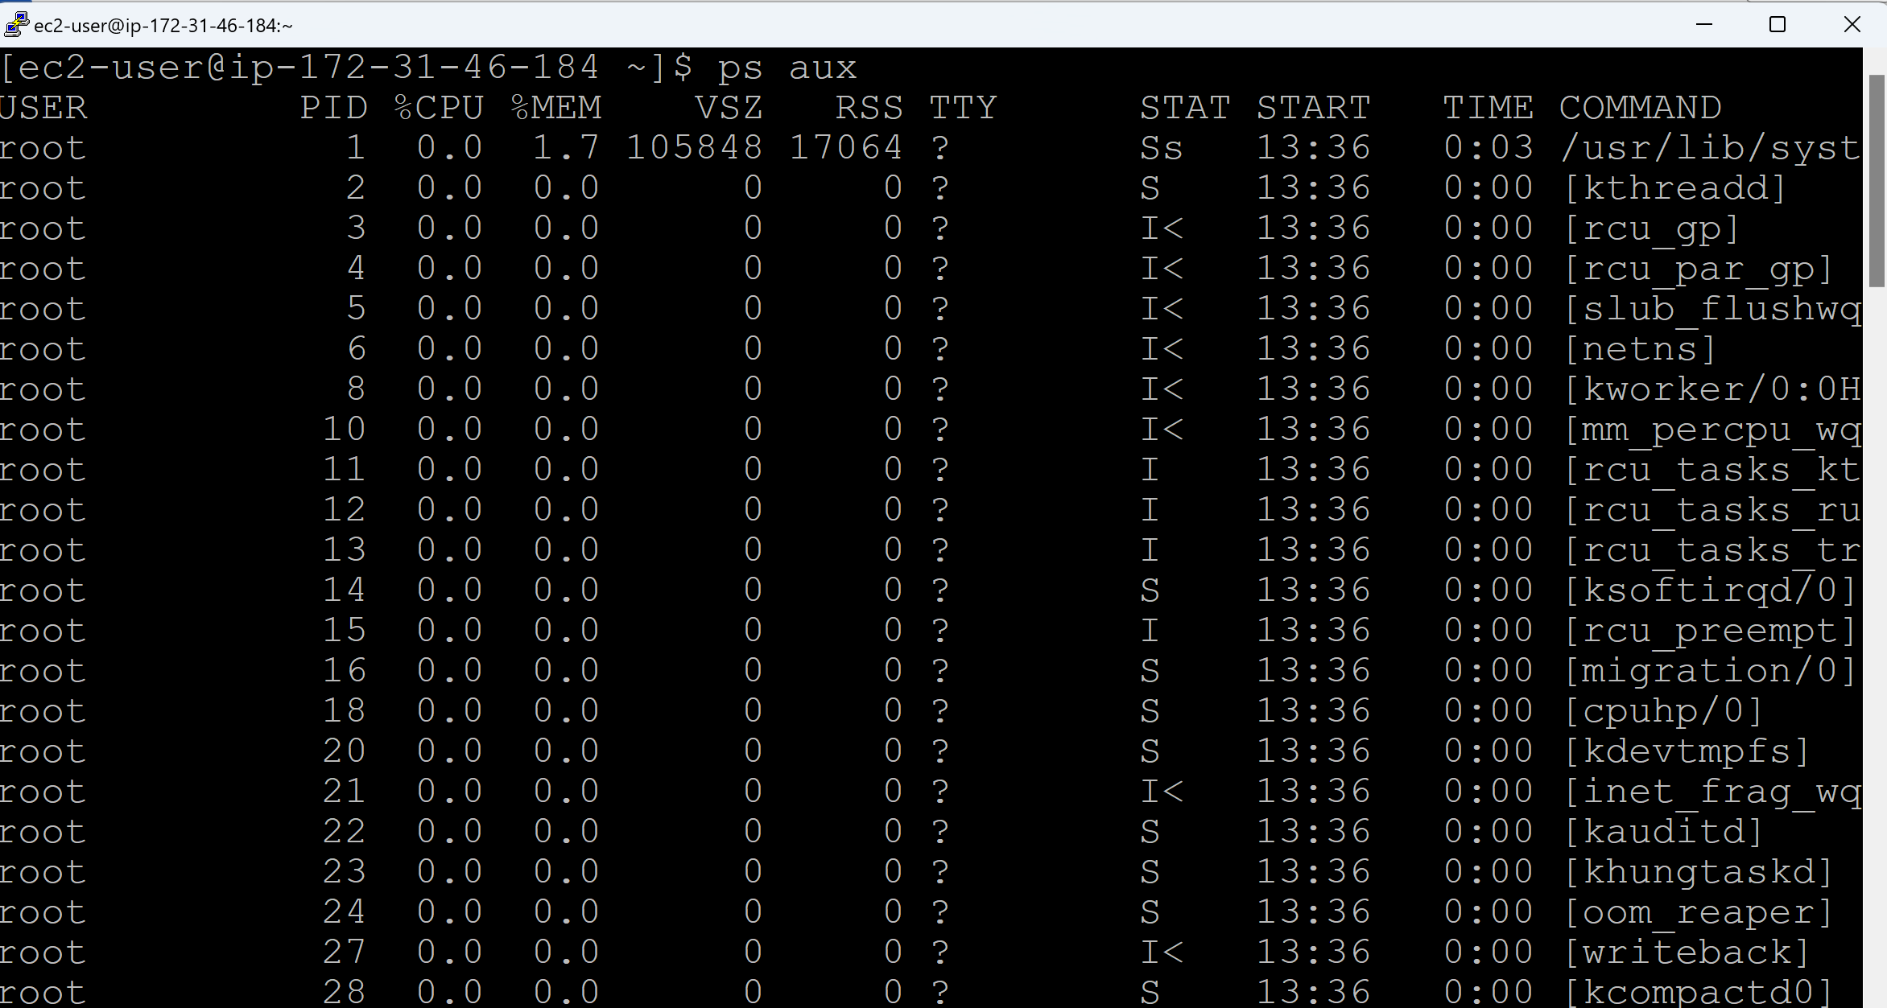

**To view the processes for a Specific User:**

ps -fU <username>

ps -fU ec2-user

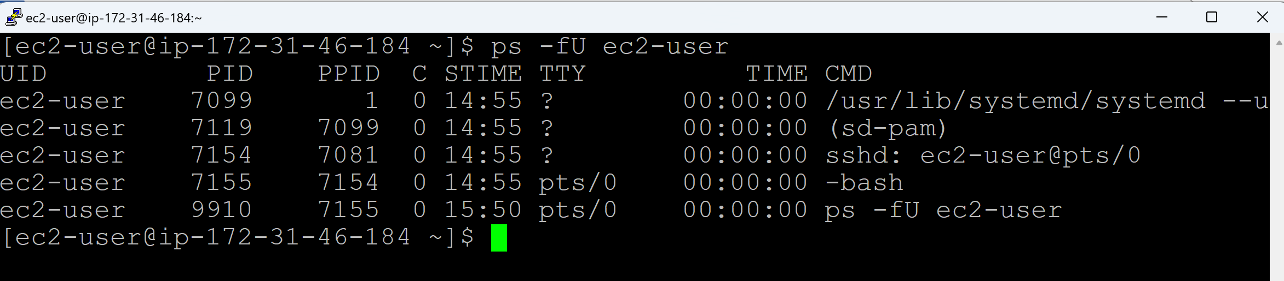

ps -fU root

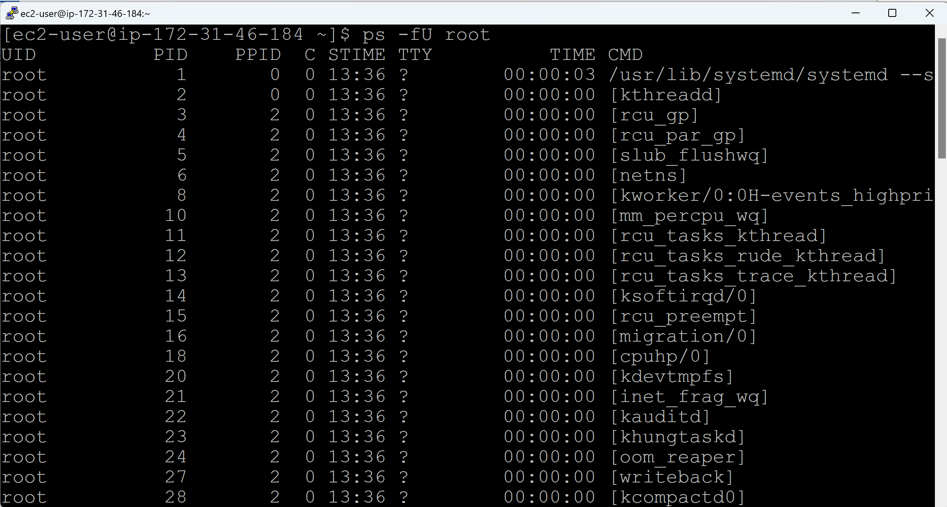

**You have a Process Name and you want to know the Process IDs of it:**

pidof <processname>

pidof sshd

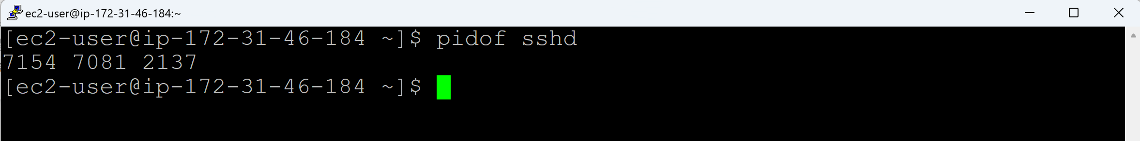

**You have a Process ID and you want to know the Process Name of it:**

ps -p 5 -o comm=

-p 5 refers to Process ID of interest, which in this case is 5

-o is used to customize the output fields.

comm: Outputs only the command name (i.e., the executable name of the process, excluding its path or arguments).

=: Removes the default column header.

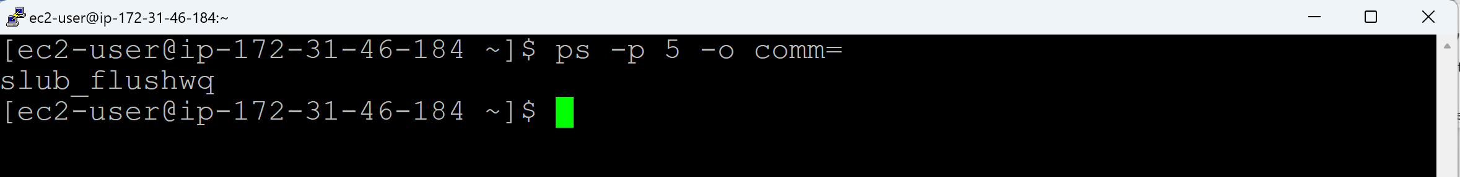

**Close/Kill the Process:**

kill <processid>

**Forcefully Close/Kill the Process:**

kill -9 <processid>

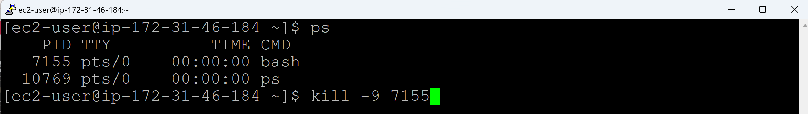

**Variables in Shell scripting:**

* Connect to the Linux server using SuperPuTTY and WinSCP
* Create a file using below script
  + **touch hello-world.sh**

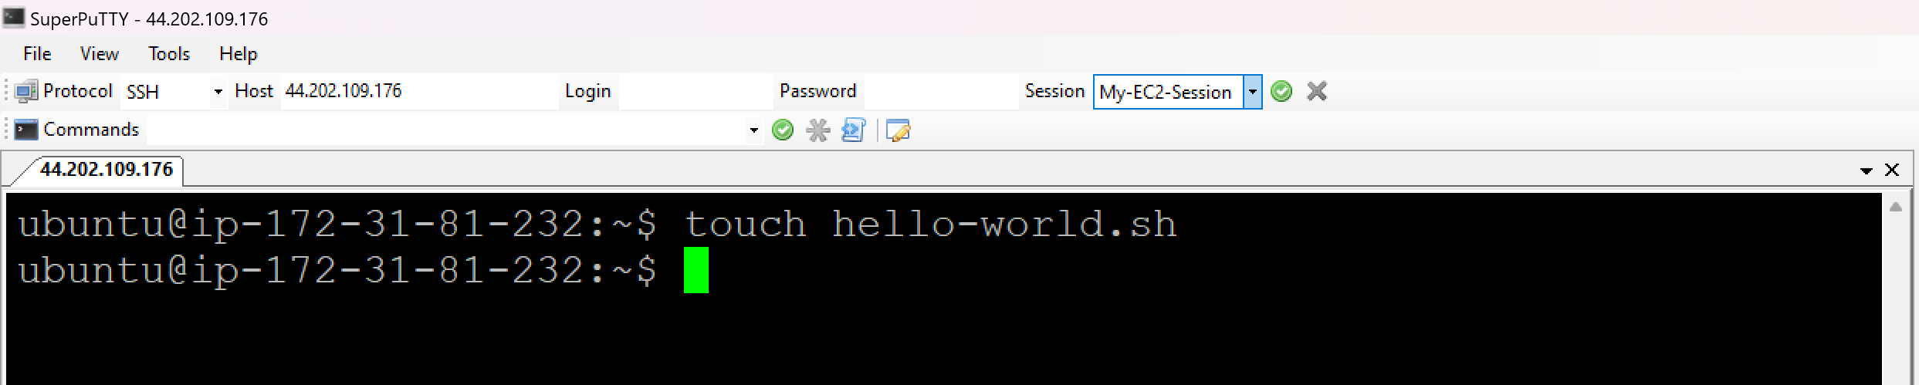

* Go to WinSCP and click on refresh > Newly create file will be appeared

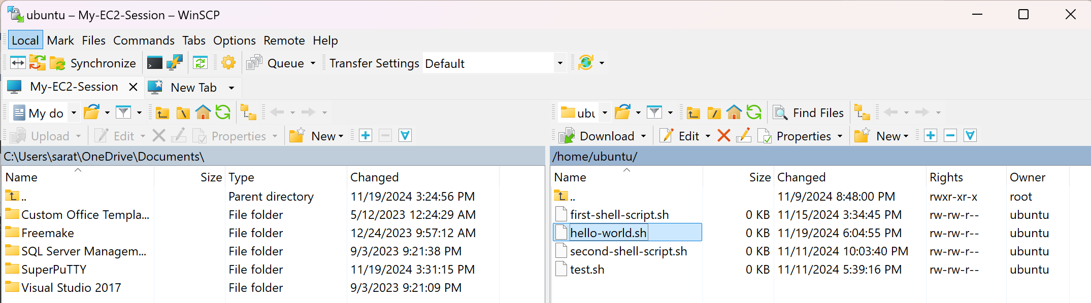

* Double click on the newly created file (hello-world.sh) > it will be opened in Notepad++

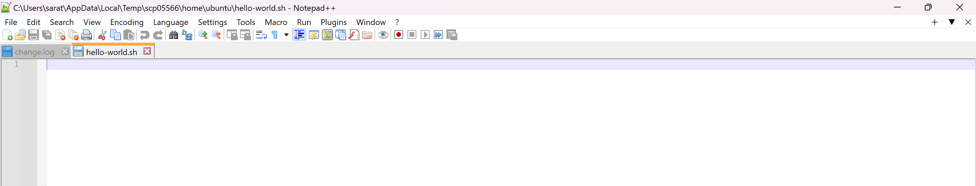

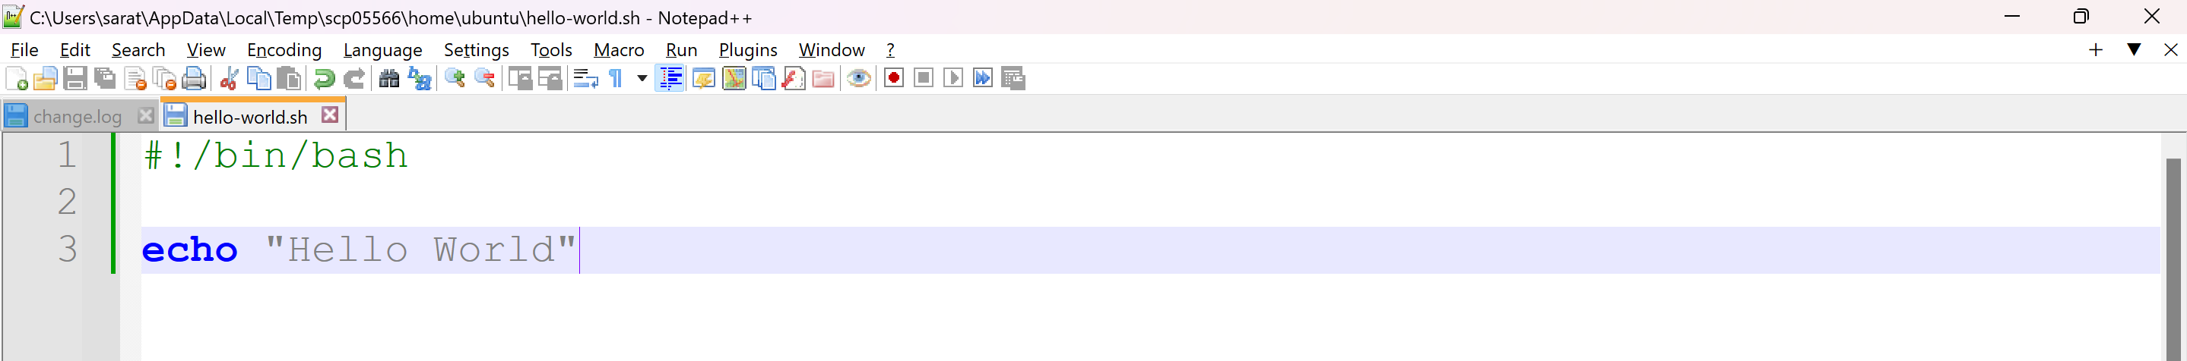

* Save the file
* **cat <filename>** - To display the content of the file

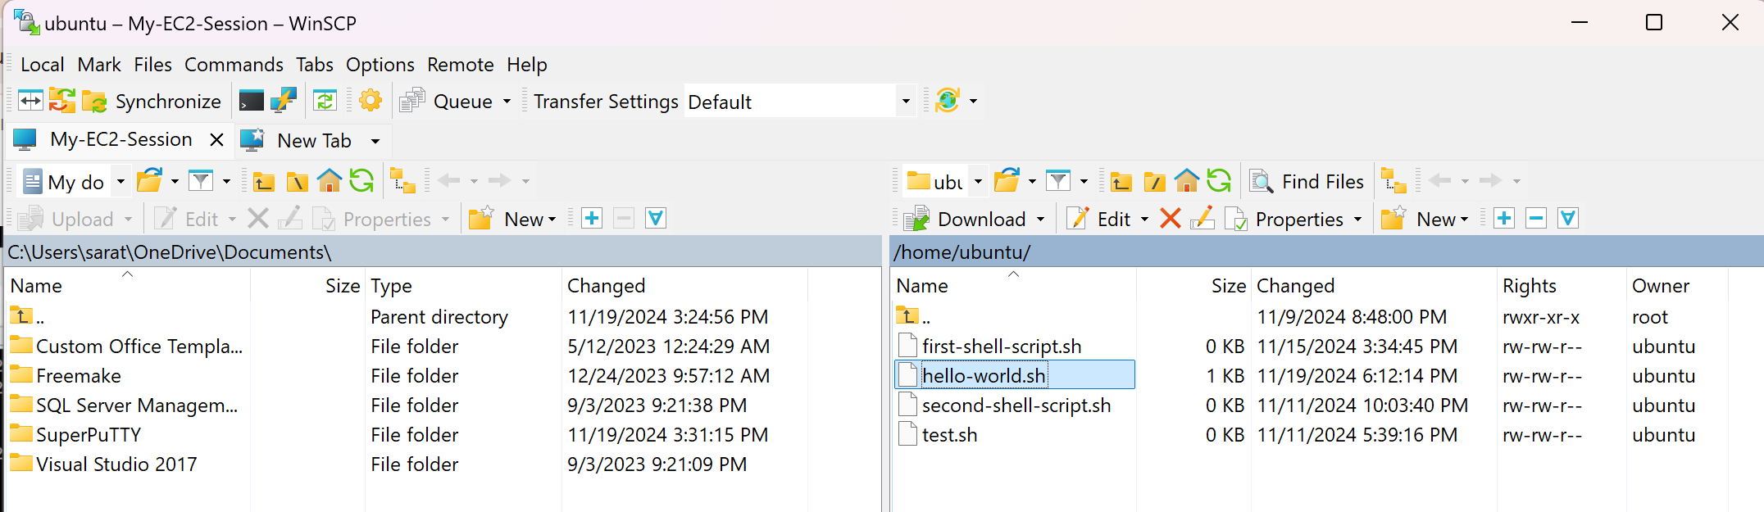

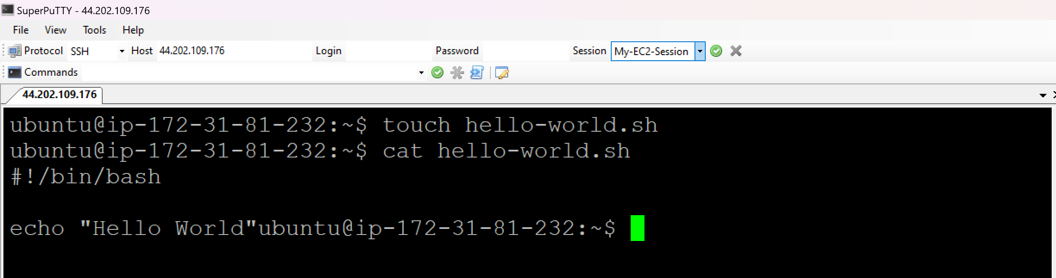

* **ls -l** – To display the list of files

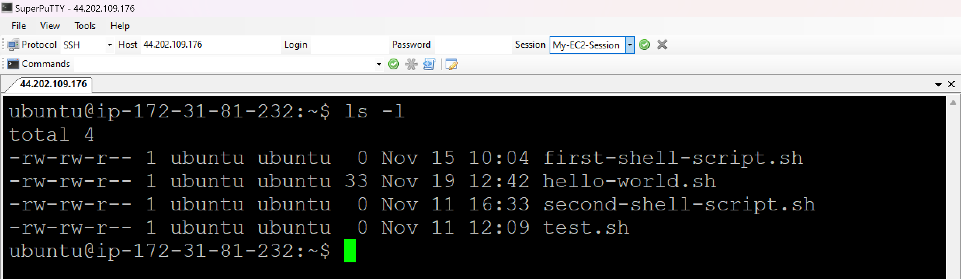

* **sh <filename>** - To execute the script

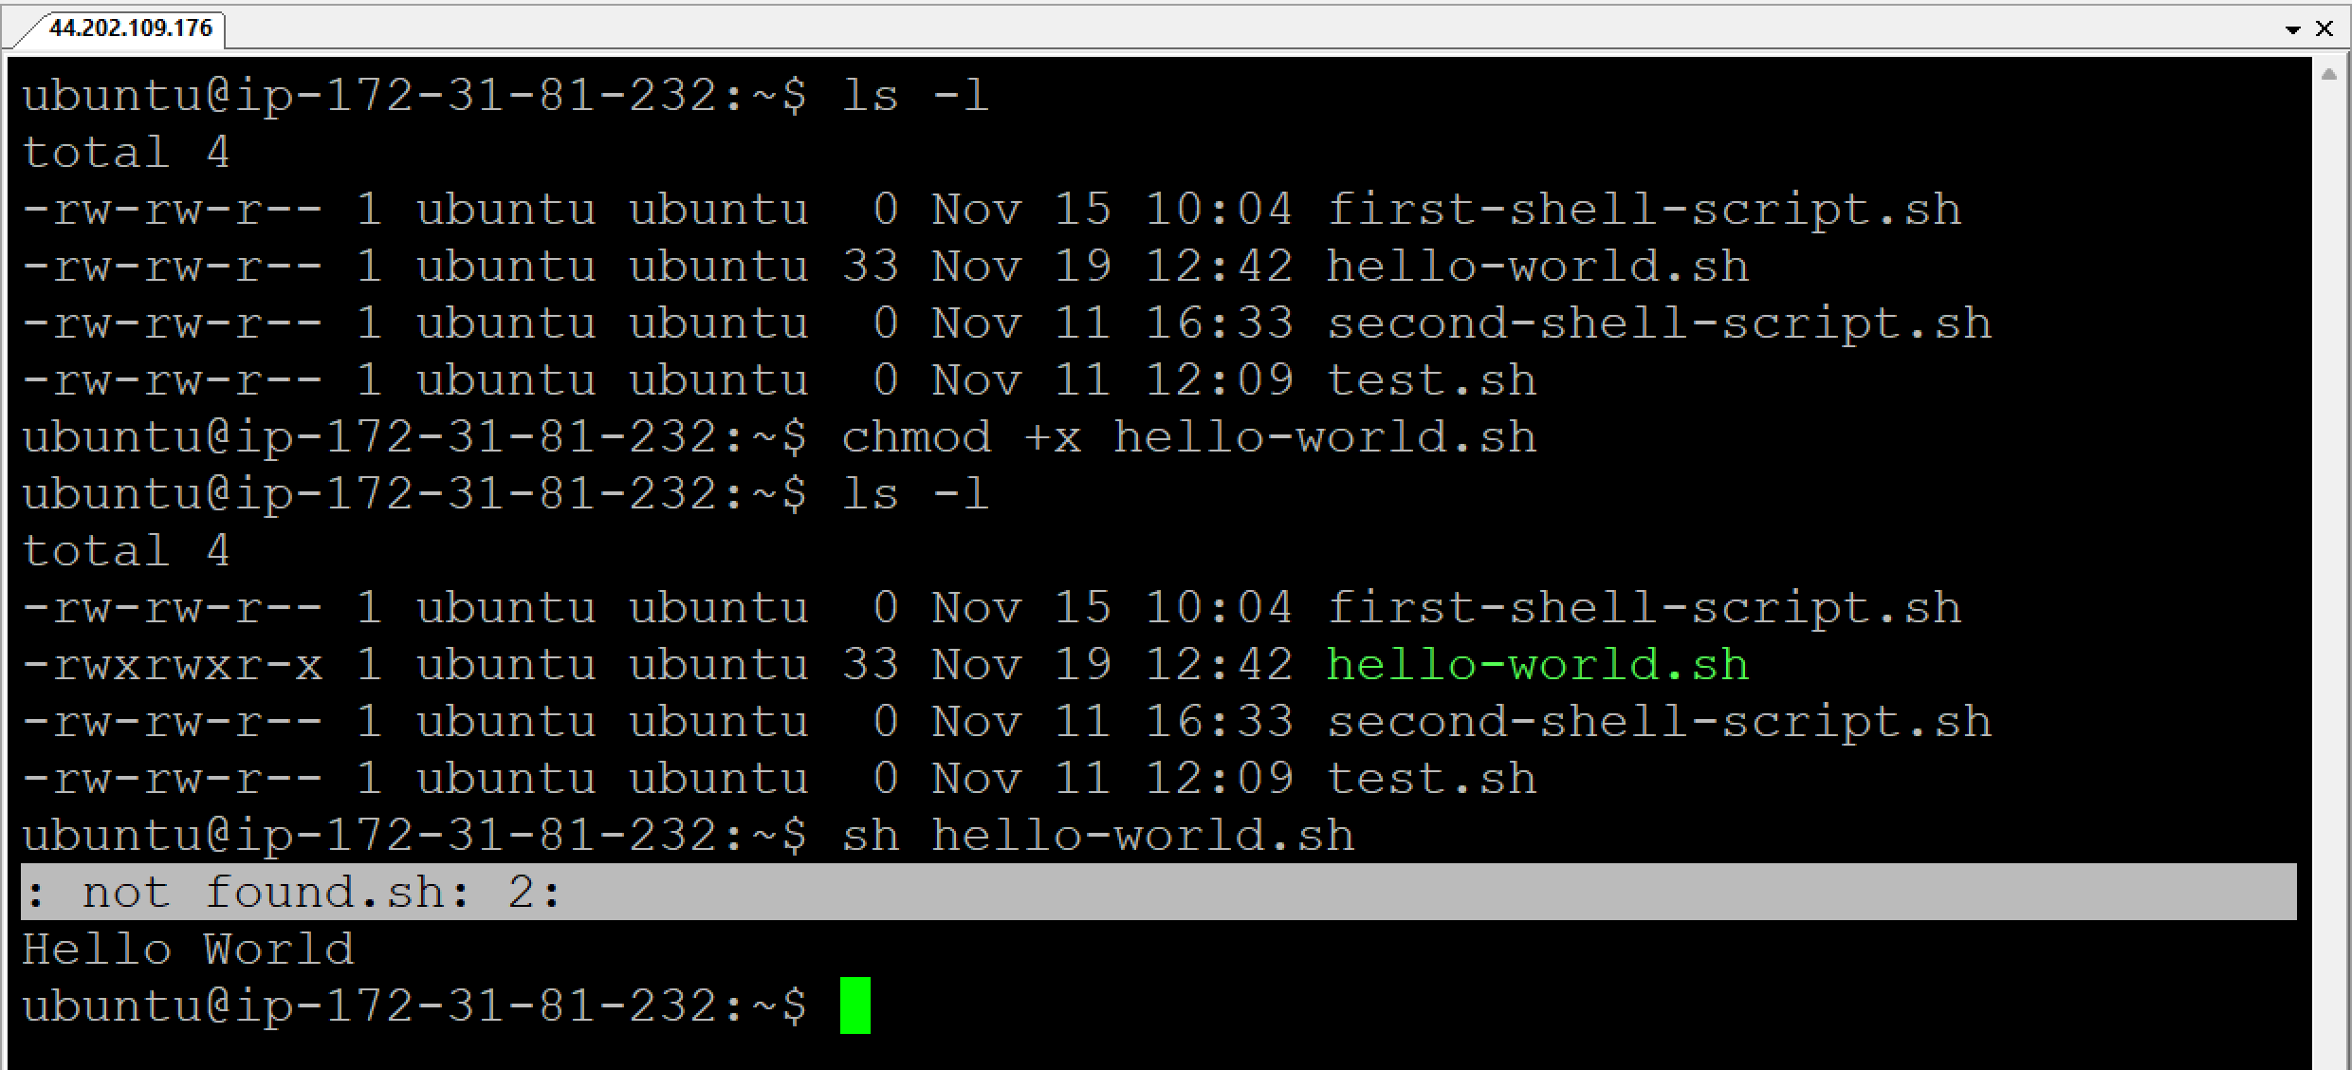

* Script will be executed with ‘not found’ error. (EOL Conversion to be changed, since we are writing the script in Windows and uploading to Ubuntu)
* To resolve this, Go to Notepad++ > Edit > EOL Conversion > Unix (LF)
* Click on Save

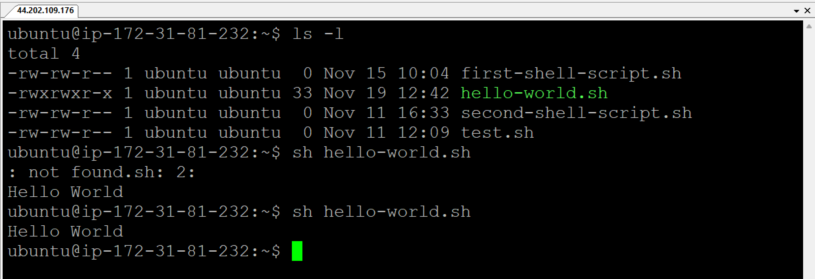

01-variables.sh

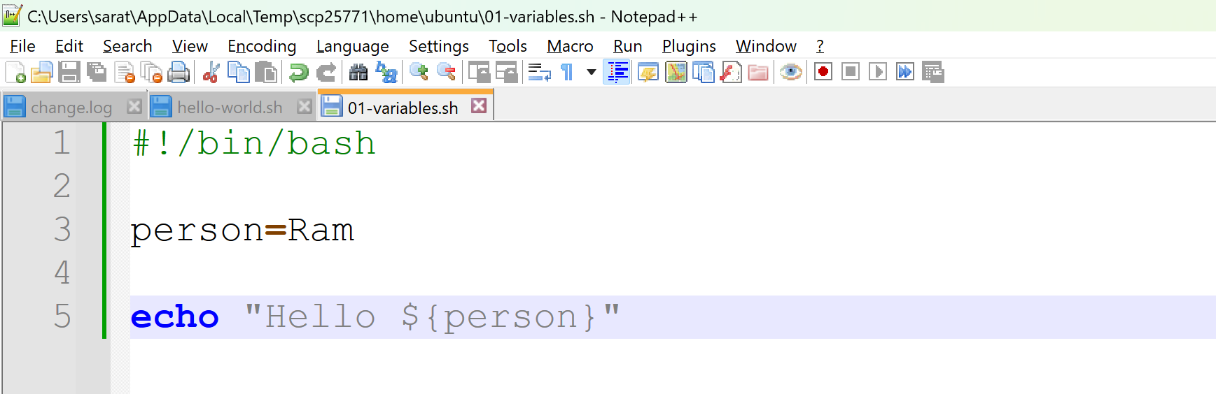

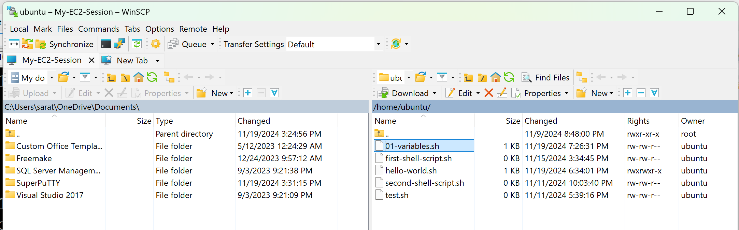

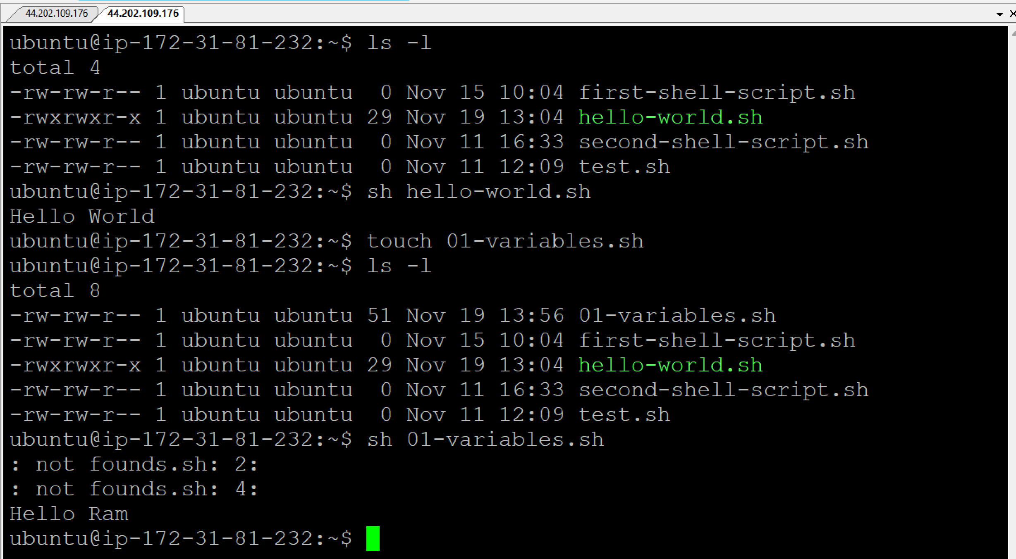

* Go to Notepad++ > Edit > EOL Conversion > Unix (LF)

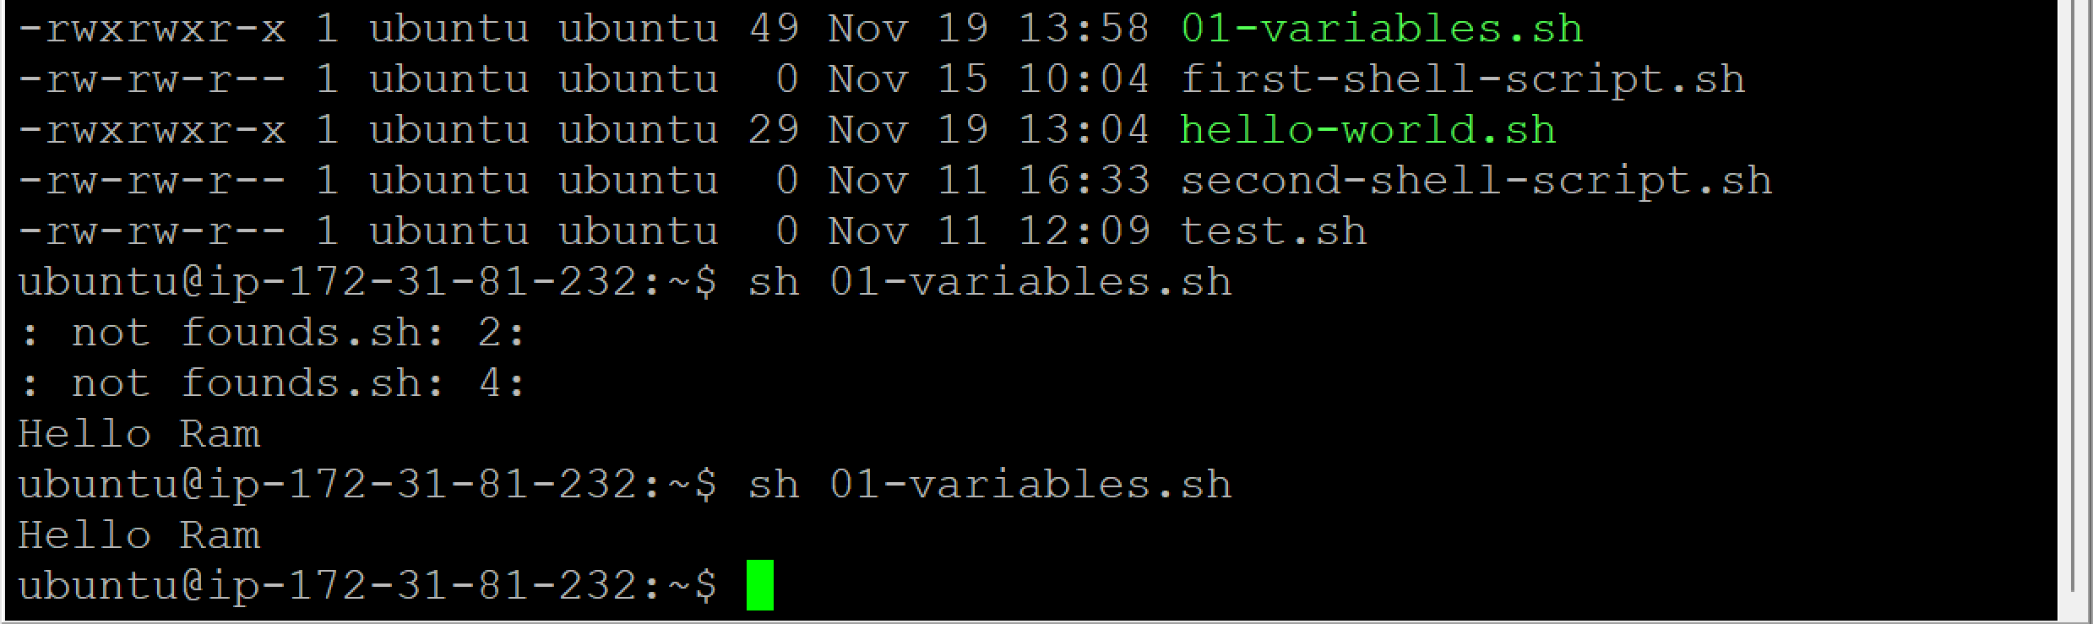

* Go to Notepad++ > Change the Name from Ram to Ramesh > Save the file

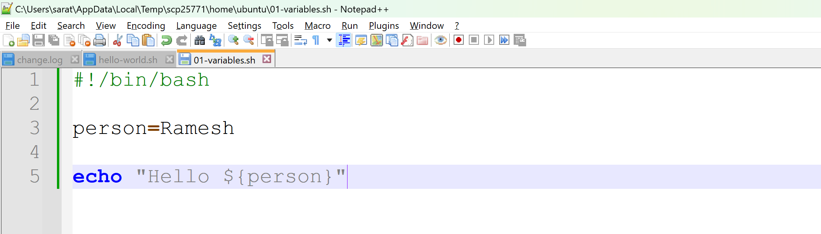

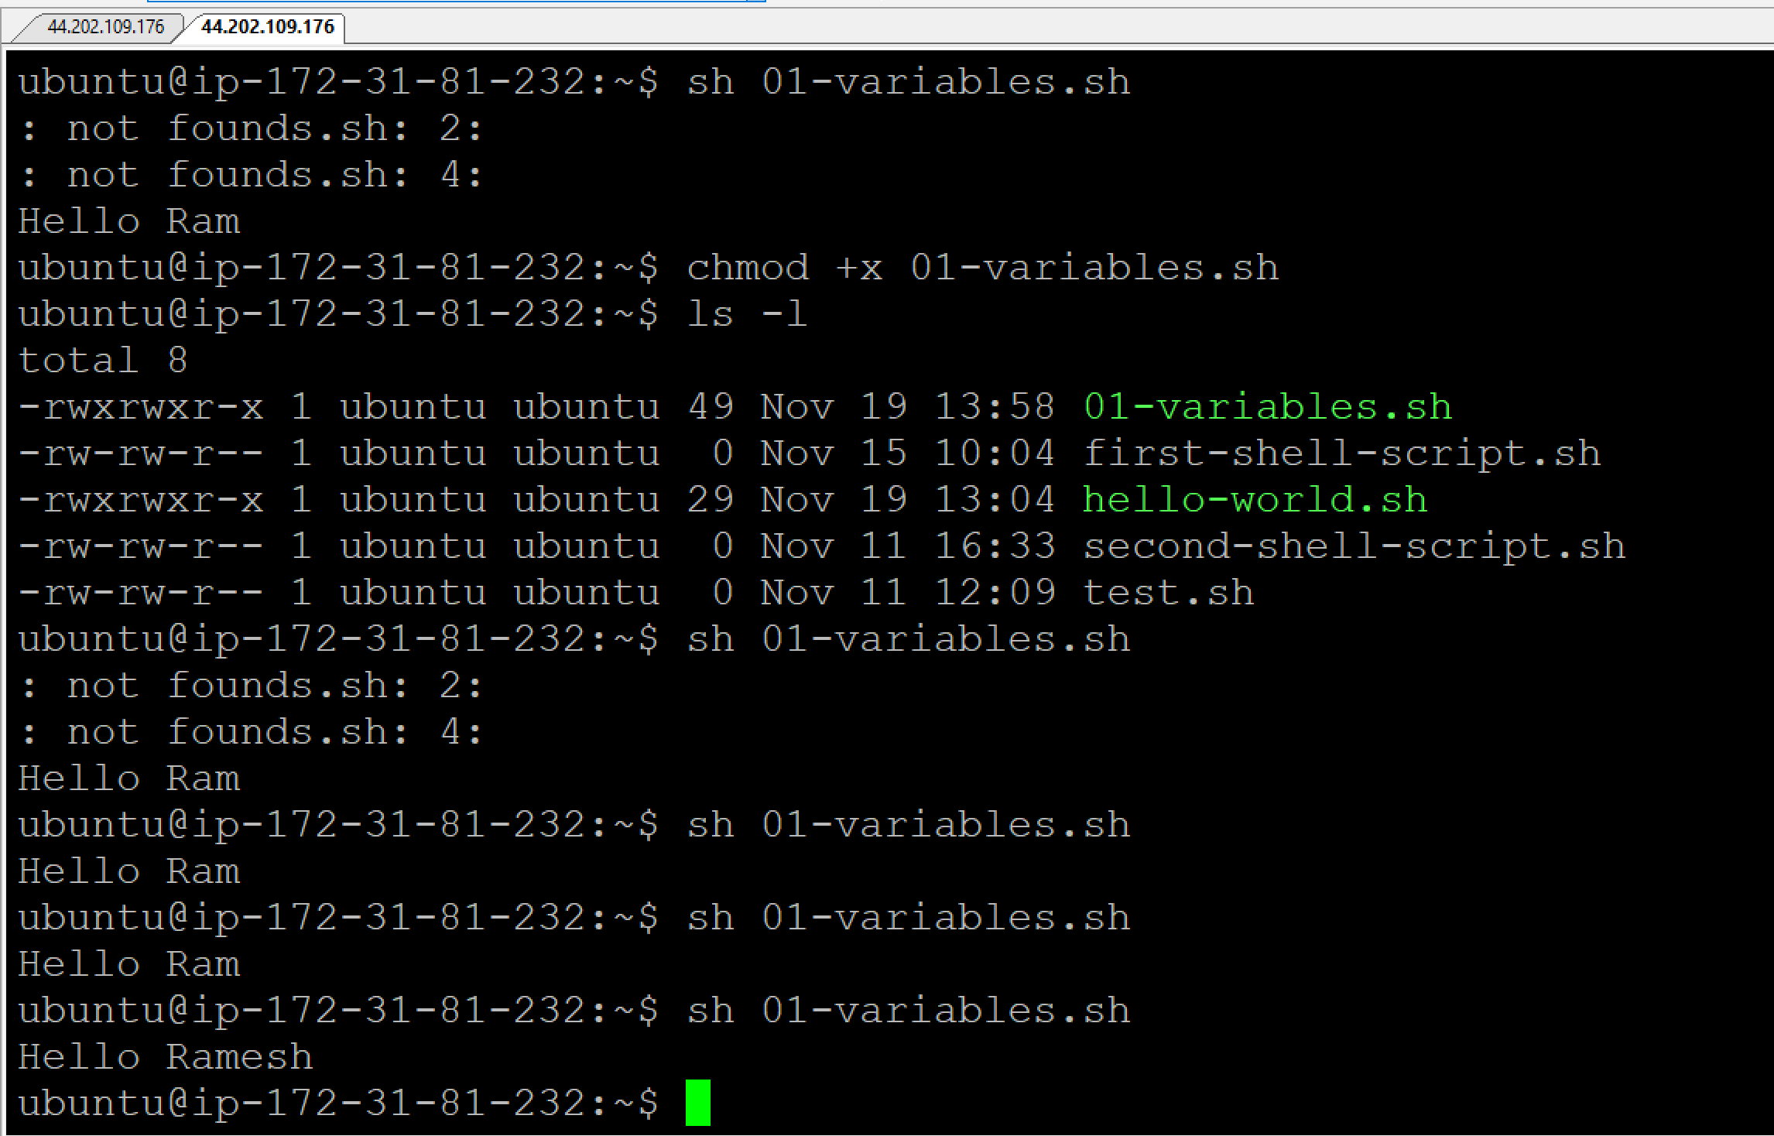

**Scripting without variables:**

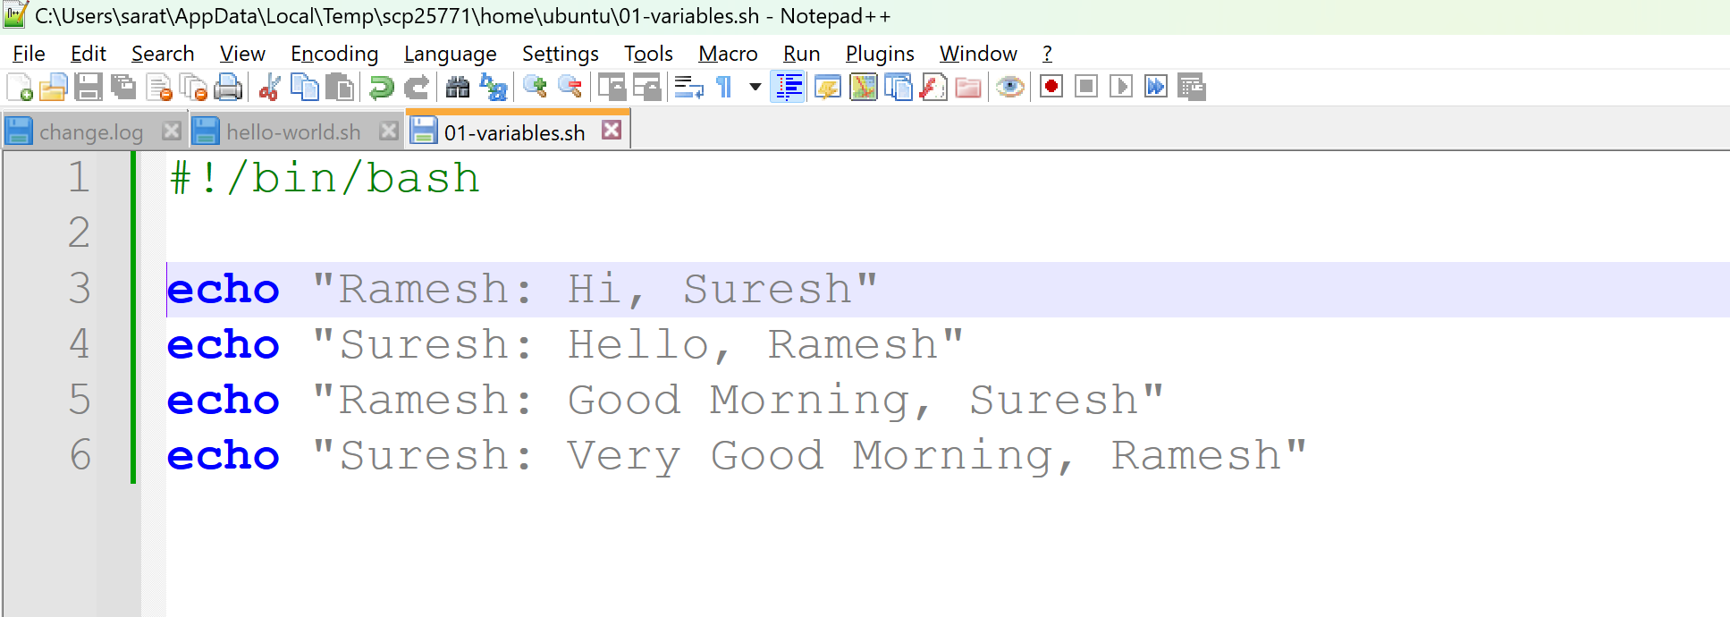

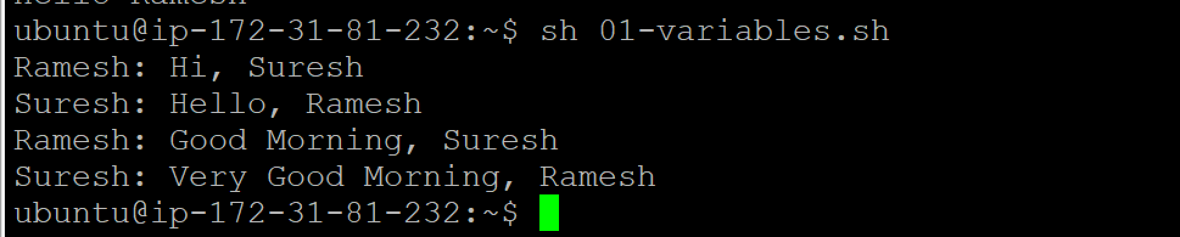

**Scripting with variables:**

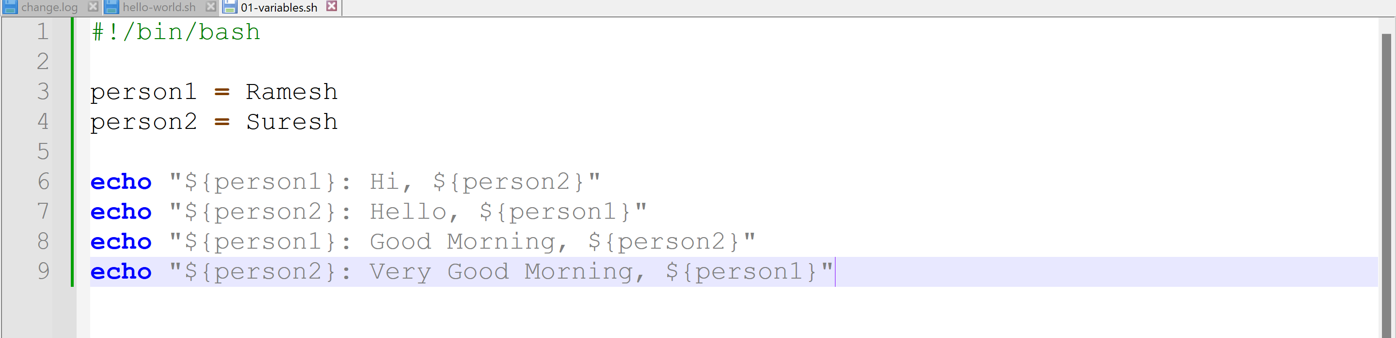

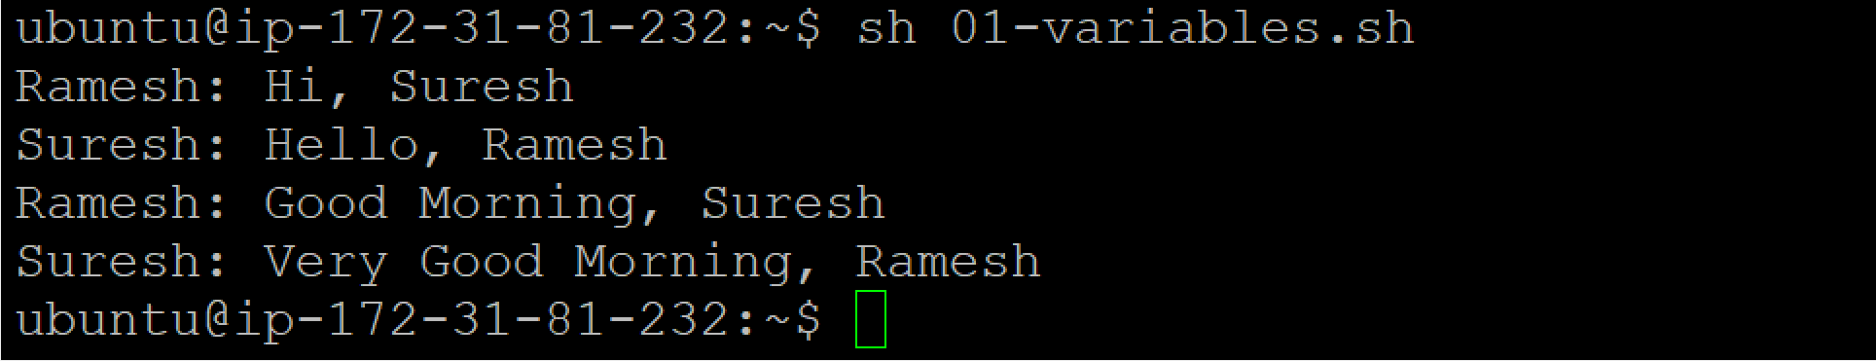

* In the above example, we are hardcoding the varaible values.
* If you want to change the variable names, we need to go to the script and change the values.
* To avoid this, use the below script and pass the parameters in run time.

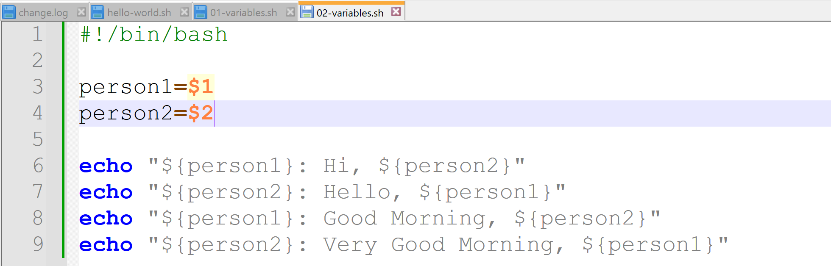

* Go to Notepad++ > Change the Name from Ram to Ramesh > Save the file

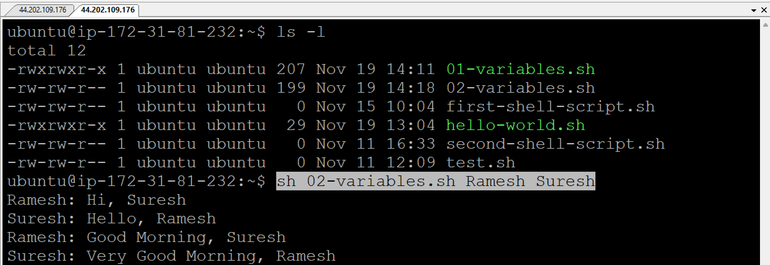

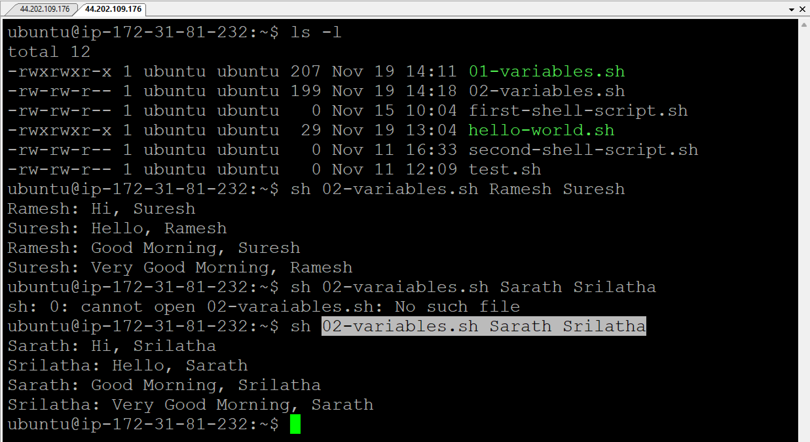

**Requirement:**

I need to execute the command in shell script and take the output into variable.

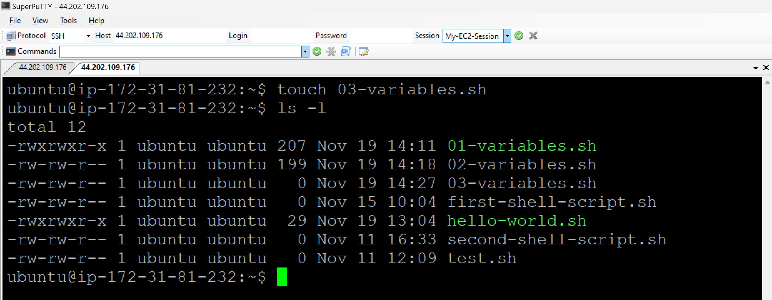

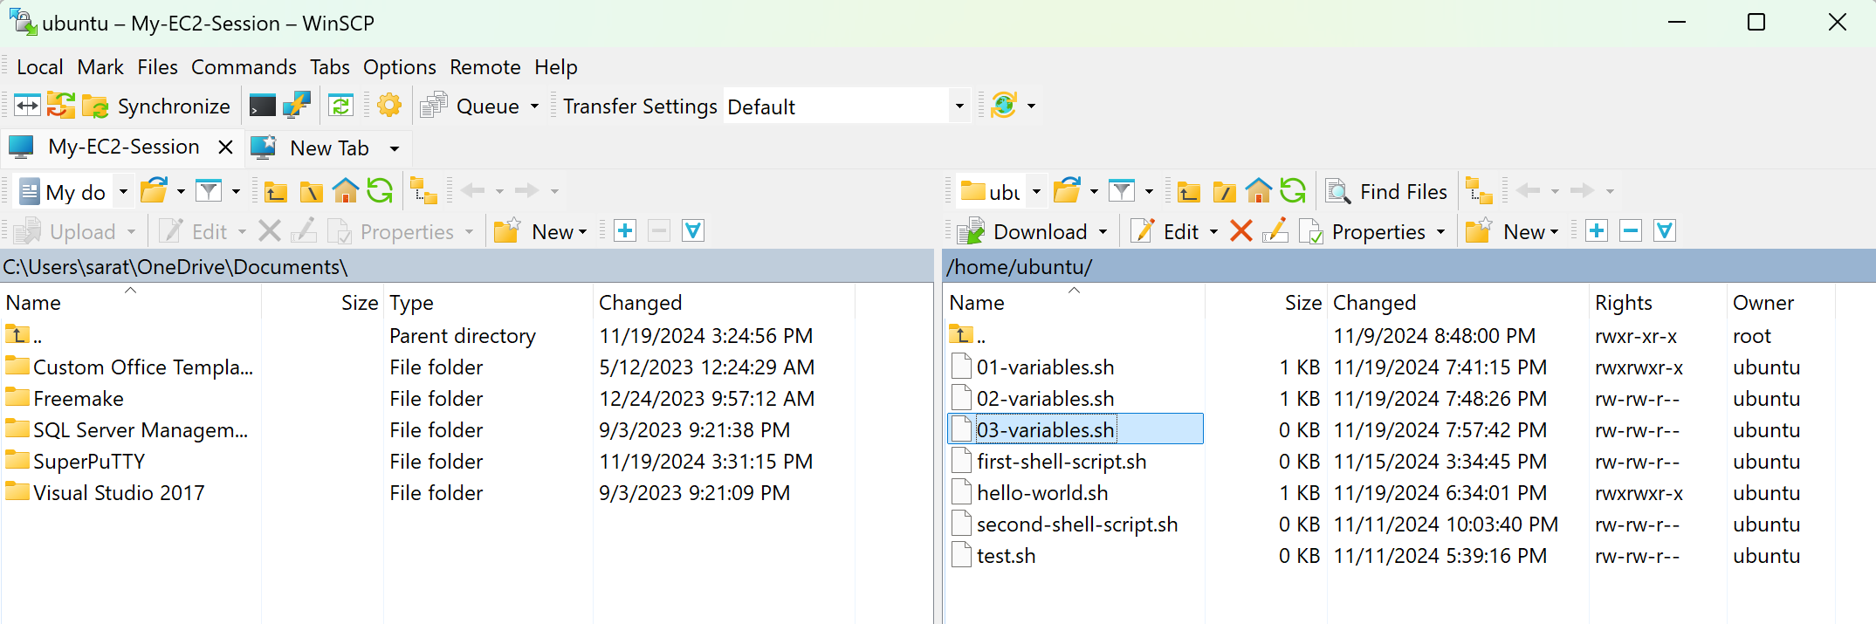

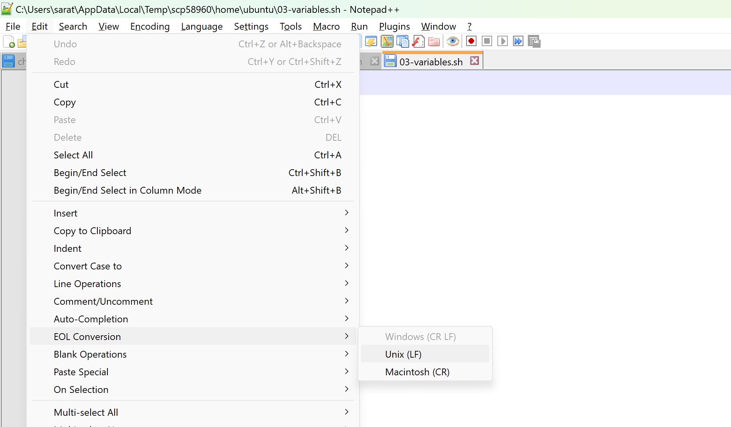

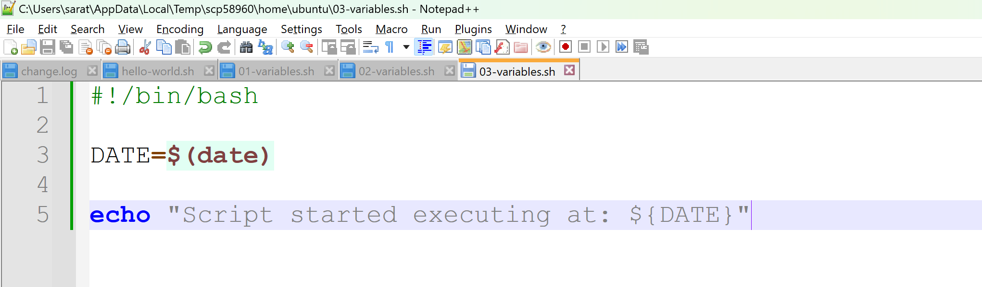

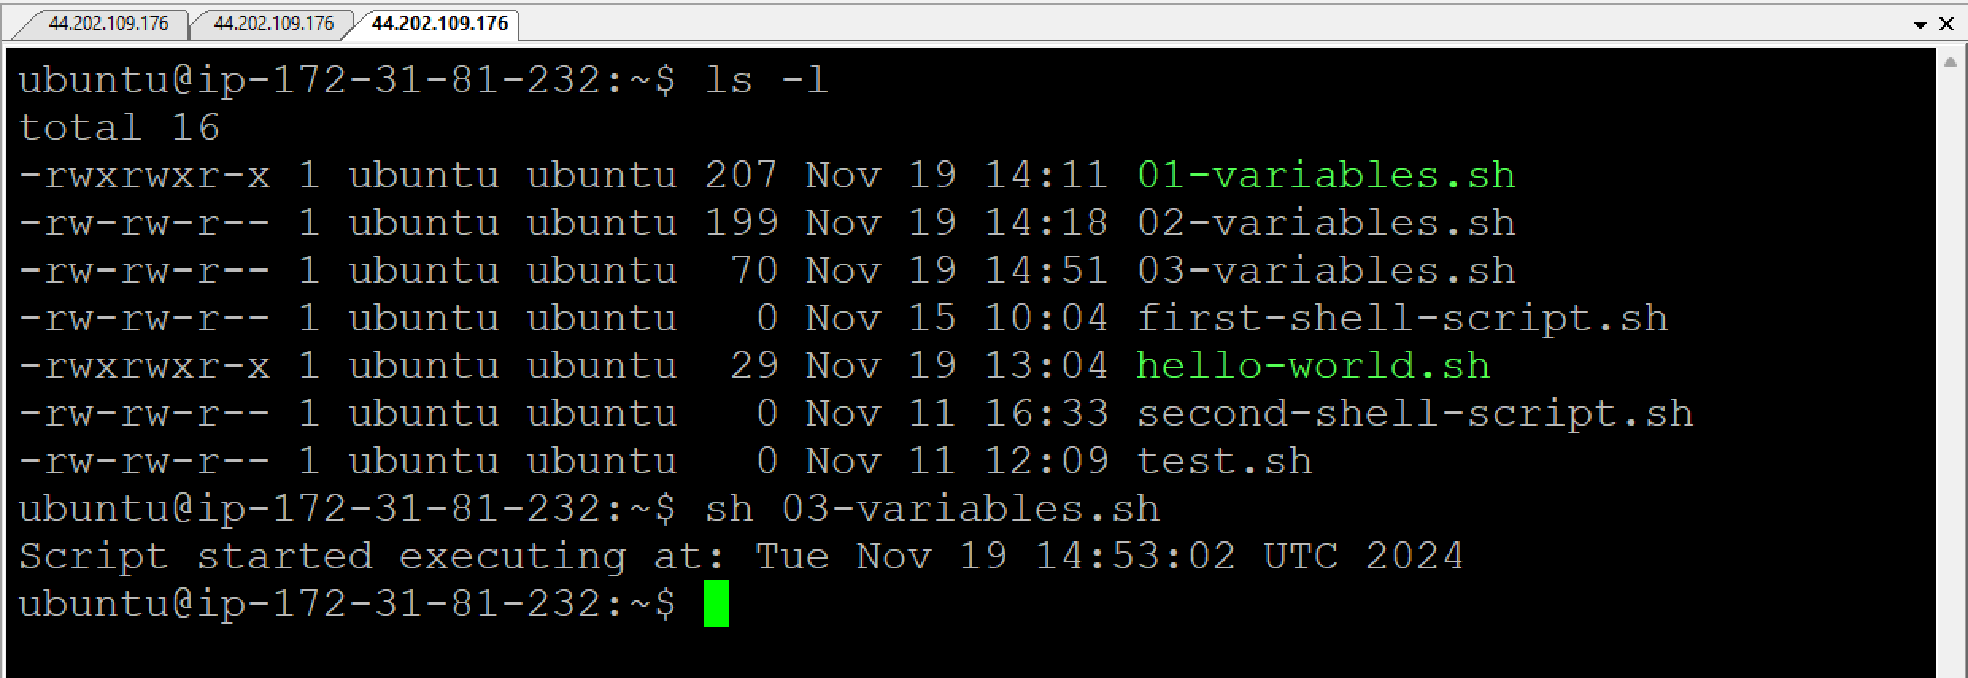

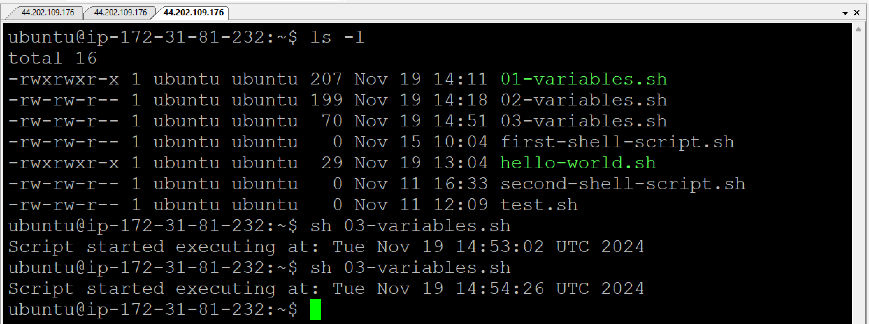

**Requirement:**

I want to connect to database from shell script, so I need username and password.

But username and password are sensitive, they should not be exposed.

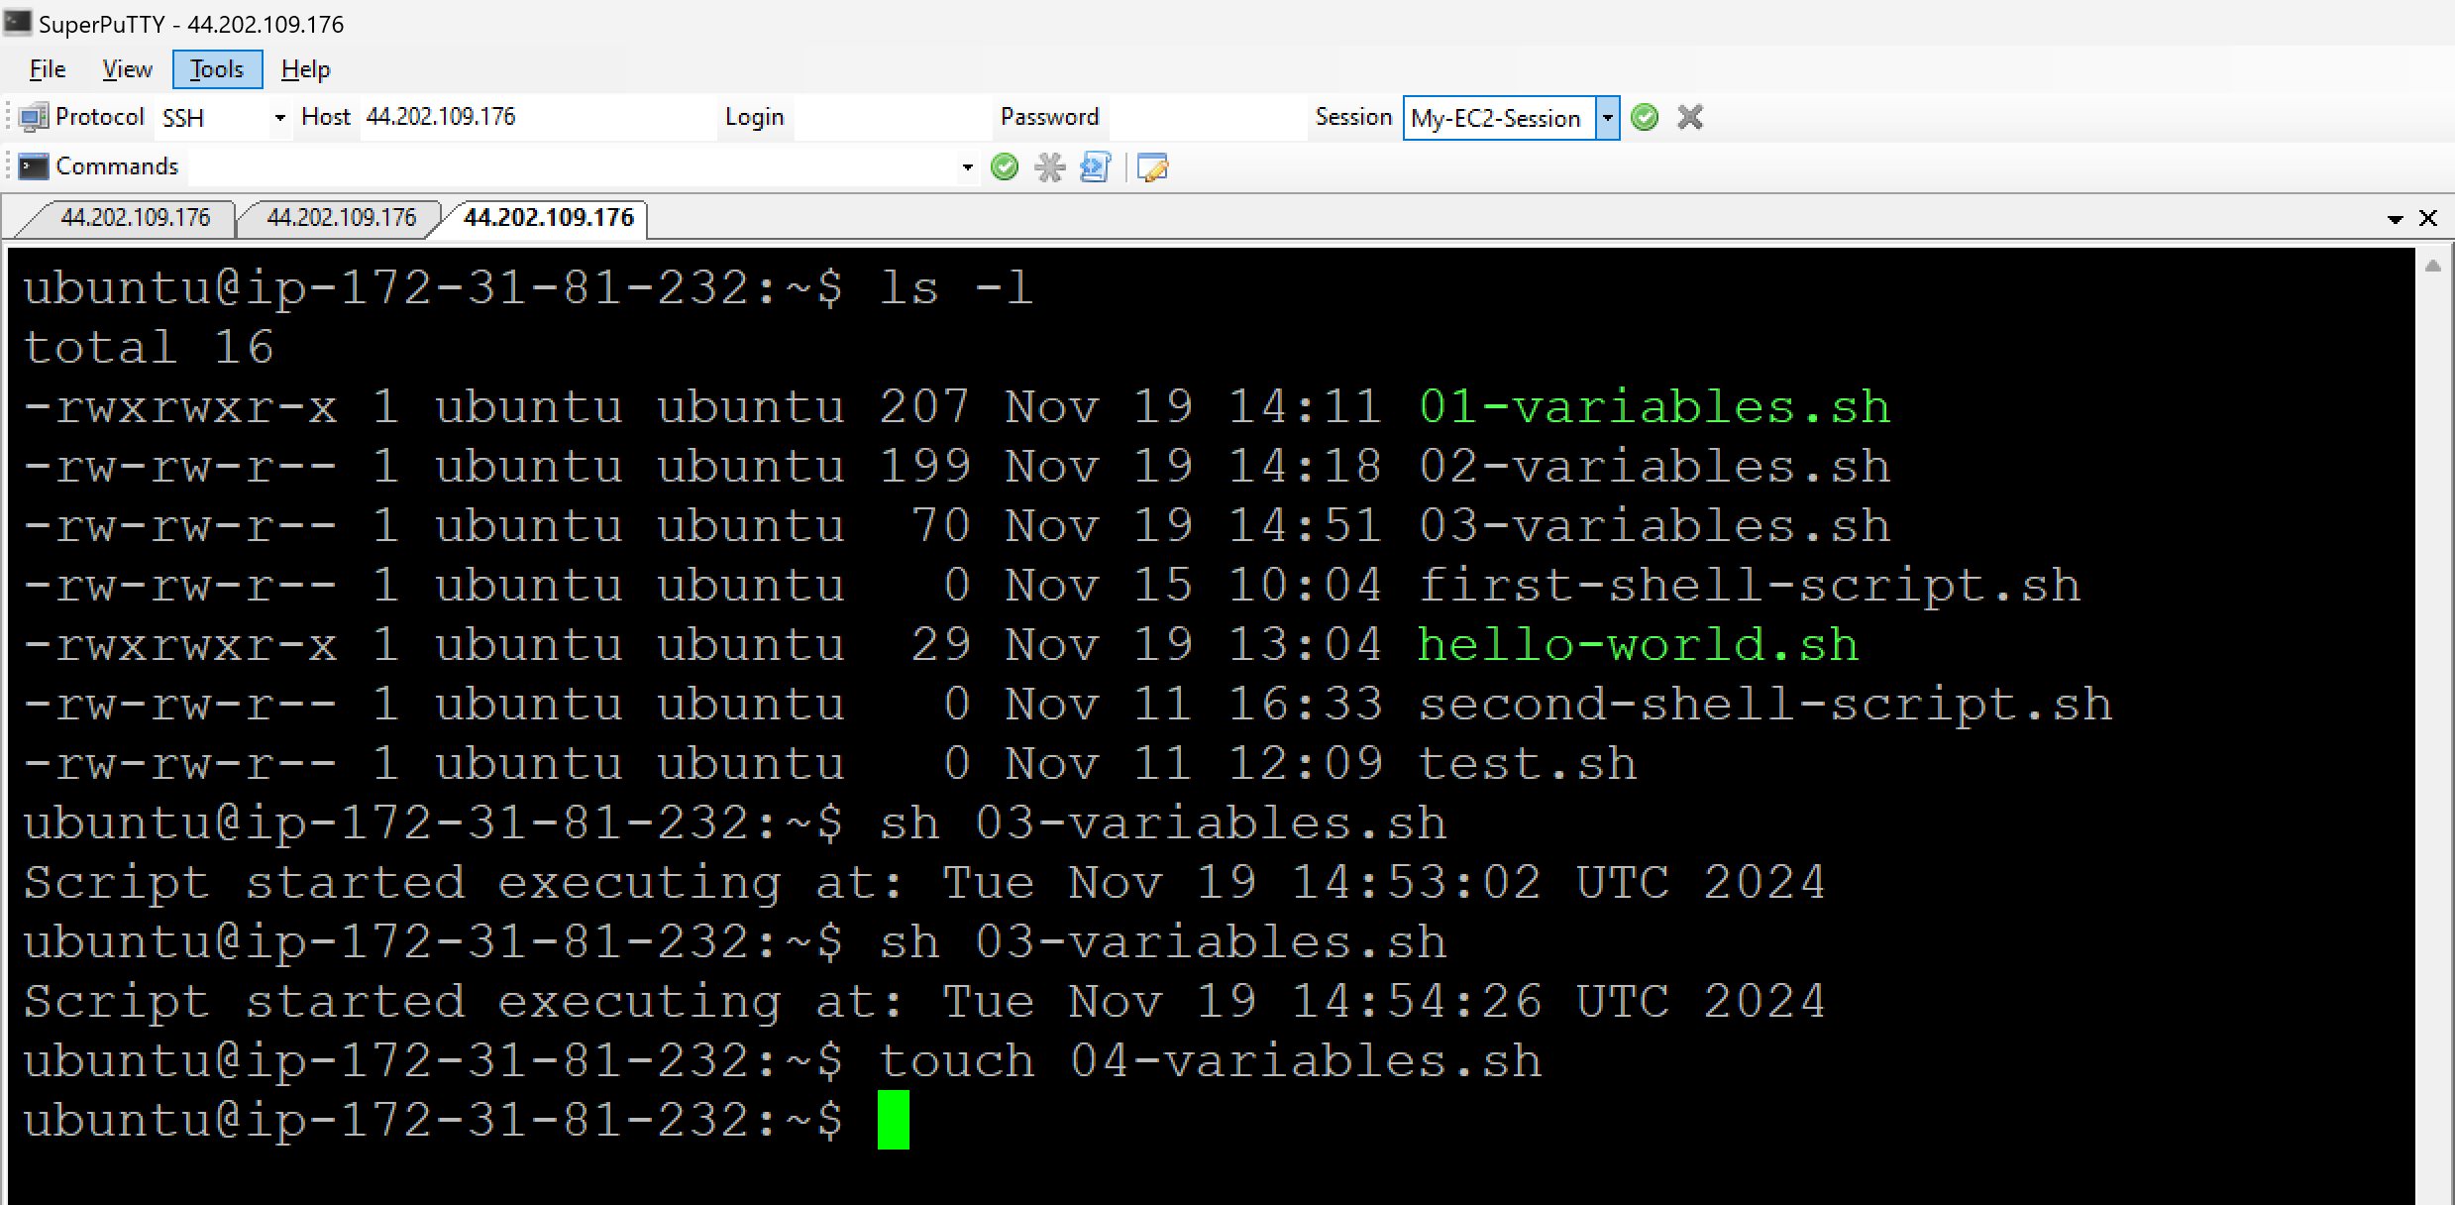

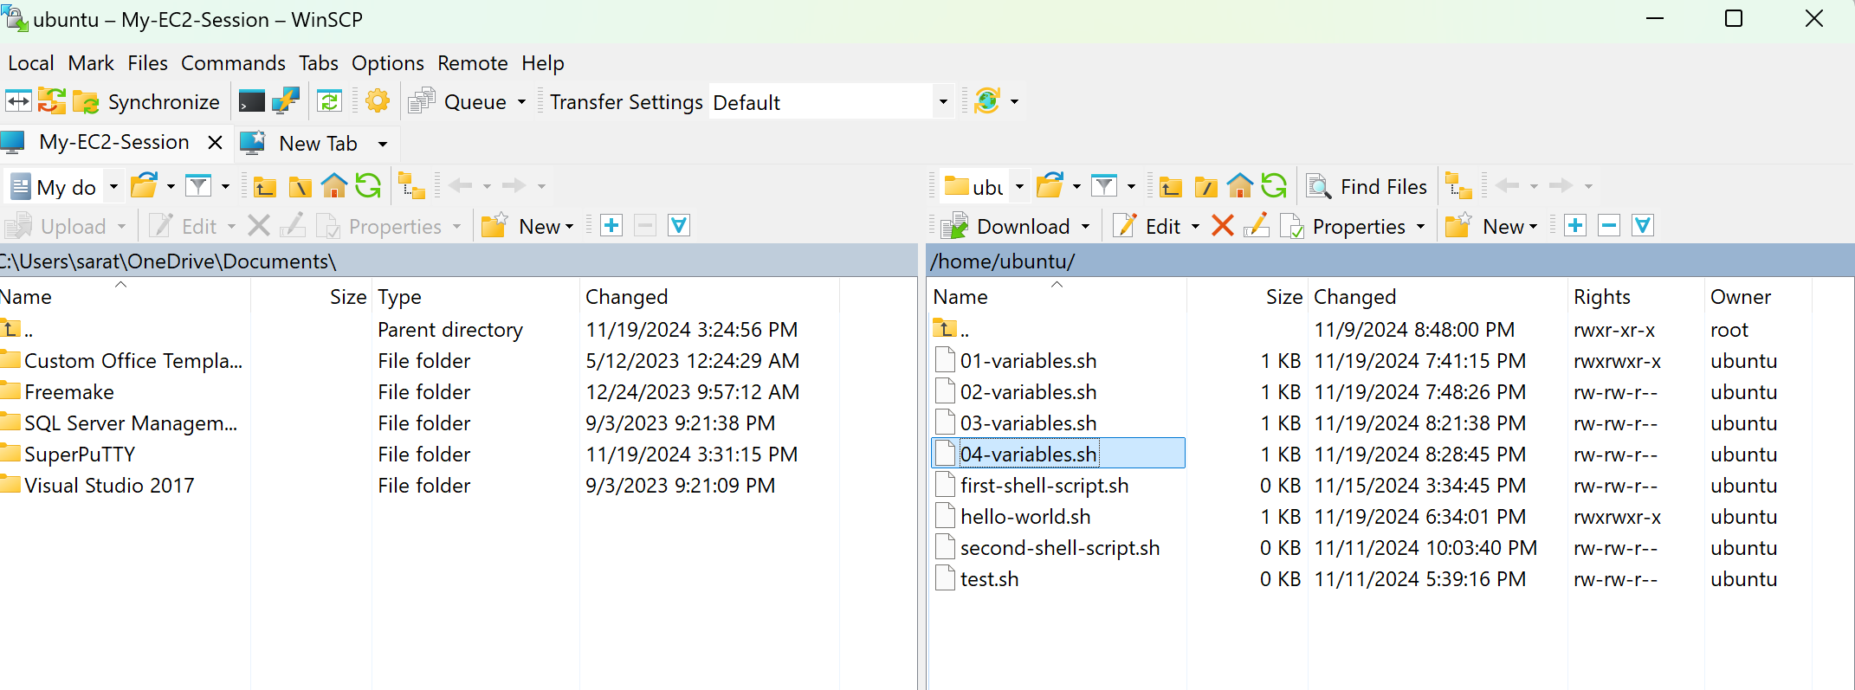

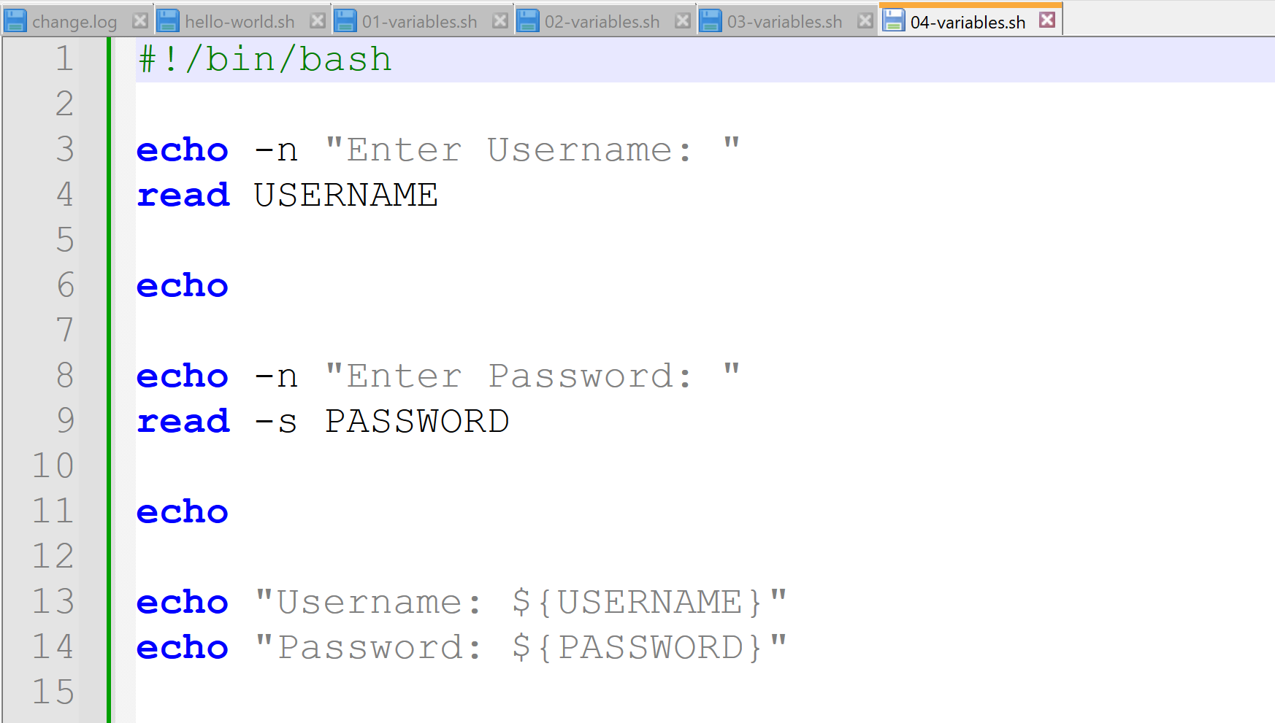

* ‘s’ is nothing but secure
* ‘-s’ command will not be supported by -sh, hence bash will be used to run the script

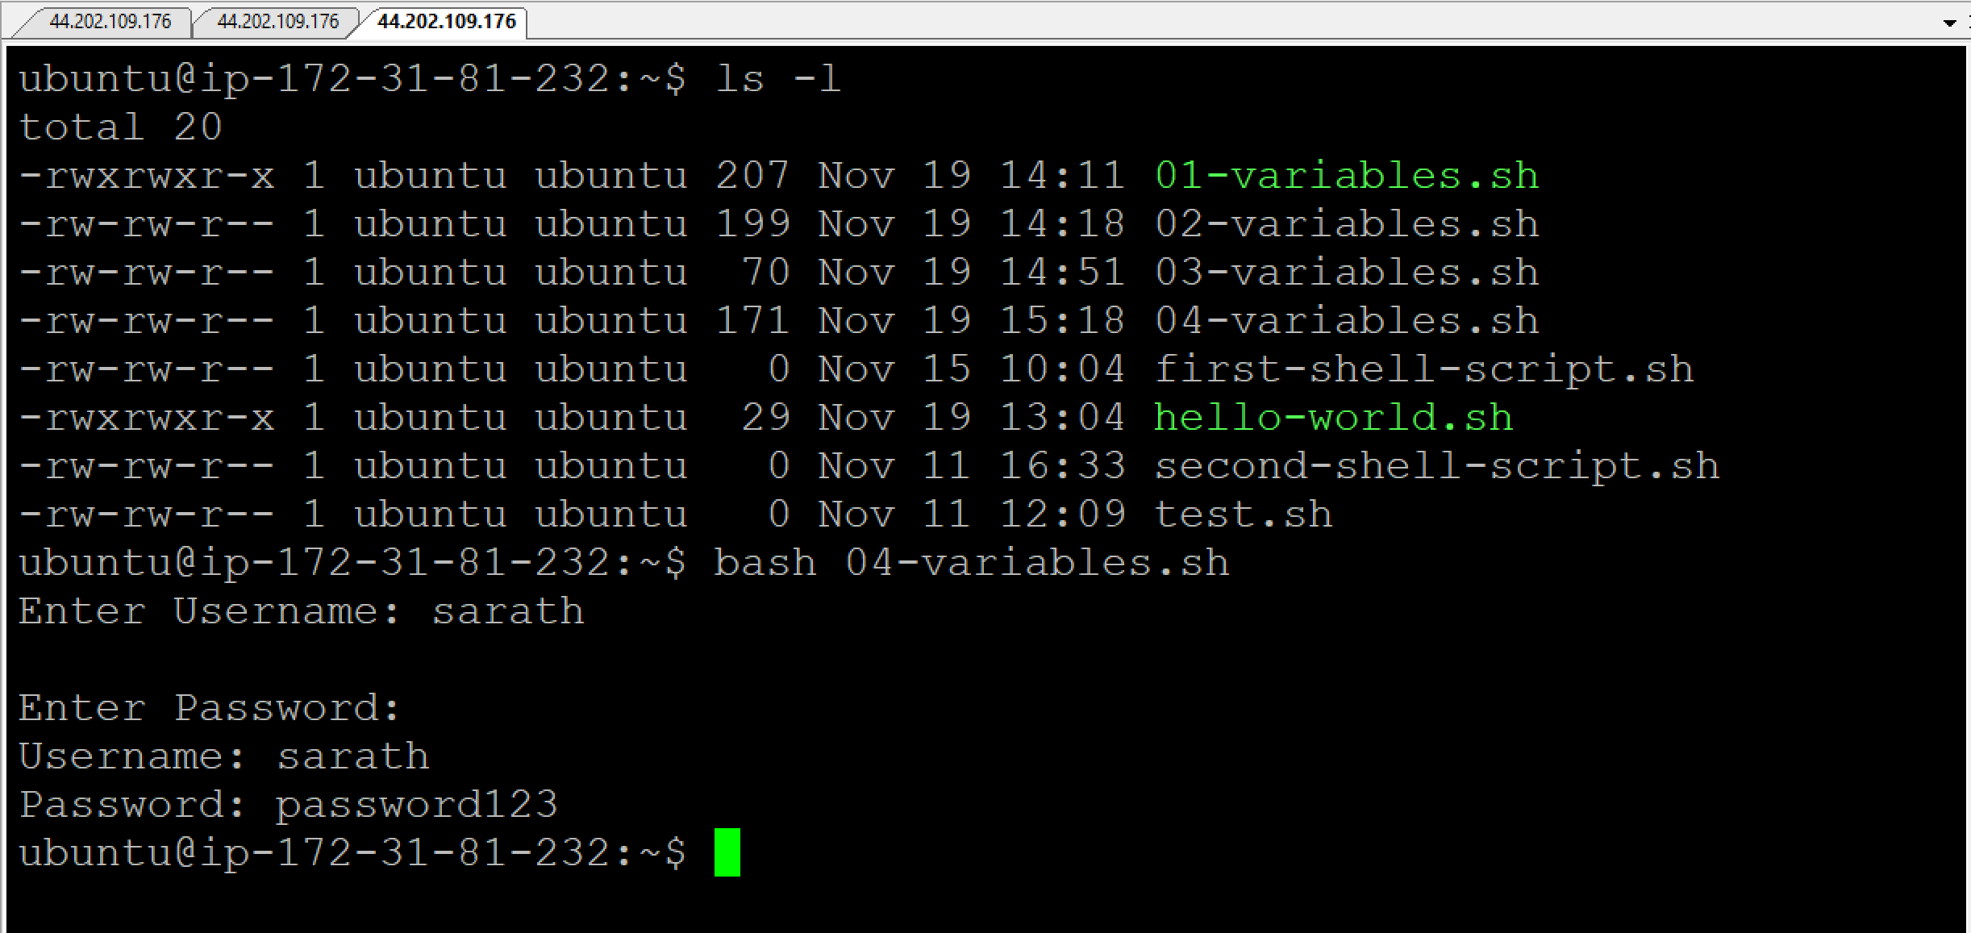

**Linux commands for Infrastructure:**

Create an EC2 instance with AMI as “Amazon Linux 2023 AMI”

In this case login username is ‘**ec2-user**’

When you see present working directory (use **pwd** command to check), it would be empty.

In the Linux directory, there is a default folder (/etc/passwd) where users account and password information is available.

Copy this directory using **cp /etc/passwd passwd**

Now check the present working directory (use **pwd** command to check), a new file with name ‘passwd’ will be created.

**wget <URL>** = Download the file

**curl <URL>** = To print the file in the terminal

Check for the file:

**ls -l**

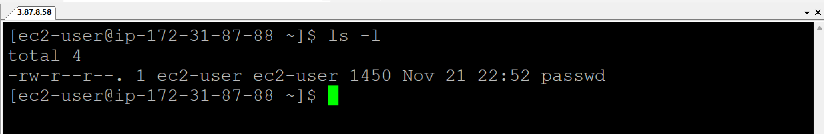

Check for the content of the file:

**cat passwd**

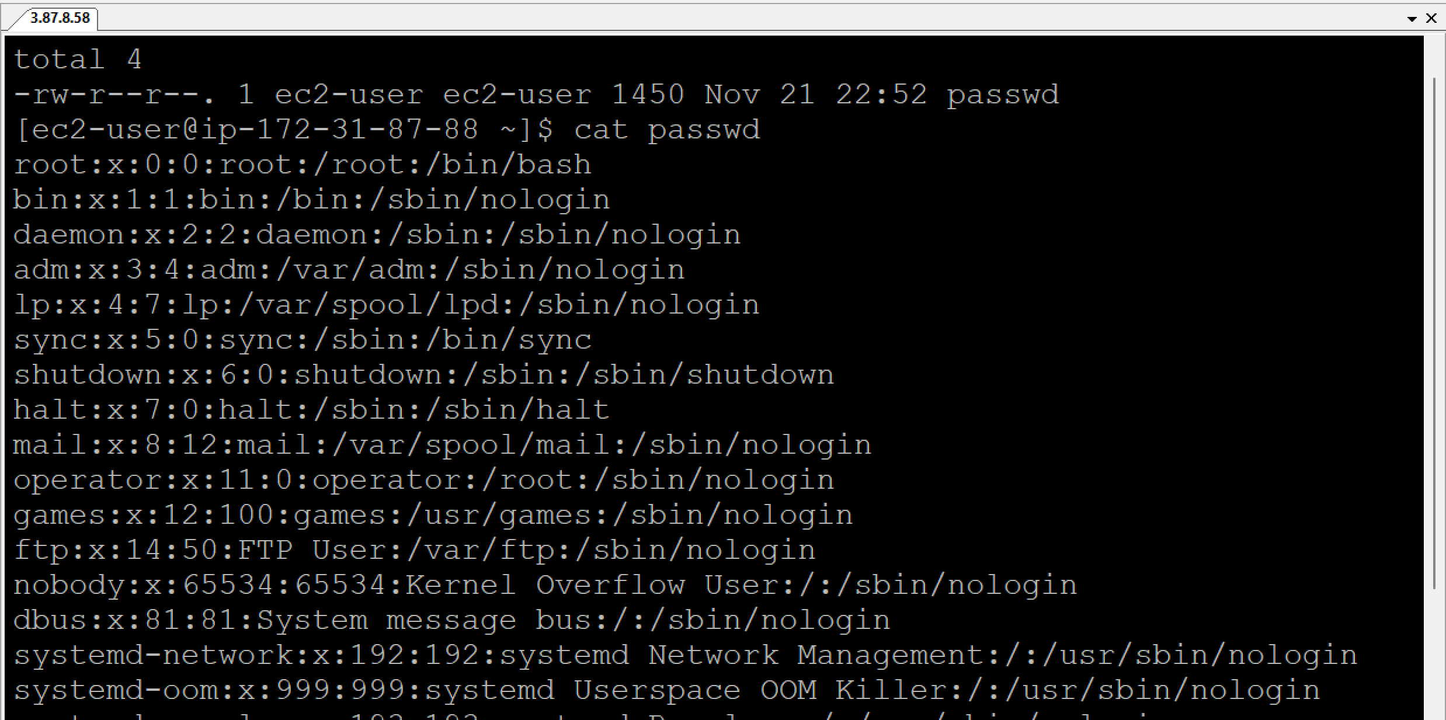

**grep <word> <filename>** = To find and highlight the text in a file. **cat <filename> | grep <word>**

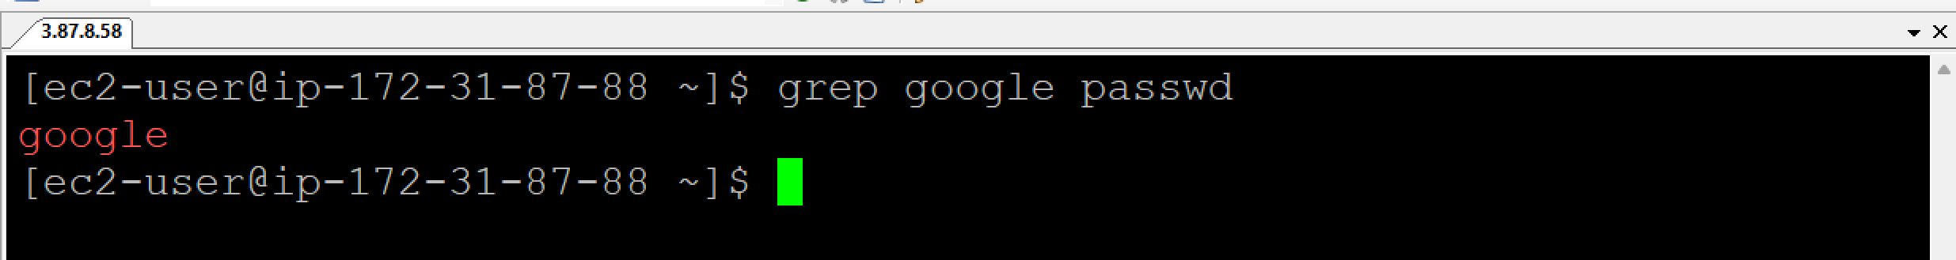

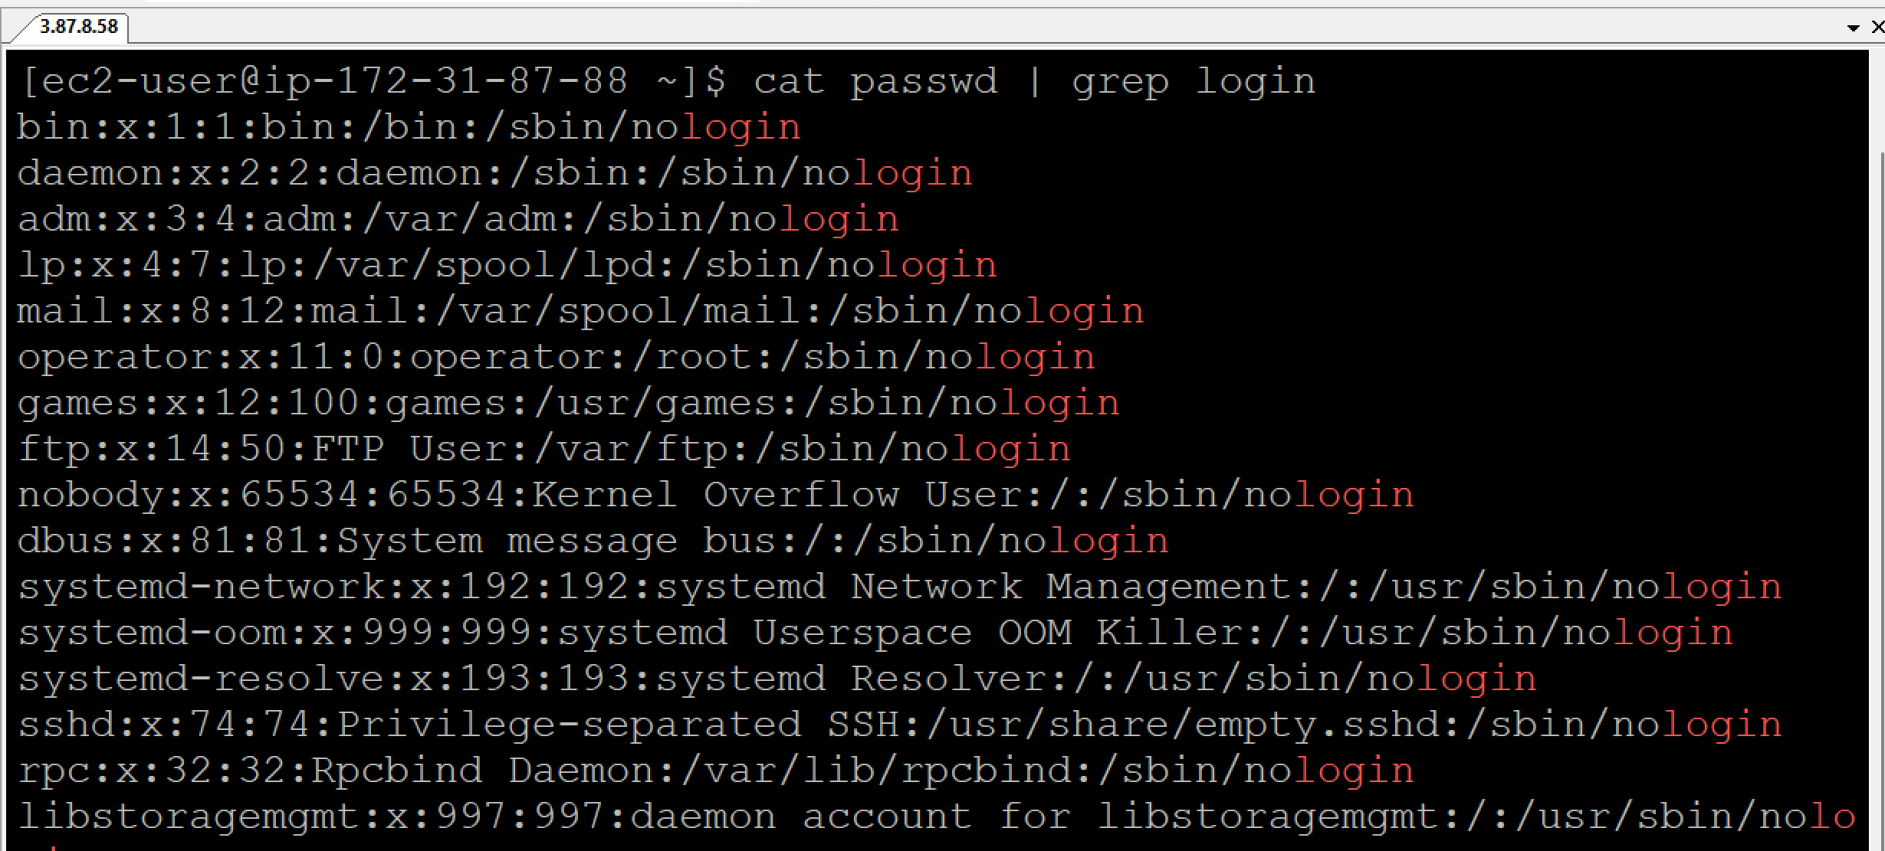

**grep -i <word> <filename>** = Consider the text incasesensitive. **cat <filename> | grep -i**

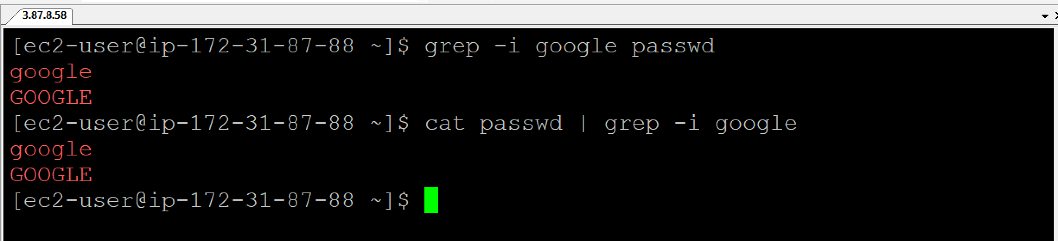

**head <filename>** = To display the first 10 lines of the file by default. **cat <filename> | head**

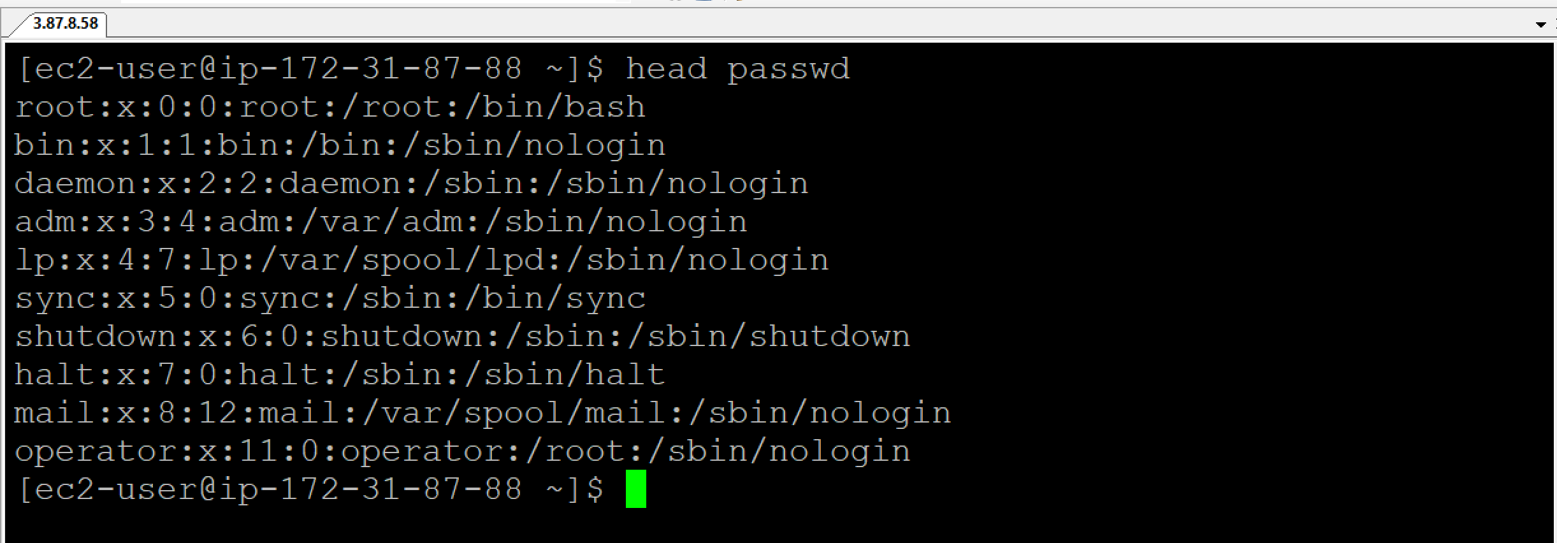

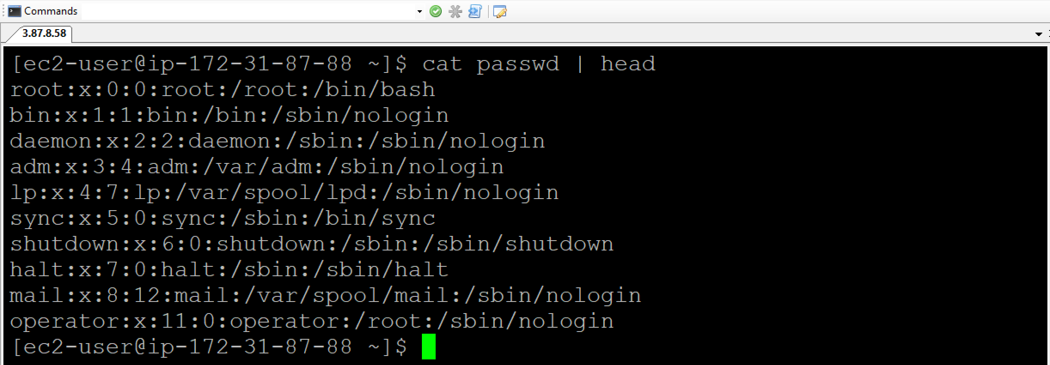

**tail <filename>** = To display the last 10 lines of the file. **cat <filename> | tail**

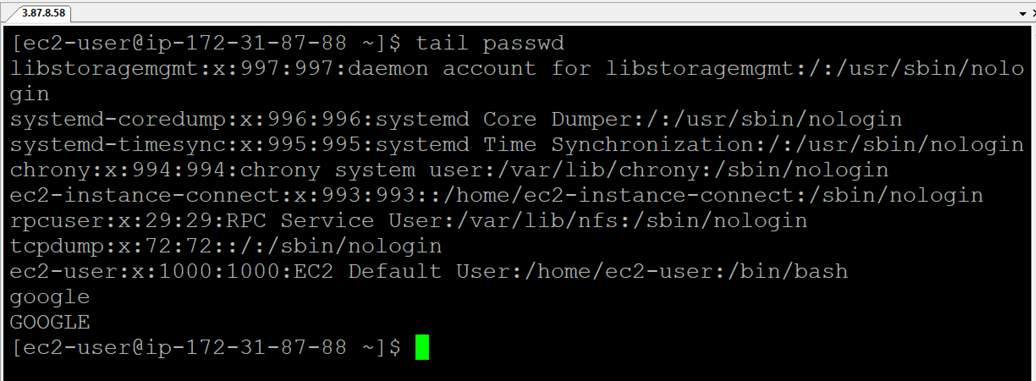

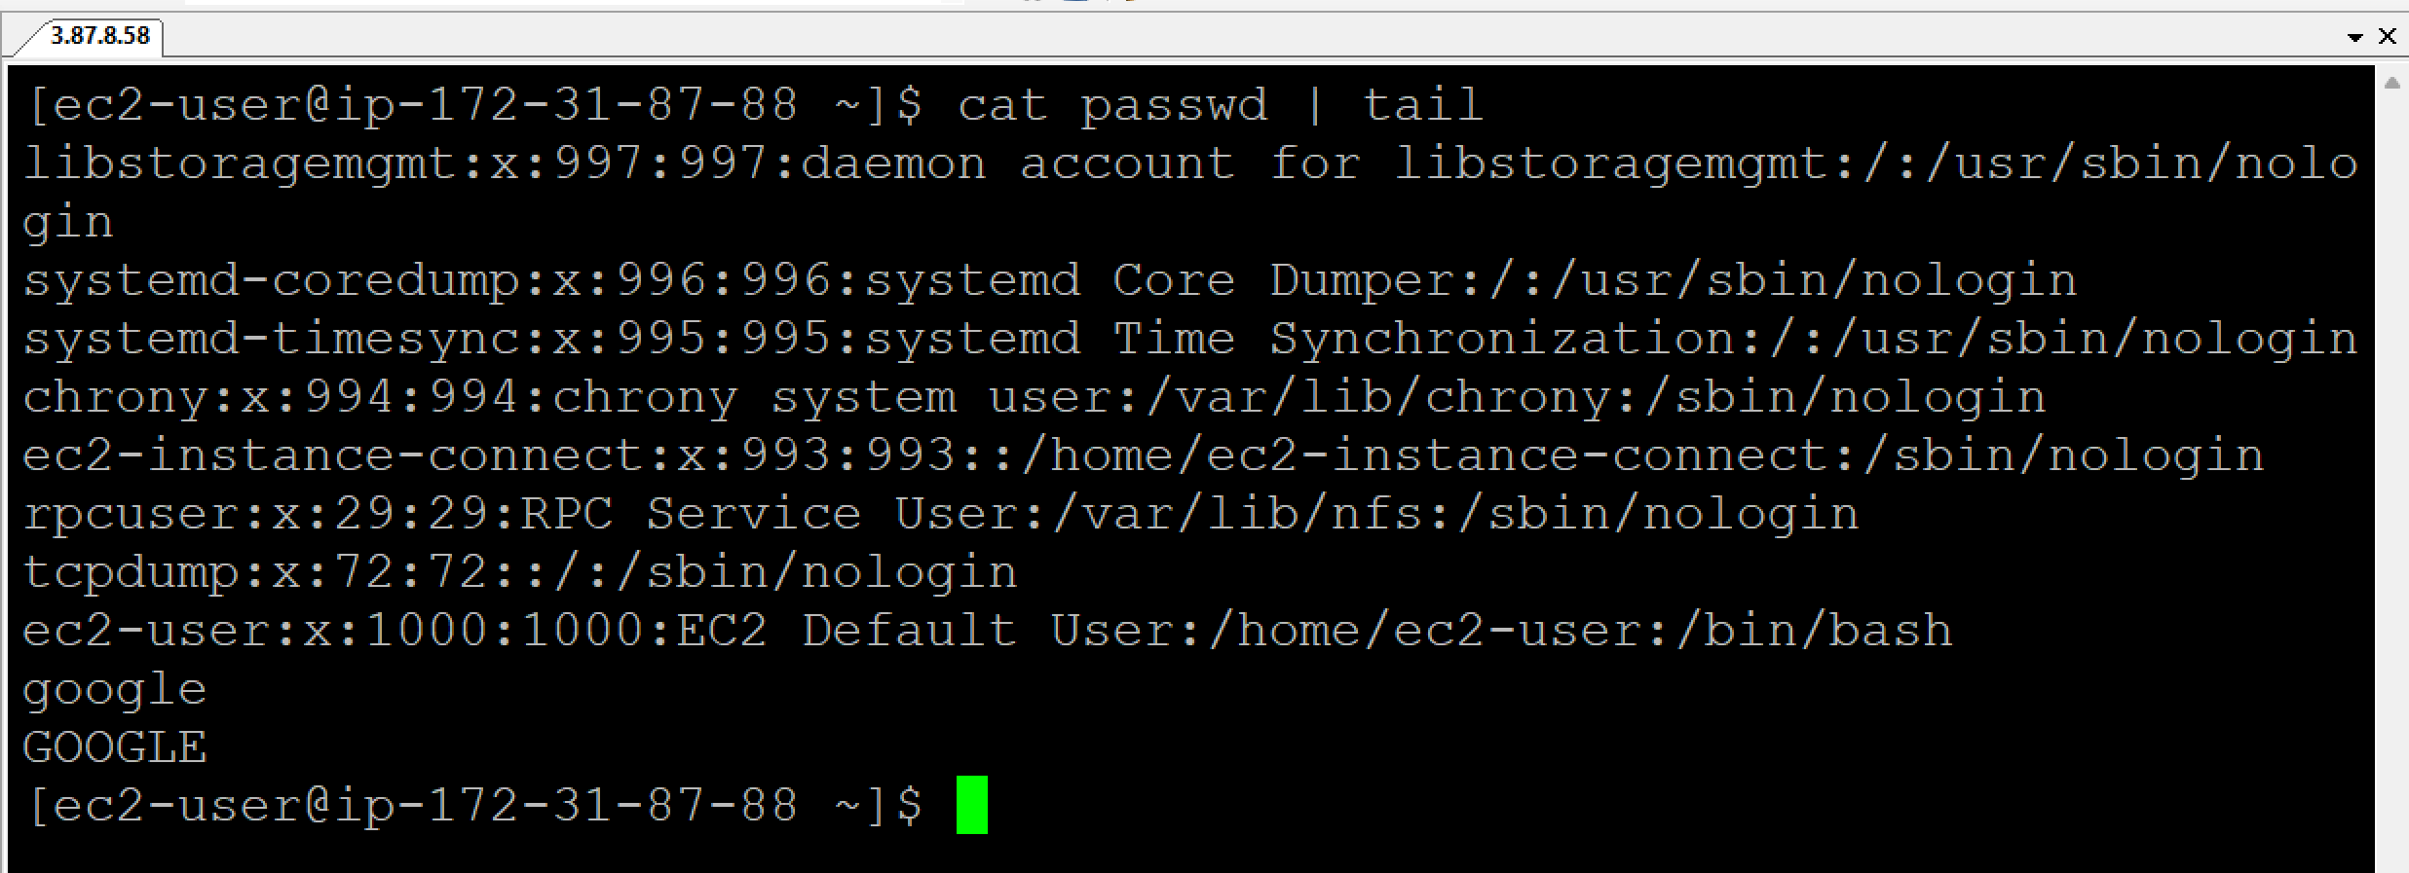

**head -n 2 <filename>** = To display the first 2 lines of the file. **cat <filename> | head -n 2**

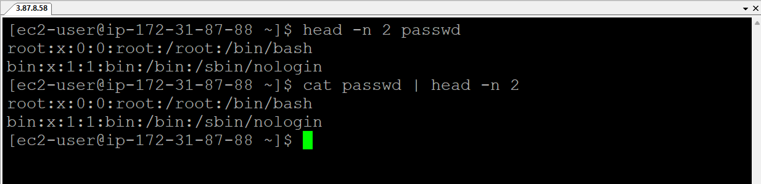

**tail -n 5 <filename>** = To display the last 5 lines of the file. **cat <filename> | tail -n 5**

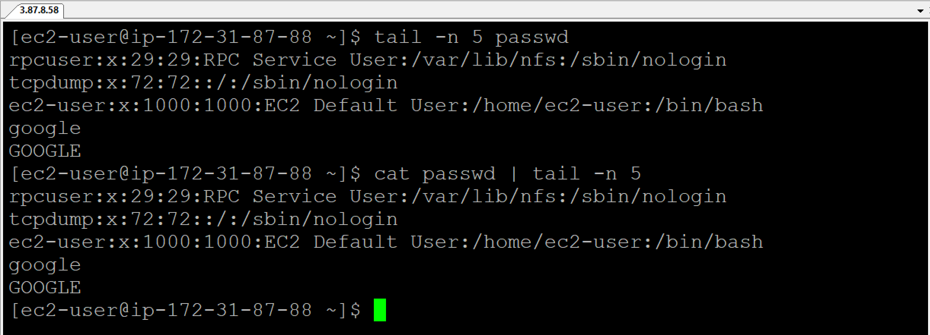

**wget <URL>** = Download the file

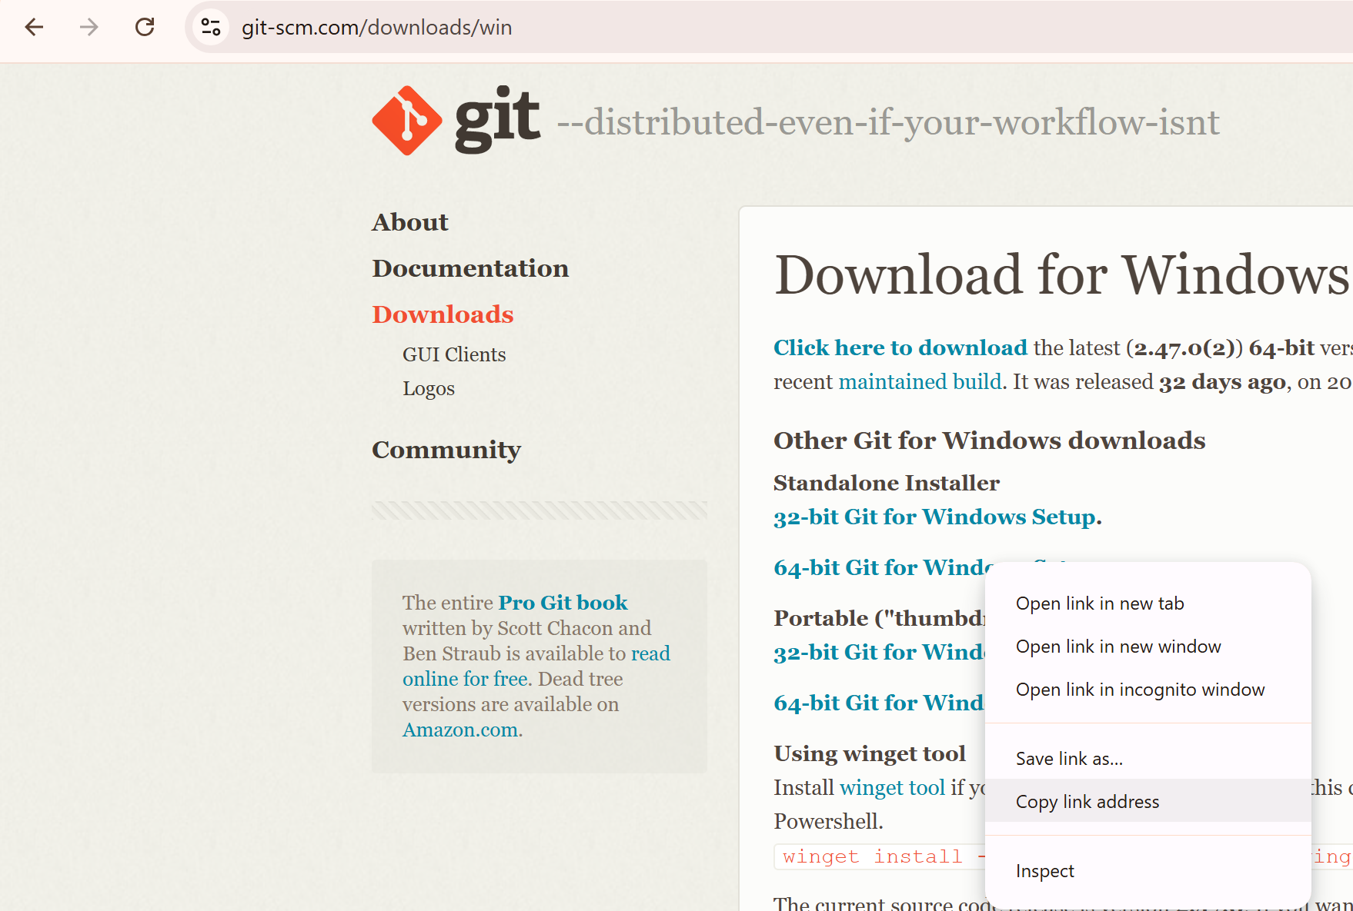

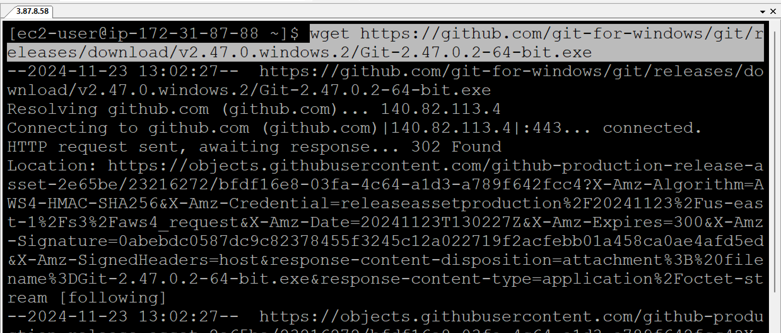

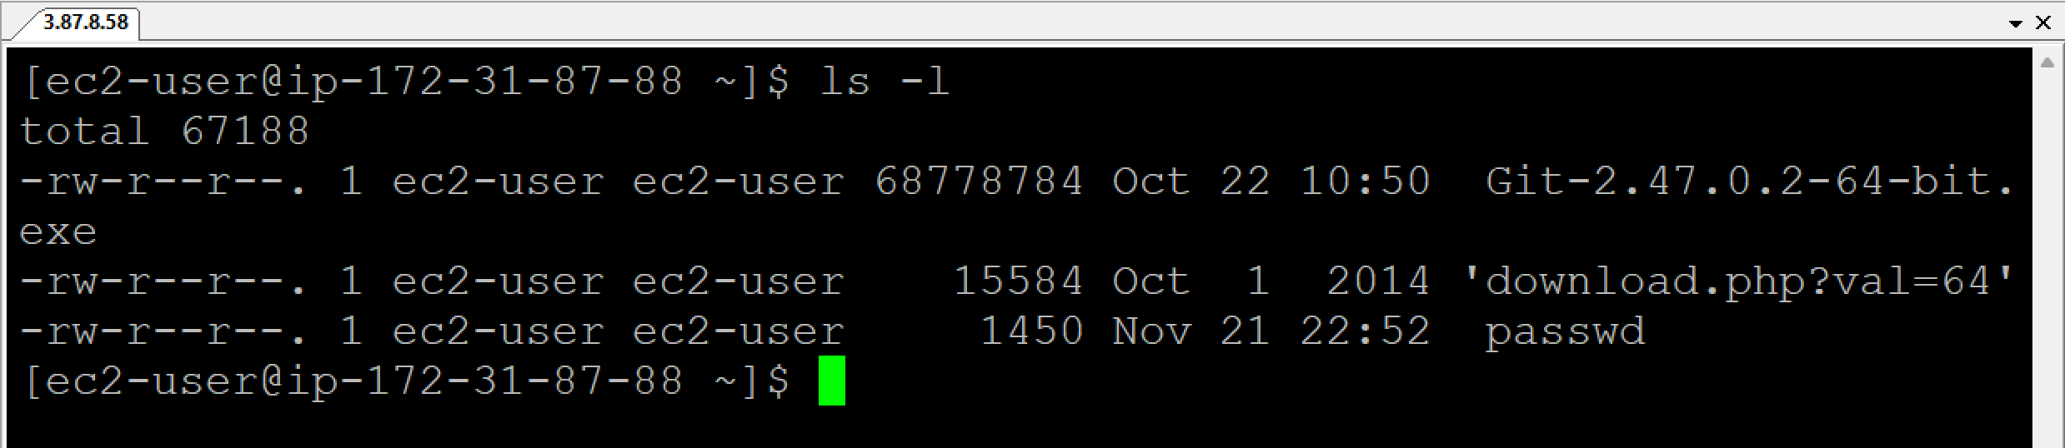

**curl <URL>** = To print the file in the terminal. You can retrieve the information from any external devices from the internet.

**Example:**

**curl** <https://raw.githubusercontent.com/sandbox/main/log/dummylog.log> | **grep** ERROR

‘**cut’** command is used to cut the string based on delimiter (/, :, etc.)

**echo** <https://github.com/disha2461/xxxxxx>| **cut -d / -f 1** = To print the first fragment (https:)

**echo** <https://github.com/disha2461/xxxxxx> | **cut -d / -f 2** = To print the second fragment ( )

**echo** <https://github.com/disha2461/xxxxxx> | **cut -d / -f 3** = To print the third fragment (github.com)

**d** refers to delimeter.

**f** refers to fragment.

**awk** command is used, if fragments are more in number in a given url. And also can be used for column based.

**echo** <url> **| awk -F “/” ‘{print $1F}’** = To print the first fragment

**echo** <url> **| awk -F “/” ‘{print $2F}’** = To print the second fragment

**echo** <url> **| awk -F “/” ‘{print $NF}’** = To print the last fragmentset

**Monitor the Node health:**

To monitor the node health, you can monitor the CPU and RAM.

**nproc** = To print the list of CPUs on your machine

**free** = To print the free memory, total memory, used memory, shared memory

**df** = To print disk space like all the information about the available storage space.

**top** = To print what are the processes that are running on your machine like which processor is taking more memory, which processor is taking less memory.

**df -h** = To display the disk space usage of file systems

**free -g** = To display the system’s memory usage in GB.

**nproc** = To display the number of processing units (CPU cores) available to the current user.

**Writing the shell script in a file:**

1. *Create a file and open it in edit mode*

**vim** **nodeHealth.sh**

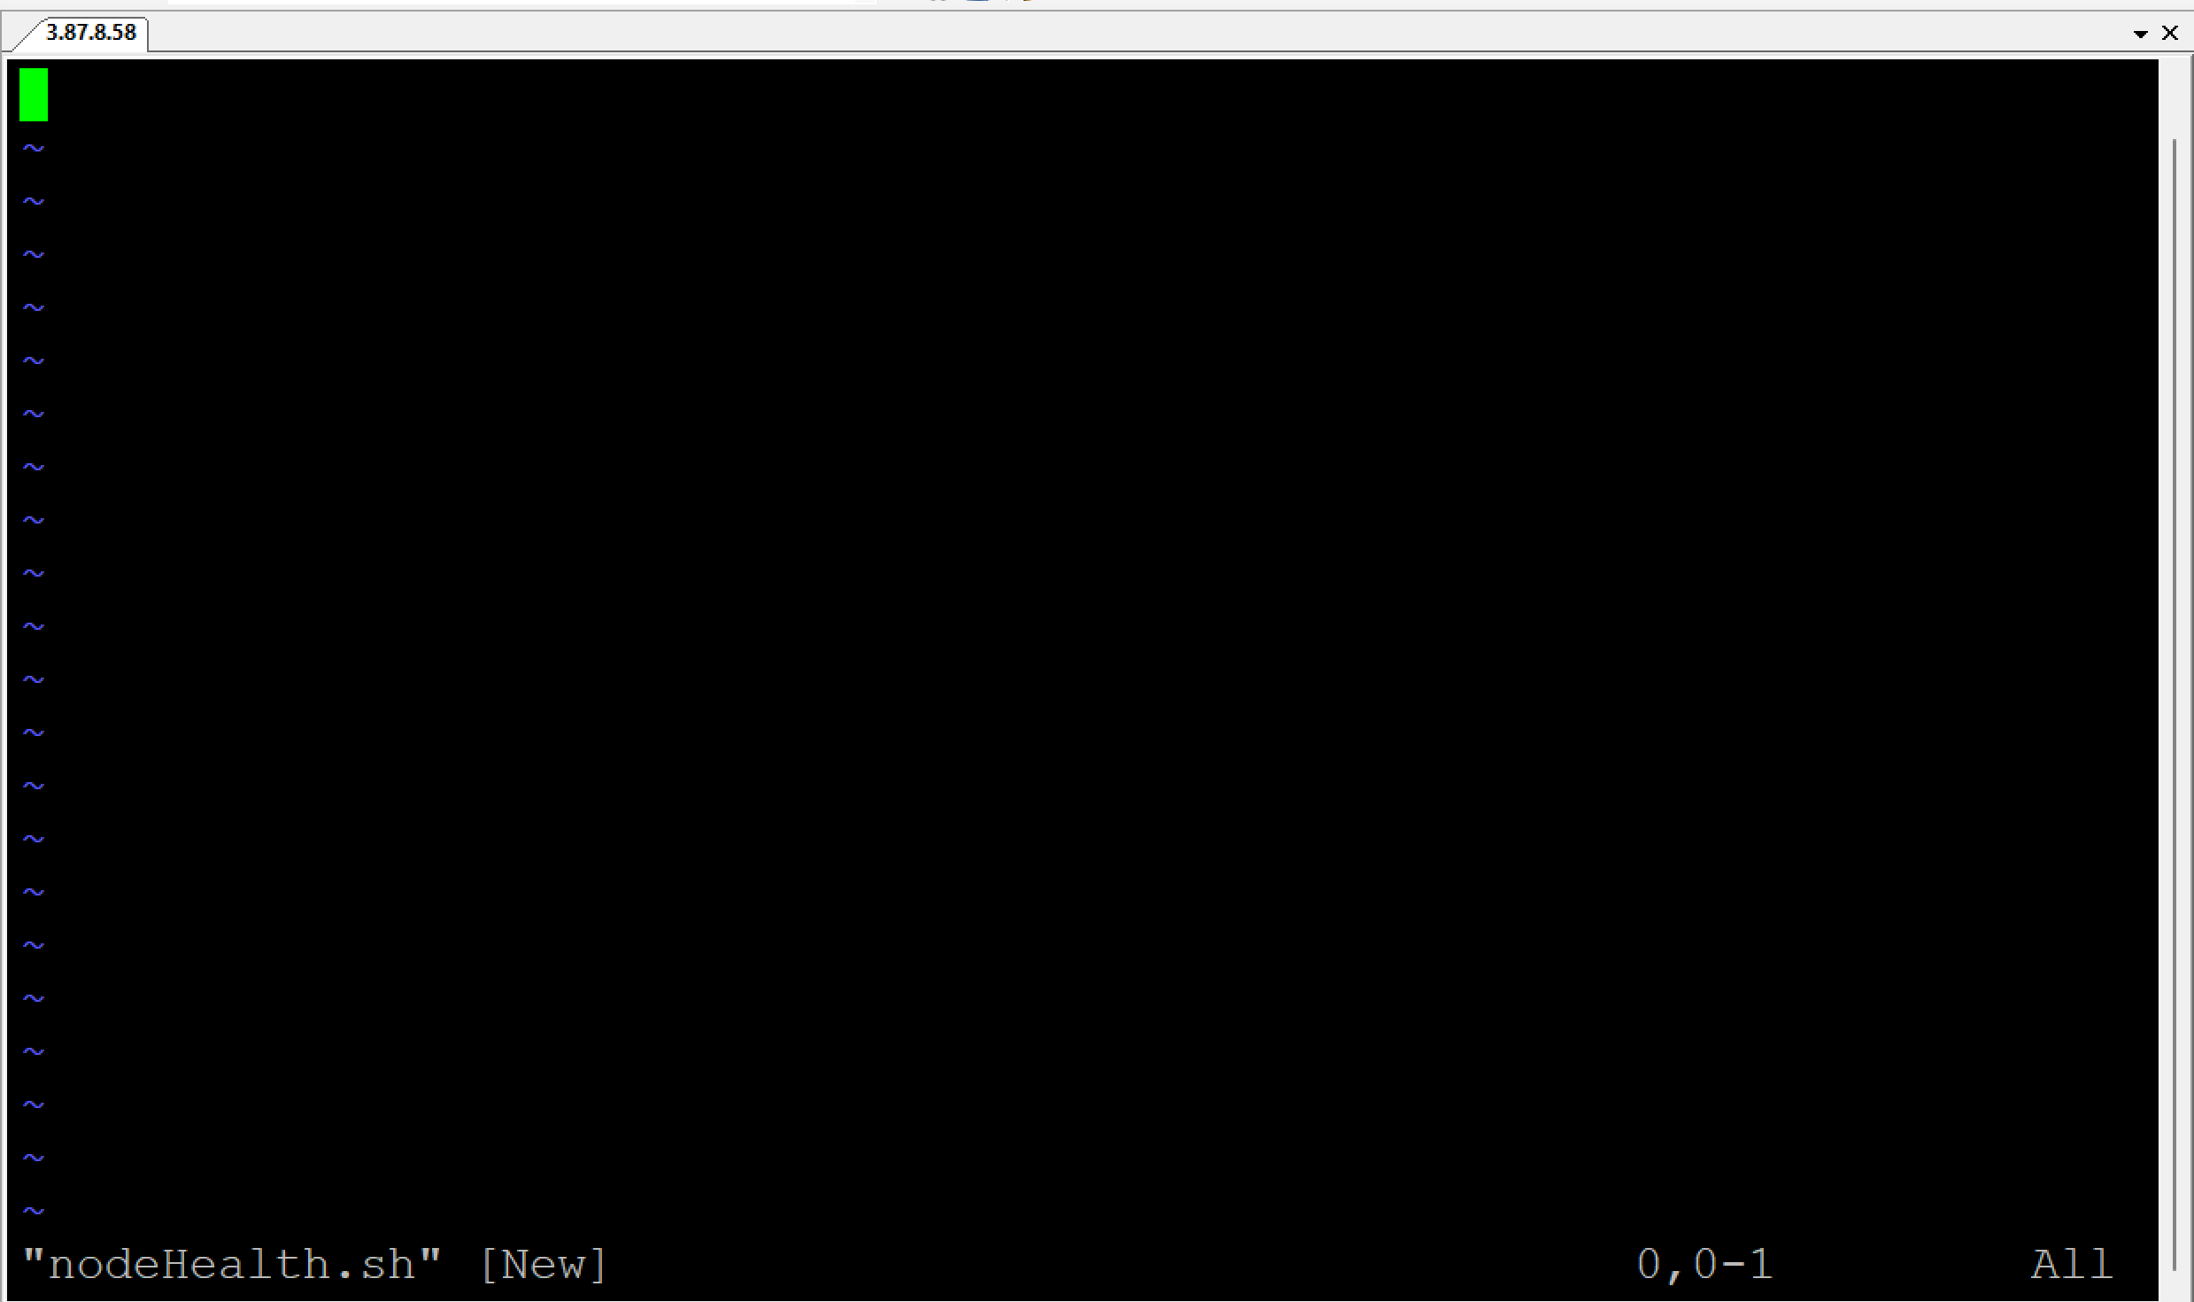

Press Esc button and then I button to go to Insert mode

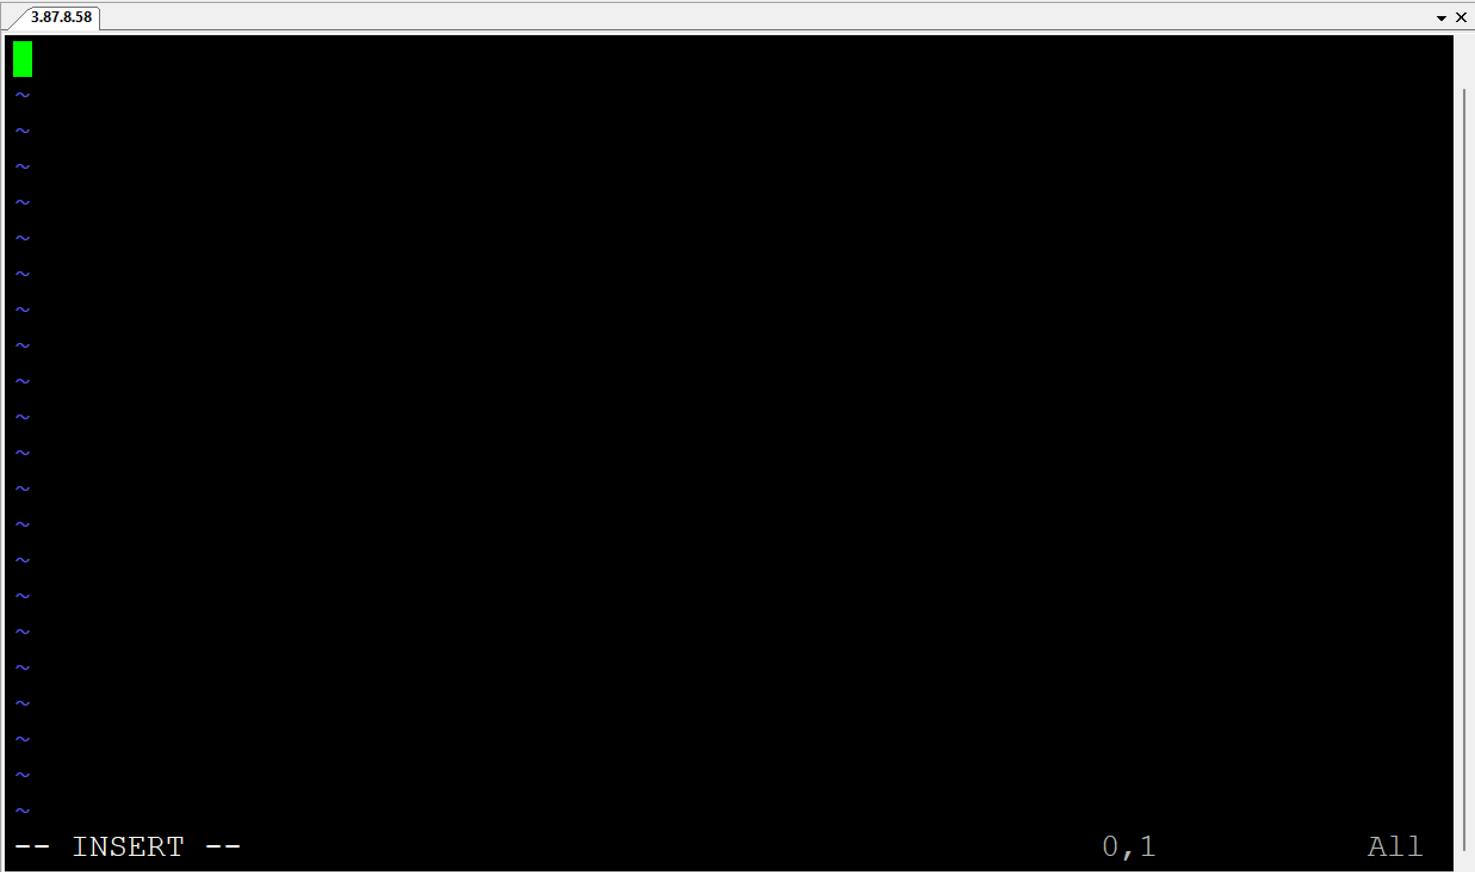

**#!/bin/bash**

1. *Provide the metadata information as below:*

**##############################**

**# Author: Sarath**

**# Date: 11/11/2024**

**#**

**# This script outputs the node health**

**#**

**# Version: v1**

**###############################**

**df -h**

**free -g**

**nproc**

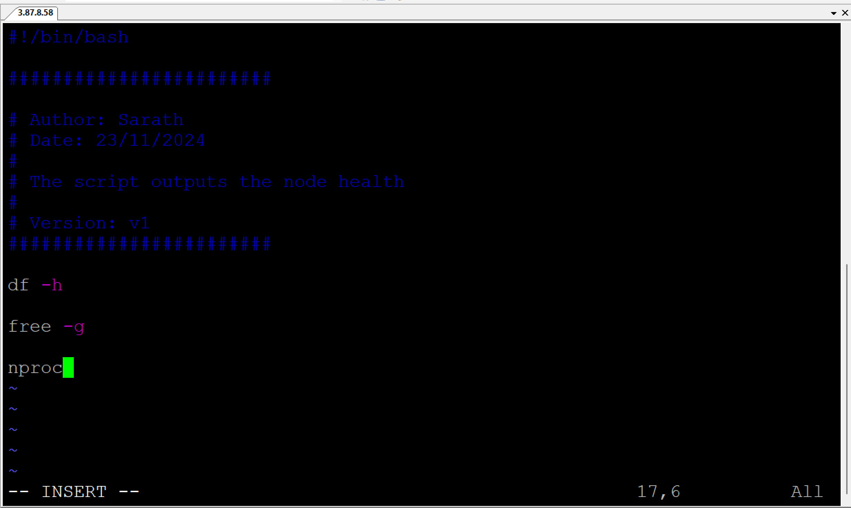

Press Esc button and type **:wq!**

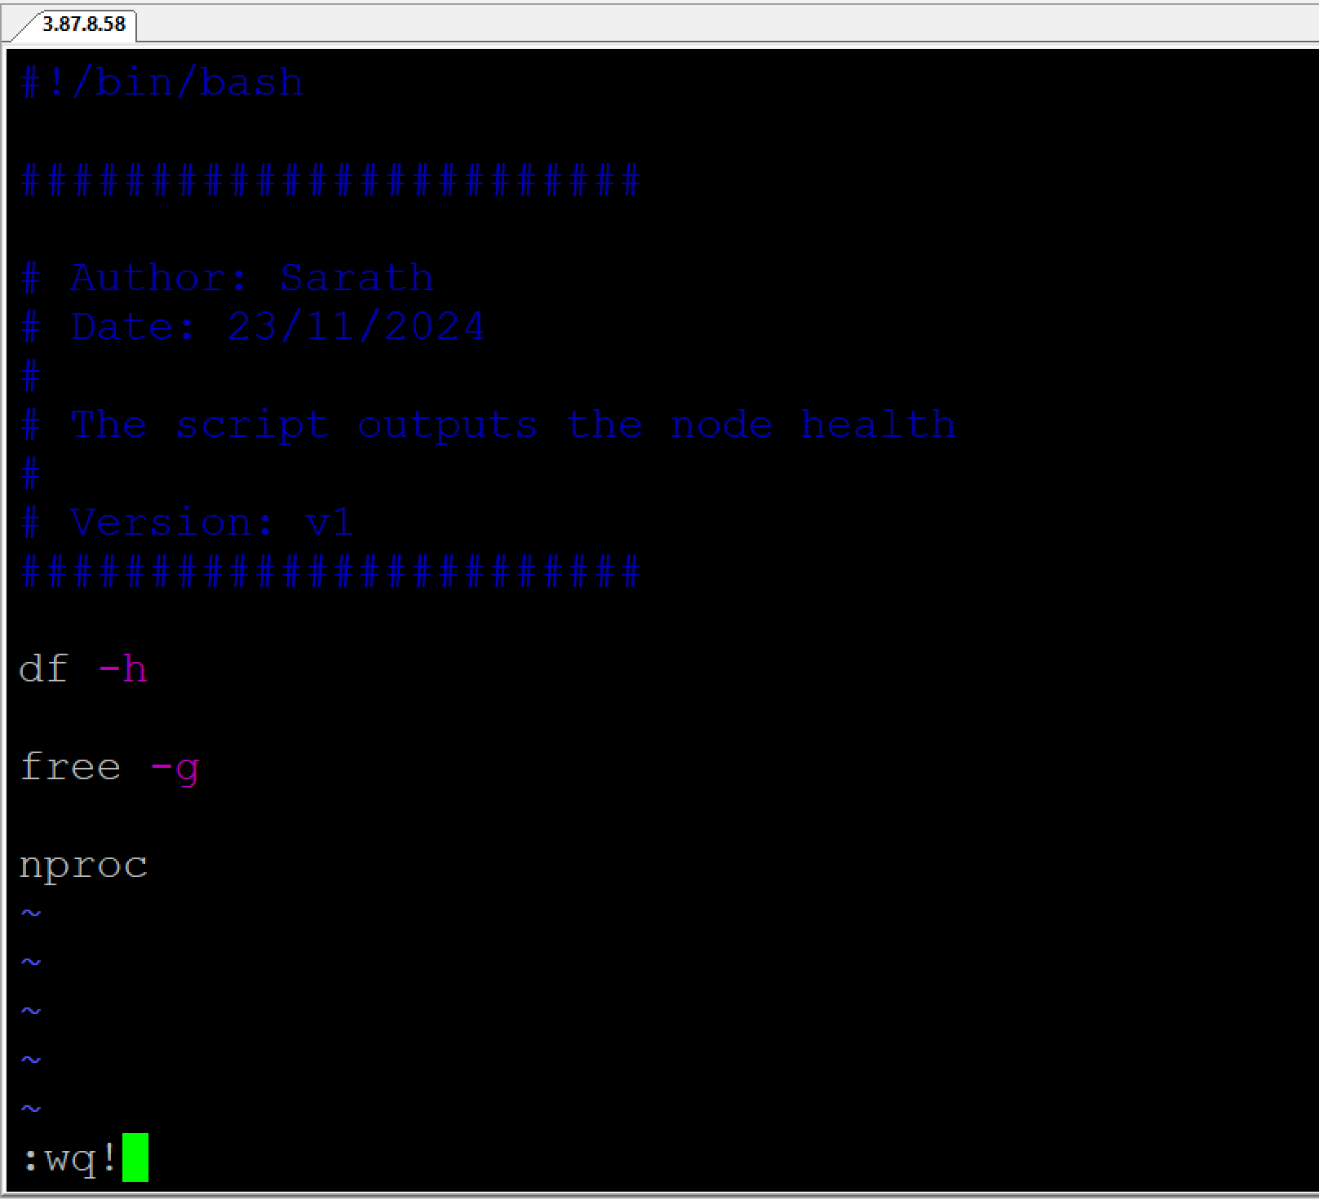

Hit Enter

1. *Provide the permissions to the file*

**chmod 777 nodeHealth.sh**

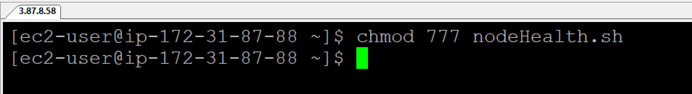

1. *Execute the script*

**./nodehealth.sh**

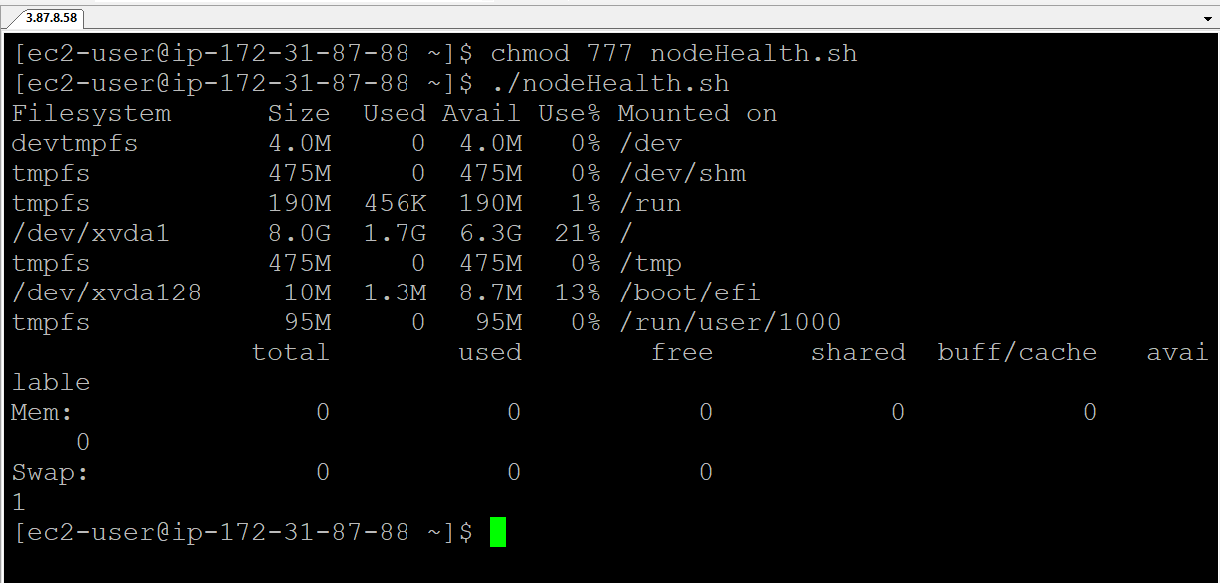

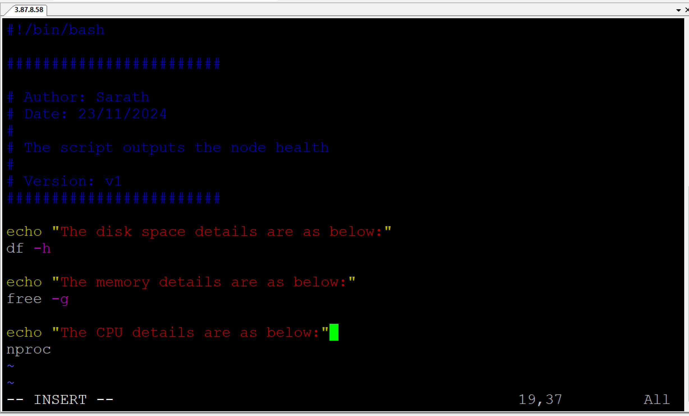

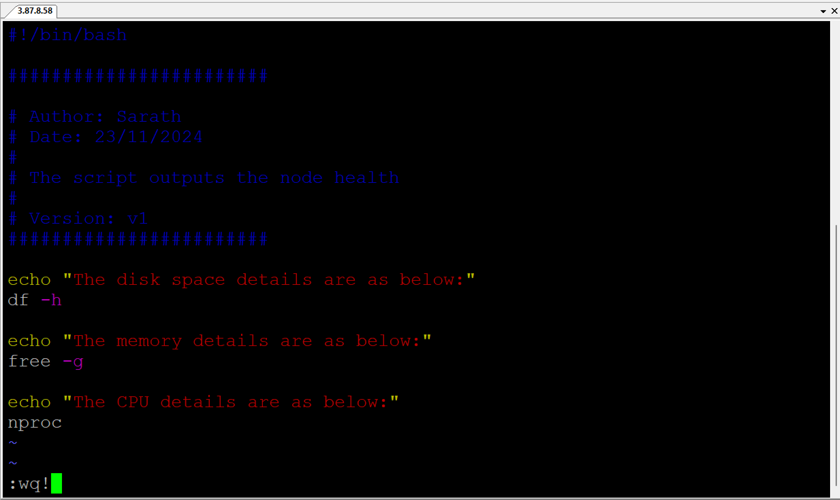

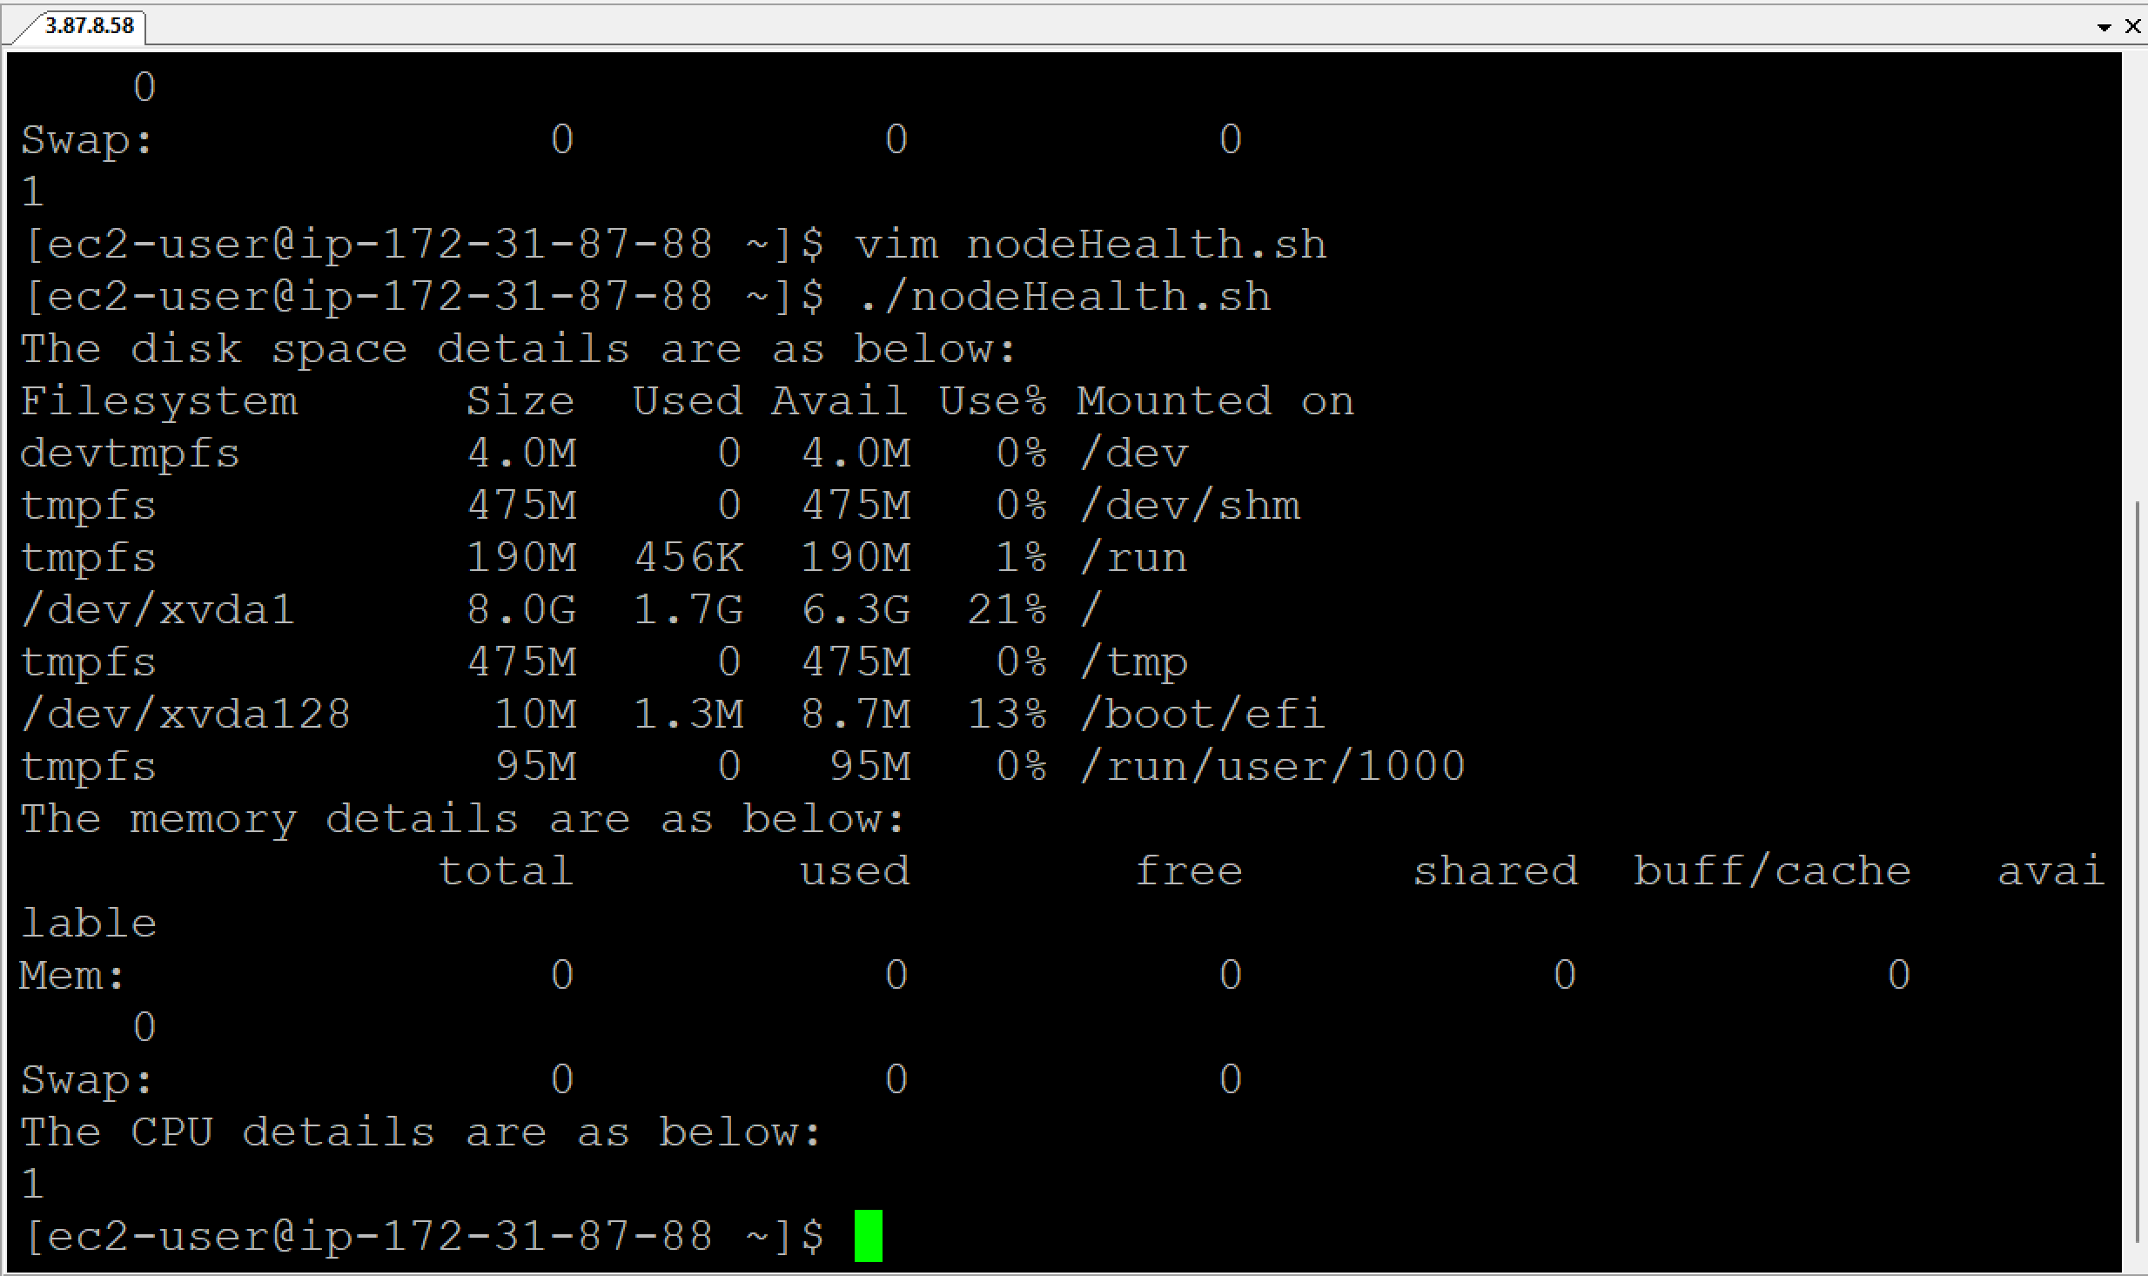

* Writing echo statements is not good all the times when you have a huge script.

**set -x** = is a debug mode. It will show you the commands that you are executing and it also prints the output.

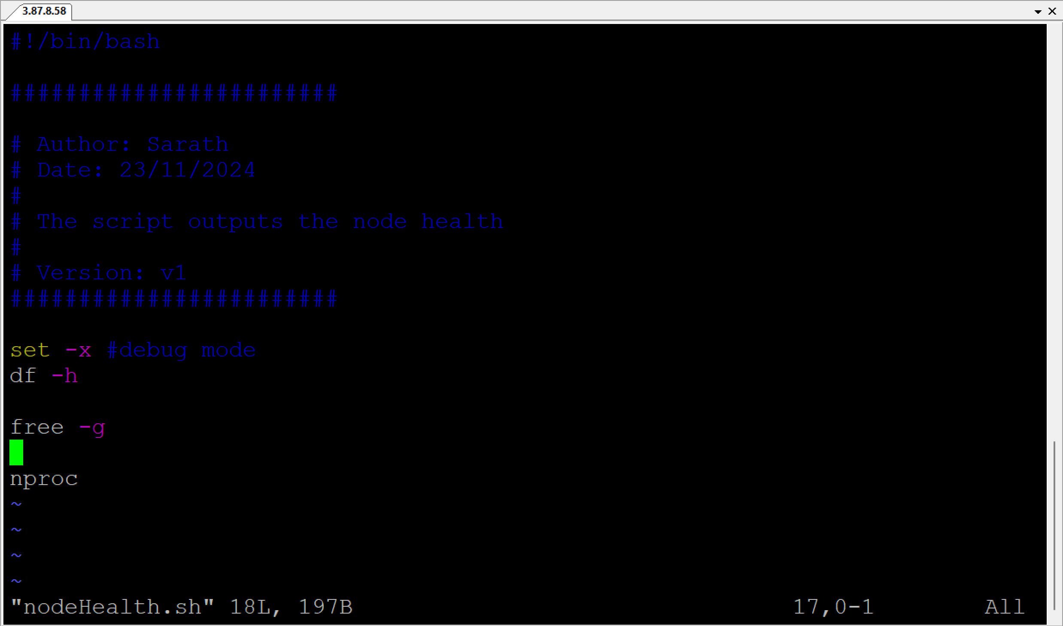

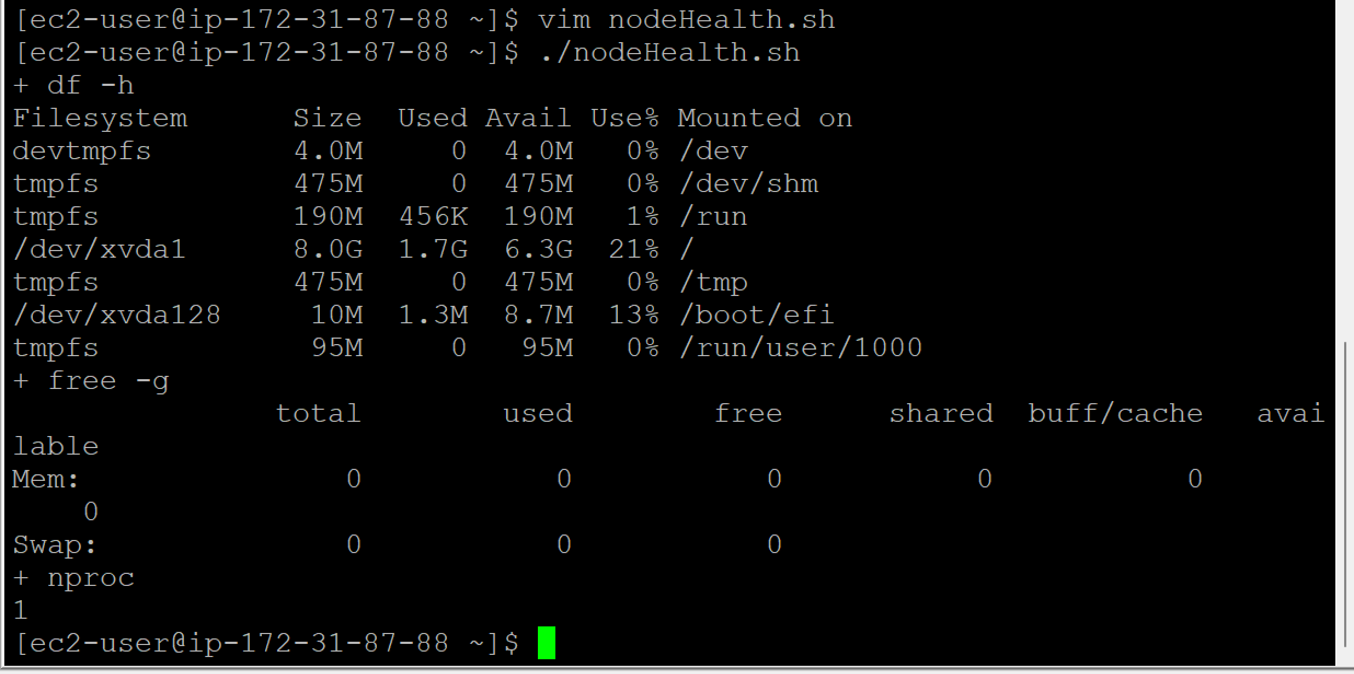

In Linux machine which doesn’t have a graphical user interface, there is command to find out the processes.

**ps -ef =** To see the number of processes

**ps** stands for processes

**ef** stands for entire details of the process like it provides the details of the processes in a full format.

**ps -ef | grep “amazon”** = To find out the number of processes that are running by amazon.

**awk** = To give specific columns from the output.

**|** (pipe command) sends the output of the first command to the second command.

**Example:**

vim test.sh

echo 1

echo 11

echo 12

echo 55

echo 99

:wq!

chmod 777 test.sh

./test.sh | grep 1

Output is:

1

11

12

**Example:**

date

Thu Dec 1 12:08:41 UTC 2024

date | echo “today is”

today is

date is a system default command. What this command does is it sends the output to stdin and piple will not be able to receive the information from stdin. Pipe can only receive the information, if the command is not sending the infromation to stdin and if the command is ready to pass the information to the next command.

**set -e** = exit the script when there is an error. **set -e** will not capture any pipe failures as it will look for the last command in the pipe arguments.

* If last command in pipe arguments is correct, script will execute.
* If last command in pipe arguments is incorrect, script will fail.

**set -o** = pipefail. **set -o** will capture the pipe failures, if any.

It is better to add all the below 3 statements separately while writing the script. As per the client requirement, if any statement is not required, we can comment it easily.

**set -x** # debug mode

**set -e** # exit the script when there is an error

**set -o** #pipefail

**find** = It will find using the location that you give.

**if** loop in shell scripting:

if [condition]

then

adafadfdafd

adfadfadsfas

else

hljkhkjhkjhj

fi

**Example:**

a=4

b=10

if [ $a > $b ]

then

echo “a is greater than b”

else

echo “b is greater than a”

fi

**for** loop in shell scripting:

Example:

for i in {1, 100}; do echo $i; done

**trap** = It is used to catch signals and execute specific commands when the script receives those signals. This is particularly useful for handling unexpected interruptions (e.g., Ctrl+C).

trap echo “do not use Ctrl+C” SIGINT

Interview Questions:

**List some of the commonly used shell commands?**

For listing the files, I use ls command.

I use find command to find some files on a Linux machine.

I use some debug commands like top, sar, df commands

cp, mv, mkdir, touch, vim, grep

**Write a shell script to list all processes.**

**ps -ef** will list all the processes.

I use **ps -ef | awk -F“ “ ‘{print $2}’** to print the process id.

**Write a shell script to list only errors from a remote log**

I use **curl <url> | grep ERROR**

**Write a shell script to print numbers divided by 3 & 5 and not 15**

vim sample.sh

Press Esc and I key

#!/bin/bash

#################

# Author: Sarath Bitra

# Date: 06-Dec-2024

# The script outputs the numbers divided by 3 & 5 and not 15

# Version: v1

#################

# Divisible by 3, Divisible by 5, Not 3*5 = 15

for i in {1..100}; do

if ([‘expr $i % 3’ == 0] || [‘expr $i % 5’ == 0]) && [‘expr $i % 15’ != 0];

then

echo $i

fi;

done

:wq!

chmod 777 sample.sh

./sample.sh

**Write a shell script to print the number of “S” in mississippi**

vim number.sh

Press Esc and I key

#!/bin/bash

#################

# Author: Sarath Bitra

# Date: 06-Dec-2024

# The script outpus the number of “S” in mississipi

# Version: v1

#################

x=mississipi

grep -o “s” <<<”$x” | wc -l

## o refers to only alphabet “s”

## <<< It will send all the four “s” to x and then ti will do the word count.

## wc refers to word count

:wq!

chmod 777 number.sh

./number.sh

**How will you debug the shell script?**

set -x

**What is crontab in Linux? Can you provide an example of usage?**

Crontab (Cron table) is a configuration file that specifies tasks (or jobs) to be automatically executed at specific times or intervals. These tasks are managed by the cron daemon, a time-based job scheduler.

**Crontabl structure:**

<minute> <hour> <day_of_month> <month> <day_of_week> <command>

* **minute**: (0–59) When the task will run.
* **hour**: (0–23) The hour to run the task.
* **day_of_month**: (1–31) Specific day of the month.
* **month**: (1–12) Month of the year.
* **day_of_week**: (0–7) Days of the week (0 and 7 = Sunday).
* **command**: The command/script to execute.

**Creating a Cron job:**

crontab -e = To open and edit the crontab file for the user.

**Example for Cron job:**

Run a backup script at 2.30AM every day:

30 2 * * * ./backup.sh

**List Cron jobs:**

crontab -l

**Remove Cron jobs:**

crontab -r

**How to open a read-only file?**

vim -r <filename>

What is the difference between soft and hard link?

* **Soft Link**: A new inode is created for the link, which contains the path to the target file.
* **Hard Link**: No new inode is created; instead, it shares the same inode as the original file, meaning they are indistinguishable from one another.

**Create a Soft link:**

ln -s /path/to/original /path/to/link

This creates a symbolic link (/path/to/link) pointing to /path/to/original

**Create a Hard link:**

ln /path/to/original /path/to/link

This creates a hard link (/path/to/link) that shares the same inode as /path/to/original.

Behavior when original file is deleted:

Soft link:

* If /path/to/original is deleted:
  + The link becomes invalid
  + Accessing the link results in an error

Hard link:

* If /path/to/original is deleted:
  + The data remains accessible through the hard link because the inode still exists.

**What is the difference between break and continue statements?**

Break – Breaking the execution

Continue – Continuing the execution (SKIP) => Skip this and continue the next

**What are some disadvantages of Shell scripting?**

* Errors are frequent and costly, and a single error can alter the command.
* The execution speed is slow.
* Large or Complex tasks are not wells suited to it.
* Every time a shell command is executed, a new process is launched.

**How to handle nested if-else conditions in shell?**

**What are different types of loops and when to use?**

**Is bash dynamically or statically typed and why?**

Dynamically typed. This is because variable types in Bash are determined at runtime rather than at the time of writing the script or during compilation.

* In Bash, you don't need to declare the data type of a variable.
* Bash automatically converts variables between types depending on the context.
* Errors occur at runtime.

**Explain about a network troubleshooting utility?**

Traceroute is a toll that you can for network troubleshooting/debugging.

**How will you replace multiple occurrences of a string in a file?**

**How will you sort list of names in a file?**

**How will you manage logs of a system that generate huge log files everyday?**

Using logrotate, you can efficiently manage linux machine or application logs.

* It rotates log files based on size or time (e.g., daily, weekly).
* Compresses old log files to save space.
* Deletes or archives logs after a certain retention period.

**What is a Sticky Bit in linux?**

The **Sticky Bit** in Linux is a special permission applied to directories that ensures only the **owner of a file**, the **owner of the directory**, or the **root user** can delete or rename files inside that directory. This is particularly useful in shared directories where multiple users have write access, such as /tmp.

The most common use of the Sticky Bit is on the /tmp directory, where all users have write access, but files are protected from being deleted by others.

chmod +t <directory_name> => To add the Sticky Bit

chmod -t <directory_name> => To remove the Sticky Bit

**How Do We Verify if Our Shell Script is Executed Successfully?**

To verify if a shell script executed successfully, you can check its **exit status**, which is stored in the special variable **$?**. An exit status of **0** indicates success, while a non-zero value indicates failure.

1. Check the Exit status direclty:

* After running your script, immediately check the exit status with:

./myscript.sh

echo $?

* 0 => Script executed successfully
* Non-zero => An error occurred

1. **Handle Exit status in the script:**
   * Add appropriate exit codes in your script to signal success or failure.

#!/bin/bash

if [ -f /path/to/file ]; then

echo “File exists”

exit 0 #success

else

echo “File does not exist”

exit 1 #Failure

fi

* + **Run and check:**

./myscript.sh

if [ $? -eq 0 ]; then

echo “Script executed successfully”

else

echo “Script failed”

fi

**What is the flag to check, if a file is empty or not?**

To check if a file is **empty**, you can use the -s flag in a conditional statement. This flag checks whether the file exists and is **non-empty** (i.e., has a size greater than zero). If the file is empty, the condition evaluates to false.

if [ -s <filename> ]; then

echo “The file is not empty”

else

echo “The file is empty”

fi

**What is a Positional Parameter?**

**Positional parameters** are special variables used to pass and reference arguments to a script or function. They are numbered variables ($1, $2, $3, etc.) that correspond to the arguments passed to the script or command.

**Usage in scripts:**

* + Positional parameters represent the arguments passed to the script.
  + For example, if a script is called with arguments:

./myscript.sh arg1 arg2 arg3

$0: Name of the script (myscript.sh).

$1: First argument (arg1).

$2: Second argument (arg2).

$3: Third argument (arg3).

**Default Variables:**

* $@: Represents all arguments as a list (each quoted separately).
* $*: Represents all arguments as a single string.
* $#: Number of arguments passed to the script.
* $?: Exit status of the last executed command.

**Inside Functions:**

* Positional parameters can also be used within functions, referencing arguments passed to the function.

my_function() {

echo "First argument: $1"

echo "Second argument: $2" }

my_function foo bar

# Output:

# First argument: foo

# Second argument: bar

**Example Script:**

#!/bin/bash

echo "Script name: $0"

echo "First argument: $1"

echo "Second argument: $2"

echo "Total arguments: $#"

**Running the script:**

./example.sh hello world

**Output:**

Script name: ./example.sh

First argument: hello

Second argument: world

Total arguments: 2

**What is Command Substitution?**

**Command substitution** in Linux allows you to capture the output of a command and use it as input in another command or assign it to a variable. This is a powerful feature in shell scripting and command-line tasks.

* 1. Using Backticks (` `):

result = ‘command’

Example:

current_date=`date`

echo "Today is: $current_date"

* 1. Using $(…): (Preferred)

result = $(command)

Example:

current_date=$(date)

echo "Today is: $current_date"

**AWS Project using Shell Scripting**

Write a script to report the usage of AWS in your project?

**Manageability:**

You have to create your own data centers, own servers, you have to keep patching them whenever there is security issue, you have to constantly upgrade those servers.

The problem here is that you should have a systems engineer team or a dedicated team who completely takes care of these servers and the systems.

**Cost:**

If you are buying your physical infrastructure for your company, whether you use it or not, you already have it in your data center, you have to pay for it.

Monitor the usage of EC2 instance, S3, Lambda, IAM in AWS.

Using the Shell script, create a file and this file will have all of the resource usage like how many EC2 instances are active, how may S3 buckets are there, how many lambda functions are there, how many IAM users are there.

Integrate the Shell script with a Cron job

Using the cron job, script can be executed everyday at a given time.

First check, if AWS CLI is installed.

Open cmd

Type aws

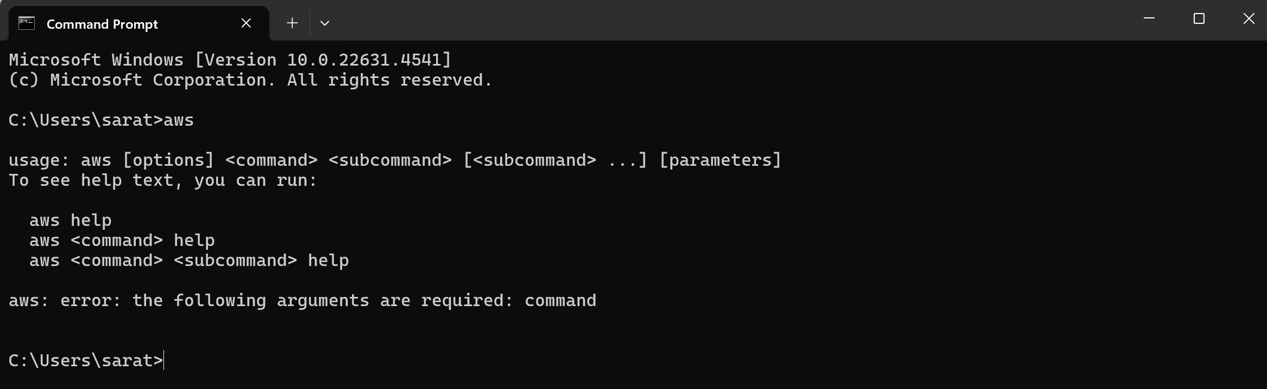

# Now connect to Linux or ubuntu instance.

# Create an EC2 instance in AWS

# Open PuTTY

aws

clear

# Enter the credentials to communicate with the AWS

aws configure

# Provide AWS Access Key ID

# Provide AWS Secret Access Key

clear

# AWS configuration Authentication is done till now.

vim aws_resource_tracker.sh

Esc and press I

#!/bin/bash

#################

# Author: Sarath Bitra

# Date: 08-Dec-2024

#

# The script reports the usage of AWS

#

# Version: v1

#################

set -x # To exeucte the script in debug mode

# AWS S3

# AWS EC2

# AWS Lambda

# AWS IAM Users

*### You can search for the AWS CLI commands in google. Go to google and search for AWS CLI Commands Reference.*

*### Go to s3 and click on it.*

*### Go to the bottom of the page and search for ls and click on it.*

# List AWS S3 buckets

echo “List of AWS S3 buckets”

aws s3 ls > resourceTracker

*### You can search for the AWS CLI commands in google. Go to google and search for AWS CLI Commands Reference.*

*### Go to EC2 and click on it.*

*### Search for describe-instances and click on it.*

# List AWS EC2 instances

echo “List of AWS EC2 instances”

aws ec2 describe-instances | jq ‘.Reservations[].Instances[].InstanceId’

*### You can search for the AWS CLI commands in google. Go to google and search for AWS CLI Commands Reference.*

*### Go to lambda and click on it.*

*### Search for list-functions and click on it.*

# List AWS Lambda functions

echo “List of AWS Lambda functions”

aws lambda list-functions >> resourceTracker:q!

*### You can search for the AWS CLI commands in google. Go to google and search for AWS CLI Commands Reference.*

*### Go to iam and click on it.*

*### Search for list-users and click on it.*

# List AWS IAM Users

echo “List of AWS IAM users”

aws iam list-users

:wq!

./aws_resource tracker.sh